Second Field Integrals before tuning.
Q1
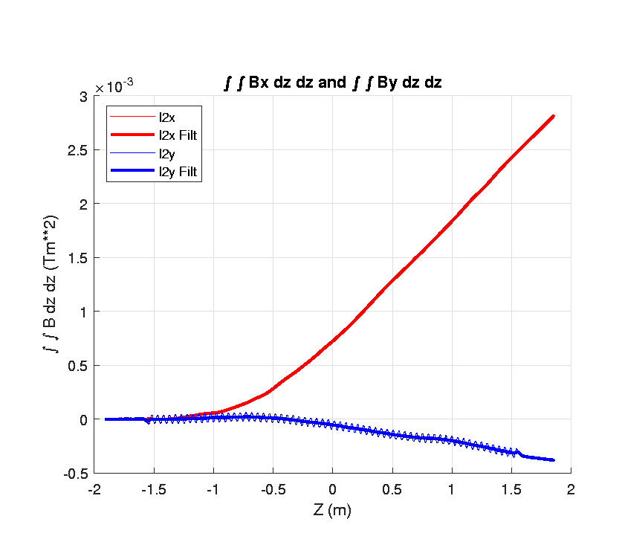

Q2
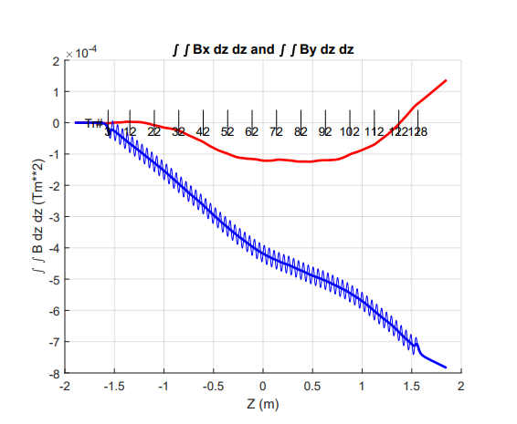

Q3
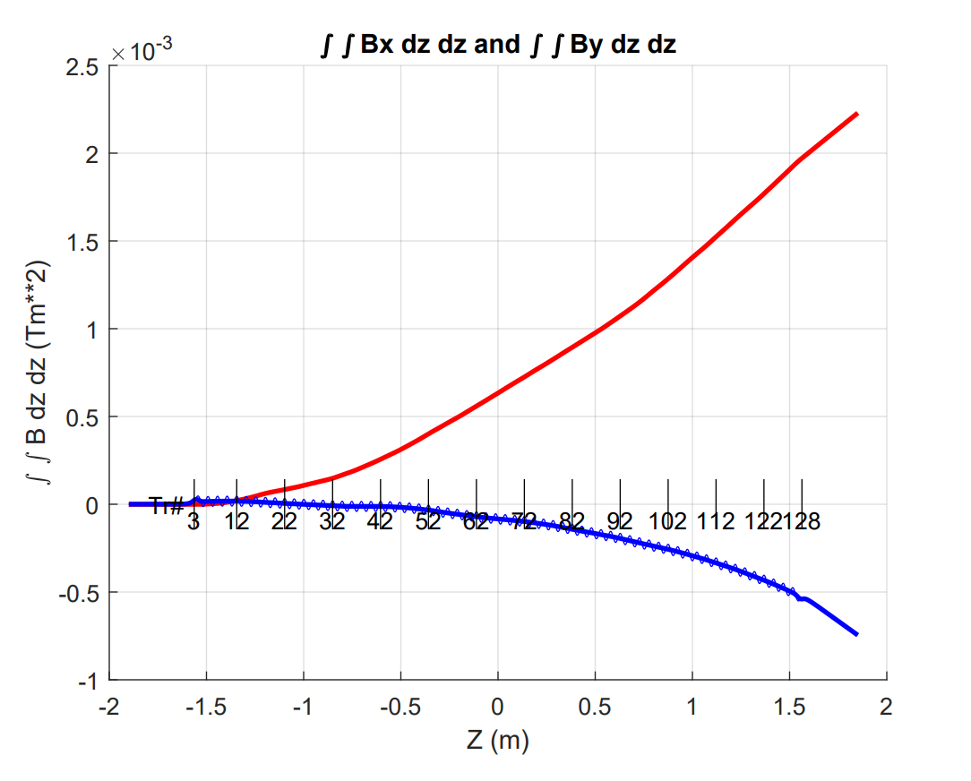

 | K
Q1 | 2.108283
Q2 | 2.110612
Q3 | 2.106790

