Procedure to assemble the DELTA-II keepers.

Preparations:
1. All keepers’ thicknesses, dimension 24.64 on the keeper drawing attached, should be measured, and recorded.
2. Set screws should be pre-installed as in the picture below.

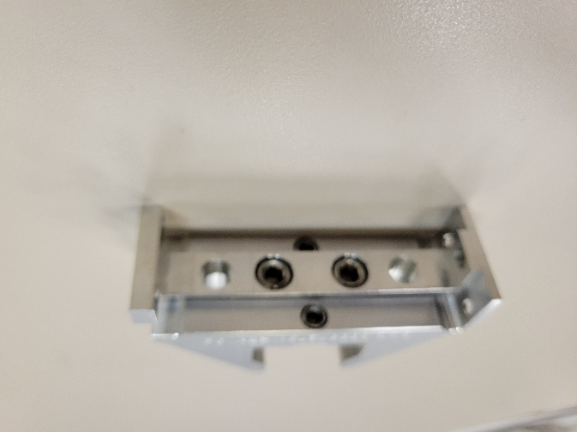
Two M8 set screws
Two M6 set screws
3. Warm-up Keyence sensor for ~ 1 hour.
4. Remove all magnetic items from the work area.
5. Prepare magnet placement information for the quadrant.

Assembly:
1. Fill in information in columns 1÷4 of the table below.
2. Without any magnet or shim on the assembly plate zero the Keyence sensor. Re-zero the sensor before assembling each new keeper.

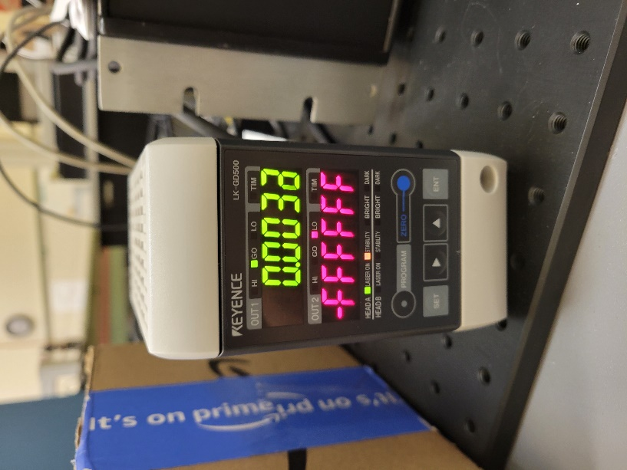
Zero button

3. Place a keeper on the assembly plate. For Q2 and Q4 the two counterbore holes + one threaded hole should be on the left. For Q1 and Q3 they should be on the right.

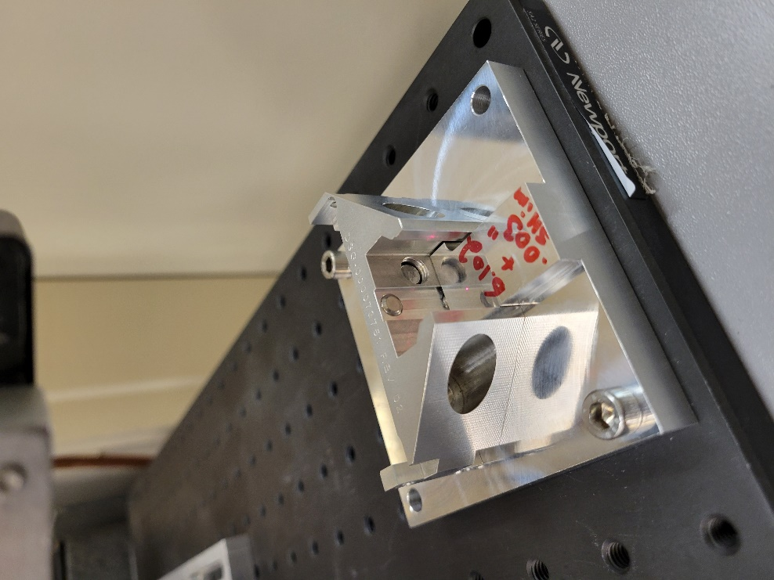
Counterbore holes

4. Find the correct large magnet for the keeper from the Magnet Placement table. Figure out correct magnet orientation; the magnet side with an arrow and a number is the non-flipped side. If magnet should be mounted non-flipped (“0” in column 6 of the magnet placement table) the magnet should be placed into the keeper with the writings on the left. If magnet is indicated as flipped, the writings should be on the right.
5. Check zero reading, re-zero if needed.
5. Place the magnet into the keeper.
6. Read the sensor. Write the number in column 5 on the table.
7. Calculate a shim thickness in columns 7÷9.
8. Install shim under the magnet.
9. Pushing the keeper slightly down fix the magnet in position by two M8 set screws, torque to 0.9 N-m.
10. Remove the shim from under the magnet.
11. Read final position of the magnet from Keyence sensor. Write the position in column 10.
12. Flip the keeper 180° and read the sensor again. Write the number in column 11.
13. Calculate the difference between column 10 and column 11. The difference should be less than 20µm. Otherwise, repeat steps 8-12. It might be needed to change the shim thickness. Write the difference in column 12.
14. Place the keeper under the magnet loader and secure it with two clamps. For Q2 and Q4 the two counterbore holes + one threaded hole should be on the left. For Q1 and Q3 they should be on the right.
15. Find the correct horizontally magnetized US magnet number from the Magnet Placement table. Check the magnet orientation as in item 4.
16. Place the magnet in correct orientation into the loader arm, secure with two thumb screws.
17. Lower the magnet into the keeper. A slight re-positioning might be needed to fit the magnet. When magnet is inside the keeper it will be stay in place by magnetic force. Release the keeper and magnet clamp. Slide it off the loader arm. The magnet will stay in the keeper. Tighten M6 screws to secure the magnet in place by applying clamping force to the magnet at the same time to eliminate any gaps. Torque the screws to 0.9 N-m.
18. Repeat items 14-17 for the DS horizontal magnet.
19. The final keeper assembly should look like in the picture, without visible gaps between the magnets. Apply a drop of locktight to each screw.

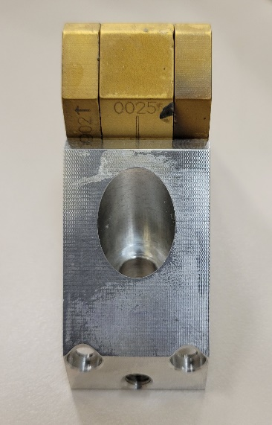

20. Place the assembled keeper into a Styrofoam box. Write the quadrant number and the keeper number on the box.

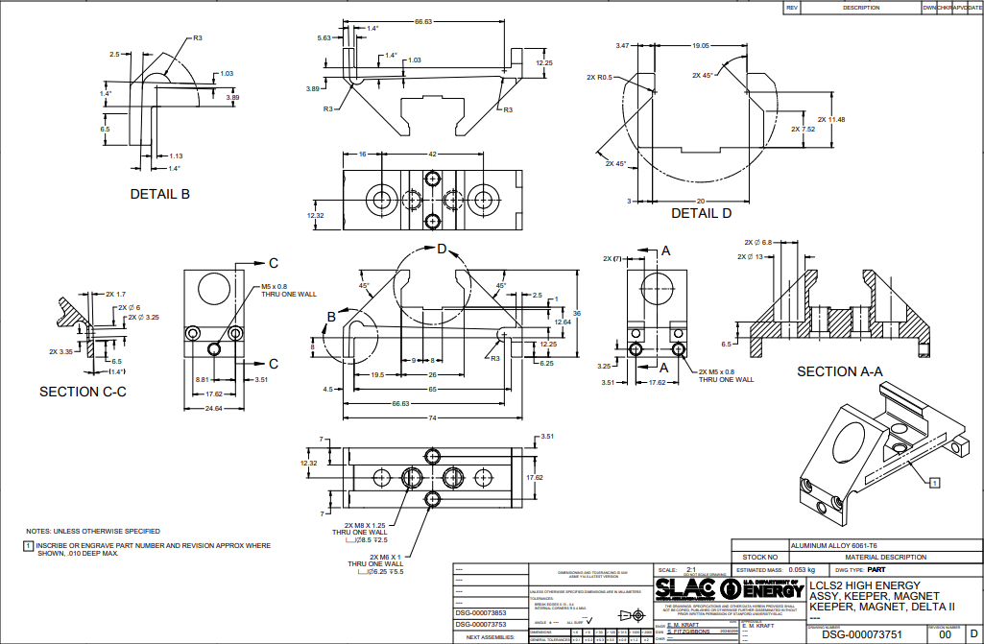
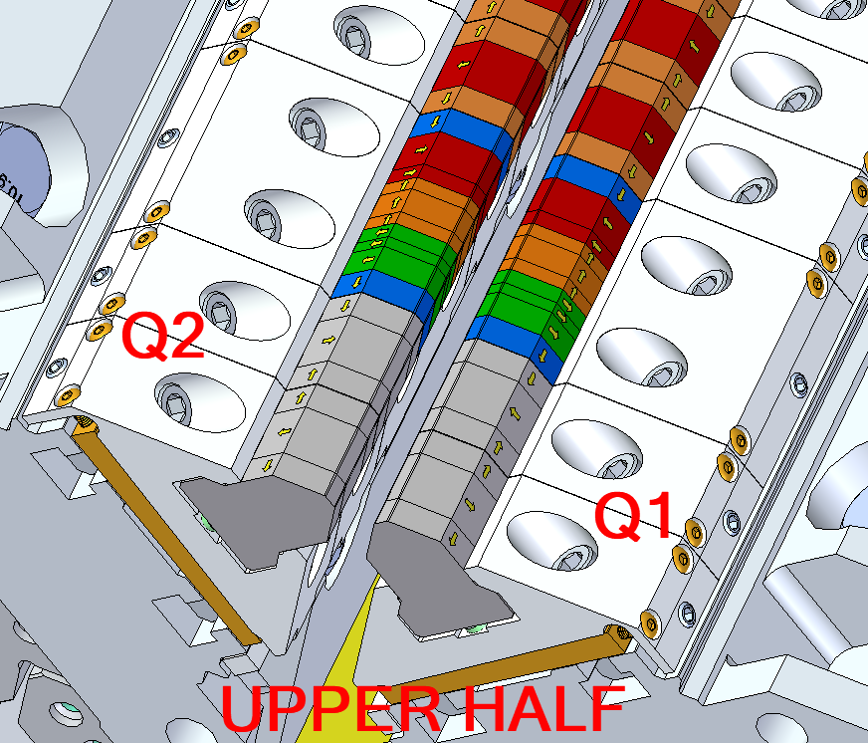
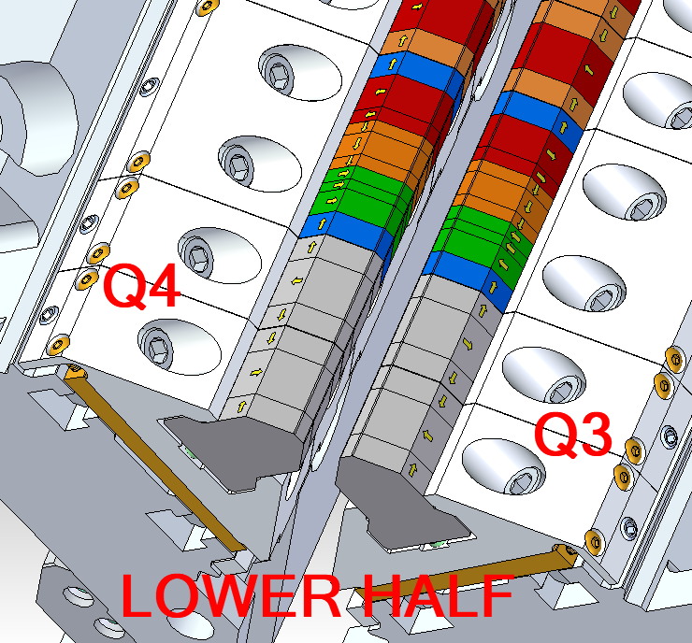
Quad. | Pos. | S/N | Keeper  Thk./2 | Magnet Thk. | Magnet Thk./2 | Column #6 + 6.102 | Shim  (#4-#6) | Column #8/25.4 | Final Pos.1 | Final Pos.2 | Δ (10-11)
1 | 2 | 3 | 4 | 5 | 6 | 7 | 8 | 9 | 10 | 11 | 12

