Document Approval: | Date Approved
Originator: Gene Kraft, SLAC Project Lead Mechanical Engineer
Originator: Franz Peters, SLAC Project Lead Engineer Emeritus
Approver: Shane Fitzgibbons, SLAC Mechanical Design Engineer
Approver: Keith Caban, SLAC CMM Manager
Approver: Robert Pushor, SLAC MMF Controls Engineer
Approver: Yuri Levashov, SLAC MMF Physicist
Approver: Daniele Caltabiano, SLAC Project Lead Controls Engineer
Approver: Briant Lam, SLAC Lead Power Conversions Engineer
Approver: Georg Gassner, SLAC Metrology Department Manager/Project CAM
Approver: Heinz-Dieter Nuhn, SLAC Undulator Systems Physicist
Approver: Zachary Wolf, SLAC Lead Undulator Magnetic Measurements
Revision History
Revision | Date Released | Description of Change
R0 | March 30, 2023 | Original Release.

Table of Contents
1 Purpose 3
2 Scope 3
3 Definitions 3
4 References 3
5 Responsibilities 4
6 Overview 4
6.1 SCU Overview and Layout 4
6.2 SCU Magnet Sub-system 6
6.3 Cryogenic Sub-system 7
6.4 Coldmass Support and Alignment Sub-system 8
6.5 Beam Chamber Vacuum Sub-system 10
6.6 Insulating Vacuum Sub-system 10
7 SCU Assembly and Beamline Layout 11
8 SCU Cryomodule Assembly 11
8.1 Cryogenic Assembly 11
8.2 Support Raft Assembly with Vertical and Horizontal Positioners 11
8.3 Liquid Helium Tank 11
8.4 Insulating Vacuum Assembly 11
8.5 External Support Structures 12
9 SCU Magnet Assembly 12
9.1 SCU magnets and corrector coil assembly 12
9.2 Quadrupole magnet 12
9.3 RF Cavity BPM 12
9.4 Phase Shifter Assembly 12
9.5 Beam Vacuum Assembly 12
9.6 Vacuum beam pipe 14
10 Device and beam pipe supports 15
11 Facilities Infrastructure Requirements 15
12 Beam Stay Clear Apertures 16
13 Radiation Shielding Requirements 16
14 Installation 17
15 Repurposed LCLS-II Installation Practices and Equipment 17
16 Vacuum Chamber and Support Structure Re-Installation 18
17 Recovery of the LCLS-II Beamline 18
18 Procurement, Fabrication and Assembly 18
18.1 Materials 18
18.2 Machined Components 18
18.3 Purchased Components 19
18.4 Vacuum Assembly 19
18.5 Alignment Fiducials 19
18.6 Identification 19
19 Tests and Measurements 19
20 Installation 19
21 Safety 19
22 Risk Assessment 20

Purpose
The Accelerator Free Electron Laser Delta-II Undulator Mechanical Specification provides information for individual supporting sub-systems, mechanical installation and vacuum components in LCLS-II SXR Undulator (HXU) Beamline and device information related to the proposed location of this Delta-II Undulator on the SXU Beamline.

Scope
This document covers the FEL Delta-II Undulator and its supporting sub-systems, which will connect to the existing LCLS-II Soft X-ray beam line in the Undulator Hall. This Delta-II Undulator will undulate the electron bunches to produce soft X-rays, can be quickly switched on or off, allowing normal, uncompromised SASE operations or either polarization controlled SXR operation (vertical, horizontal, circular), enhanced SASE tapering, or enhanced second harmonic radiation. This document presents only mechanical aspects of undulator system design and installation. All other aspects as BCS, PPS, MPS, controls, cables, etc. are not discussed here.

Definitions
FEL | Free Electron Laser
SASE | Self-amplified spontaneous emission
MAD Deck | Methodical Accelerator (Machine Active Device) Design Deck
LCLS | Linac Coherent Light Source
LCLSII | Linac Coherent Light Source II
LCLS-II-HE | Linac Coherent Light Source II High Energy
HXR | Hard X-Ray
HXU | Hard X-Ray Undulator
SXR | Soft X-Ray
SXU | Soft X-Ray Undulator
FRS | Functional Requirements Specifications
BSC | Beam Stay Clear
BCS | Beam Containment System
MPS | Machine Protection System
PPS | Personal Protection System
PRD | Physics Requirements Document
PAMM | Planned Access for Machine Maintenance
RF | Radio Frequency
RFBPM | Radio Frequency Beam Position Monitor
EBD | Electron Beam Dump
UH | Undulator Hall

References
SLAC-I-120-1XX-R0 | Delta-II Undulator PRD
SLAC-I-120-1XX | Delta-II Undulator FRS
LCLSII-2.7-PR-1074 | LCLS-II Beam Containment System Controls
Published - Beam Position Monitor Requirements.pdf - LCLS-2 Physics Requirements (sharepoint.com) | LCLS-II Beam Position Monitor Requirements
LCLSII-2.7-PR-0079 | LCLS-II Electron Beam Loss and Maximum Credible Beam
Published - Quadrupole_Magnet_Vibration.pdf - LCLS-2 Physics Requirements (sharepoint.com) | LCLS-II Quadrupole Magnet Vibration Requirements
Published - Steering_Corrector_Magnets_PRD.pdf - LCLS-2 Physics Requirements (sharepoint.com) | LCLS-II Steering Correct Magnets
Published - Undulator Phase Shifter.pdf - LCLS-2 Physics Requirements (sharepoint.com) | LCLS-II Undulator Phase Shifter PRD
Published - Undulator System.pdf - LCLS-2 Physics Requirements (sharepoint.com) | LCLS-II Undulator System
FP-202-631-14 | Technical specification “fabrication of UHV components”
Published - Undulator_PhaseShifter_FRS.pdf - LCLS-2 Functional Requirements Specifications (sharepoint.com) | LCLS-II Undulator Phase Shifter FRS
Published - UH_Temperature_FRS.pdf - LCLS-2 Functional Requirements Specifications (sharepoint.com) | Undulator Hall Temperature Monitoring FRS
SLAC-I-720-0A24E-001-R006 | Seismic Design Specification for  Buildings, Structures, Equipment, and  Systems: 2020
Published - Undulator_Hall_RDS.pdf - LCLS-2 Room Data Sheets (sharepoint.com) | Undulator Hall Room Data Sheet

Responsibilities
Heinz-Dieter Nuhn | Project Physicist and Manager
Zachary Wolf | Project MMF Physicist and Manager
Eugene Kraft | Project Mechanical Lead Engineer
Yuri Levashov | Project MMF Physicist
Shane Fitzgibbons | Project Mechanical Design Engineer

Overview

SCU Overview and Layout
One of the unique features of this design of the Delta-II Undulator is that the undulator can be connected inside the undulator hall to form a contiguous line of undulators at the end of the SXR beamline (Fig. 1). In addition to the four quadrants of permanent magnets, this design will incorporate an internal vacuum chamber. Per the Delta-II Undulator Physics Requirement Document (PRD), the first Delta-II Undulator will have 56-mm periods to be in resonance with the SXR undulators. The final configuration and mounting of the permanent magnets will be determined after obtaining the results of the PHASE 2 magnet carrier prototype test (expected to occur in 2024).
One concern with the physical size and total weight of the Delta-II Undulator. The total length includes the permanent magnet length in each quadrant, the length of vacuum chamber, and the gaps between the magnets. The maximum length of the Delta-II Undulator Assembly is driven by the SXU Cell z-length in the Undulator Hall (UH). This cell length is 4.4 meters. Delta-II Undulator installation will be interleaved with LCLS-II-HE SXU upgrades and operations. Initial installation could be completed in a multi-day PAMM (design target is less than 3 days). All beam line parameters and operation modes are described in the PRD (SLAC Document Number SLAC-I-XXXX-PR-0-R0) and FRD (SLAC Document Number SLAC-1-XXXX-PR-0-R0).
Any new Delta-II Undulator assemblies, including an LCLS-II SXU Interspace (quad, phase shifter, RFBPM) installed at the end of the SXU beamline, will require Beam-Based Alignment (BBA) before operation (July 2026).
The Delta-II Undulator Vacuum is not a Particle Free System. The electron-photon pass-through beam chamber is UHV, as the remainder of the SXU vacuum transport. (~10⁻⁶ Torr).
Beamline recovery, post installation, will allow the accelerator transport line to achieve base pressure of < 10⁻⁶ Torr within a typical PAMM. Fig. 1 shows the topology of the Delta-II Undulator that will be installed at the end of the Soft X-ray (SXR) undulator line and the vacuum beam transport to the beam dump (not shown). Additional beamline optics will be installed to match the electron beam into the Delta-II vacuum chamber and then allow transport of the beam onto the SXR beam dump, located at SXU Cell 48.
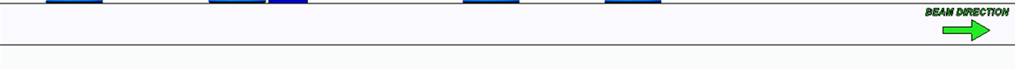
Figure 1. Conceptual layout of Delta-II Undulator System with Vacuum Transport
Delta-II Undulator and supporting beamline devices span the LCLS-II SXU Beamline over approximately 4.4 meters in beam direction. The Delta-II Undulator supporting beam diagnostics will be incorporated into the LCLS-II-HE operating system. These elements are shown in CAD model in Fig. 2a (side view) and 2b (cross-section view). They are also shown schematically in Fig. 3.
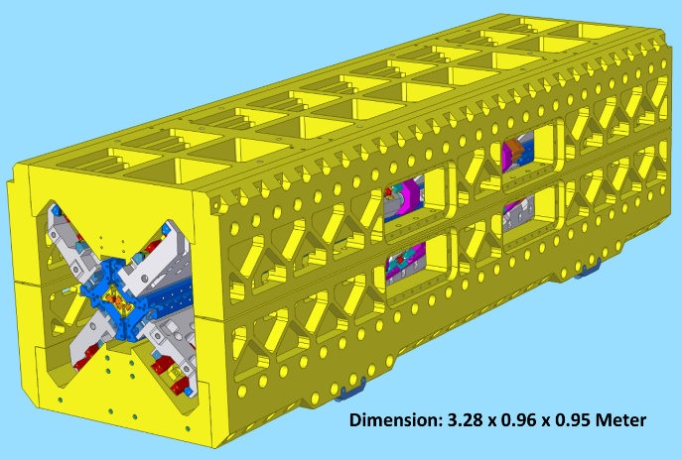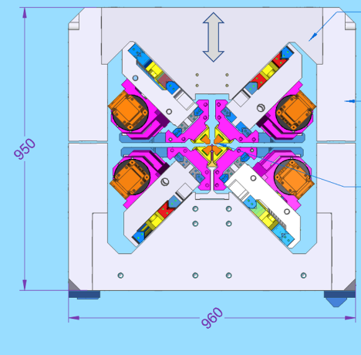

Figure 2. Conceptual layout of Delta-II Undulator and the transverse cross-section.
Each Delta-II Undulator consists of the following sub-systems:
- Magnet carrier sub-system (Section 6.2)
- Gap and phase carrier motion sub-system (Section 6.3)
- Pedestal support and alignment sub-system (Section 6.4)
- Beam vacuum chamber sub-system (Section 6.5)
- Beam vacuum chamber water cooling sub-system (Section 6.6)
- LCLS-II Interspace sub-system (Section 6.7)
- Control sub-system (Section 6.8)

Magnet Carrier Sub-system
A CAD model of the Delta-II Undulator Magnet with gap orientation (magnetic field directions are up and down) is shown in Fig. 3a. The magnets will have a gap orientation as shown in Fig. 3a and 3b. Each magnet consists of . The Delta-II Undulator magnet is illustrated schematically in Fig. 4. There are four sets of magnet carriers within both halves of the Delta-II undulator assembly, the main undulator magnet and keeper (orange) and the adjusters with the magnet carrier (green).
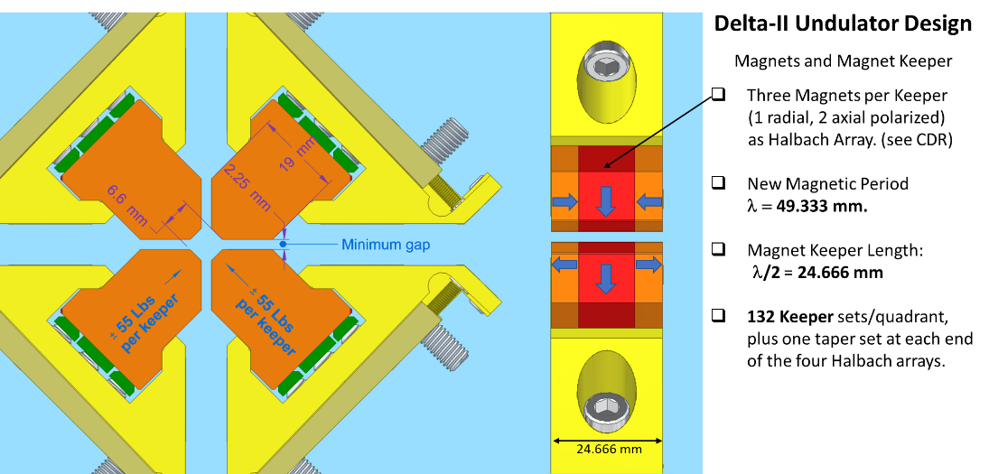
Figure 3. a) CAD rendering of the Delta-II Undulator magnet array

Figure 3. b) cross-section of the magnet array with the vertically aligned beam chamber sandwiched between the magnet cores.
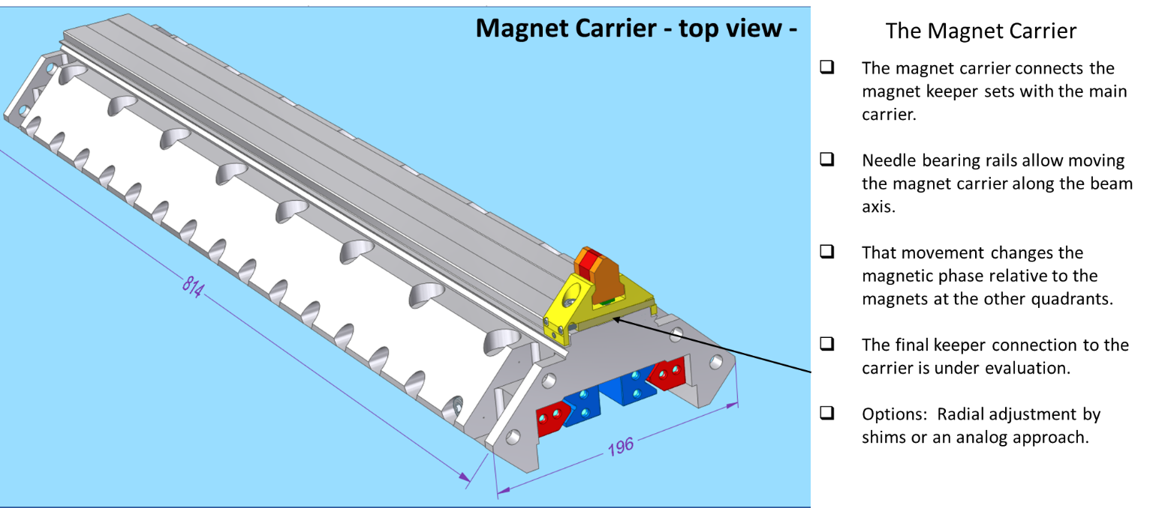
Figure 4. CAD rendering of one end of the Delta-II Undulator magnet carrier with one magnet keeper assembly.
Delta-II Undulator and associated parameters are show in Table 1 below.
Table 1. Magnetic parameters of the Delta-II Undulator
Parameter | Values | Unit
Undulator Period Length (λυ) | 49.3 | mm
Number of Periods per Segment (Np) | >71
Segment Length | 3.280 | m
Undulator Type | Variable Phase & Gap
Magnet Material | Vacodym 956 TP
Gap Orientation (Undulator Field Direction) | 45° Offset Halbach Array
Magnet Field Symmetry | Antisymmetric
Full Magnetic Gap Range | 6.6-22.0 | mm
Undulator Operating Temperature | 293 | K
Maximum On-Axis Magnetic Field Amplitude | 1.32--1.38 | T
Relative Magnetic Field Stability | +/-0.017%
Maximum K | >3.14

Gap and Phase Carrier Motion Sub-system
The main carrier connects the magnet carrier to the strong back via a set of needle bearing rails These rails have a common angle, relative to the beam axis to limit motion of the magnets. Moving the main carrier along the rails, varies the radial distance to the beam axis and, as a result, changes the gap. System design parameters include (per undulator segment) per the following in Table 2.
Parameter | Values | Unit
Undulator Carrier Travel | 40 | mm
Number of Carriers per Quadrant | 4
Carrier Length | 820 | mm
Drive Units per Quadrant | 2
Carrier Material | Aluminum 6061-T6

Table 2. Motion Parameters of the Delta-II Undulator
- Modularity
Delta-II Undulator Carrier segments are designed for end-to-end connection with a shared common angle (with respect to the beam axis) rail system, with end stops terminating the segment string. The main carrier connects the magnet carrier to the strong back via a set of needle-bearing rails. Each magnet carrier is interchangeable. Four versions of the main carrier (based on the two drive unit configurations) are used on the four Halbach Array quadrants.
One drive unit changes the magnetic phase, by moving the magnet carrier set parallel to the beam axis. One drive unit changes the gap, by moving the main carrier set under a common angle to the beam axis. One quadrant of the Halbach Array for the main carriers is shown in Figure 5.
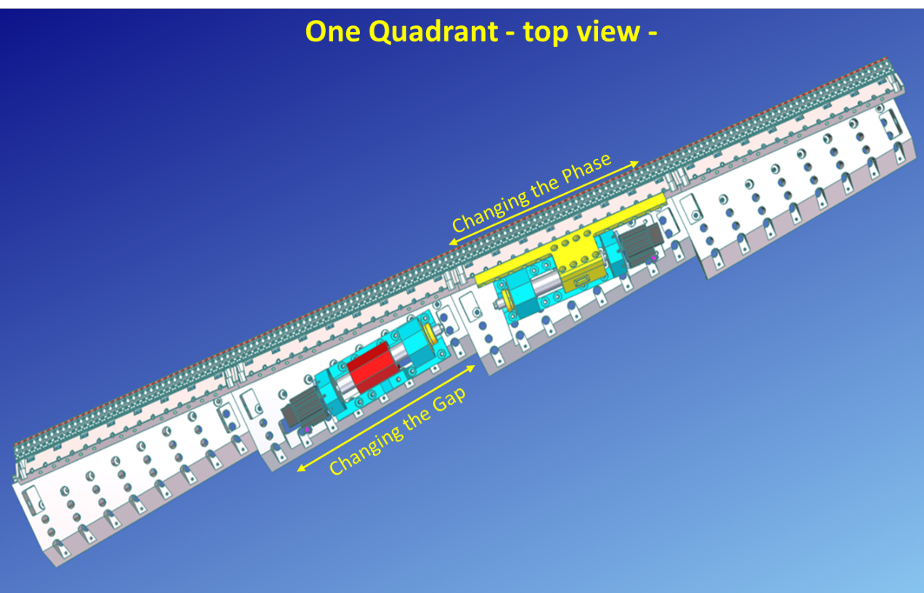
Figure 5. CAD Rendering of one Quadrant of the Delta-II Undulator Main Carrier System

- Maintainability
The main carrier connects the magnet carrier to the strong back via a set of needle-bearing rails, shown in Figure 6, which are oil lubricated with a high duty cycle. No maintenance is required for tens of thousands of cycles.
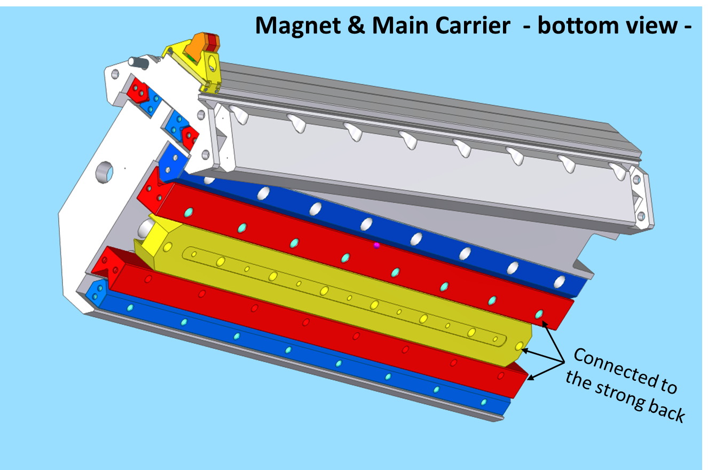
Figure 6. CAD Rendering of Delta-II Undulator Main Carrier System

Pedestal Support and Alignment Sub-system
The mechanical system shall provide rigid inter-module connection, strongback alignment, motion controls, and vacuum support. Each Delta-II Undulator will mount to two LCLS-I style pedestals with cam movers, shown in Figure 7.

The cams to align the undulator will be the same (ANL design), as used at the HXR undulators. With a cross section of 1 square meter, the Delta-II undulator will fit into the SXU Beam Line.
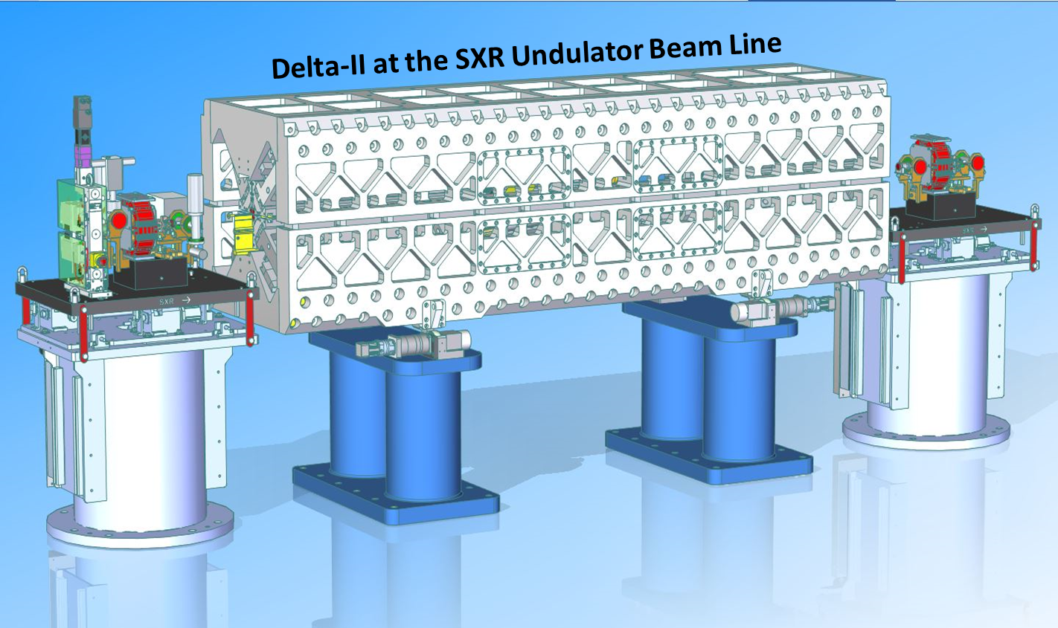
Figure 7. CAD Rendering of Delta-II Undulator Complete Installed System

The Delta-II Undulator system design parameters are summarized in Table 3:
Table 3. Rigid Inter-module Connection Requirements
SCU CM transverse position accuracy | 50 microns
SCU CM longitudinal position accuracy | 1.1 mm
SCU CM transverse position stability | 50 microns
SCU CM longitudinal position stability | ? microns
Vacuum connection | O-rings
Beam transport vacuum when operational | < 1E⁻⁶ torr
- Strongback Alignment Requirement

- Table 4. Internal Strongback Alignment Requirements
Magnet transverse position accuracy | 50 microns
Magnet longitudinal position accuracy | 1.1 mm
Phase shifter transverse position reproducibility | 50 microns
BPM transverse position reproducibility | 50 microns
Strongback transverse position accuracy | 50 microns
Strongback longitudinal position accuracy | 1.1 mm

- Environment Compatibility Requirements
Table 5. Environmental Compatibility Requirements
Cam motor heat generation (average) | < 100 W

Beam vacuum chamber Sub-system
The Delta-II Undulator supporting vacuum system connects the undulator beam transport chamber to the existing LCLS-II SXU beamline and is the physical interface to the connecting high vacuum system. The interior vacuum tube will need to interface to the accelerator beam transport line from the existing SXUs, which has an operating base pressure of 10-6 Torr, within the Ultra-high vacuum regime. Figure 8 shows the conceptual layout of the proposed vacuum system.

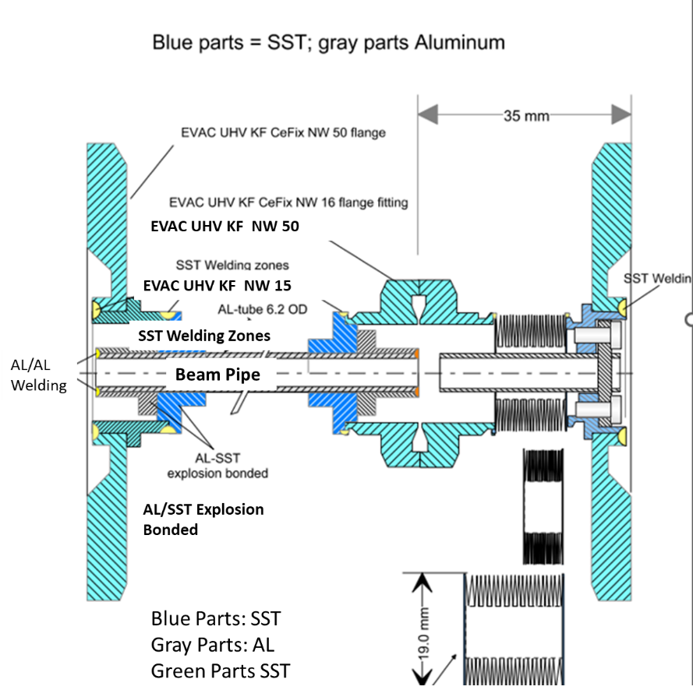
Figure 8: Delta-II Undulator Vacuum Chamber concept showing the beam chamber with flanges and its own vacuum. The beam direction is from right to left.

- Delta-II Undulator Beam Chamber Requirements
The vacuum beam chamber shall be a polished aluminum extrusion with dimensions shown in Fig. 9. The requirements for the surface roughness, dimension tolerance, and material compatibility are shown in Table 6. These requirements are driven by the resistive wall wake heating, magnetic measurements with a room-temperature Hall probe, and mechanical connections to a stainless-steel vacuum pipe.
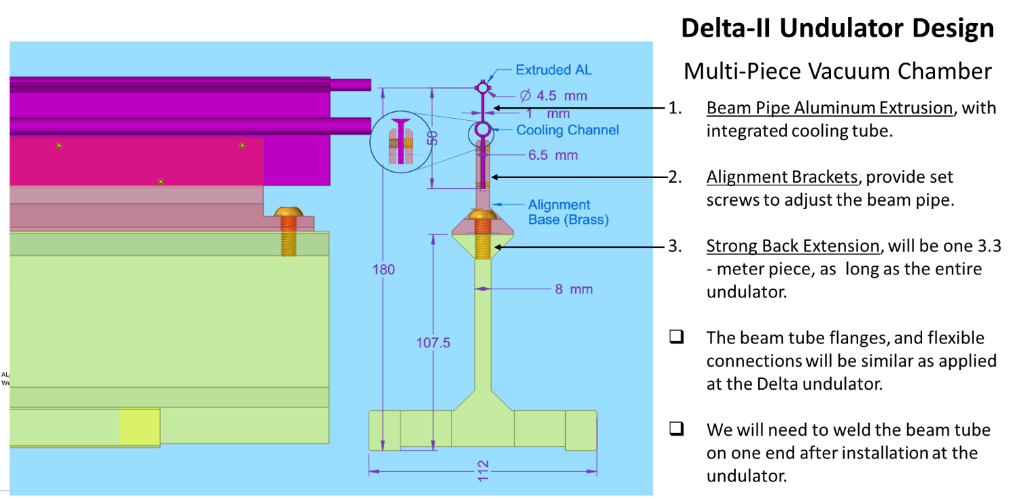
Figure 9: Delta-II Undulator Vacuum Chamber concept

Table 6. Environmental Compatibility Requirements
Beam stay clear (PRD) | +/- 2.3 mm
Zack will provide requirements for Hall probe
Slope (more important) of the oval-shaped bore | < 30 mrad
Surface roughness of the oval-shaped bore | < 100 nm rms
Bore width (horizontal) dimension accuracy | +/- 50 microns
Beam chamber width dimension tolerance | +/- 50 microns
Aluminum extrusion alloy | 6063-T5

Beam Vacuum Chamber Water Cooling Sub-system
Due to the increased electron beam repetition rates for SC LINAC operations, heat will be generated with the beam vacuum chamber effecting the permanent magnet properties through radiative and free convention heat transfer.
Table 6. Environmental Compatibility Requirements
Maximum heat dissipation per unit length | 1 W/m
Maximum flow through vacuum chamber | <2 gpm
Maximum water pressure drop provided at source | < 60 psi
Water transport materials | Aluminum 6063-T5, Copper piping, Synflex hose

SCU Assembly and Beamline Layout
The plan is three Delta-II Undulators will be installed at the end of the SXR undulator line. The physical location can be seen from the “screen shot” of the installation drawings for the Sector 48-50 SXR Undulator Beamline Area, ID-375-045-18-R01, as shown in Figure 10.

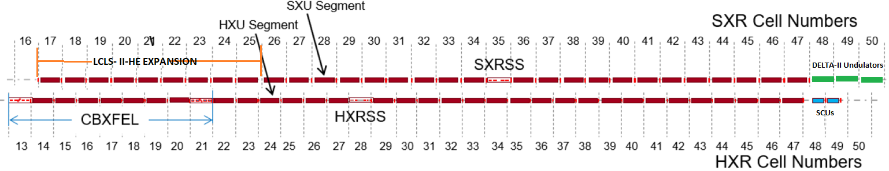
Figure 10: HXR Undulator Beamline, Cells 13 to 47, SXR Undulator Beamline, Cells 16 to 50. from the installation drawings (ID-375-044-18-01/ID-375-045-18-02) with the three Delta-II Undulators installed in SXU Cells 48-50. Cables, water lines, BLMs, assorted peripheral supports are not shown.
MAD deck will be updated with the Delta-II Undulators after all the magnetic components, BPMs, and their locations have been specified. The actual positions of the Delta-II Undulator components are TBD.

Delta-II Undulator Magnet Assembly

Delta-II Undulator magnets and Corrector Coil Assembly

Quadrupole Magnet
The LCLS Undulator Quad Magnet design will be reused. The supports at the top plate assembly to the SXU interspace, based on the LCLS-II design will be used.

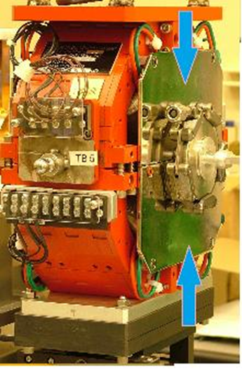
Figure 11. LCLS-II Undulator Quad Magnet with Vacuum Connections

RF Cavity BPM
The LCLS-II Undulator RFBPM design will be used. The current RFBPM can achieve successful operation for the Delta-II Undulator.
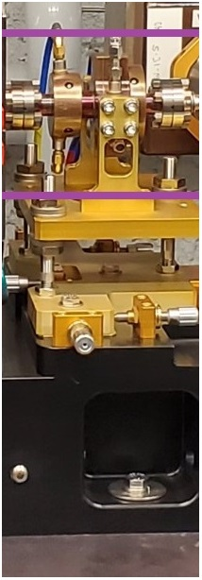

Figure 12. LCLS-II SXU RFBPM Assembly with Vacuum Connections

Phase Shifter Assembly
The LCLS-II Undulator Phase Shifter Assembly design will be used, as shown in Figure 13. The current Phase Shifter Assembly can achieve successful operation for the Delta-II Undulator.
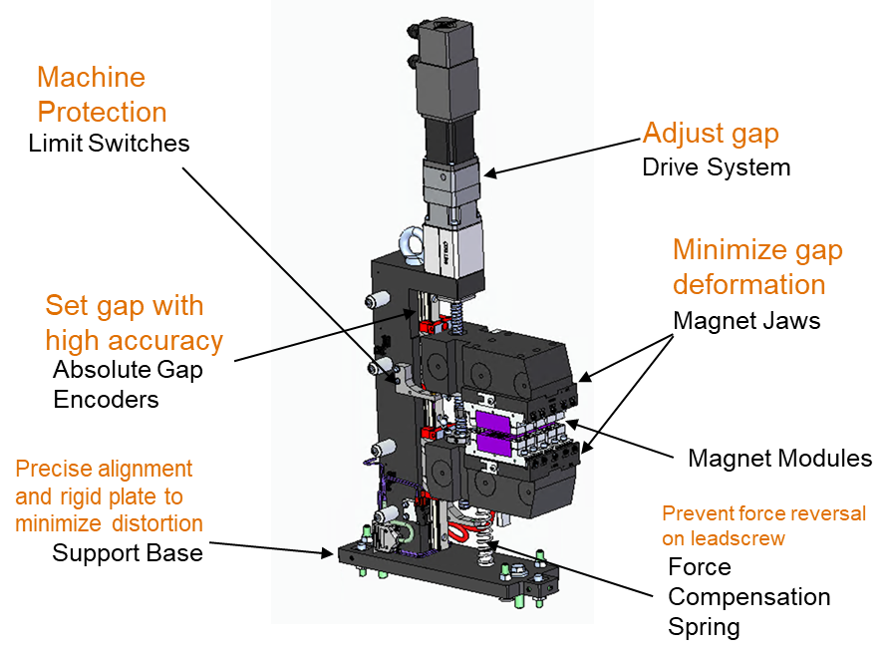
Figure 13. LCLS-II Undulator Phase Shifter

SXU Beam Transport Vacuum Assembly
The vacuum line will be updated. The drift tubes on SXU Cell 48 (and eventually for SXU Cells 49 and 50) will be replaced by the three Delta-II Undulators. The connection between the last Delta-II Undulator vacuum and the start of the SXR EBD Transport will be through a drift tube of 10mm OD and CF flange 2 ¾”. The vacuum section between beginning of SXU Cell 48 and end of SXU Cell 50 has to be isolated if needed. There is already a gate valve at the start of the SXR EBD Transport beamline, model VAT48132-CE24-002, all shown in Figure 14.

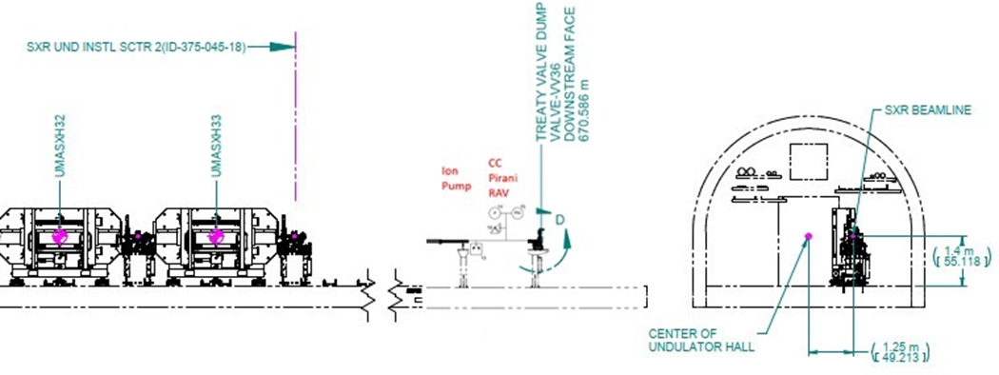

Figure 14. LCLS-II SXU Beamline in UH

On SXU Cell 48, a new pneumatic gate valve will be installed at the upbeam SXU Interspace. Between the two valves, a vacuum tree with a Right angle valve, a Cold Cathode and Pirani gauge will be installed, onto the top plate assembly of the new SXU Interspace, the configuration for this interspace (ID-375-045-35-R04) will be installed in that vacuum section to ensure proper vacuum as required, as shown in Figure 15.

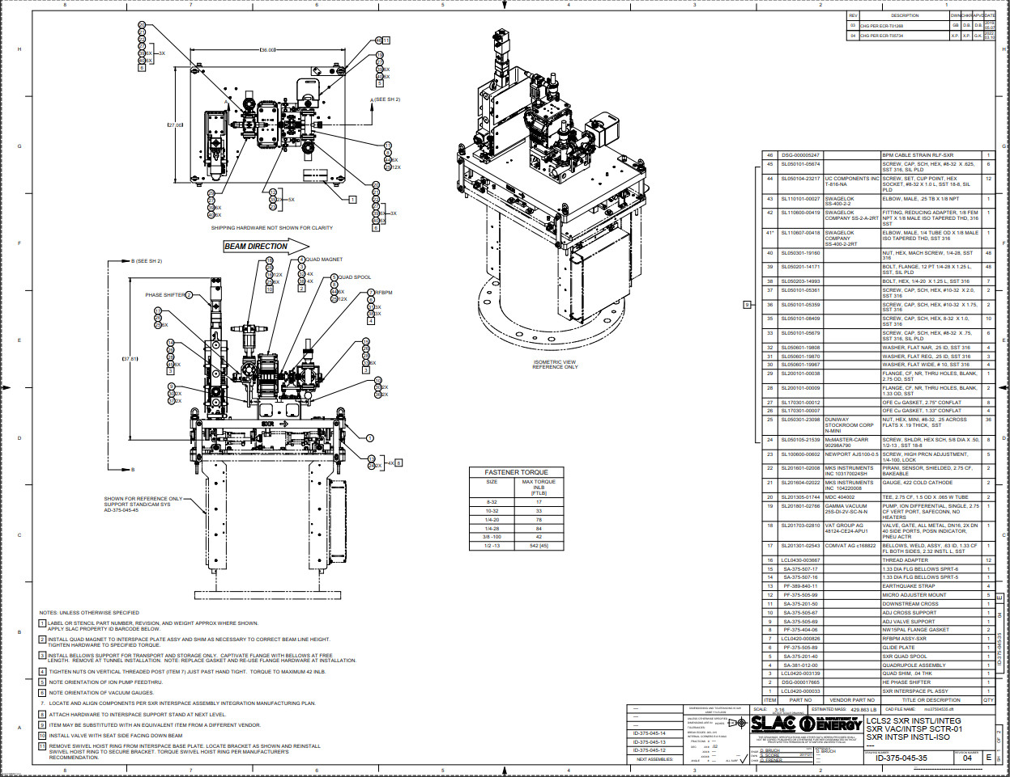

Figure 15. LCLS-II SXU Interspace Assembly with Vacuum Connections

Vacuum Ion Pumps (we are using ion pumps every 4 meters)
If additional pumping is required for the accelerator beamline, then the ion pumps chosen will be a Varian/Agilent Vacion Plus with 20 liter/sec pumping speed. The part model number is 9191125. The product details are found in Appendix A.

Vacuum Pressure Gauges
Vacuum pressure monitoring requirements for adjacent sections of the installed Delta-II Undulator on the accelerator beamline are dictated by LCLS-II vacuum requirements. For the SLAC UHV requirements, MKS Instruments Cold Cathode and Pirani Sensor vacuum pressure gauges are used, and listed in Table 3, below.
Table 3. Typical UHV Vacuum Pressure Monitoring Gauges used at SLAC
No | Device | Model
1 | Gauge Cold Cathode | MKS 422 (#104220008)
2 | Convection – Enhanced Pirani | MKS 317 (#103170024SH)

Vacuum Manual Isolation and Pumping Port Valves
Vacuum requirements for Delta-II Undulator on the SXR Undulator accelerator beamline are dictated by LCLS-II vacuum requirements. SLAC currently uses the VAT Valve All Metal Seal, Right Angle Valves. The specific model for interface with 2.75” CFF, is 54132-GE02-0001. This will be added only if determined to be needed to isolate the Delta-II Undulator beam transport vacuum chamber from the SXR Undulator beamline.

Electron Transport Vacuum Beam Drift Pipe
Beam pipe will be reused at the existing install location. The beam pipe internal diameter is dictated by the beam stay clear at its specified location in z along beam path. The current beamline vacuum drift tubes at the install location can be seen in Figure 16.
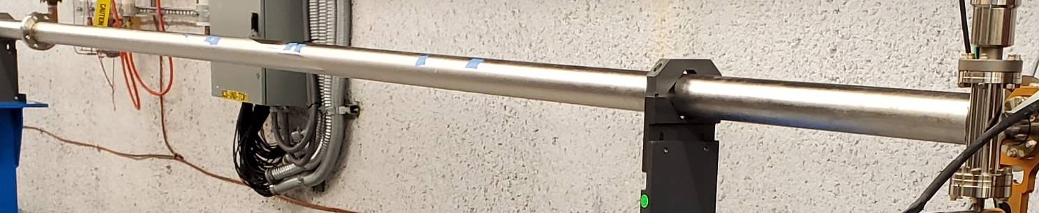
Figure 16. LCLS-II SXR Undulator to EBD Transport Beamline Vacuum Drift Tubes

Device and beam pipe supports
For supporting devices and beam pipes similar supports to LCLS-II will be used. The Beam pipe connected upbeam and downbeam of the Delta-II Undulator will be supported by the existing support structures, where applicable.
Similar stands design will be used. Vibration tolerances are not critical for the support design (stand and alignment stage) as shown in Fig. 10. They currently meet the performance requirements for LCLS-II, so they will be reused.

Facilities Infrastructure Requirements
KEY ITEMS TO CONSIDER:
- Need cooling and power requirements table for each Delta-II Undulator Vacuum Chamber.
- Facilities infrastructure updates to the tunnel and support building 921 needed to install, monitor and operate each Delta-II Undulator.
- All support equipment will be located at the location installation in the Undulator Hall, however, initial estimates show no significant additional heat load in the tunnel.
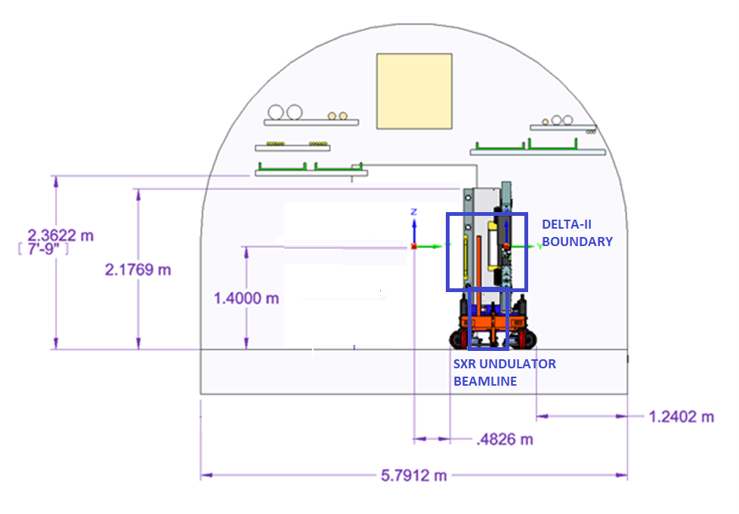
Figure 17. Support Configuration using Drift Pipe within Undulator Hall Enclosure.
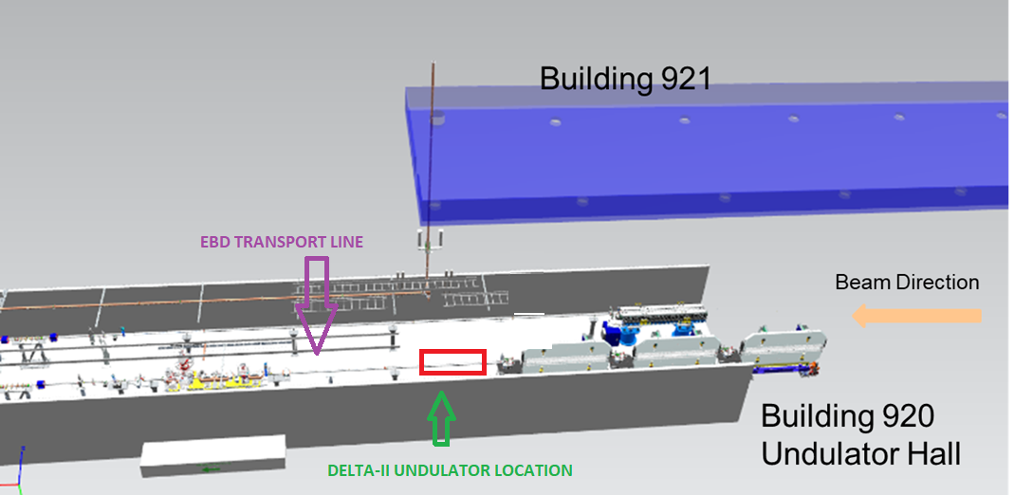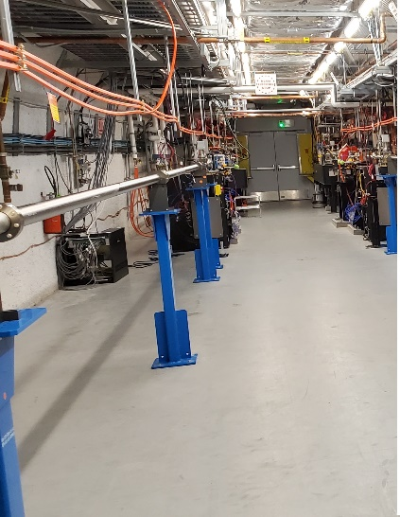
Figure 18. Install Final Configuration and Current Configuration in UH.

Beam Stay Clear Apertures
According to the LCLS-II SXR Undulator Mad Deck BSC varies from diameter 8.314mm (0.445”) to 8.49mm (0.452”).
Beam pipe of 1.5” outer diameter will be used along the entire beam line, not including the undulator core vacuum chamber which will satisfy BSC requirements.
Link to Current BSC (Nov 27 2023).

Radiation Shielding Requirements
According to the LCLS-II SXR Undulator Beamline varies, but from discussion with Clive Field:
- The radiation dose measured near the beam axis with the copper linac at 120 Hz is on the order of a few hundred rad per year
- The radiation dose increases rapidly if there is a neckdown in the beam chamber due to synchrotron radiation
- Synchrotron radiation is expected to be not an issue if the Delta-II Undulator beam chamber aperture larger than the SXU beam chamber
- Encoders are damaged when the cumulative dose exceeds a few kilorad level
- The Delta-II Undulator motion encoders, if located at >18" away from the beam axis, should see much lower radiation dose, on the order of a few rad per year.

Installation
For installation, the currently installed beam pipe will need to be vented and removed. Adequate clearances will need to be provided upbeam, requiring the removal of the existing beamline vacuum transport pipes. The install site does NOT require Particle Free Best Practices. No templates will be used to mark the floor for the Delta-II Undulator support mounting location. Alignment group will provide the marking. No alignment plate will be used between the Delta-II Undulator Pedestals as on LCLS-I HXU pedestals, during their original installation. The install scheme for these new devices is shown in Fig. 19.
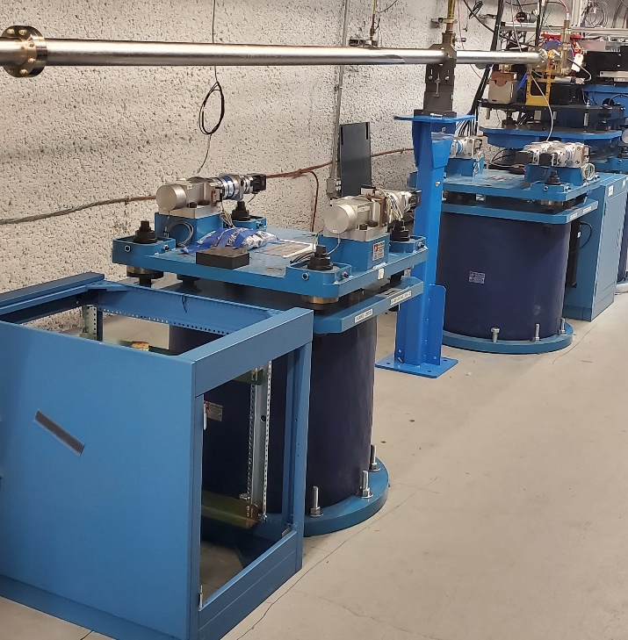

Figure 19. LCLS-I/LCLS-II HXU Pedestals.

Repurposed LCLS-II Installation Practices and Equipment
For installation, standard rigging and transportation practices used on LCLS installation will be reused with an updated lift plan generated by MFD. Alignment group will provide the marking and positional verification during the transport to the final position. Lifting and placement scheme will use proven LCLS-II best practices.
Transportation: shipments, logged data for HXU/SXU from MMF to Undulator Hall
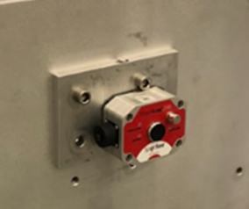
Figure 20. LCLS-II Undulator Transport Shock Logger.

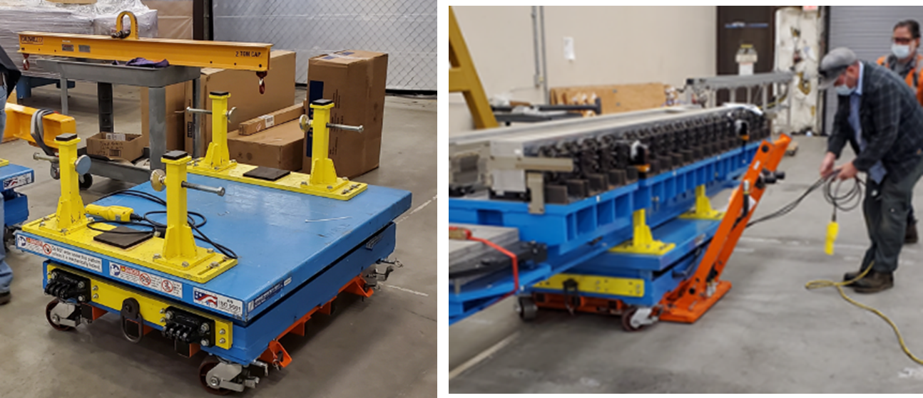
Figure 21. LCLS-II Undulator Transport System within Undulator Hall.

Vacuum Chamber and Support Structure Re-Installation
For installation, standard rigging and transportation practices used on Vacuum Chamber and Supports relocation. The original LCLS-II HXU/SXU installation lift plans will be reused with an updated lift plan generated by MFD. Alignment group will provide the marking and positional verification. The currently proposed lifting and placement scheme will attempt to repeat what was accomplished for LCLS-II HXU/SXUs. This effort will drive key features of the Delta-II Undulator outer structure design. The approximate installation site conditions and the LCLS-II HXU key install process steps can be seen in Figures 16. This will be similar for the Delta-II Undulator.

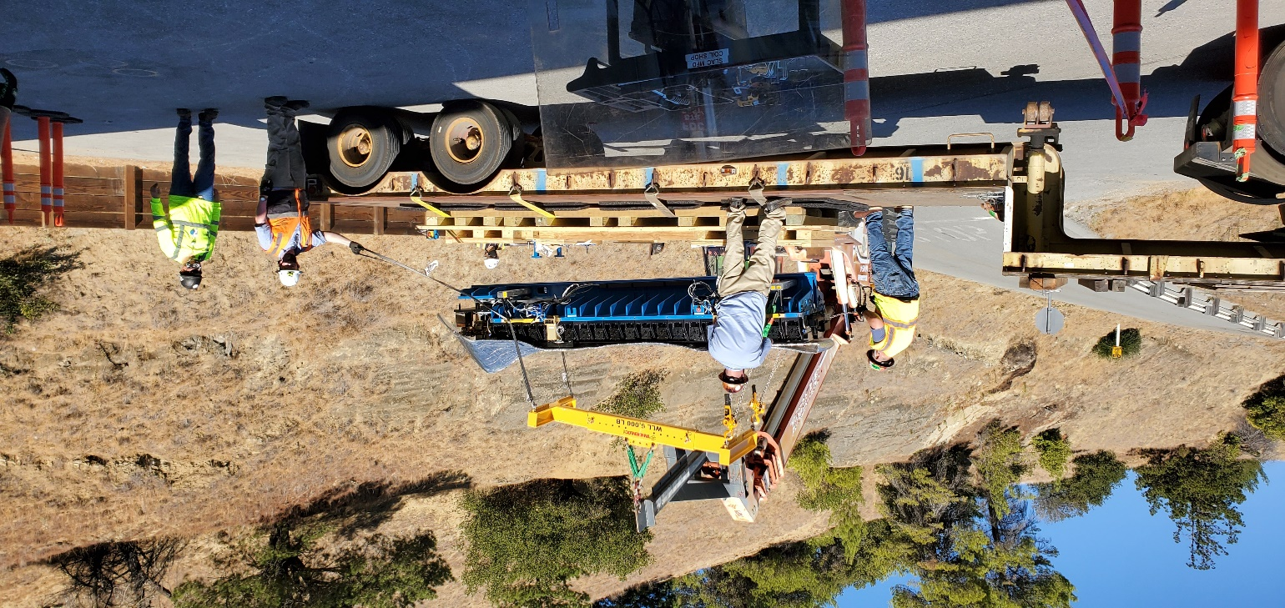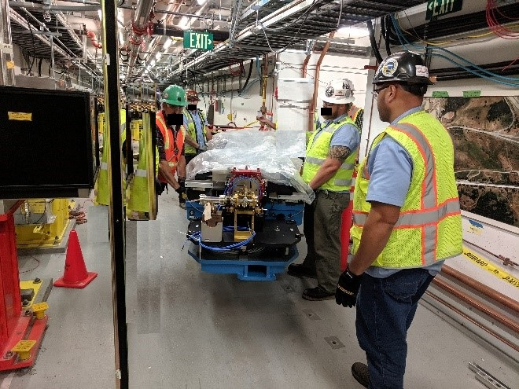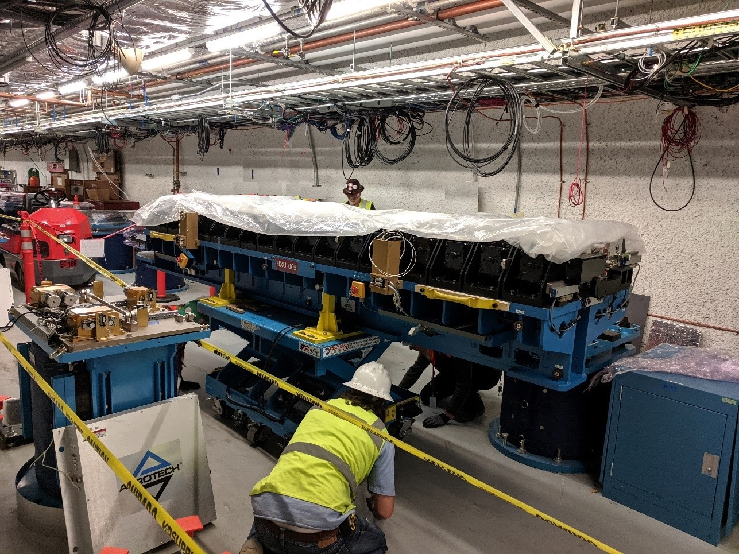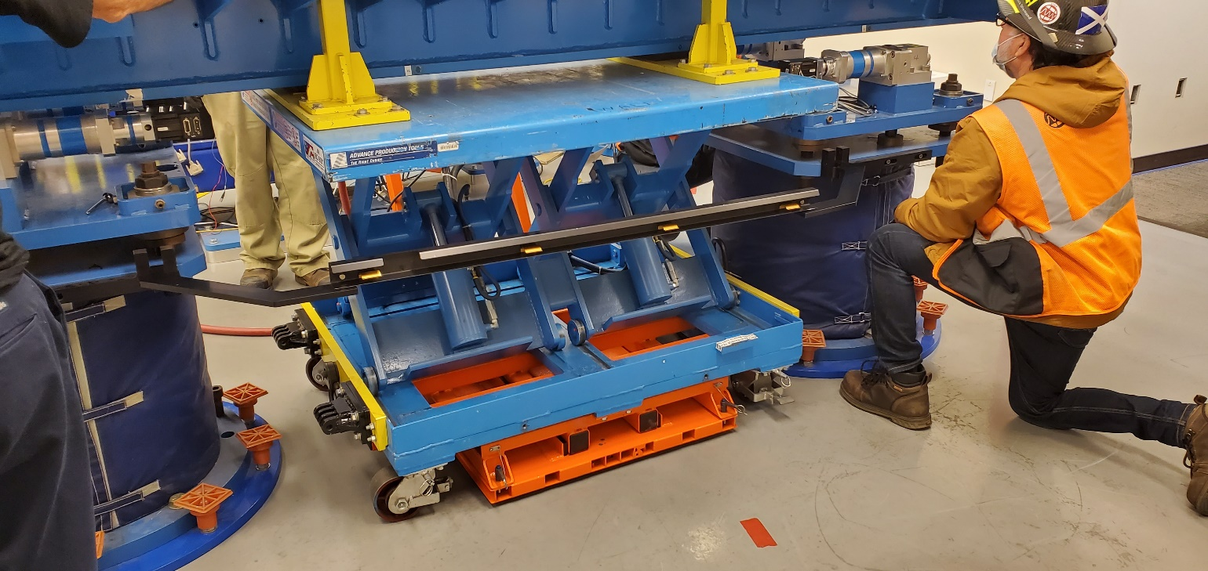
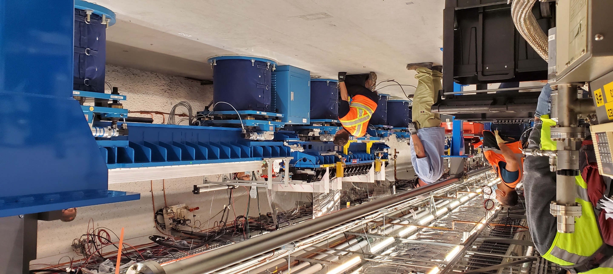
Figure 22. Photo of planned Move and Reinstallation scheme –Current LCLS-II HXU Installation Scheme shown as example

Recovery of the LCLS-II Beamline
For LCLS-II operations, the beamline in. Alignment group will provide the marking and positional verification of the original vacuum drift support stands. Details for this restoration will be provided to MFD.

Procurement, Fabrication and Assembly

Materials
All parts to be installed in vacuum must conform to the SLAC vacuum standard for machined components including materials requirements and lubricant restrictions. See SLAC FP-202-631-14 for details. All test results shall be recorded in the traveler.

Machined Components
All in vacuum parts must be leak checked prior assembly. All in-vacuum parts must be fabricated in accordance to SLAC vacuum standard SLAC-FP-202-631-14. All machined parts must be inspected for conformance to drawing dimensions, tolerances and requirements. Acceptance of parts is to be recorded on the component traveler.

Purchased Components
All purchased components including controls hardware must conform to applicable SLAC safety policies and practices. Controls hardware must be acceptable rated by nationally recognized testing laboratory or pass internal SLAC electrical safety inspection.

Vacuum Assembly
Assembly of in-vacuum parts must be performed in SLAC Clean Room. Leak testing of components and sub-assemblies shall be performed in such a manner as to identify leaks as early as possible.

Alignment Fiducials
Included in the design of various assemblies / components are provisions for tooling ball sockets. Each assembly / component must have the tooling ball fiducialized on a CAMM with respect to the vacuum chamber beam axes.

Identification
Major assemblies shall be marked with assembly part number and weight in pounds. Where the device size allows it, every assembly shall also have a white, painted, engraved or stenciled arrow on each side pointing in the direction shown in the drawing with “Beam Direction” lettered on the shaft of the arrow (with at least ½” high characters) as illustrated in Figure 16. On smaller device assemblies the same information will be clearly marked or inscribed.

Figure 17. Beam direction arrow

Tests and Measurements
Tests and measurements must be performed to assure that the major assemblies / components perform as designed. Tests and measurements shall include part and assembly qualification, electrical safety inspection, actuation testing, limit switch tests, pressure tests, leak checks, assembly fiducialization and vacuum qualification bake-out. Tests shall be performed in the laboratory to qualify the device prior to installation. For actuating devices to include “dry run” for 100 cycles. All tests and measurements shall be recorded on a device traveler which corresponds to the unique device serial number.

Installation
Precision alignment of the beamline device is required; to be performed by the SLAC Metrology group. Interconnection and testing of controls shall be performed following vacuum interconnection. Additional field testing may be performed by SLAC Radiation Physics.

Safety
Precision installation and transport will follow the Enhanced WPC processes implemented in CY2023.
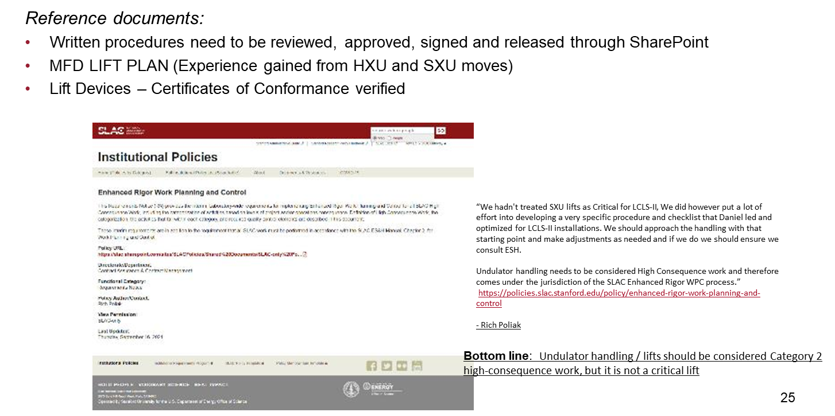
Figure 18. Enhanced WPC Process for the LCLS-II Undulator Transport and Installation.

Risk Assessment
Risk Assessment is evaluated from Lessons Learned from LCLS-II, CBXFEL and XLEAP Projects. The processes reviewed and implemented in CY2023, and can be seen in Figure 19.

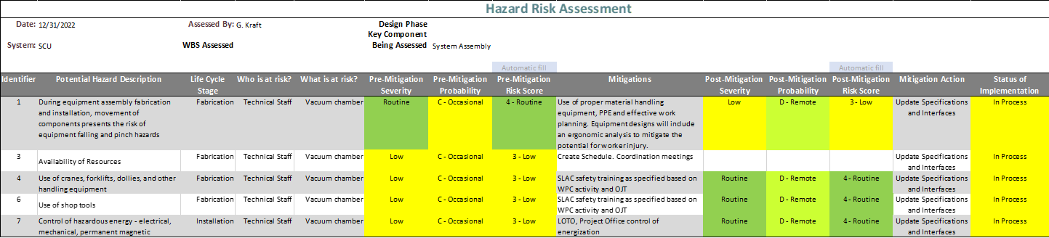
Figure 23. DELTA-II Undulator Hazard Risk Assessment Matrix.

APPENDIX A:

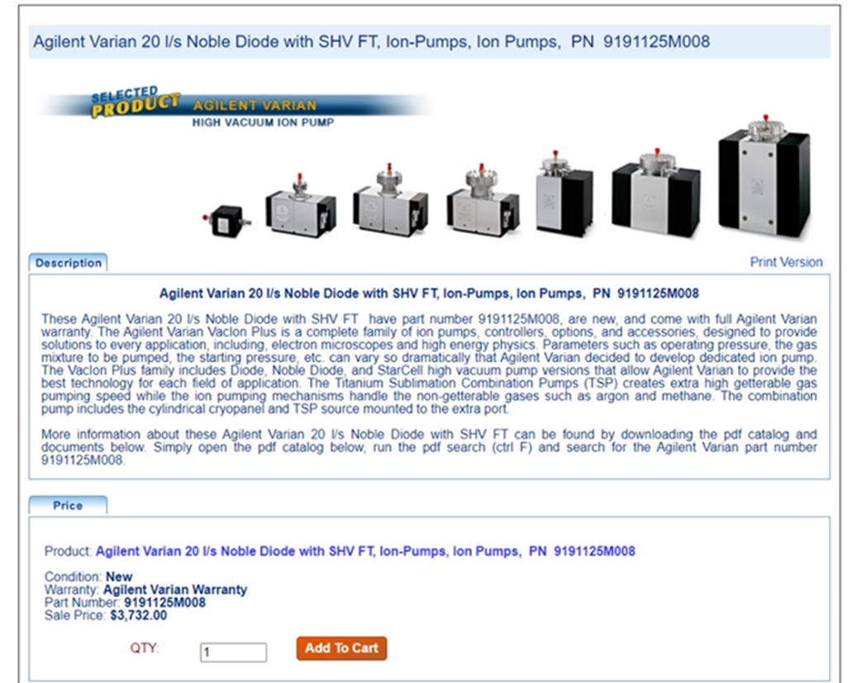

Figure 20. Proposed Vacuum Ion Pumps for additional transport line pumping.

