LCLS2 SXR Undulator

Alignment Engineering Group
L2?????
SN 29A804-007
March 23, 2018

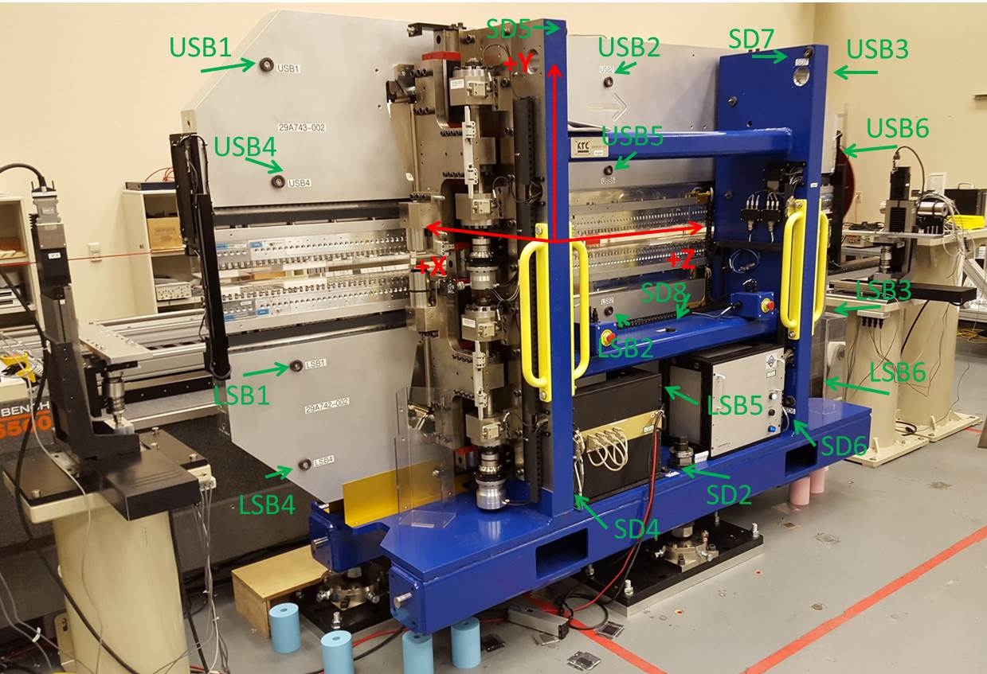

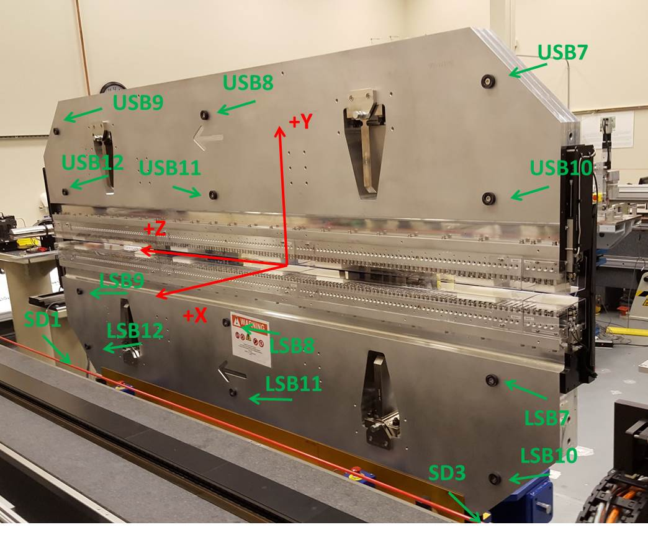

Tooling ball values to center of 1.5 inch sphere, all units are inches. Coordinates are to the SXR Undulator Magnetic Axis.
Tooling Ball | Z (in) | X (in) | Y (in)
LSB1 | -57.4846 | -3.4875 | -10.4734
LSB2 | -0.0043 | -3.4983 | -10.4726
LSB3 | 57.4723 | -3.4841 | -10.4809
LSB4 | -57.4807 | -3.4818 | -24.2471
LSB5 | -0.0050 | -3.4923 | -24.2497
LSB6 | 57.4724 | -3.4798 | -24.2511
LSB7 | -57.4811 | 3.4921 | -10.4733
LSB8 | -0.0081 | 3.4853 | -10.4786
LSB9 | 57.4659 | 3.4920 | -10.4699
LSB10 | -57.4849 | 3.4979 | -24.2480
LSB11 | -0.0154 | 3.4911 | -24.2520
LSB12 | 57.4650 | 3.4971 | -24.2493
SD1 | 50.9912 | 7.2316 | -34.6387
SD2 | -3.9515 | -19.5264 | -34.7071
SD3 | -50.9843 | 7.2456 | -34.6317
SD4 | -25.6279 | -21.7023 | -29.5605
SD5 | -25.6709 | -21.6956 | 29.4768
SD6 | 25.6478 | -21.6780 | -29.5579
SD7 | 25.6227 | -21.7048 | 29.4746
SD8 | -0.0093 | -16.9668 | -12.3115
USB1 | -57.4847 | -3.4901 | 24.2456
USB2 | 0.0035 | -3.4921 | 24.2533
USB3 | 57.4842 | -3.4881 | 24.2533
USB4 | -57.4842 | -3.4899 | 10.4700
USB5 | -0.0028 | -3.4934 | 10.4724
USB6 | 57.4782 | -3.4917 | 10.4704
USB7 | -57.4814 | 3.4868 | 24.2494
USB8 | 0.0027 | 3.4909 | 24.2493
USB9 | 57.4824 | 3.4897 | 24.2535
USB10 | -57.4794 | 3.4883 | 10.4721
USB11 | 0.0046 | 3.4893 | 10.4753
USB12 | 57.4816 | 3.4857 | 10.4730

Center | Z (m) | X (m) | Y (m) | Z (in) | X (in) | Y (in)
PM10M | -2.814806 | -0.026441 | 0.000730 | -110.8191 | -1.0410 | 0.0287
PM11M | 2.727362 | -0.026669 | 0.000484 | 107.3765 | -1.0500 | 0.0191
RFM | -2.669988 | 0.039005 | 0.000018 | -105.1176 | 1.5356 | 0.0007

PM10 and Granite coordinate system with Yurii shifts.
 |  | From Yurii |  |  | Measured
Device | Z (m) | X (m) | Y (m) | Z (m) | X (m) | Y (m) | dX (mm) | dY (mm)
PM10 | -0.368854 | -0.102452 | 0.000996 | -2.814806 | -0.102444 | 0.000996 | 0.008 | 0.000
PM11 | 5.173434 | -0.102664 | 0.000747 | 2.727362 | -0.102672 | 0.000750 | -0.008 | 0.003
RefBlock |  |  |  | -2.669988 | -0.036998 | 0.000284

