LCLS2 HE SXR Undulator

Alignment Engineering Group
L2?????
SN 29A804-0007
October 17, 2022

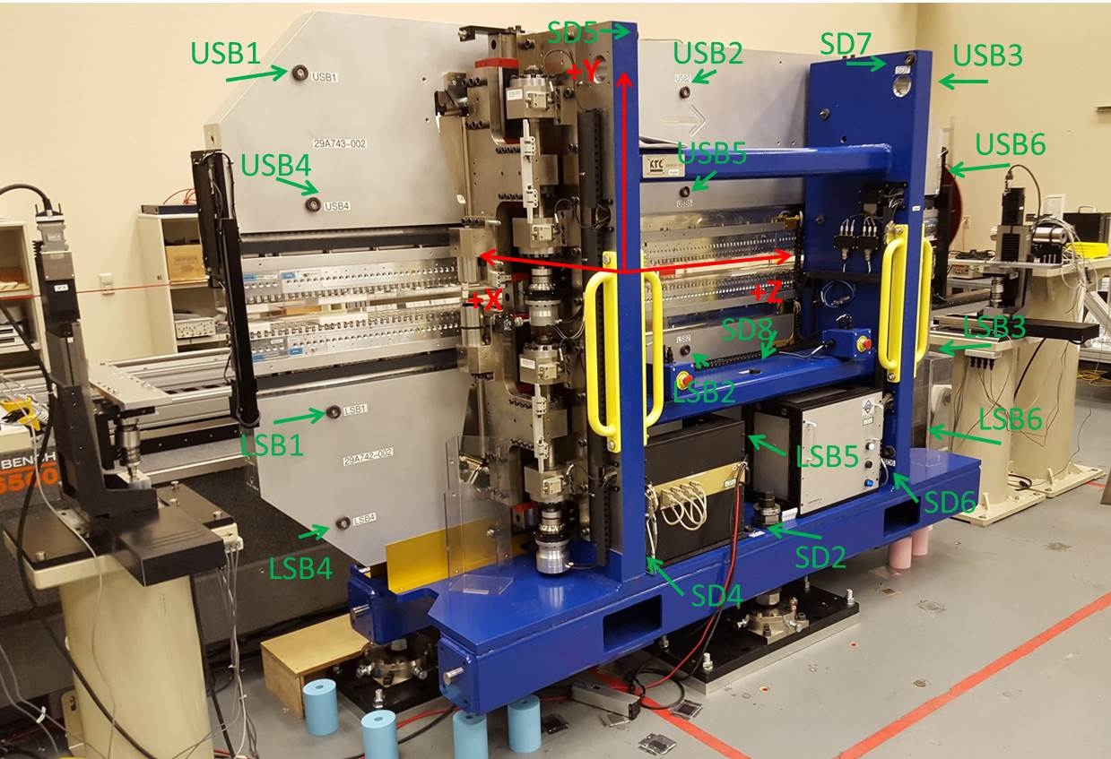

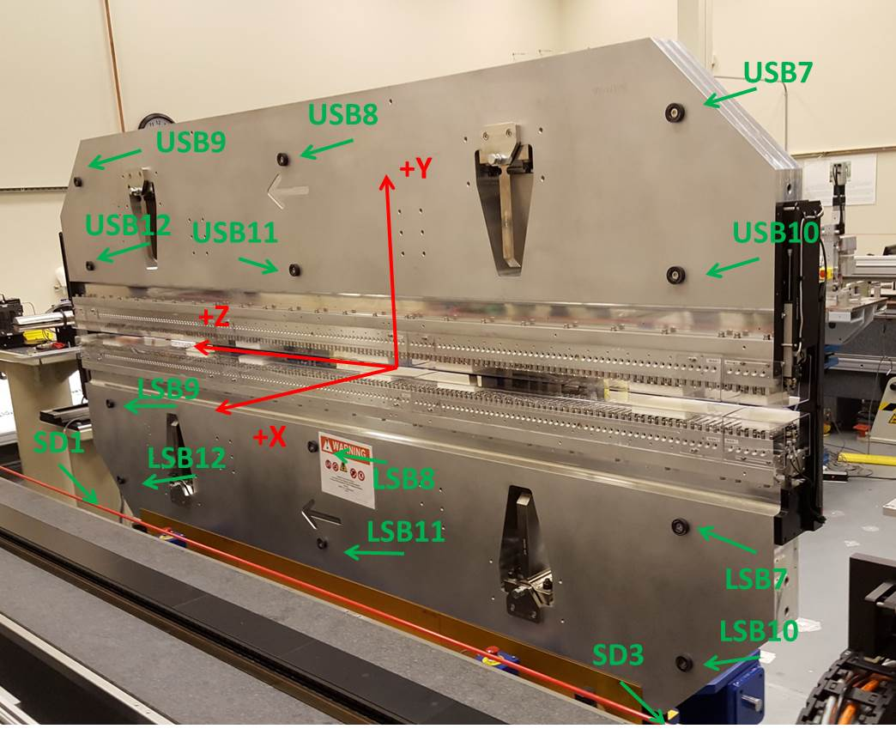

Tooling ball values to center of 1.5 inch sphere, all units are inches. Coordinates are to the SXR Undulator Magnetic Axis.
Tooling Ball | Z (in) | X (in) | Y (in)
LSB1 | -57.385 | -3.487 | -10.487
LSB2 | -2.264 | -3.484 | -10.496
LSB3 | 57.390 | -3.486 | -10.488
LSB4 | -57.368 | -3.481 | -24.277
LSB5 | -2.252 | -3.478 | -24.265
LSB6 | 57.396 | -3.481 | -24.261
LSB7 | -57.372 | 3.488 | -10.489
LSB8 | -2.270 | 3.493 | -10.491
LSB9 | 57.397 | 3.493 | -10.483
LSB10 | -57.383 | 3.492 | -24.267
LSB11 | -2.261 | 3.499 | -24.274
LSB12 | 57.394 | 3.494 | -24.265
SD1 | -50.986 | 7.175 | -34.752
SD2 | -3.900 | -19.478 | -34.831
SD3 | 50.724 | 7.294 | -34.744
SD4 | -25.743 | -21.874 | -33.735
SD5 | -25.744 | -21.924 | 29.634
SD6 | 25.729 | -21.919 | -33.858
SD7 | 25.746 | -21.888 | 29.503
SD8 | -0.053 | -9.054 | -12.432
USB1 | -57.409 | -3.485 | 24.259
USB2 | -2.282 | -3.490 | 24.277
USB3 | 57.384 | -3.490 | 24.272
USB4 | -57.385 | -3.486 | 10.486
USB5 | -2.275 | -3.493 | 10.492
USB6 | 57.372 | -3.491 | 10.485
USB7 | -57.391 | 3.490 | 24.265
USB8 | -2.268 | 3.485 | 24.266
USB9 | 57.388 | 3.483 | 24.271
USB10 | -57.385 | 3.488 | 10.487
USB11 | -2.267 | 3.484 | 10.489
USB12 | 57.388 | 3.485 | 10.489

Center | Z (m) | X (m) | Y (m) | Z (in) | X (in) | Y (in)
PM10M | -2.815658 | -0.025903 | 0.000649 | -110.853 | -1.020 | 0.026
PM11M | 2.726342 | -0.02614 | 0.000402 | 107.336 | -1.029 | 0.016
RFM | -2.670889 | 0.049072 | -0.000014 | -105.153 | 1.932 | -0.001

PM10 and Granite coordinate system with Yurii shifts.
 |  | From Yurii |  |  | Measured
Device | Z (m) | X (m) | Y (m) | Z (m) | X (m) | Y (m) | dX (mm) | dY (mm)
PM10 | -2.815673 | -0.025902 | 0.000650 | -2.815658 | -0.025903 | 0.000649 | -0.001 | -0.001
PM11 | 2.726358 | -0.026142 | 0.000400 | 2.726342 | -0.026140 | 0.000402 | 0.002 | 0.002
RefBlock |  |  |  | -2.670889 | 0.049072 | -0.000014

