LCLS2 SX Phase Shifter

Alignment Engineering Group
L200384
SN SXPS-16348
Dec 21, 2017

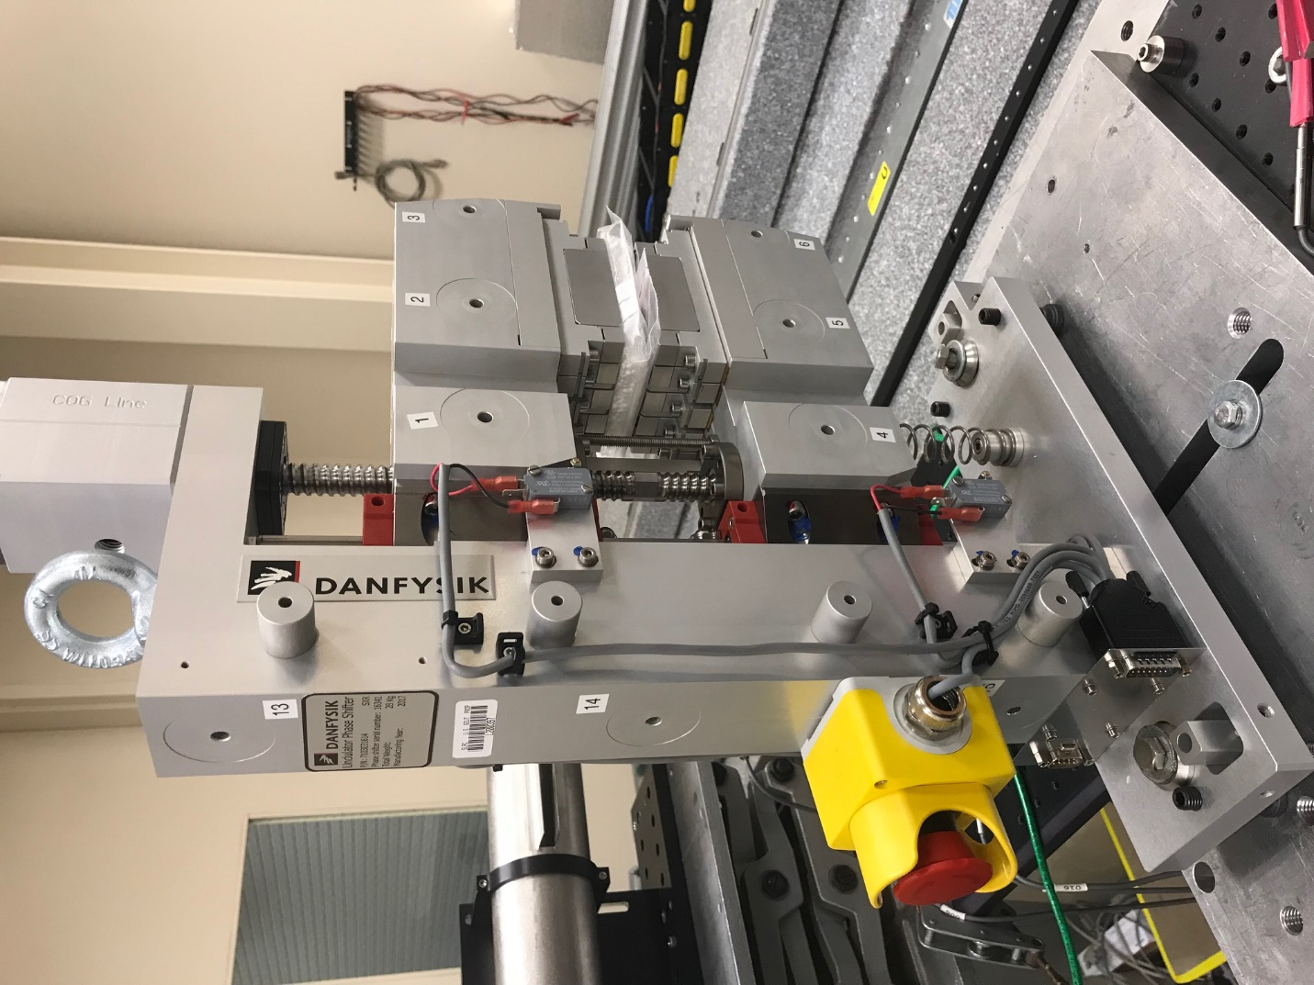
TB1
TB2
TB3
TB6
TB5
TB4
TB13
TB14
TB15
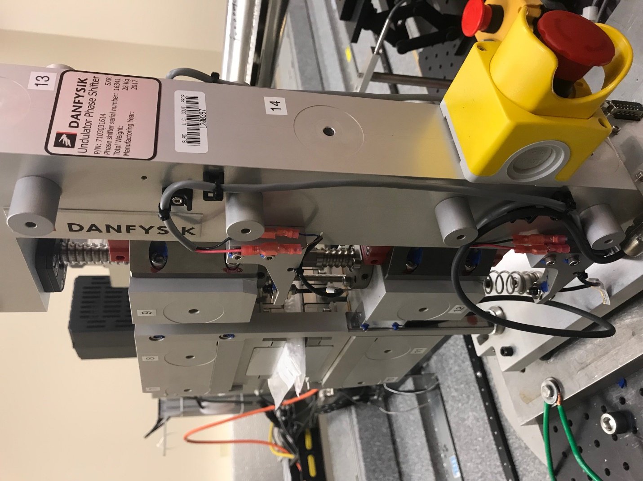
TB6
TB7
TB8
TB12

TB11
TB10
TB13
TB14
TB15

Tooling ball values to center of 1.5 inch sphere, all units are meter. Coordinates are to the HX Phase Shifter Magnetic Axis.
Tooling Ball | Z [m] | X [m] | Y [m]
TB1 | 0.070164 | -0.108811 | 0.083385
TB2 | 0.070115 | -0.026323 | 0.083398
TB3 | 0.070062 | 0.056172 | 0.083457
TB4 | 0.070289 | -0.108690 | -0.083357
TB5 | 0.070224 | -0.026226 | -0.083181
TB6 | 0.070173 | 0.056309 | -0.083021
TB7 | -0.070295 | 0.056062 | 0.083417
TB8 | -0.070257 | -0.026443 | 0.083400
TB9 | -0.070226 | -0.108950 | 0.083343
TB10 | -0.070160 | 0.056222 | -0.083078
TB11 | -0.070126 | -0.026286 | -0.083227
TB12 | -0.070081 | -0.108781 | -0.083352
TB13 | -0.000156 | -0.268179 | 0.186336
TB14 | -0.000017 | -0.268008 | 0.016395
TB15 | 0.000058 | -0.267846 | -0.153610

