LCLS2 HX Phase Shifter

Alignment Engineering Group
L201245
SN HXPS-16305
May 15, 2018

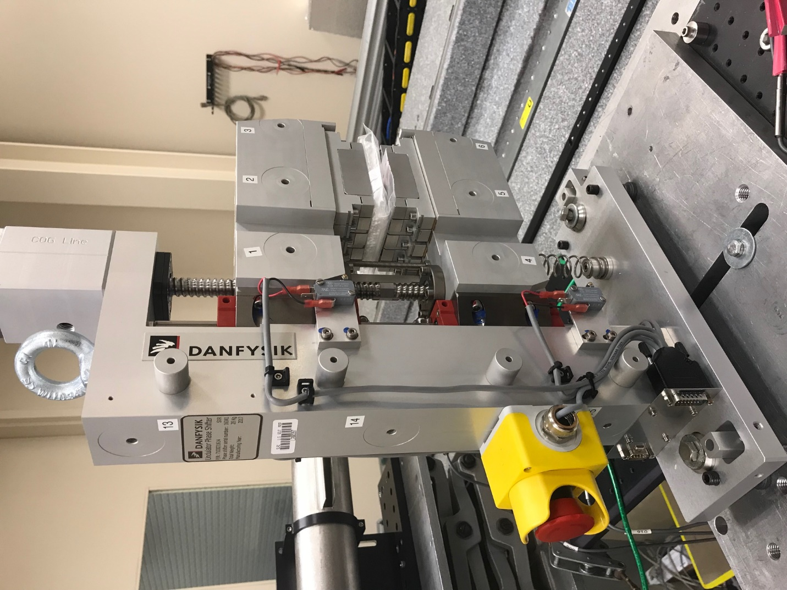
TB1
TB2
TB3
TB6
TB5
TB4
TB13
TB14
TB15
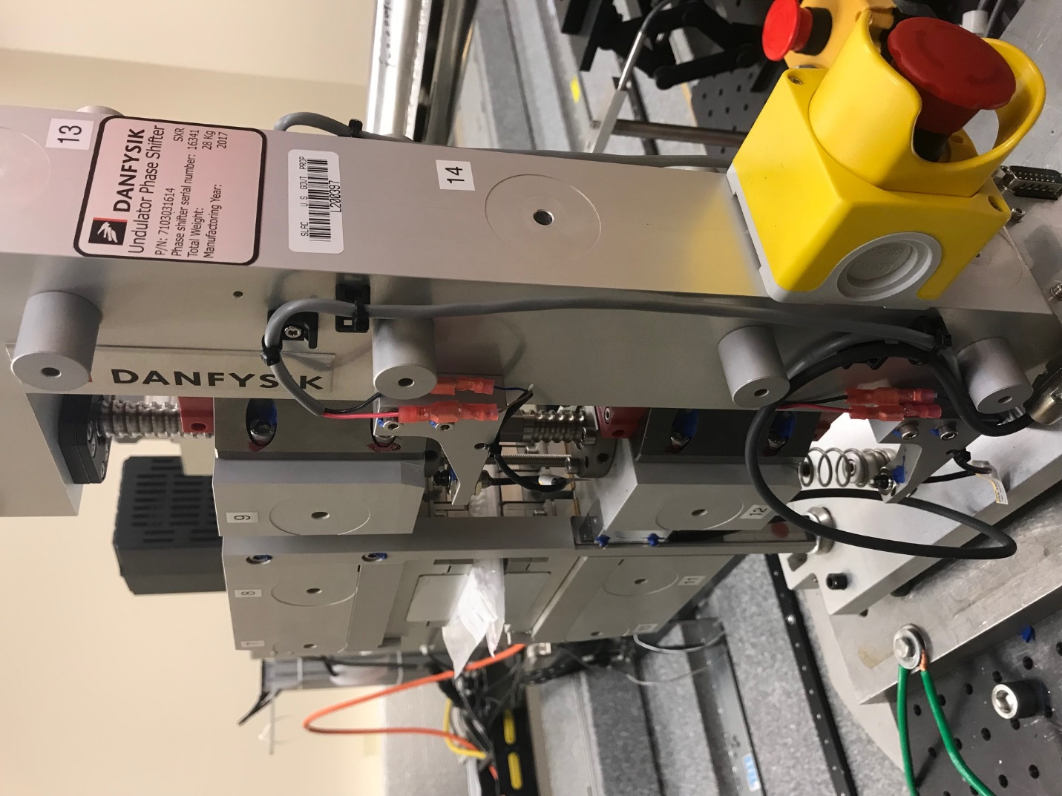
TB6
TB7
TB8
TB12

TB11
TB10
TB13
TB14
TB15

Tooling ball values to center of 1.5 inch sphere, all units are meter. Coordinates are to the HX Phase Shifter Magnetic Axis.
Tooling Ball | Z [m] | X [m] | Y [m]
TB1 | -0.070266 | 0.108889 | 0.080667
TB2 | -0.070314 | 0.026384 | 0.080700
TB3 | -0.070368 | -0.056106 | 0.080702
TB4 | -0.070241 | 0.108847 | -0.080704
TB5 | -0.070339 | 0.026376 | -0.080657
TB6 | -0.070439 | -0.056115 | -0.080547
TB7 | 0.069935 | -0.056164 | 0.080579
TB8 | 0.070000 | 0.026310 | 0.080555
TB9 | 0.070064 | 0.108828 | 0.080529
TB10 | 0.069889 | -0.056319 | -0.080567
TB11 | 0.069995 | 0.026186 | -0.080668
TB12 | 0.070103 | 0.108698 | -0.080716
TB13 | 0.000114 | 0.268129 | 0.186529
TB14 | 0.000118 | 0.268010 | 0.016522
TB15 | 0.000178 | 0.267906 | -0.153481

