LCLS2 HE SXR Undulator

Alignment Engineering Group
L2?????
SN 29A804-021
May 30, 2025

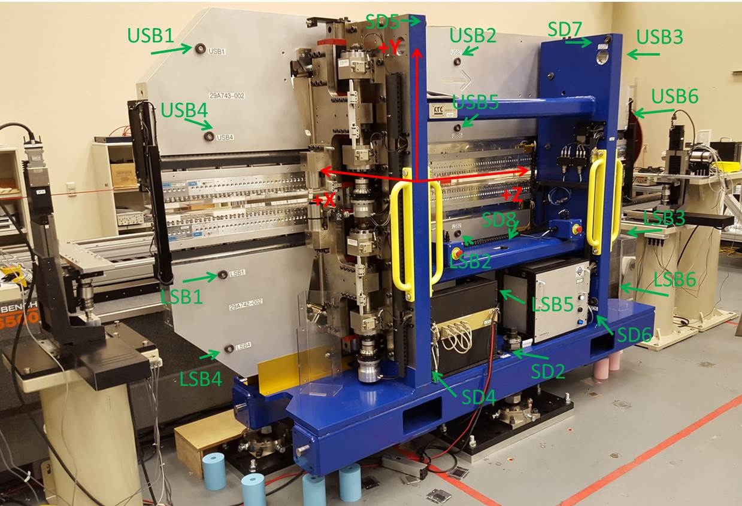

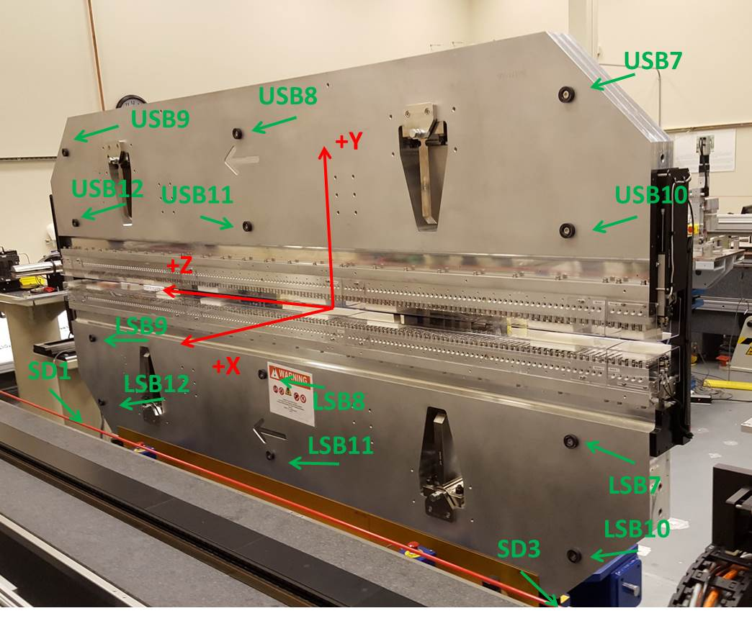

Tooling ball values to center of 1.5 inch sphere, all units are inches. Coordinates are to the SXR Undulator Magnetic Axis.
Tooling Ball | Z (in) | X (in) | Y (in)
LSB1 | -57.4774 | -3.4905 | -10.5578
LSB2 | -0.0086 | -3.4848 | -10.5544
LSB3 | 57.4734 | -3.4920 | -10.5612
LSB4 | -57.4796 | -3.4845 | -24.3391
LSB5 | -0.0033 | -3.4799 | -24.3355
LSB6 | 57.4700 | -3.4865 | -24.3169
LSB7 | -57.4800 | 3.4844 | -10.5424
LSB8 | -0.0091 | 3.4901 | -10.5520
LSB9 | 57.4624 | 3.4800 | -10.5469
LSB10 | -57.4899 | 3.4888 | -24.3270
LSB11 | -0.0132 | 3.4960 | -24.3291
LSB12 | 57.4651 | 3.4859 | -24.3176
SD1 | 50.9815 | 7.2729 | -34.7164
SD2 | -3.9341 | -19.5159 | -34.7692
SD3 | -50.9941 | 7.2474 | -34.7170
SD4 | -25.5881 | -21.6819 | -29.6222
SD5 | -25.5861 | -21.6986 | 29.4248
SD6 | 25.6709 | -21.6542 | -29.6225
SD7 | 25.6623 | -21.6896 | 29.4345
SD8 | 0.0437 | -16.9959 | -12.3364
USB1 | -57.4943 | -3.4880 | 24.2114
USB2 | -0.0094 | -3.4866 | 24.2191
USB3 | 57.4616 | -3.4815 | 24.2057
USB4 | -57.4880 | -3.4894 | 10.4492
USB5 | -0.0172 | -3.4887 | 10.4494
USB6 | 57.4689 | -3.4842 | 10.4389
USB7 | -57.4757 | 3.4893 | 24.2174
USB8 | 0.0049 | 3.4895 | 24.2200
USB9 | 57.4862 | 3.4933 | 24.2197
USB10 | -57.4708 | 3.4884 | 10.4495
USB11 | 0.0019 | 3.4873 | 10.4350
USB12 | 57.4826 | 3.4917 | 10.4389

Center | Z (m) | X (m) | Y (m) | Z (in) | X (in) | Y (in)
PM10M | -2.81894 | -0.026212 | -0.000736 | -110.9819 | -1.0320 | -0.0290
PM11M | 2.722657 | -0.026539 | -0.000713 | 107.1912 | -1.0448 | -0.0281
RFM | -2.674186 | 0.048766 | -0.001424 | -105.2829 | 1.9199 | -0.0561

PM10 and Granite coordinate system with Yurii shifts.
 |  | From Yurii |  |  | Measured
Device | Z (m) | X (m) | Y (m) | Z (m) | X (m) | Y (m) | dX (mm) | dY (mm)
PM10 | -2.818940 | -0.026218 | -0.000730 | -2.81894 | -0.026212 | -0.000736 | 0.006 | -0.006
PM11 | 2.722698 | -0.026532 | -0.000720 | 2.722657 | -0.026539 | -0.000713 | -0.007 | 0.007
Ref Block |  |  |  | -2.674186 | 0.048766 | -0.001424

