LCLS2 HE SXR Undulator

Alignment Engineering Group
L2?????
SN 29A804-019
September 17, 2026

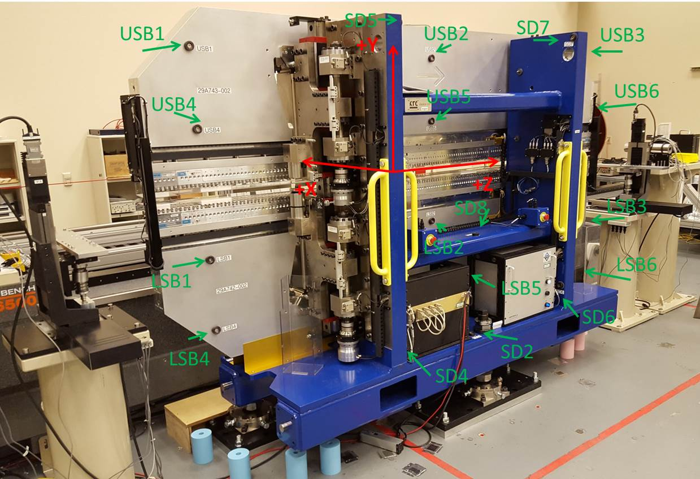

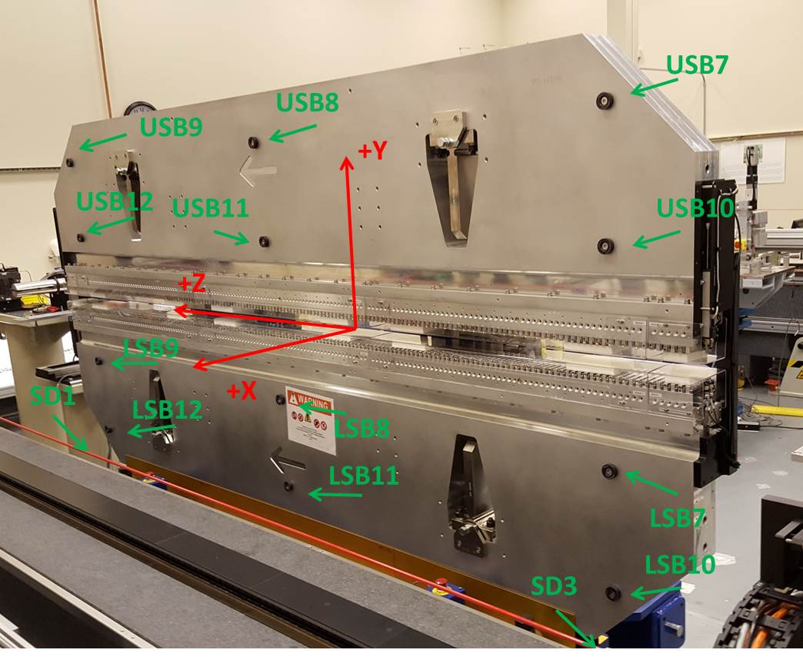

Tooling ball values to center of 1.5 inch sphere, all units are inches. Coordinates are to the SXR Undulator Magnetic Axis.
Tooling Ball | Z (in) | X (in) | Y (in)
LSB1 | -57.4758 | -3.4872 | -10.4911
LSB2 | -0.0030 | -3.4870 | -10.4866
LSB3 | 57.4538 | -3.4878 | -10.4952
LSB4 | -57.4856 | -3.4816 | -24.2657
LSB5 | -0.0039 | -3.4820 | -24.2597
LSB6 | 57.4779 | -3.4840 | -24.2733
LSB7 | -57.5004 | 3.4887 | -10.4904
LSB8 | -0.0064 | 3.4894 | -10.4948
LSB9 | 57.4738 | 3.4894 | -10.4890
LSB10 | -57.4916 | 3.4935 | -24.2765
LSB11 | -0.0127 | 3.4931 | -24.2692
LSB12 | 57.4737 | 3.4921 | -24.2698
SD1 | 50.9879 | 7.2467 | -34.6709
SD2 | -3.9354 | -19.5262 | -34.7096
SD3 | -50.9732 | 7.2500 | -34.6736
SD4 | -25.6682 | -21.6894 | -29.5624
SD5 | -25.6484 | -21.6707 | 29.4537
SD6 | 25.6219 | -21.6699 | -29.5572
SD7 | 25.6349 | -21.6817 | 29.4796
SD8 | -0.0622 | -17.0280 | -12.4139
USB1 | -57.4952 | -3.4832 | 24.2689
USB2 | -0.0087 | -3.4861 | 24.2728
USB3 | 57.4681 | -3.4860 | 24.2658
USB4 | -57.4857 | -3.4857 | 10.4969
USB5 | -0.0200 | -3.4897 | 10.4865
USB6 | 57.4591 | -3.4917 | 10.4896
USB7 | -57.4995 | 3.4942 | 24.2672
USB8 | -0.0230 | 3.4914 | 24.2716
USB9 | 57.4639 | 3.4913 | 24.2685
USB10 | -57.4938 | 3.4921 | 10.4856
USB11 | -0.0180 | 3.4883 | 10.4832
USB12 | 57.4654 | 3.4861 | 10.4801

Center | Z (m) | X (m) | Y (m) | Z (in) | X (in) | Y (in)
PM10M | -2.818422 | -0.025482 | 0.000543 | -110.9615 | -1.0032 | 0.0214
PM11M | 2.723036 | -0.025761 | 0.000547 | 107.2061 | -1.0142 | 0.0215
RFM | -2.673674 | 0.049493 | -0.000152 | -105.2628 | 1.9485 | -0.0060

PM10 and Granite coordinate system with Yurii shifts.
 |  | From Yurii |  |  | Measured
Device | Z (m) | X (m) | Y (m) | Z (m) | X (m) | Y (m) | dX (mm) | dY (mm)
PM10 | -2.818432 | -0.025488 | 0.000564 | -2.818422 | -0.025482 | 0.000543 | 0.006 | -0.021
PM11 | 2.723039 | -0.025754 | 0.000527 | 2.723036 | -0.025761 | 0.000547 | -0.007 | 0.020
Ref Block |  |  |  | -2.673674 | 0.049493 | -0.000152

