LCLS2 HE SXR Undulator

Alignment Engineering Group
L2?????
SN 29A804-008
April 24, 2026

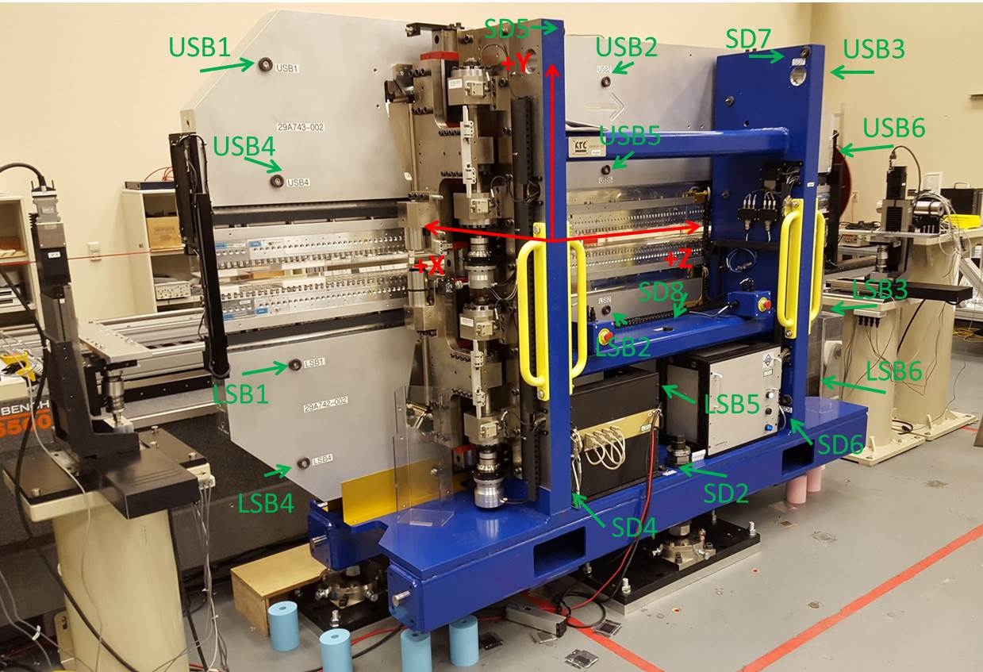

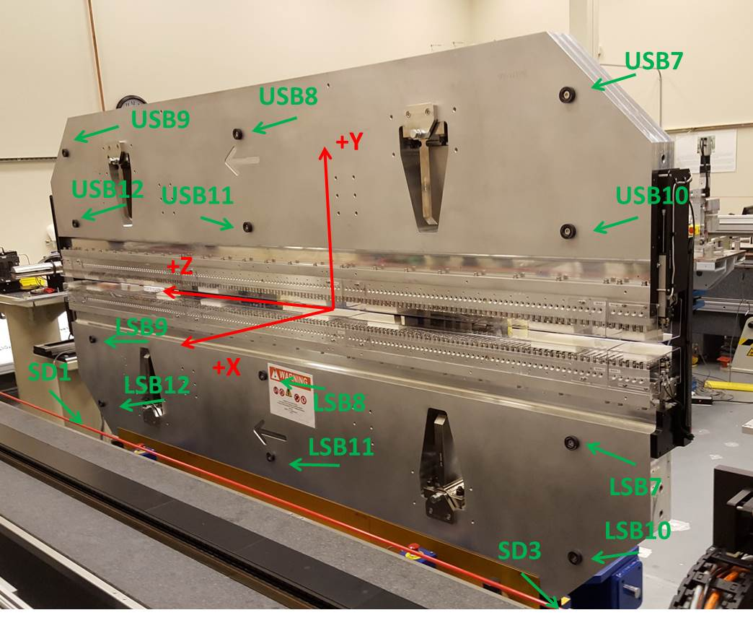

Tooling ball values to center of 1.5 inch sphere, all units are inches. Coordinates are to the SXR Undulator Magnetic Axis.
Tooling Ball | Z (in) | X (in) | Y (in)
LSB1 | -57.4557 | -3.4893 | -10.4954
LSB2 | 0.0204 | -3.4908 | -10.4922
LSB3 | 57.5028 | -3.4946 | -10.4920
LSB4 | -57.4560 | -3.4892 | -24.2740
LSB5 | 0.0234 | -3.4907 | -24.2737
LSB6 | 57.4905 | -3.4930 | -24.2738
LSB7 | -57.4491 | 3.4918 | -10.4916
LSB8 | 0.0255 | 3.4913 | -10.4939
LSB9 | 57.5037 | 3.4862 | -10.4922
LSB10 | -57.4529 | 3.4915 | -24.2712
LSB11 | 0.0265 | 3.4905 | -24.2720
LSB12 | 57.5041 | 3.4847 | -24.2739
SD1 | 50.9844 | 7.2623 | -34.6605
SD2 | -3.9240 | -19.5073 | -34.7226
SD3 | -50.9613 | 7.2512 | -34.6687
SD4 | -25.6324 | -21.6694 | -29.6154
SD5 | -25.6554 | -21.6531 | 29.4713
SD6 | 25.6514 | -21.6691 | -29.6017
SD7 | 25.6519 | -21.6598 | 29.4785
SD8 | 0.0463 | -17.0261 | -12.3103
USB1 | -57.4627 | -3.4832 | 24.2731
USB2 | 0.0187 | -3.4855 | 24.2700
USB3 | 57.5030 | -3.4870 | 24.2661
USB4 | -57.4635 | -3.4905 | 10.4928
USB5 | 0.0189 | -3.4921 | 10.4898
USB6 | 57.5007 | -3.4924 | 10.4856
USB7 | -57.4623 | 3.4987 | 24.2659
USB8 | 0.0183 | 3.4960 | 24.2654
USB9 | 57.5003 | 3.4957 | 24.2674
USB10 | -57.4617 | 3.4915 | 10.4870
USB11 | 0.0177 | 3.4900 | 10.4869
USB12 | 57.4954 | 3.4895 | 10.4878

Center | Z (m) | X (m) | Y (m) | Z (in) | X (in) | Y (in)
PM10M | -2.81855 | -0.02556 | 0.000648 | -110.9665 | -1.0064 | 0.0255
PM11M | 2.72291 | -0.02586 | 0.000654 | 107.2012 | -1.0181 | 0.0257
RFM | -2.6738 | 0.049413 | -5.2E-05 | -105.2676 | 1.9454 | -0.0020

PM10 and Granite coordinate system with Yurii shifts.
 |  | From Yurii |  |  | Measured
Device | Z (m) | X (m) | Y (m) | Z (m) | X (m) | Y (m) | dX (mm) | dY (mm)
PM10 | -2.8185585 | -0.02557 | 0.00067 | -2.818548 | -0.025563 | 0.000648 | 0.007 | -0.022
PM11 | 2.72292148 | -0.025853 | 0.000632 | 2.722910 | -0.025861 | 0.000654 | -0.008 | 0.022
Ref Block |  |  |  | -2.673798 | 0.049413 | -0.000052

