LCLS2 HE SXR Undulator

Alignment Engineering Group
L2?????
SN 29A804-003
March 24, 2026

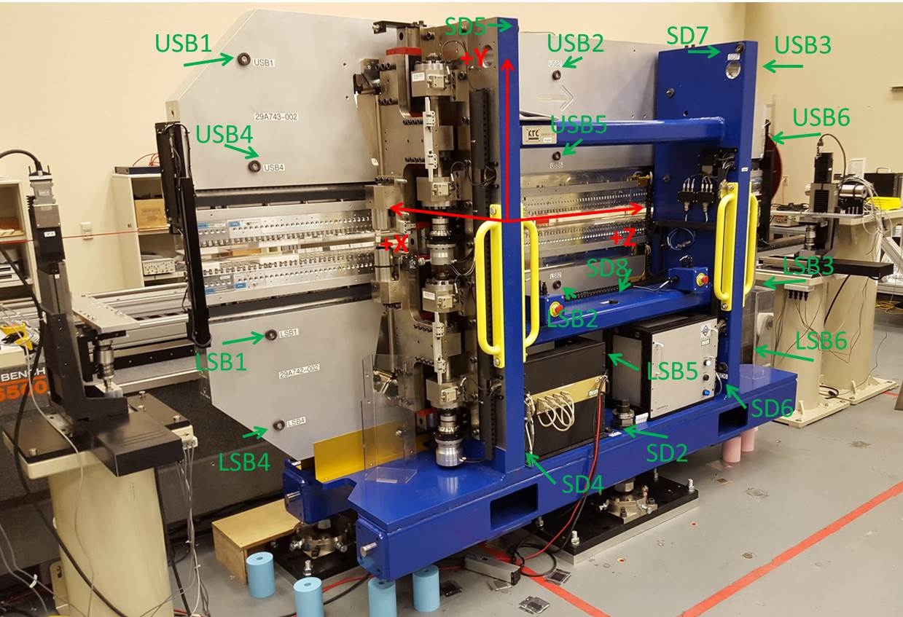

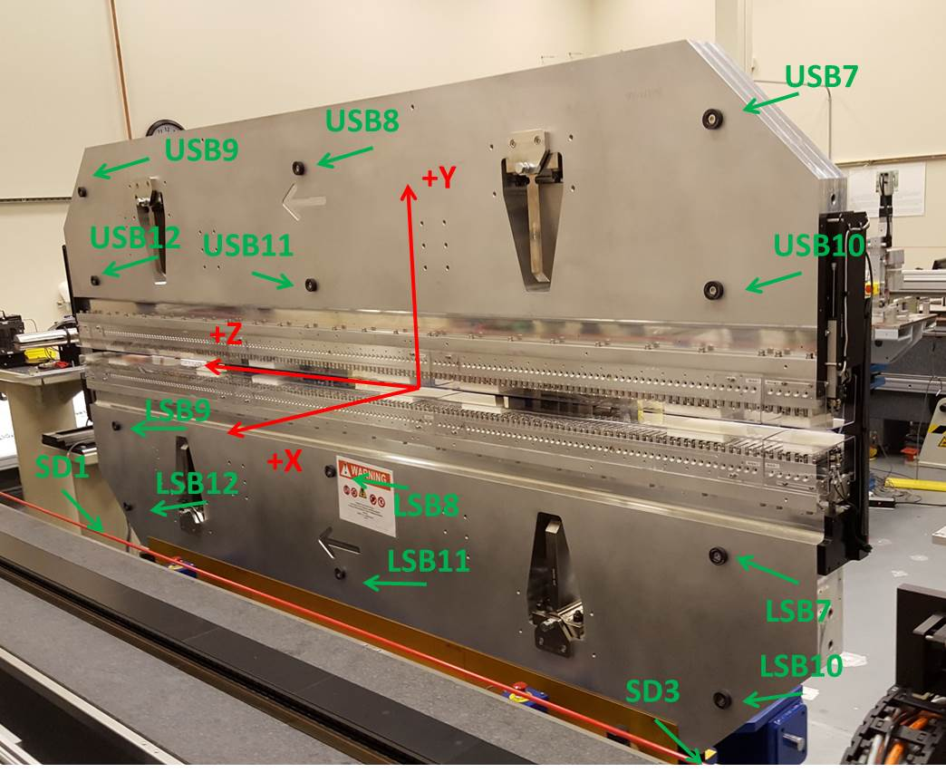

Tooling ball values to center of 1.5 inch sphere, all units are inches. Coordinates are to the SXR Undulator Magnetic Axis.
Tooling Ball | Z (in) | X (in) | Y (in)
LSB1 | -57.4778 | -3.4882 | -10.4941
LSB2 | 0.0009 | -3.4867 | -10.4932
LSB3 | 57.4853 | -3.4921 | -10.4943
LSB4 | -57.4777 | -3.4878 | -24.2730
LSB5 | 0.0030 | -3.4869 | -24.2747
LSB6 | 57.4835 | -3.4928 | -24.2755
LSB7 | -57.4828 | 3.4939 | -10.4952
LSB8 | 0.0002 | 3.4953 | -10.4968
LSB9 | 57.4792 | 3.4894 | -10.4984
LSB10 | -57.4806 | 3.4935 | -24.2774
LSB11 | 0.0007 | 3.4948 | -24.2752
LSB12 | 57.4796 | 3.4890 | -24.2801
SD1 | 50.9763 | 7.2344 | -34.6597
SD2 | -3.9348 | -19.5350 | -34.7077
SD3 | -50.9759 | 7.2359 | -34.6457
SD4 | -25.6789 | -21.6960 | -29.5686
SD5 | -25.6851 | -21.6681 | 29.4918
SD6 | 25.6415 | -21.6672 | -29.5646
SD7 | 25.6440 | -21.6850 | 29.4699
SD8 | 0.0300 | -16.8963 | -12.3103
USB1 | -57.4796 | -3.4870 | 24.2781
USB2 | 0.0036 | -3.4906 | 24.2769
USB3 | 57.4809 | -3.4811 | 24.2753
USB4 | -57.4800 | -3.4939 | 10.4979
USB5 | -0.0005 | -3.4975 | 10.4988
USB6 | 57.4804 | -3.4883 | 10.4967
USB7 | -57.4855 | 3.4932 | 24.2718
USB8 | -0.0011 | 3.4909 | 24.2713
USB9 | 57.4755 | 3.5004 | 24.2700
USB10 | -57.4841 | 3.4862 | 10.4909
USB11 | 0.0000 | 3.4843 | 10.4896
USB12 | 57.4739 | 3.4927 | 10.4892

Center | Z (m) | X (m) | Y (m) | Z (in) | X (in) | Y (in)
PM10M | -2.819144 | -0.025741 | 0.00056 | -110.9899 | -1.0134 | 0.0220
PM11M | 2.722335 | -0.026031 | 0.000544 | 107.1785 | -1.0248 | 0.0214
RFM | -2.674387 | 0.049233 | -0.000134 | -105.2908 | 1.9383 | -0.0053

PM10 and Granite coordinate system with Yurii shifts.
 |  | From Yurii |  |  | Measured
Device | Z (m) | X (m) | Y (m) | Z (m) | X (m) | Y (m) | dX (mm)
PM10 | -2.819145 | -0.025746 | 0.000570 | -2.819144 | -0.025741 | 0.00056 | 0.005
PM11 | 2.722363 | -0.026026 | 0.000534 | 2.722335 | -0.026031 | 0.000544 | -0.005
Ref Block |  |  |  | -2.674387 | 0.049233 | -0.000134

