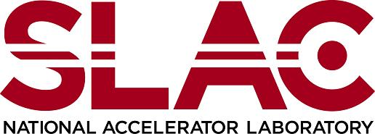  Environment, Safety & Health Division | Chapter 36: Cryogenic and Oxygen Deficiency Hazard Safety  ODH Hazard Classification Sign Templates  Product ID: 416 | Revision ID: 2264 | Date Published: 29 May 2020 | Date Effective: 29 May 2020  URL: https://www-group.slac.stanford.edu/esh/eshmanual/references/cryogenicsTemplateSigns.pdf
These sign templates meet California Department of Occupational Safety and Health (Cal/OSHA) requirements (8 CCR 3340). For additional information on sign requirements, see Cryogenic and Oxygen Deficiency Hazard Safety: ODH Requirements (SLAC-I-730-0A06S-002).

