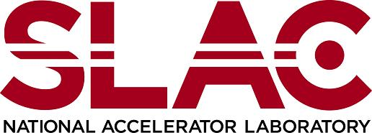  Environment, Safety & Health Division | Chapter 40: Chemical Lifecycle Management  Toxic and Hazardous Chemical Justification Form  Product ID: 461 | Revision ID: 2384 | Date Published: 26 May 2021 | Date Effective: 26 May 2021  URL: https://www-group.slac.stanford.edu/esh/eshmanual/references/chemmanageFormChemJust.pdf | .docx
This form documents line management approval of a request to purchase chemical products that are highly toxic or could be replaced with safer, environmentally preferred products but are mission critical. The chemical lifecycle management program manager issues this form to the user/requester if ESH review of a request finds that the toxic or hazardous chemical 1) falls into one of the chemical categories (banned, of concern, material-restricted, use-restricted) based on hazard or regulatory status, and 2) there are less toxic substitutes, or 3) this chemical exceeds screening criteria but is mission-critical. The requester submits the completed form to the chemical lifecycle management program manager.
See Chemical Lifecycle Management: Purchasing Procedure (SLAC-I-730-0A09C-001) and Chemical Lifecycle Management: Chemical Screening Requirements (SLAC-I-730-0A09S-033).

Request to purchase chemical (completed by user/requester)
Name: |  |  | Phone number: |  |  | E-mail:
Directorate: | Dept/group: |  | Dept/group code: |  |  |  | Mail stop:
Safety data sheet (SDS) attached? Yes No
Product name: |  | Manufacturer:
Container size (specify units): |  | Proposed storage location:
Estimated maximum quantity (# of containers): |  |  |  | Average quantity:
Mission-critical activity description:

How will this product be used? (maintenance, construction, research, fabrication, synthesis)

Less toxic or hazardous substitute was not procured because it is not available (select all that apply):
Within a reasonable period of time At a reasonable price Within performance requirements
Other (explain):
Provide a detailed justification and attach supporting documentation for each indicated reason:

Check if applicable and provide supporting documentation:
Safe storage, use, and disposal controls have been identified, implemented and personnel are trained in their use.
Signature: |  |  |  |  | Date:

Review (completed by ESH coordinator)
Select one:
I have verified that appropriate controls are in place for the use described.
Appropriate controls are not in place and the request for the item is not approved.

Name:
Title:
Signature: | Date:

Approval (completed by line management)
Select one:
The use is justified and this item is approved for the use described.
The request for the item is not approved.

Name:
Title:
Signature: | Date:

