METROLOGY-QC
USLE INSPECTION REPORT

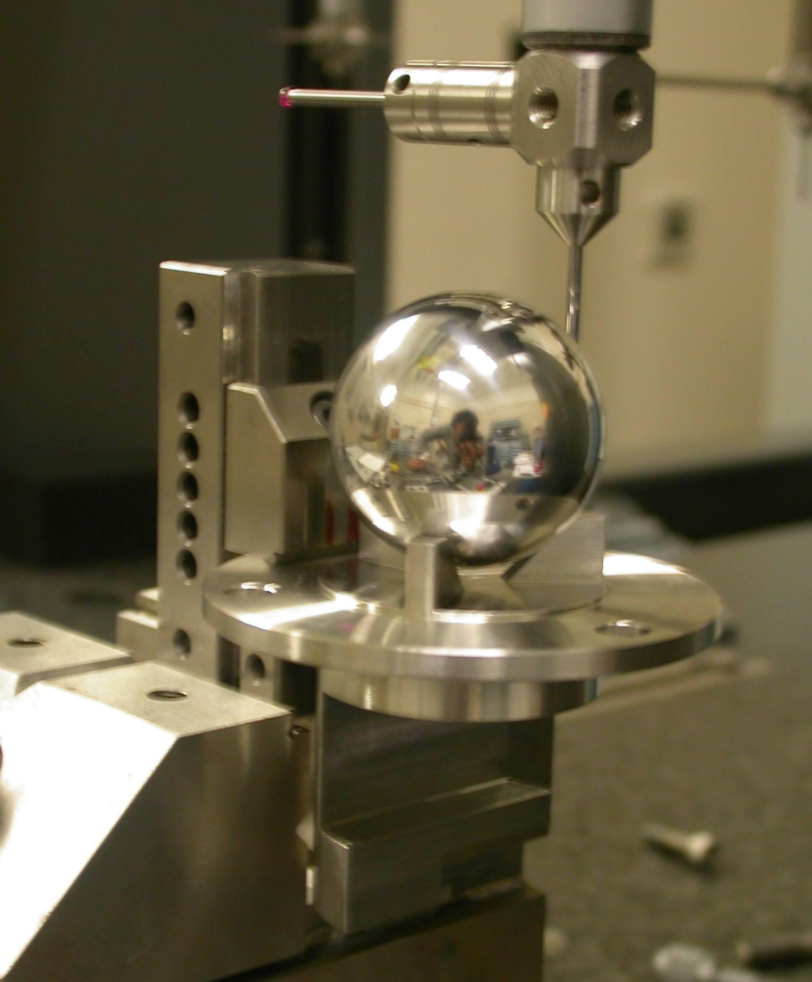

Inspector: | Keith Caban
Responsible Engineer: | Georg Gassner
Date: | Wednesday, January 23, 2008
Work Order/Charge No.:
Serial Number: | USLE-060

Coordinate System Setup
A
B
C
Z+
X+
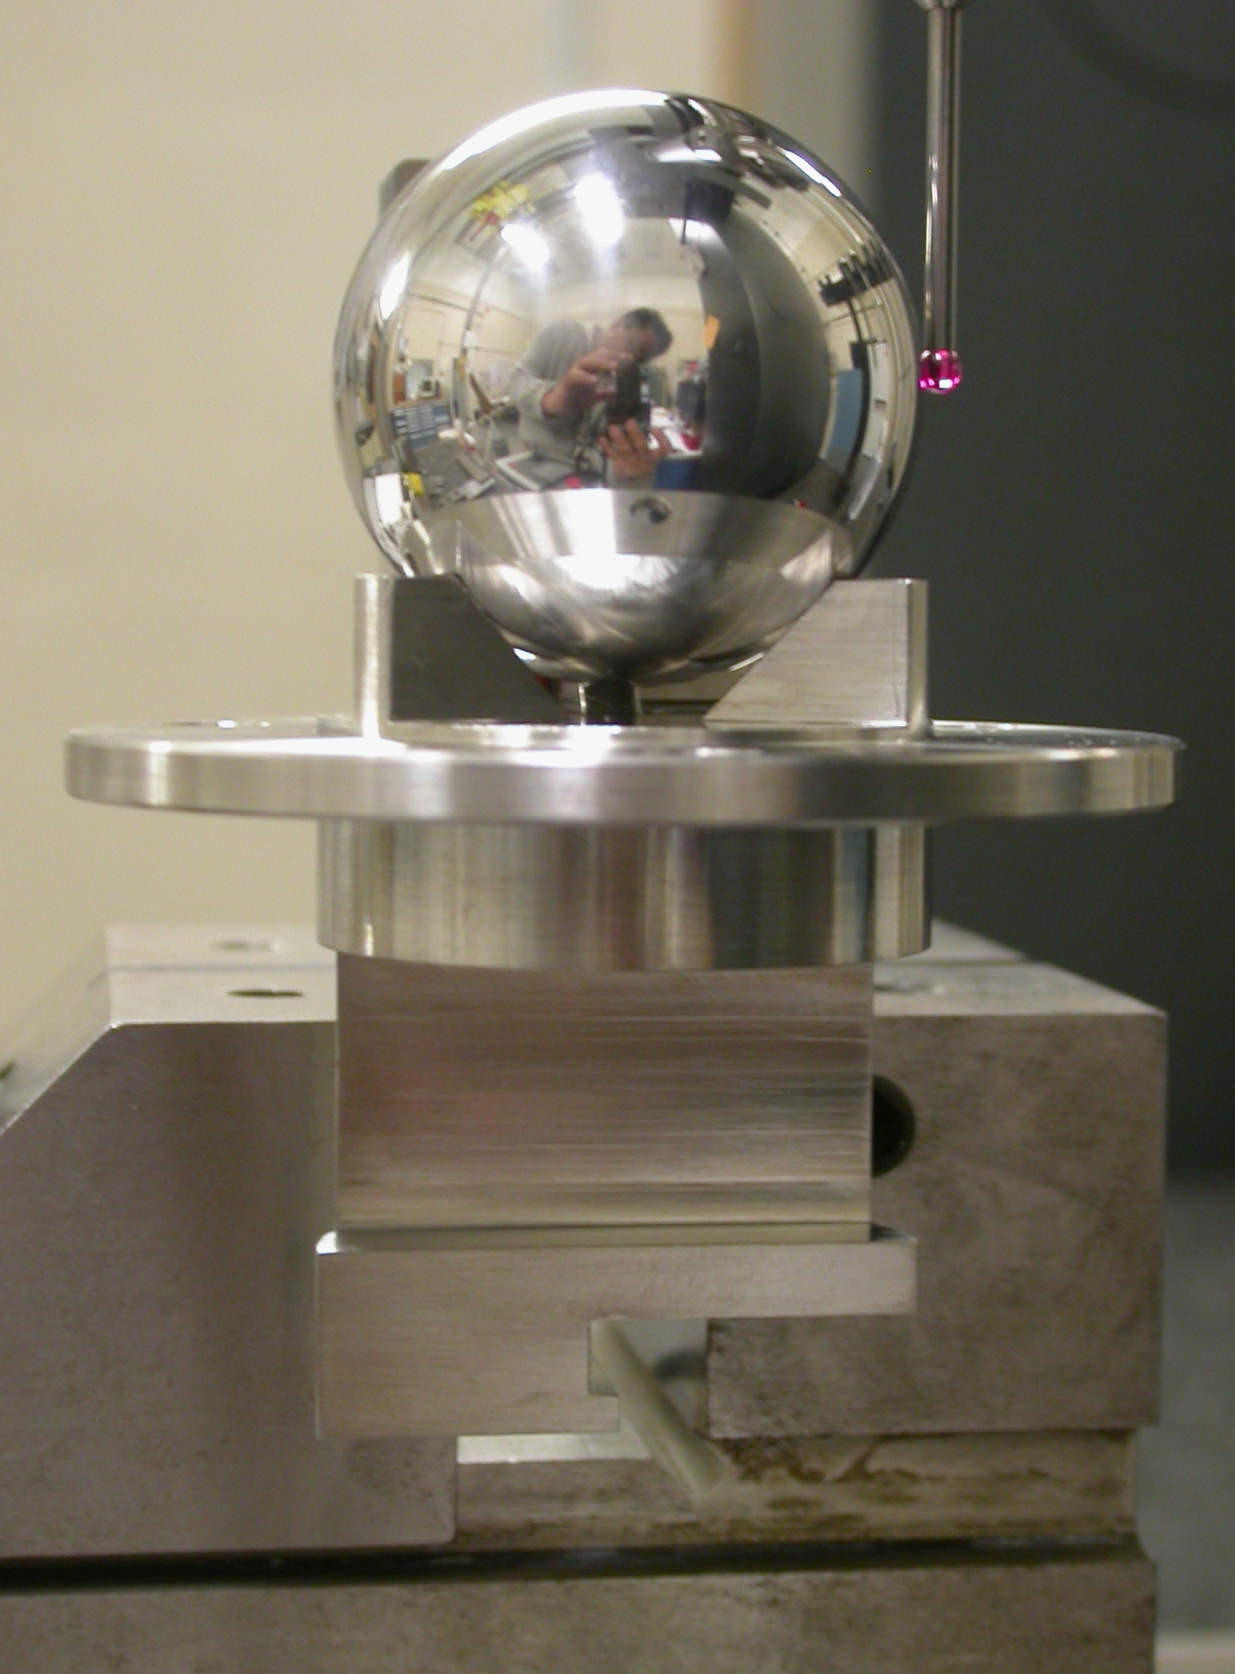

- X, Y, Z zero is the center of the spherical n of the 1.500” Ball.

- Is a plane alignment (Top Face Plane) that clocks the Z axis.

- Is a plane alignment (Side Face Plane) who’s probing vector is in the –Y direction, clocks the Y axis.

Basic Data

Sphere Data
Form : 0.00097
n : 38.10134
Plane Data
c : 0.01507
Plane Data
c : 0.00518
*Diameter Data
Form : 0.00808
n : 71.94246
X : -0.00473
Y : -0.01367
Plane(2) Data
c : 0.00753
Z : -67.95407
Plane(1) Data
c : 0.00373
Z : -60.45315

PLANE (1) & (2) ACTUAL POINTS (In Created CSY)

PLA(1) | X | Y | Z |  | PLA(2) | X | Y | Z
1 | 0.05167 | 0.03952 | -60.45379 |  | 1 | -0.05016 | 0.04046 | -67.94093
2 | 0.05198 | 1.22858 | -60.45616 |  | 2 | -0.04999 | 1.22968 | -67.94584
3 | 0.05201 | 2.41888 | -60.45598 |  | 3 | -0.04997 | 2.41949 | -67.94760
4 | 0.05195 | 3.60878 | -60.45603 |  | 4 | -0.04990 | 3.60958 | -67.94902
5 | 0.05191 | 4.79865 | -60.45587 |  | 5 | -0.04998 | 4.79944 | -67.94986
6 | 0.05178 | 5.98862 | -60.45551 |  | 6 | -0.05011 | 5.98949 | -67.95056
7 | 1.24171 | 5.98821 | -60.45426 |  | 7 | -1.23992 | 5.98925 | -67.95429
8 | 1.24157 | 4.79822 | -60.45438 |  | 8 | -1.23985 | 4.79925 | -67.95411
9 | 1.24159 | 3.60824 | -60.45465 |  | 9 | -1.23997 | 3.60921 | -67.95368
10 | 1.24166 | 2.41829 | -60.45464 |  | 10 | -1.23997 | 2.41917 | -67.95262
11 | 1.24164 | 1.22832 | -60.45445 |  | 11 | -1.23984 | 1.22909 | -67.95129
12 | 1.24172 | 0.03806 | -60.45137 |  | 12 | -1.23980 | 0.03907 | -67.94764
13 | 2.43176 | 0.03826 | -60.45064 |  | 13 | -2.42998 | 0.03932 | -67.94974
14 | 2.43187 | 1.22881 | -60.45361 |  | 14 | -2.42972 | 1.22966 | -67.95320
15 | 2.43181 | 2.41860 | -60.45371 |  | 15 | -2.42979 | 2.41974 | -67.95439
16 | 2.43167 | 3.60843 | -60.45376 |  | 16 | -2.42979 | 3.60952 | -67.95525
17 | 2.43176 | 4.79870 | -60.45359 |  | 17 | -2.42977 | 4.79947 | -67.95558
18 | 2.43166 | 5.98873 | -60.45347 |  | 18 | -2.42976 | 5.98950 | -67.95563
19 | 3.62173 | 5.98833 | -60.45293 |  | 19 | -3.62004 | 5.98936 | -67.95677
20 | 3.62159 | 4.79835 | -60.45310 |  | 20 | -3.61994 | 4.79918 | -67.95680
21 | 3.62156 | 3.60832 | -60.45322 |  | 21 | -3.61999 | 3.60925 | -67.95679
22 | 3.62151 | 2.41836 | -60.45323 |  | 22 | -3.61991 | 2.41923 | -67.95607
23 | 3.62157 | 1.22829 | -60.45308 |  | 23 | -3.61989 | 1.22919 | -67.95507
24 | 3.62158 | 0.03804 | -60.45064 |  | 24 | -3.61985 | 0.03897 | -67.95134
25 | 4.81172 | 0.03834 | -60.44992 |  | 25 | -4.80992 | 0.03932 | -67.95340
26 | 4.81161 | 1.22855 | -60.45232 |  | 26 | -4.80981 | 1.22966 | -67.95674
27 | 4.81164 | 2.41854 | -60.45245 |  | 27 | -4.80979 | 2.41975 | -67.95754
28 | 4.81164 | 3.60848 | -60.45246 |  | 28 | -4.80974 | 3.60970 | -67.95809
29 | 4.81158 | 4.79851 | -60.45220 |  | 29 | -4.80972 | 4.79962 | -67.95799
30 | 4.81156 | 5.98848 | -60.45196 |  | 30 | -4.80977 | 5.98953 | -67.95791
31 | 6.00142 | 5.98848 | -60.45143 |  | 31 | -5.99999 | 5.98934 | -67.95915
32 | 6.00140 | 4.79840 | -60.45175 |  | 32 | -5.99992 | 4.79932 | -67.95921
33 | 6.00139 | 3.60926 | -60.45267 |  | 33 | -5.99988 | 3.60930 | -67.95948
34 | 6.00157 | 2.41920 | -60.45260 |  | 34 | -5.99991 | 2.41922 | -67.95902
35 | 6.00136 | 1.22845 | -60.45200 |  | 35 | -5.99982 | 1.22928 | -67.95850
36 | 6.00141 | 0.03825 | -60.44966 |  | 36 | -5.99985 | 0.03916 | -67.95542

