Double Corner MNT Bracket
LAT-ds-03961 Rev. 1

Part Serial Number 001, 002

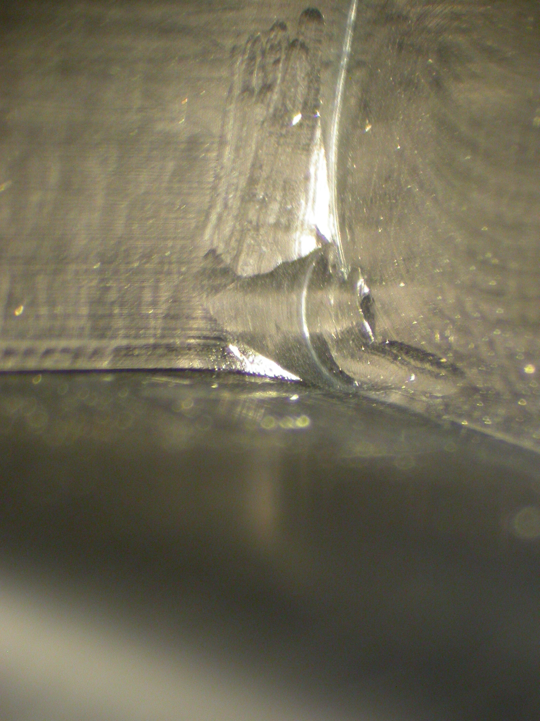
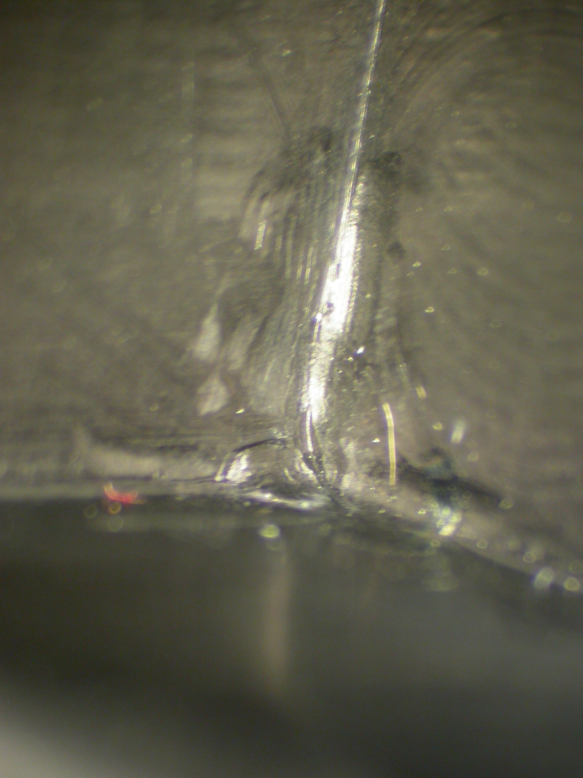

Bracket SN: 001 Bracket SN: 002

