Cable Retaining Clip
LAT-DS-03998
QC’d by: T. Nakashima

Jeff, there is nothing like a GO / NO-GO gauge when it comes to inspecting some of the Glast brackets to assure fit.
I spoke with Arthur Scholz yesterday on the measurements of Cable Retaining Clip, and we both thought it best that we mate it to it’s counter piece, Double Corner MNT Bracket for a GO / NO-GO check. Arthur also brought in a cable that was to be used, so we could measure the correct thickness to simulate the distance between the bracket and the clip. If this procedure is ok with you, we shall proceed to check the remaining clips this way.
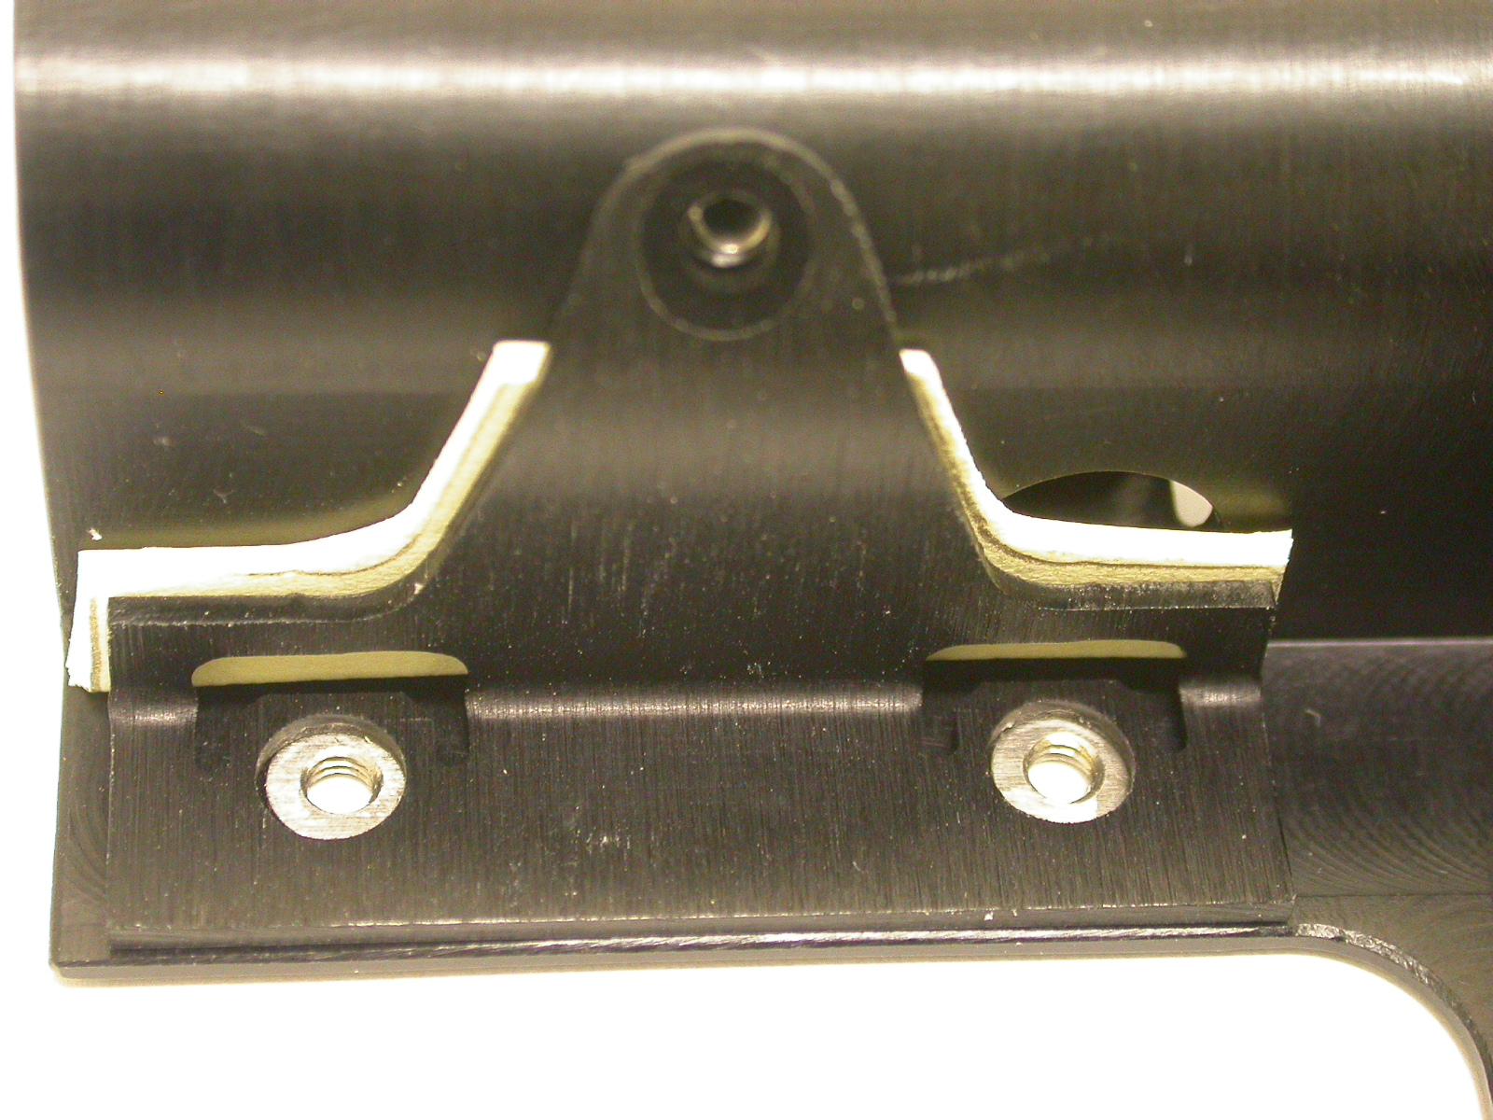
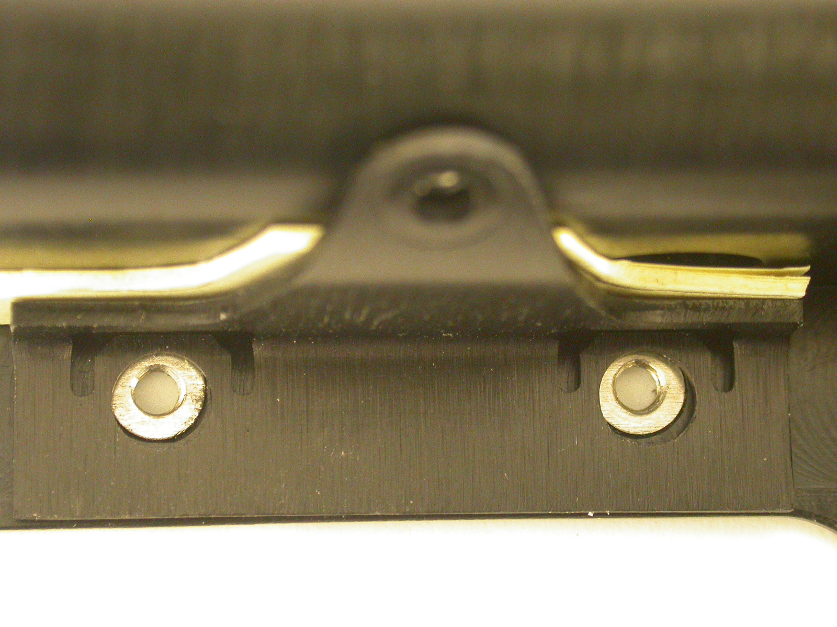
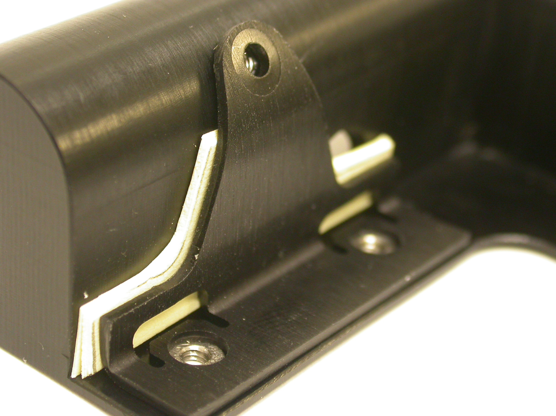
-Tom Nakashima x4271

Fig.1 Clip showing all 3 clearance Fig. 2 Shows match of 4.40mm holes. Fig. 3 Indicates correct .8 mm
mated to Bracket with correct spacing on the contour.
.8mm thickness of cable.

