PEP II LER Feedback
Two Longitudinal Kicker Assy.
Fiducialization

Inspector: Keith Caban
Customer: Mohammad Dormiani
Date: 04/06/04
Account No.:

Coordinate System Set up:

- “Z” zero is set by taking the mid-plane of the two end flanges below the knife edge.

- “X” and “Y zero is set by taking 2 diameters of the inner 3.500 diameter inner cavity, intersecting them at each end plane, which creates 2 end points
  - This creates a single axis which is the simulated Beam Direction and is “X/Y” zero, with Z+ pointing in beam direction towards the ROTATABLE FLANGE END.

- Coordinate System is “clocked” by measuring the 2 Tooling balls 90° (away from the tubes sticking out) this sets X- direction and Y is in the direction up towards the ceiling.

- All Coordinate Systems use the Right Hand Rule and Beam Direction is always +Z.

All Tooling Ball measurements are based on values within the above coordinate system.

Units: Inches (English)
Features: X, Y, Z, Tooling Ball Diameter & Form

Kicker SN 003
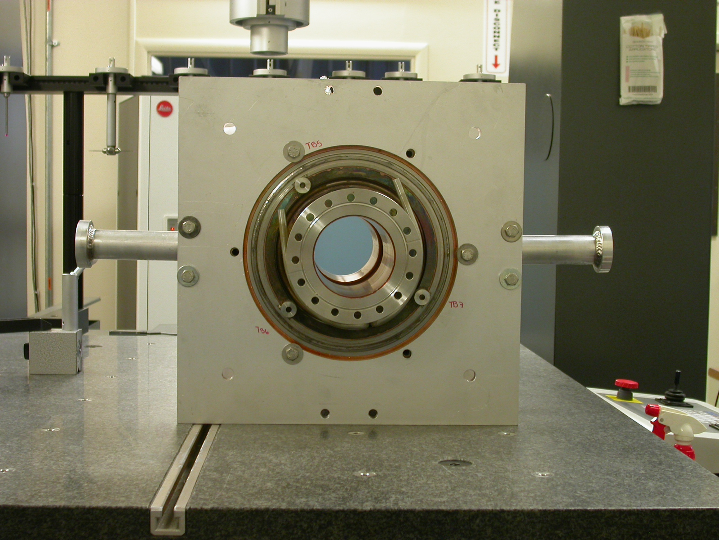  Fig 1.1 | 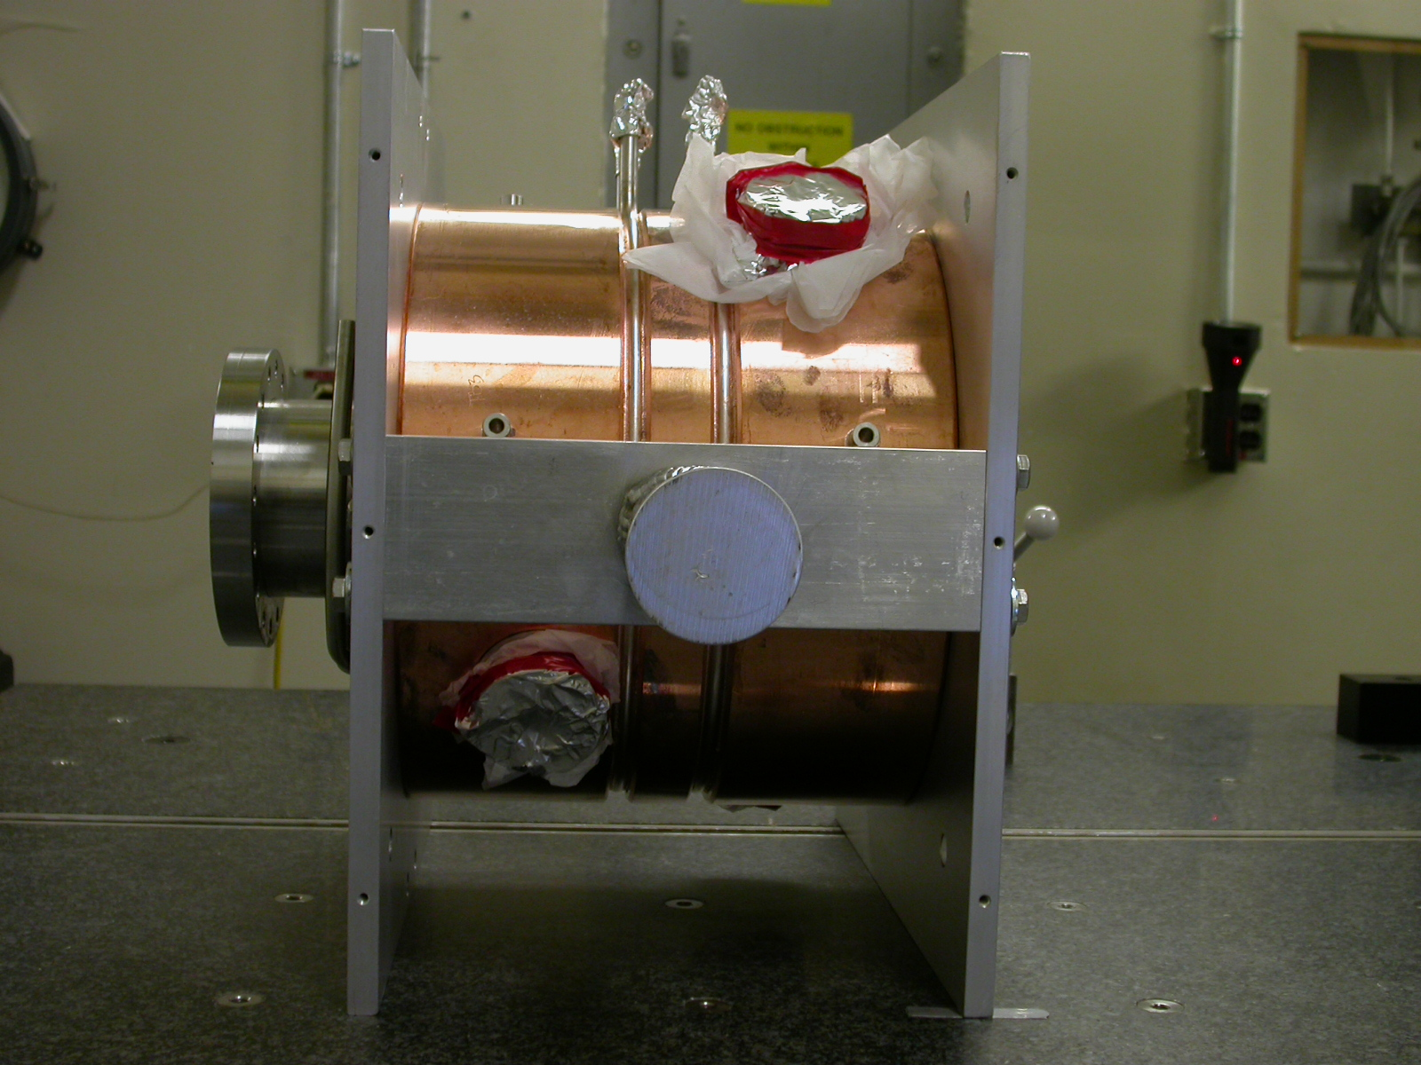  Fig 1.2

MAGNET #2
TOOLING BALL | X | Y | Z | DIAMETER | FORM
TB 1 | 7.68595 | 2.03484 | 0.01377 | 0.49363 | 0.00142
TB 2 | 2.03127 | 7.68754 | 0.02945 | 0.49360 | 0.00130
TB 3 | -2.03208 | 7.68698 | 0.02807 | 0.49323 | 0.00141
TB 4 | -7.69045 | 2.03093 | 0.00620 | 0.49618 | 0.00106

MAGNET #4
TOOLING BALL | X | Y | Z | DIAMETER | FORM
TB 1 | 7.68606 | 2.03343 | 0.03112 | 0.49802 | 0.00105
TB 2 | 2.02950 | 7.69106 | 0.02812 | 0.49807 | 0.00103
TB 3 | -2.03143 | 7.68549 | 0.01108 | 0.49671 | 0.00078
TB 4 | -7.68845 | 2.02954 | -0.00682 | 0.49770 | 0.00079

Magnets #1 & #3 Fiducials
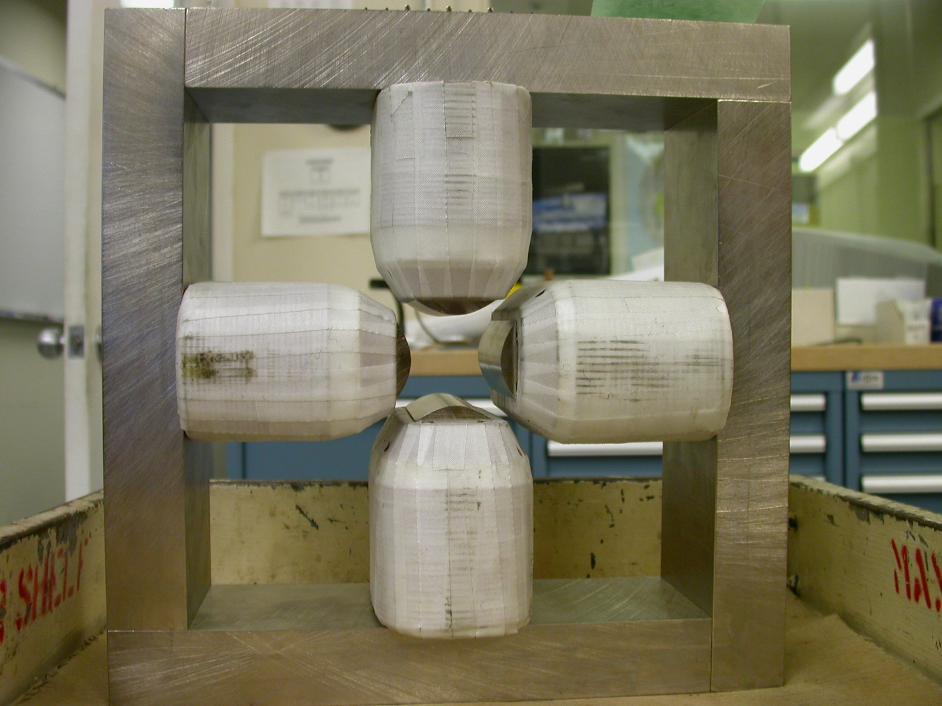  +Y  +X  Fig 1.3 | 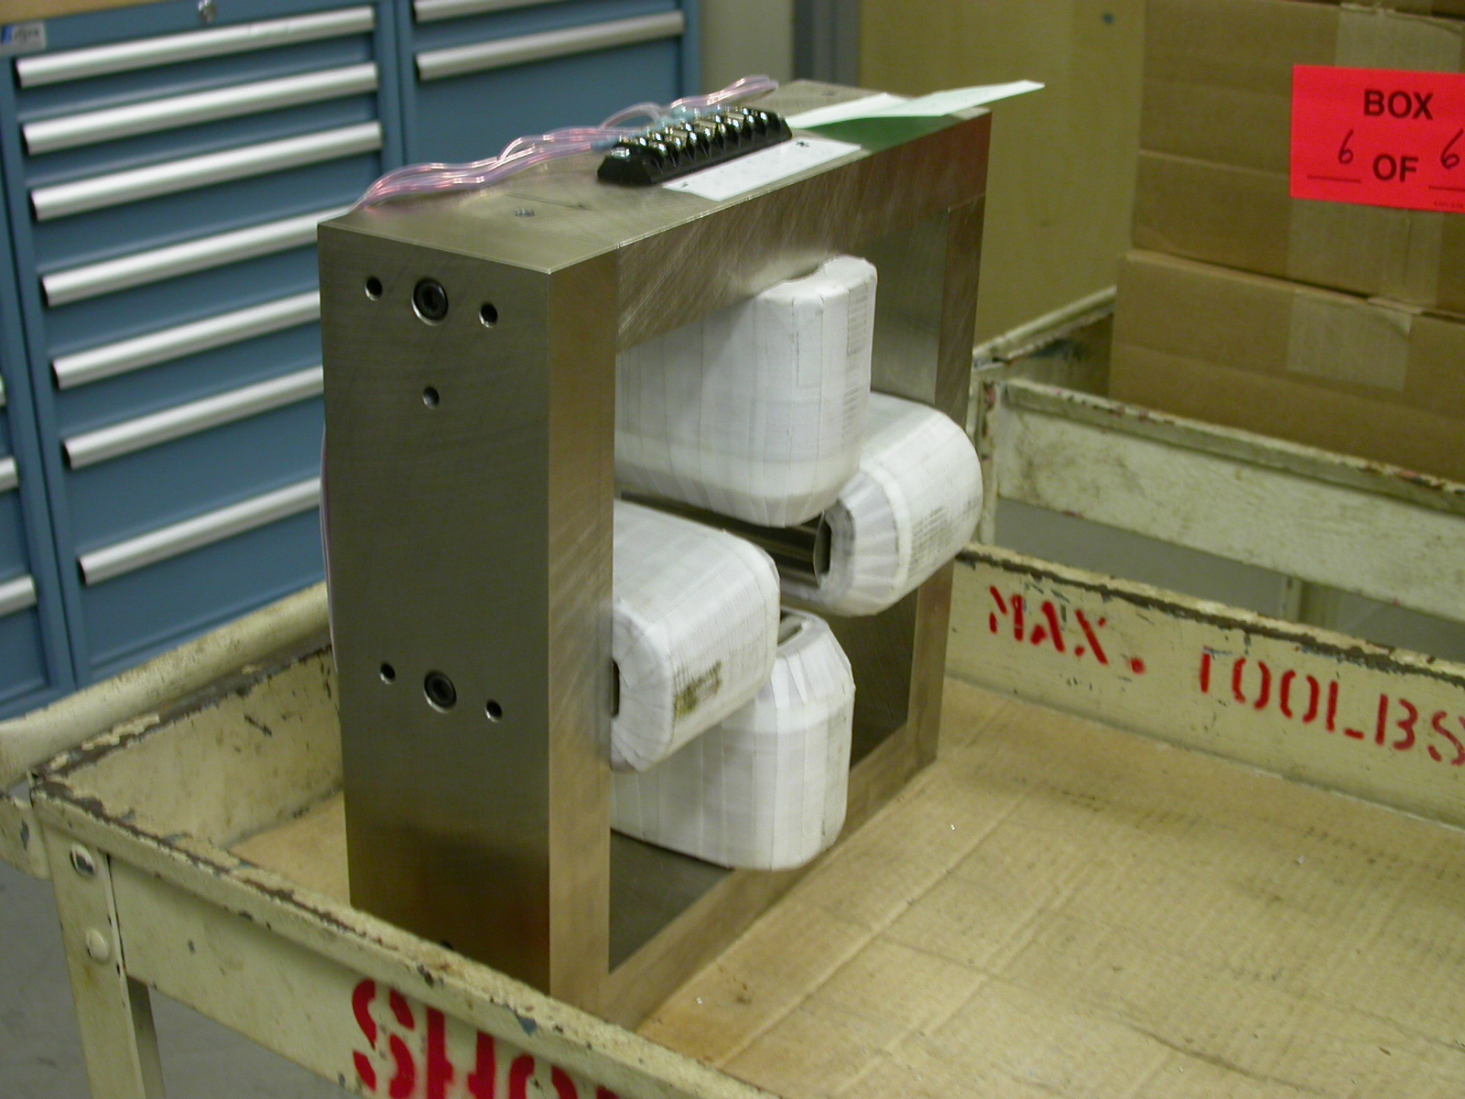  +Y  +X  +Z  (Beam Dir)  UPSTREAM  TB 1  TB 2  TB 3  TB 4  Fig 1.4

MAGNET #1
TOOLING BALL | X | Y | Z | DIAMETER | FORM
TB 1 | -7.68427 | 2.02907 | 0.01888 | 0.49745 | 0.00055
TB 2 | -2.02903 | 7.68904 | 0.00033 | 0.49888 | 0.00041
TB 3 | 2.03052 | 7.68796 | -0.01825 | 0.49680 | 0.00088
TB 4 | 7.69078 | 2.03071 | -0.02747 | 0.49497 | 0.00130
MAGNET #3
TOOLING BALL | X | Y | Z | DIAMETER | FORM
TB 1 | -7.68939 | 2.02958 | -0.00891 | 0.49646 | 0.00078
TB 2 | -2.02697 | 7.68591 | -0.00843 | 0.49583 | 0.00094
TB 3 | 2.03519 | 7.68416 | -0.00847 | 0.49568 | 0.00095
TB 4 | 7.68875 | 2.02904 | -.00762 | 0.49982 | 0.00015

Gap Measurements

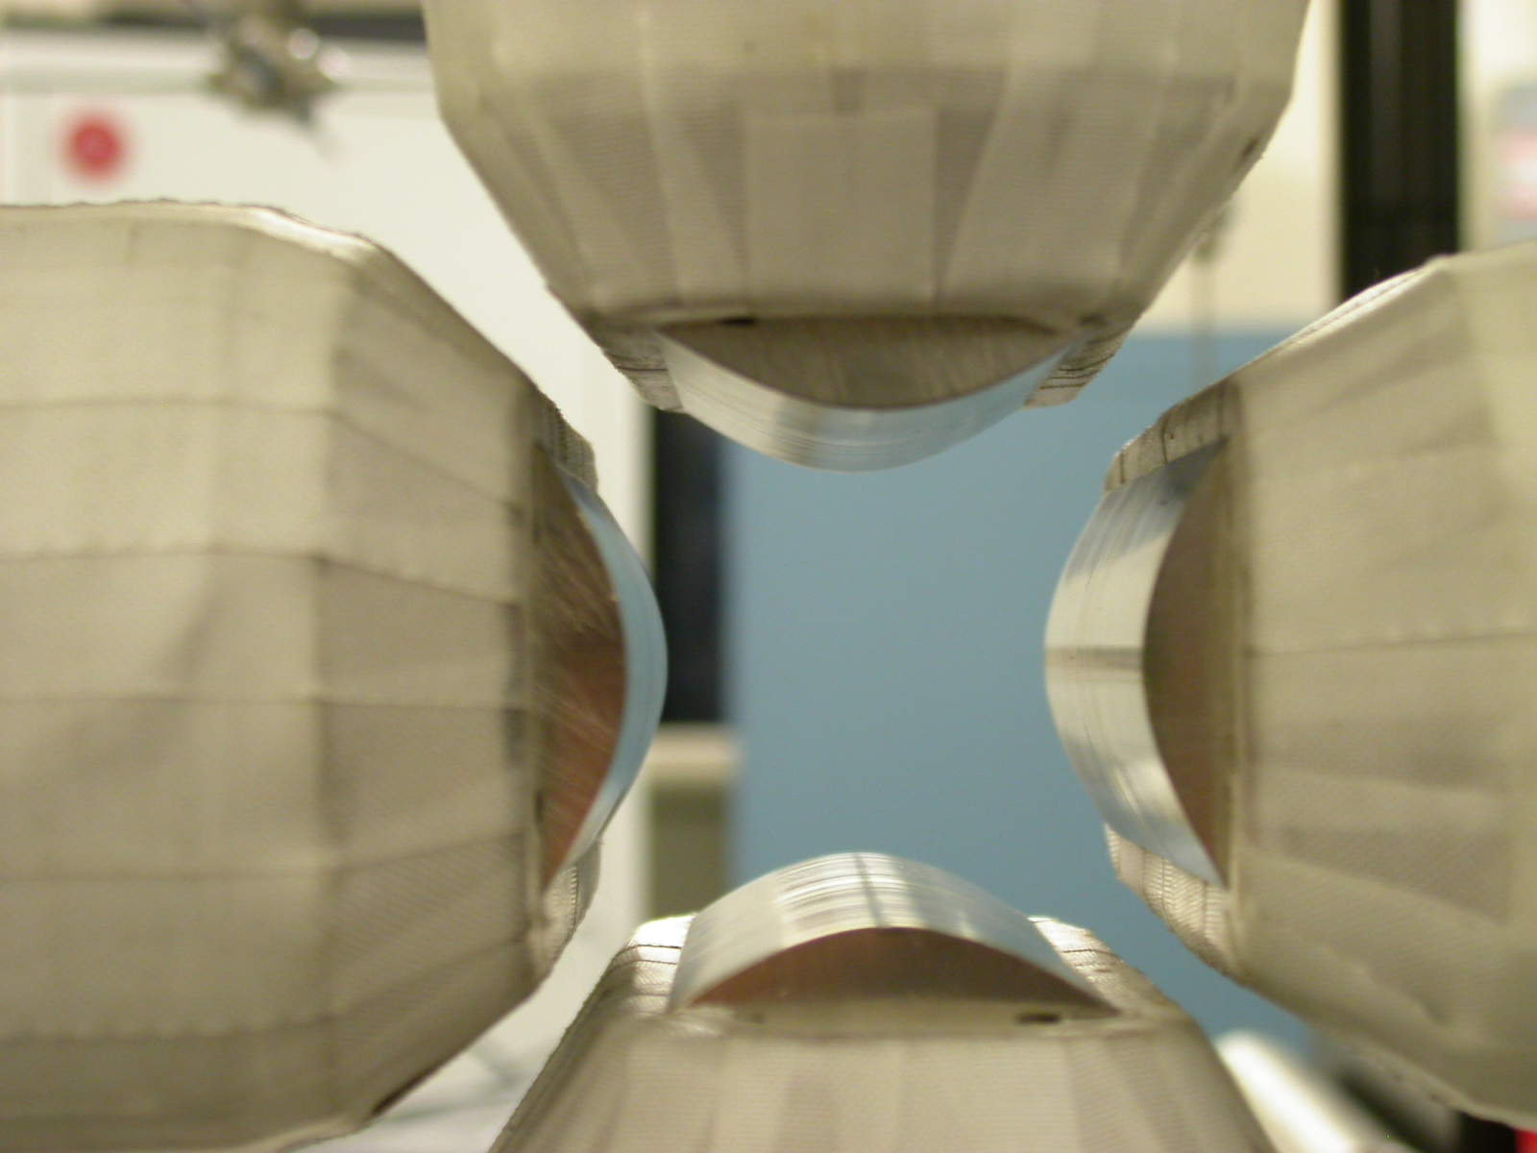
Y GAP
UPSTREAM
DOWNSTREAM
X GAP
UPSTREAM
DOWNSTREAM
Fig 1.5

GAP MEAS. | Upstream X | Downstream X | Upstream Y | Downstream Y
MAGNET 1 | 1.505 | 1.501 | 1.510 | 1.506
MAGNET 2 | 1.509 | 1.505 | 1.505 | 1.510
MAGNET 3 | 1.499 | 1.503 | 1.508 | 1.505
MAGNET 4 | 1.505 | 1.509 | 1.506 | 1.509

