

MFD NON-COMPLIANCE REPORT # 5132

PART NAME: | INBOARD FLANGE | DATE: | 7/21/05
PF/SA NO.: | PF-343-470-06 | INSPECTOR: | K. CABAN
WORK ORDER NO.: | 636102 | ENGINEER: | D. PETERSWRIGHT | EXT.: | 2940
VENDOR | C&H | ROUTE TO: | CUSTOMER

Reason For Non-Compliance: | Action (UAI,RWK,SCRP)
- 4X n .3125 ±0.0004 is undersized measuring around 0.2500 (-0.063” undersized).

- Surface machine mark on |d|.004|A|B|C|. See Picture below:

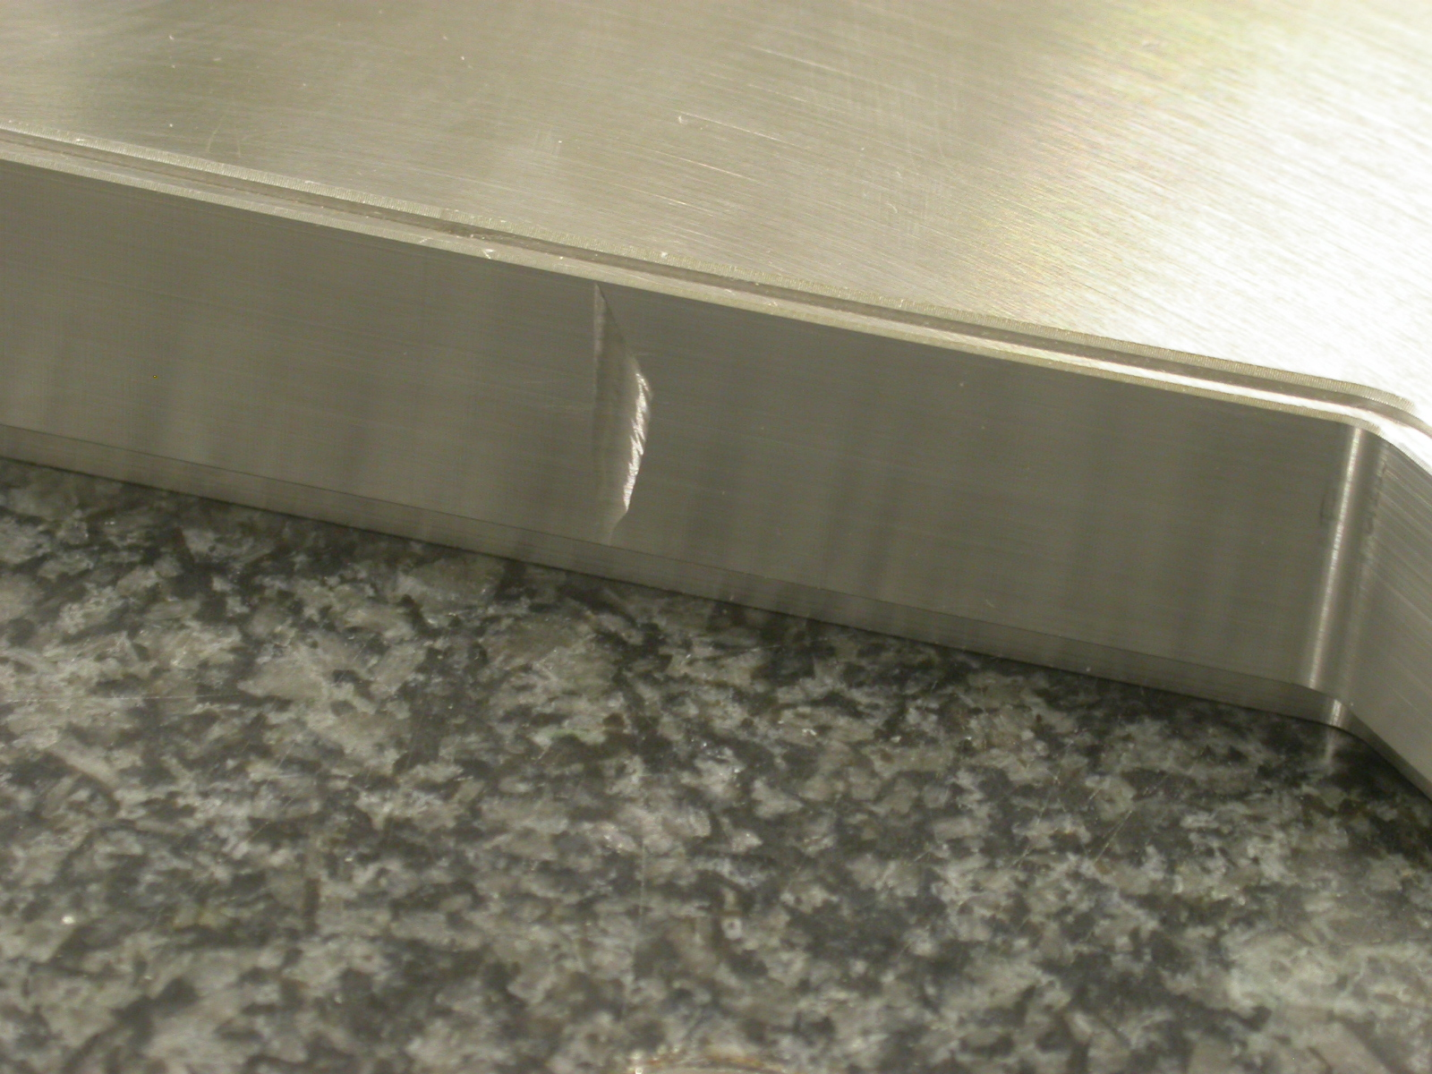

Engineer Signature: |  | Date:

