

MFD NON-COMPLIANCE REPORT # 5129

PART NAME: | STRAIGHT PLATE | DATE: | 6/13/05
PF/SA NO.: | PF-341-392-57 R0 | INSPECTOR: | K. CABAN
WORK ORDER NO.: | 19905-37 | ENGINEER: | A. HILL | 4453
VENDOR | MFD CENTRAL LAB | ROUTE TO: | BRAZE

Reason For Non-Compliance: | Action (UAI,RWK,SCRP)
- Machined dimension .230 did not clean up on 2 PARTS. See picture below
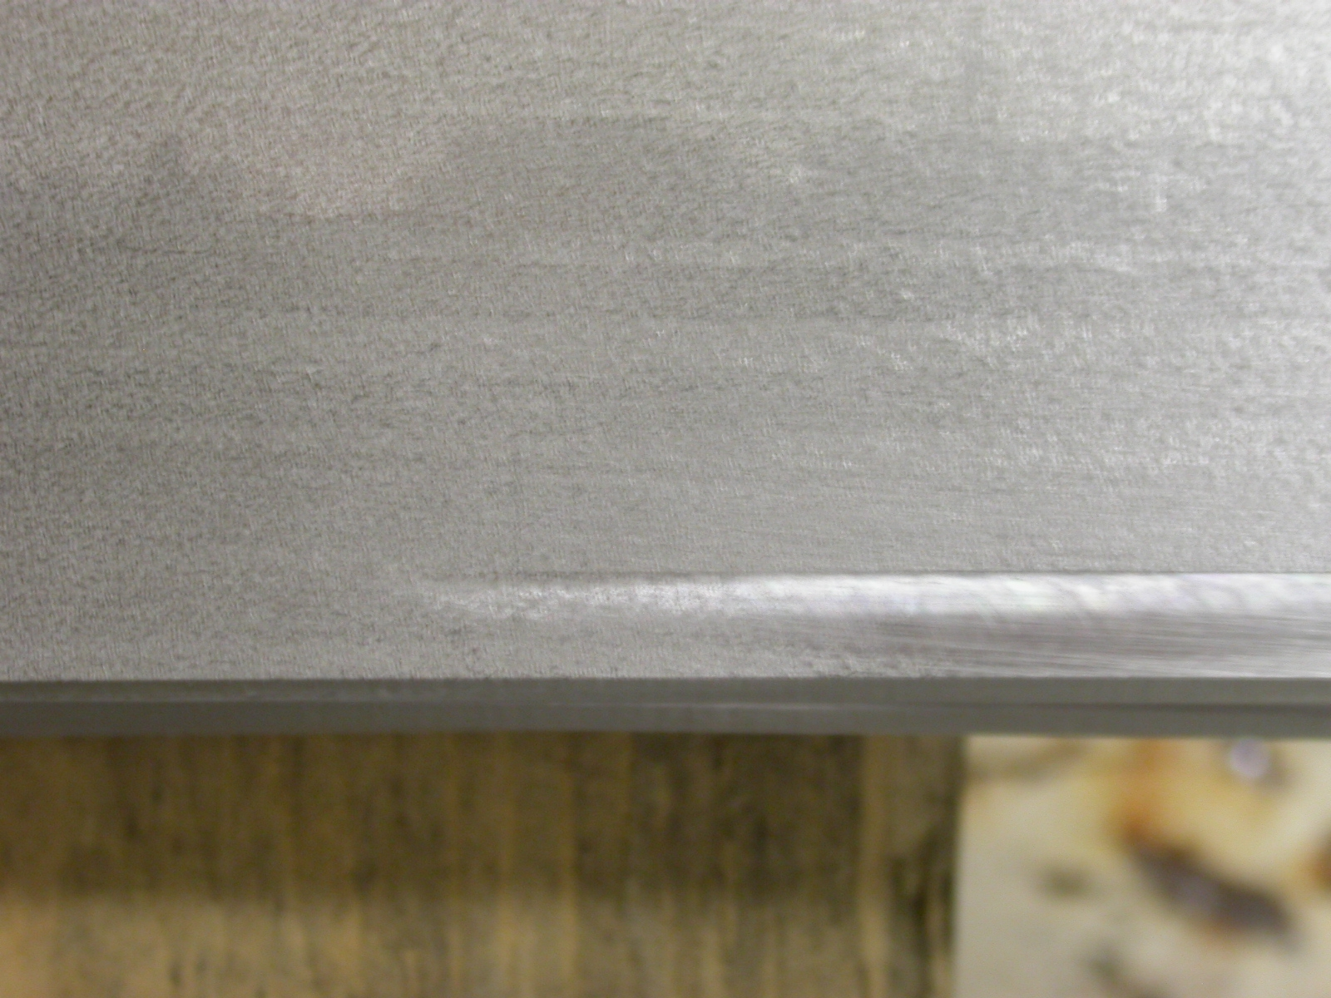

Engineer Signature: |  | Date:

