

MFD NON-COMPLIANCE REPORT # 5116

PART NAME: | TEM CONNECTOR PLATE | DATE: | 9/10/04
PF/SA NO.: | LAT-DS-01026 Rev. 51 | INSPECTOR: | K. CABAN
WORK ORDER NO.: | 2600177 | ENGINEER: | J. CULLINAN | EXT.: | 5034
VENDOR | OSV | ROUTE TO: | CUSTOMER

Reason For Non-Compliance: | Action (UAI,RWK,SCRP)
- 2 Parts Farside counter sink is missing.

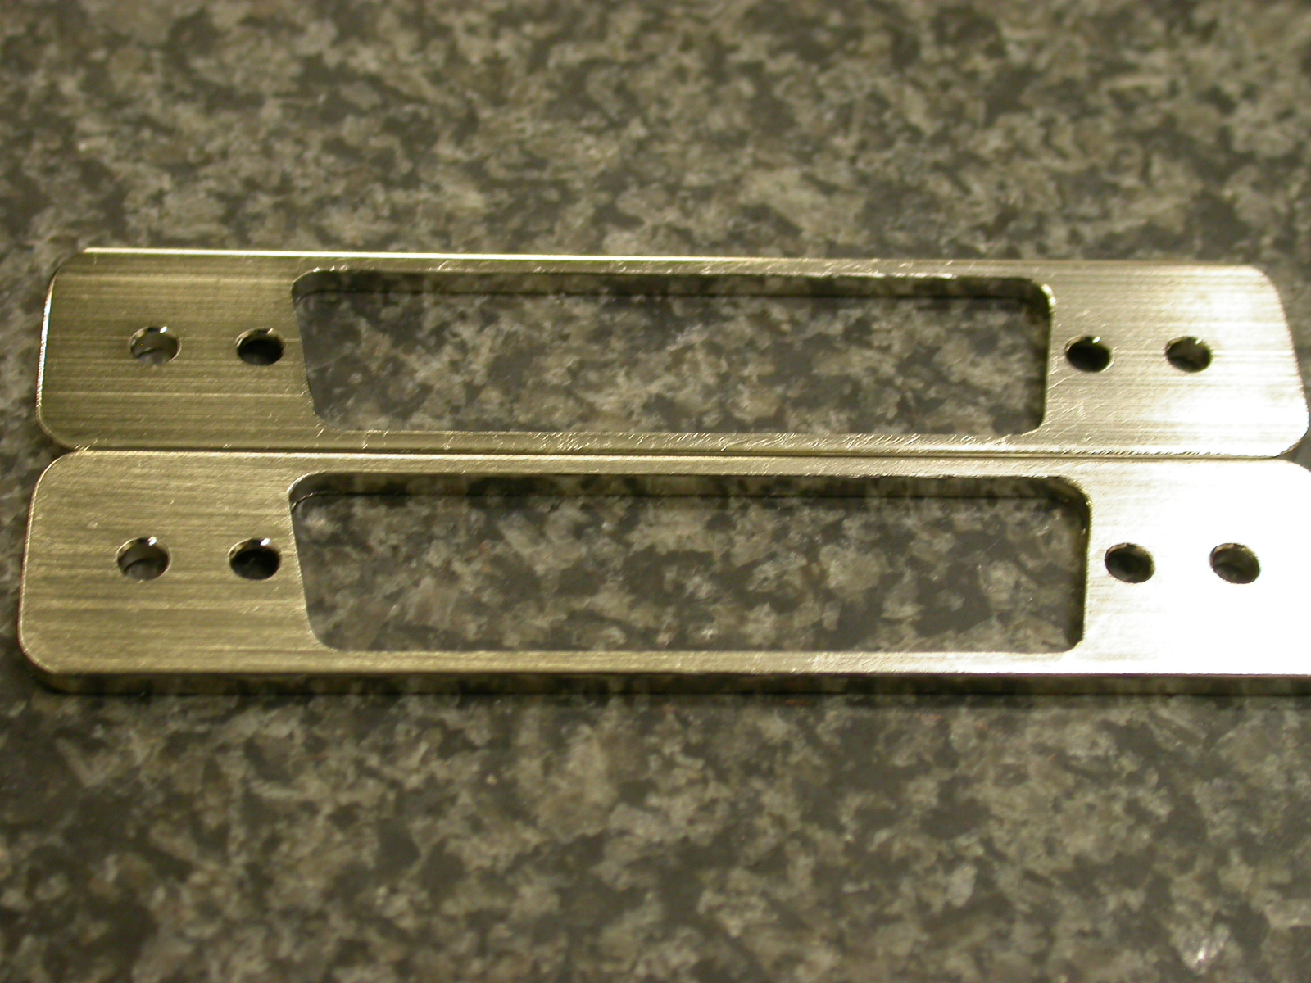  Farside showing missing countersinks | 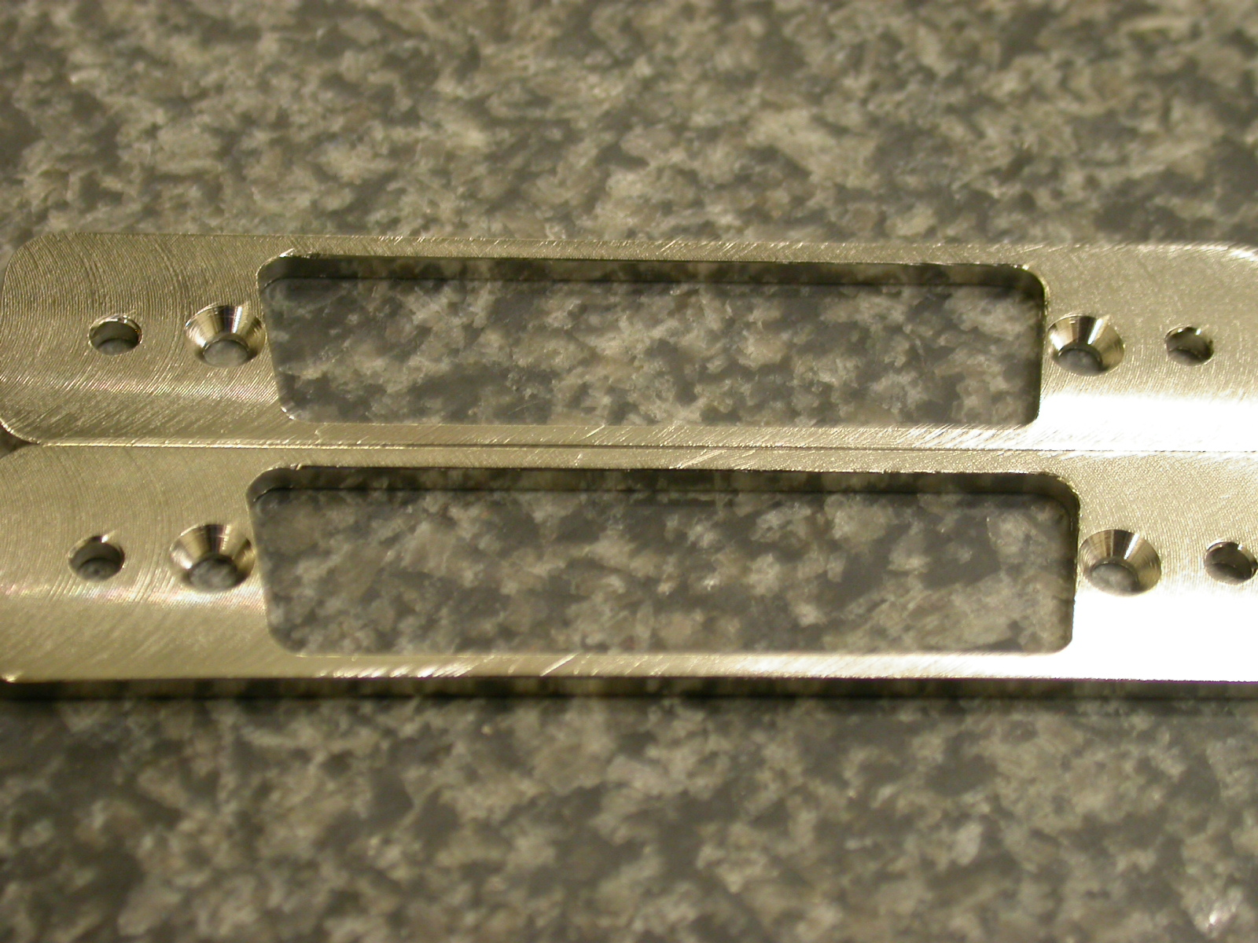  Nearside showing Countersinks

Engineer Signature: |  | Date:

