

MFD NON-COMPLIANCE REPORT #5055

Date: 2/3/04
Job #: 18018
Sub ID: -5
Part Number: PF-293-103-77 Rev. 0
Part Description: Top Cover
Engineer: J. CHAN

Ext: 5084

Reason For Non-compliance:

- R .016 ±0.001” = 0.0095”, mating base R = 0.013”. See Fit Below

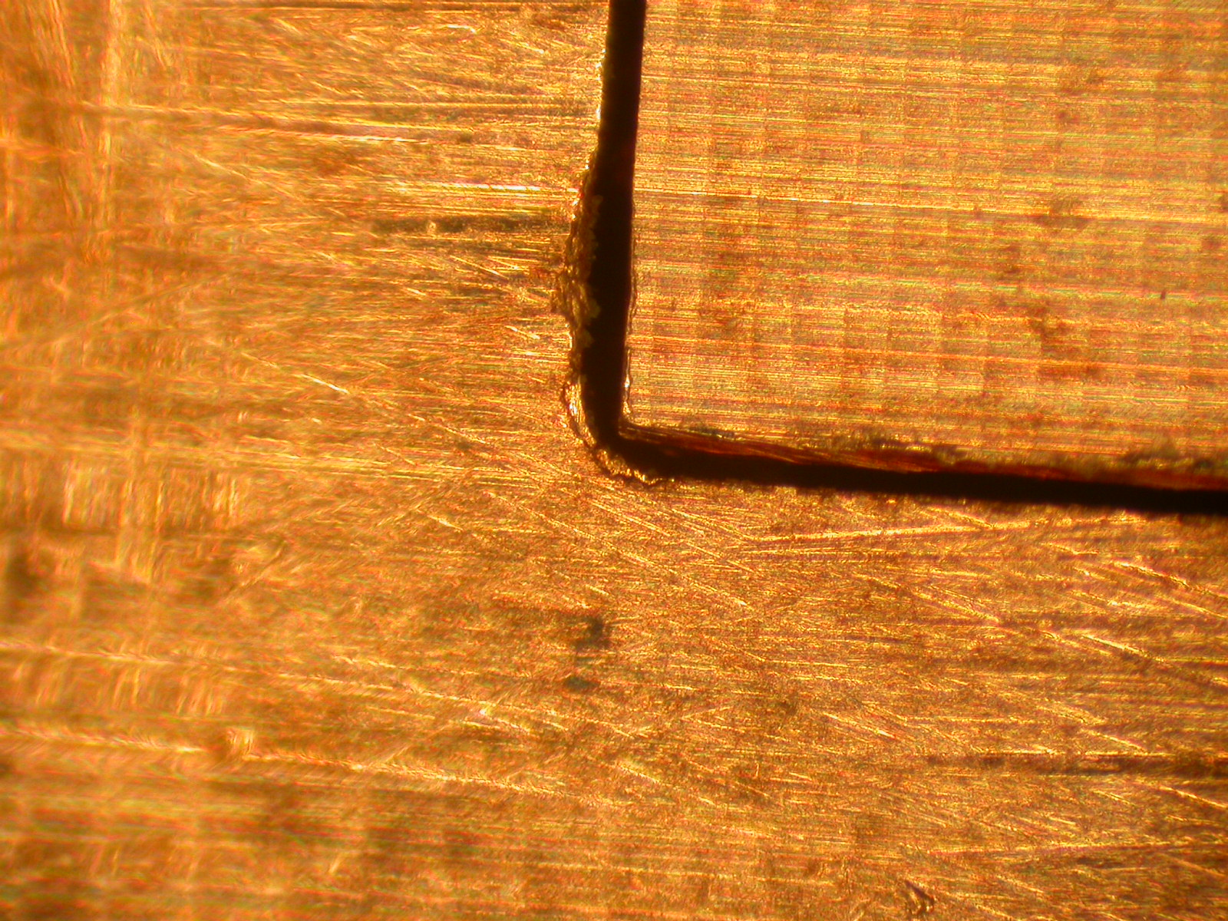
COVER
BASE

Action Taken:

Engineer Signature: _____________________ Date:_________

