

MFD NON-COMPLIANCE REPORT # 5114

PART NAME: | OUTER ECCENTRIC CONE | DATE: | 9/8/04
PF/SA NO.: | LAT-DS-02788 REV. 04 | INSPECTOR: | K. CABAN
WORK ORDER NO.: | 2600177 | ENGINEER: | J. CULLINAN | EXT.: | 5034
VENDOR | OSV | ROUTE TO: | CUSTOMER

Reason For Non-Compliance: | Action (UAI,RWK,SCRP)
- SN 003 only, has an indentation prior to pulling out of tagged back pre-QC on outer surface near smaller end of cone. See Pictures Below.

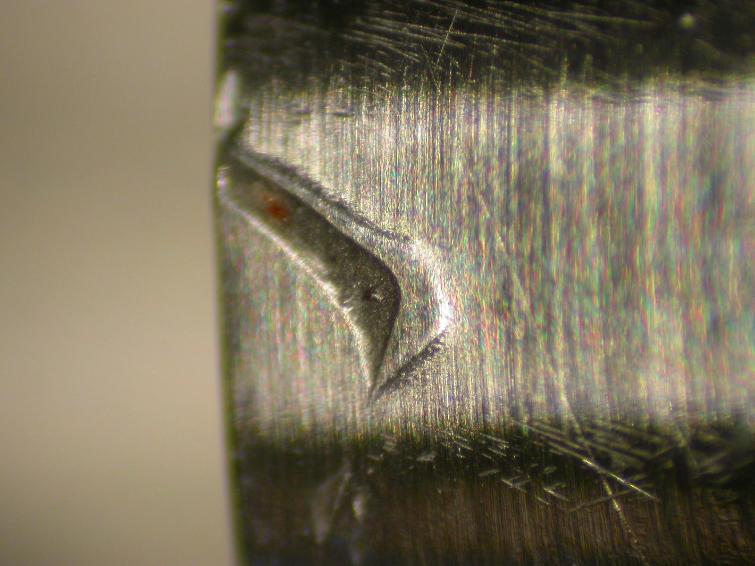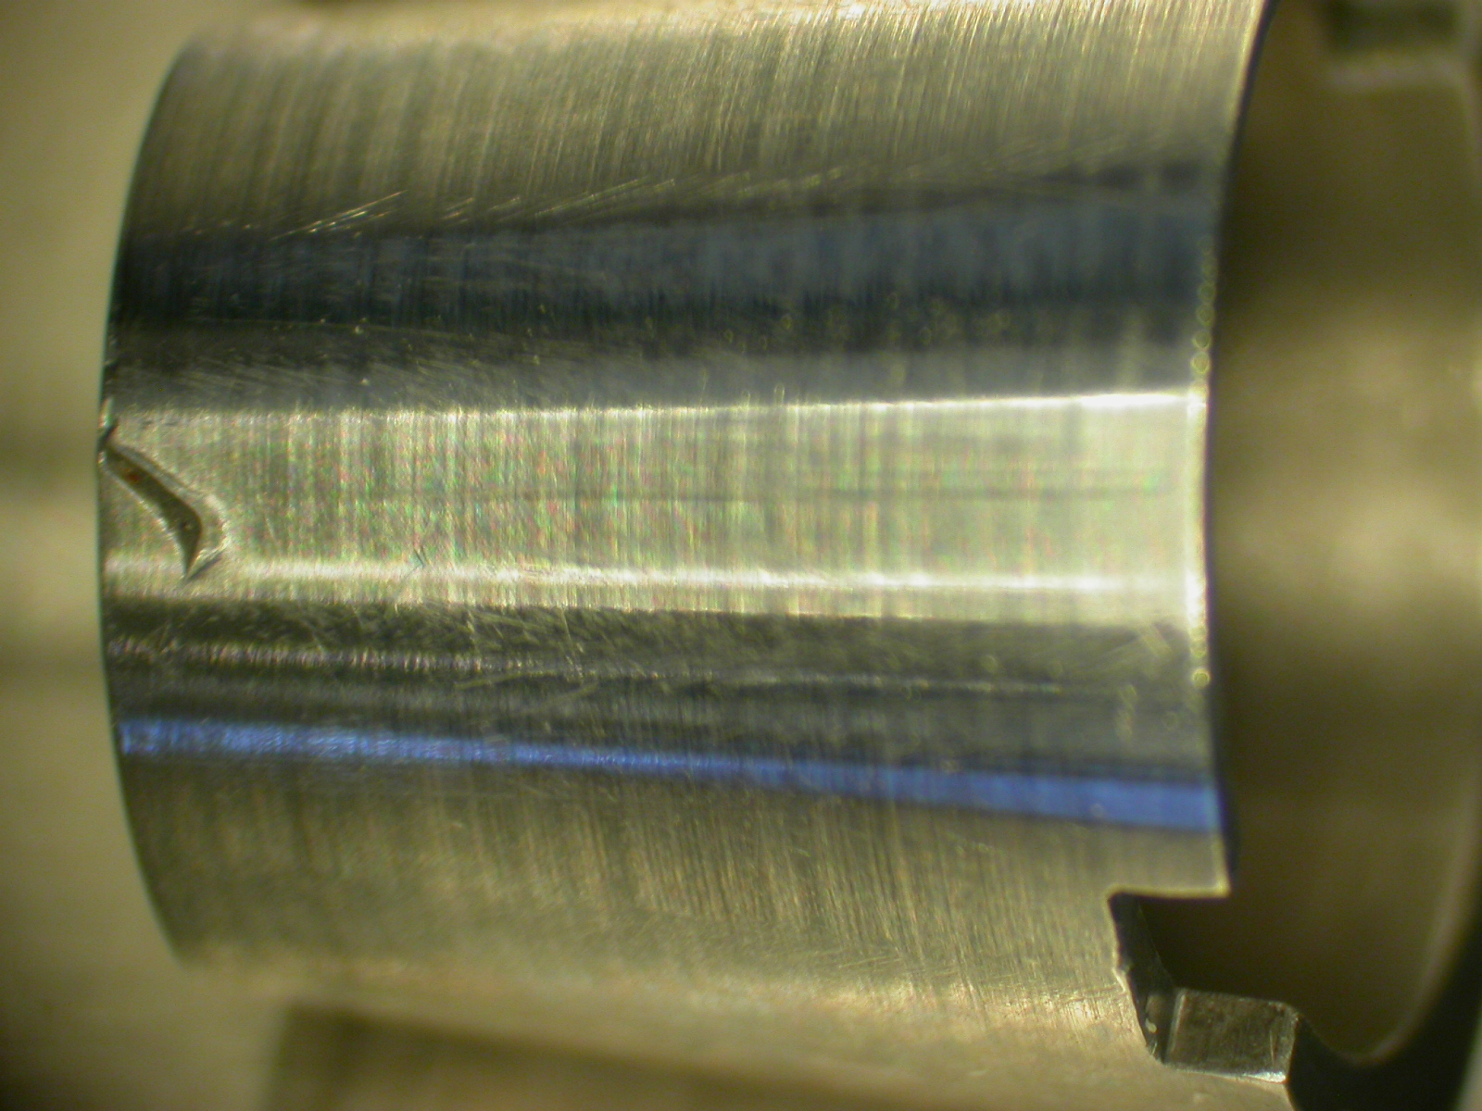

Engineer Signature: |  | Date:

