QUADRUPOLE 4.31Q1.26
MAGNET CORE ASSY
(SA-235-978-11)
FIDUCIALIZATION REPORT

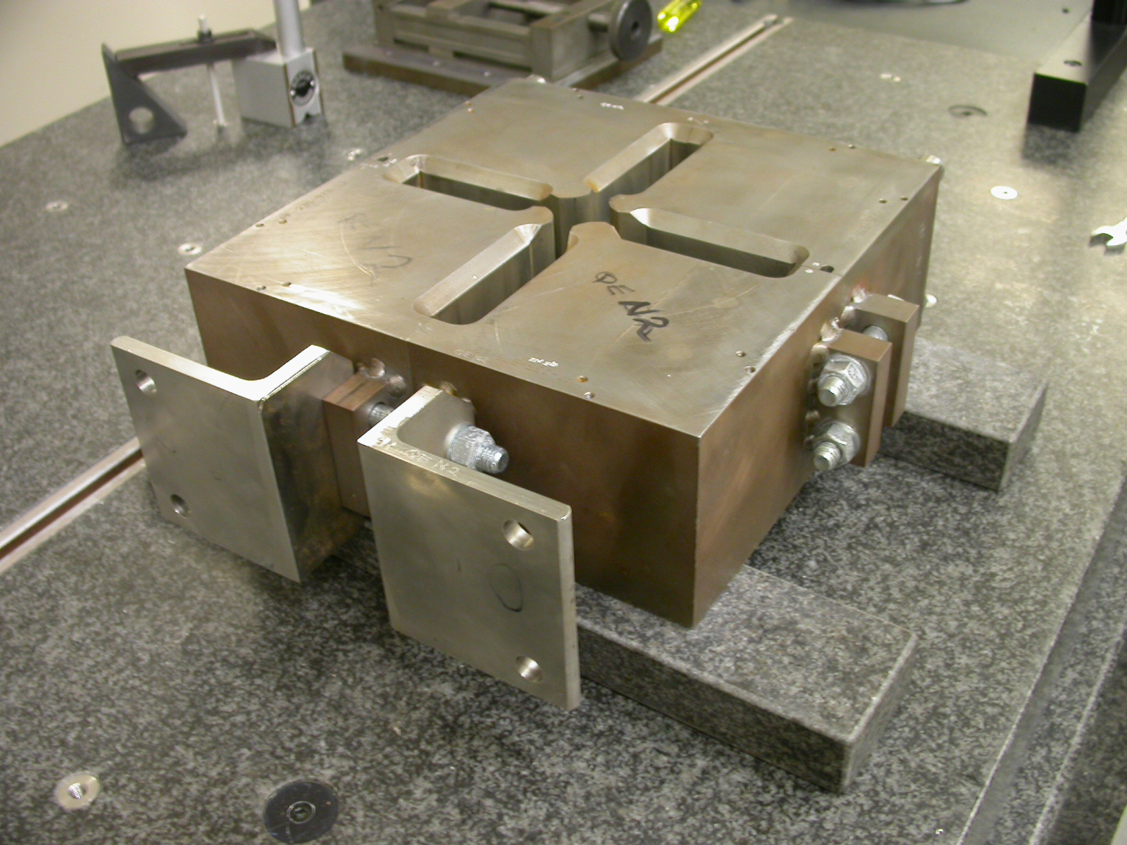

Inspector: Keith Caban
Engineer: Jim Spencer
Date:
Charge Number: 18715-1

Fiducialization Coordinate System Set Up:

Magnet is set on 2 granite parallels, with the feet of the magnet pointing away from the probe rack, with dowel pins facing down on the parallels.

