LCLS SXR NRL MAIN BACK FLANGE
FIDUCIALIZATION REPORT

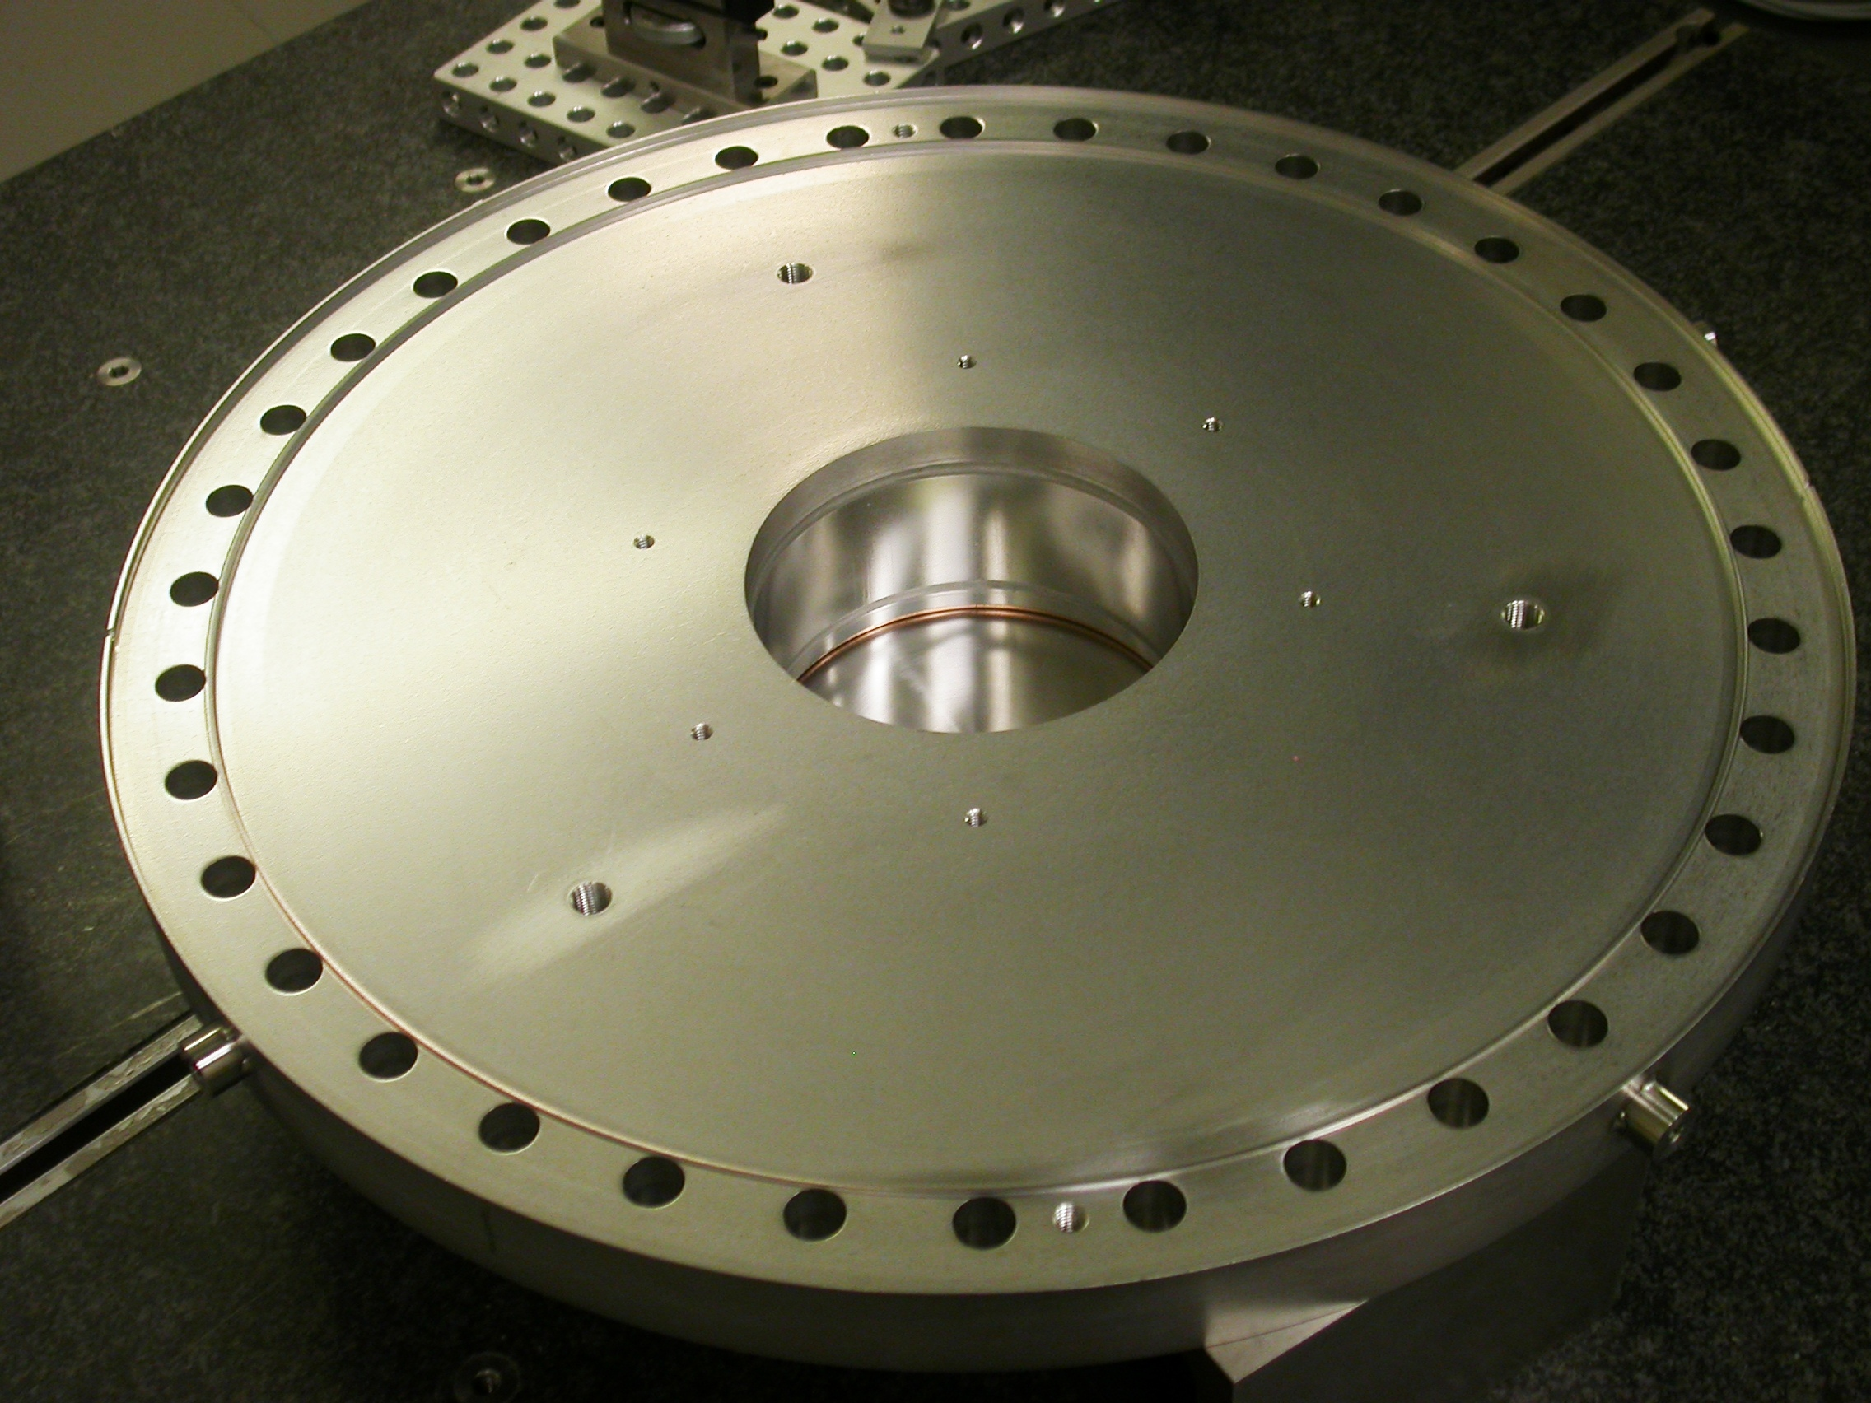

Inspector: | Keith Caban
Customer: | Michael Holmes
ate: | Thursday, July 14, 2011
Work Order/Charge No.: | 27545-1
Serial Number: | 001
Drwg. #: | SK-MH070111
URL of Fiducial Report: | \\Web002\www-group\met\Quality\FIDUCIAL REPORTS\SK-MH070111\SN 001.pdf

Part Set-up – Fiducial Coordinate System (per Michael Holmes)

- Sealing Surface sets zero in ‘Z’ (Dashed Green Area, see picture below)
- Thru ID simulates Beamline center that sets zero in ‘X’ & ‘Y’, and sets the planar alignment, where -Z moving away from the Sealing Surface.
- Roll is eliminated by the axis of the center of the thru ID circle and the Center of Hole #0, which creates the –X axis.

-Z
+Y
-X
Hole #0

TB(4)

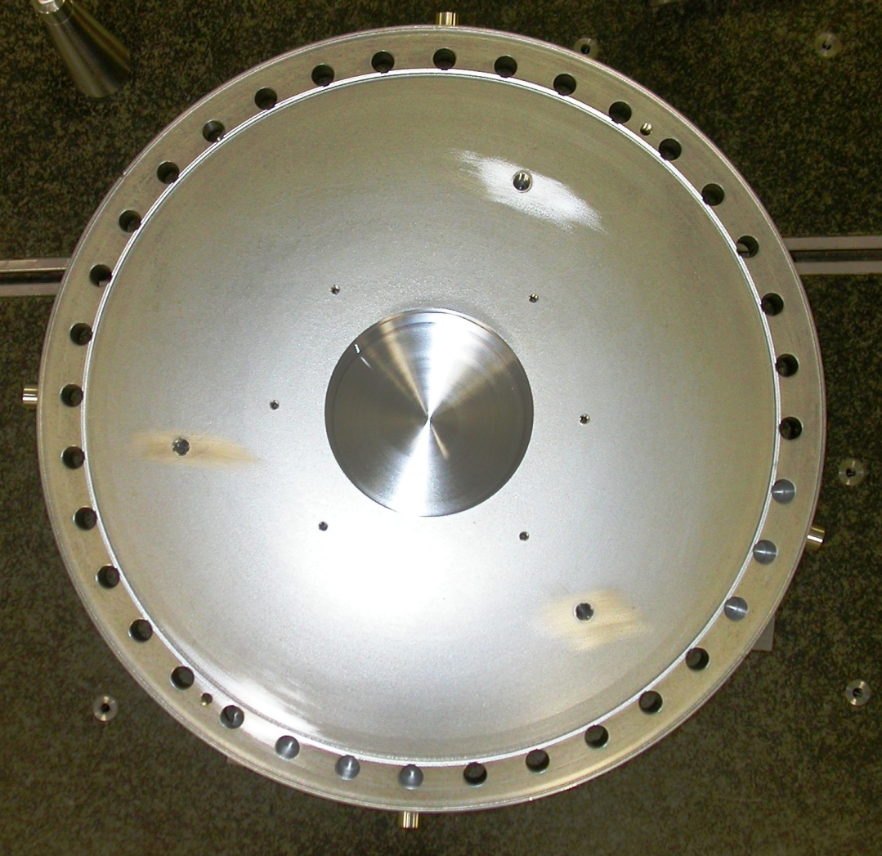
TB(3)
+Y
TB(2)
TB(1)
-X

Tooling Ball Measurements/Locations

Using ½” Diameter Tooling Balls with 1” extension
TB’s are scribed on Part located near TB Holes and/or TB Adapters (welded)

Tooling Ball | Form | Diameter | X | Y | Z
TB 1 | 0.00028 | 0.49939 | -12.12697 | -3.25697 | 0.44075
TB 2 | 0.00018 | 0.49748 | -0.00739 | -12.55978 | 0.44180
TB 3 | 0.00012 | 0.49857 | 12.56029 | -0.02362 | 0.49608
TB 4 | 0.00066 | 0.49747 | -0.03335 | 12.55806 | 0.50175

Location of OD Flange to ID (Beamline Center)

X = 0.00241
Y= -0.00047

LIP DISTANCE (Outer ring to OD) FROM SEALING SURFACE = 0.25205

