
INTENSITY MONITOR TANK
FIDUCIALIZATION REPORT

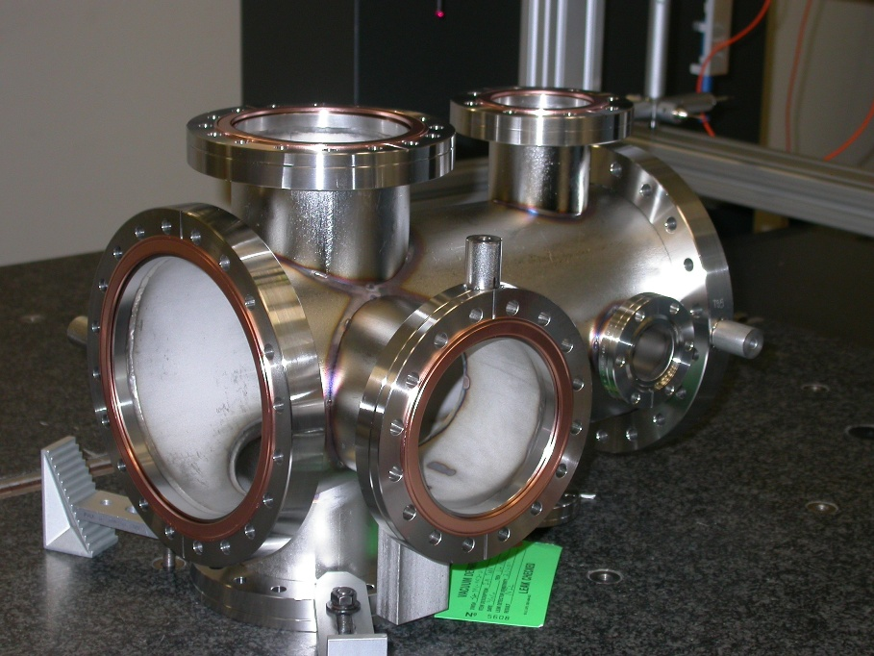

Inspector: | Keith Caban
Customer: | Michael Holmes
Date: | Wednesday, February 24, 2010
Work Order/Charge No.: | 25507-2/60
Serial Number: | 001
Drwg. #: | SA-391-952-61 Rev 0
URL of Fiducial Report: | \\Web002\www-group\met\Quality\FIDUCIAL REPORTS\SA-391-952-61\SA-391-952-61 SN 001.pdf

Part Set-up – Coordinate System Set-up

Used Datums A, B, & C for CSY.

Planar Alignment

- Axis of the centerline of the 2 End 8” non-rotatable flanges, see direction for Z

Spatial Alignment

- Plane of Datum -B- , which points in the positive Y direction.

“Z” Zero

- Plane of Datum -A- which sets zero in Z.

“X” & “Y” Zero

- X, Y zero is the axis created by Port 1 & 17 flanges (see planar alignment)

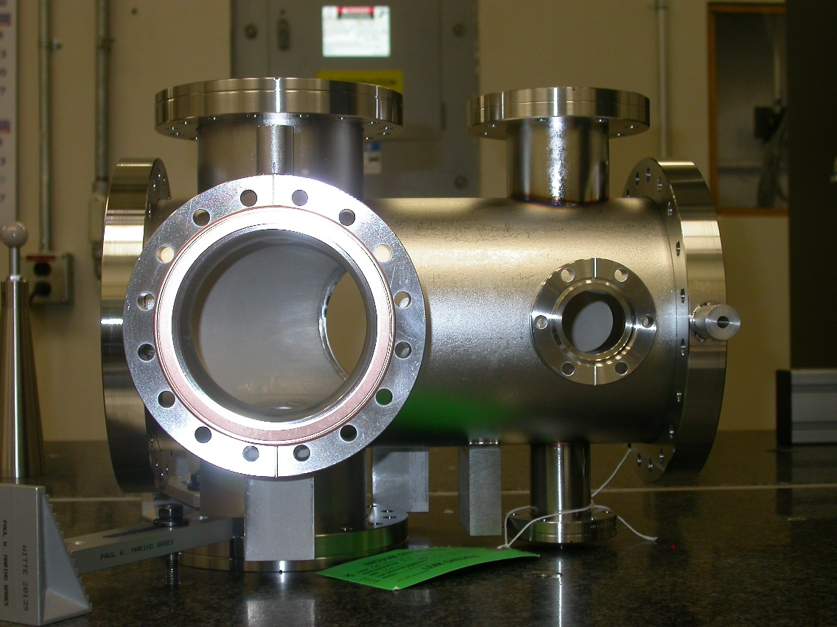
+Z
+Y

View looking from +X

Tooling Ball Measurements/Locations

Using ½” Diameter Tooling Balls with 1” extension
TB’s are scribed on Part located near TB Holes and/or TB Adapters (welded)

Tooling Ball | Form | Diameter | X | Y | Z
TB 1 | 0.00061 | 0.49381 | -5.97394 | 0.03278 | -0.44924
TB 2 | 0.00155 | 0.49365 | 5.51770 | 4.99125 | -3.74220
TB 3 | 0.00088 | 0.49509 | -3.54598 | 3.96922 | -6.73853
TB 4 | 0.00123 | 0.49220 | -5.97374 | -0.00086 | -12.98432
TB 5 | 0.00078 | 0.49487 | 5.97616 | -0.00807 | -13.01048

