
VAC CHMBR, PLS PICK / ATTEN
FIDUCIALIZATION REPORT

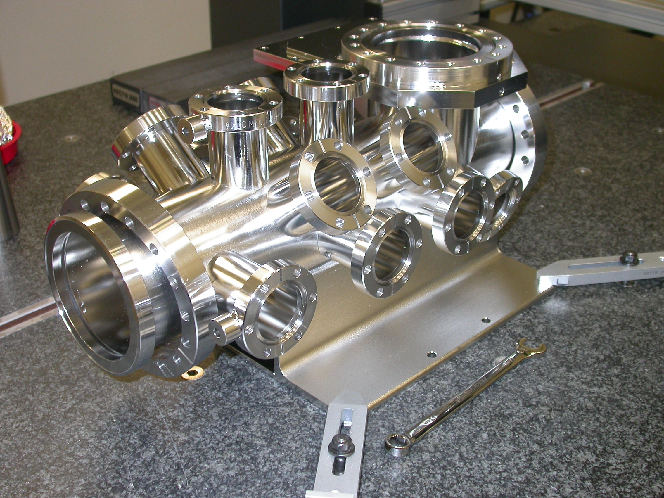

Inspector: | Keith Caban
Customer: | Marc Campell
Date: | Monday, April 12, 2010
Work Order/Charge No.: | 9120547
Serial Number: | 003
Drwg. #: | SA-391-900-10 Rev 1
URL of Fiducial Report: | \\Web002\www-group\met\Quality\FIDUCIAL REPORTS\SA-391-900-10\SA-391-900-10 SN 003.pdf

Part Set-up – Coordinate System Set-up

Used Datums A, B, & C for CSY.

Planar Alignment

- Axis of Port 1 flange to Port 17 flange is the Z axis in which positive Z is pointing towards Port 17.

Spatial Alignment

- Plane of Datum –A- (Port 3), which points in the positive Y direction.

“Z” Zero

- Plane of Datum –C- (Port 1) which sets zero in Z.

“X” & “Y” Zero

- X, Y zero is the axis created by Port 1 & 17 flanges (see planar alignment)

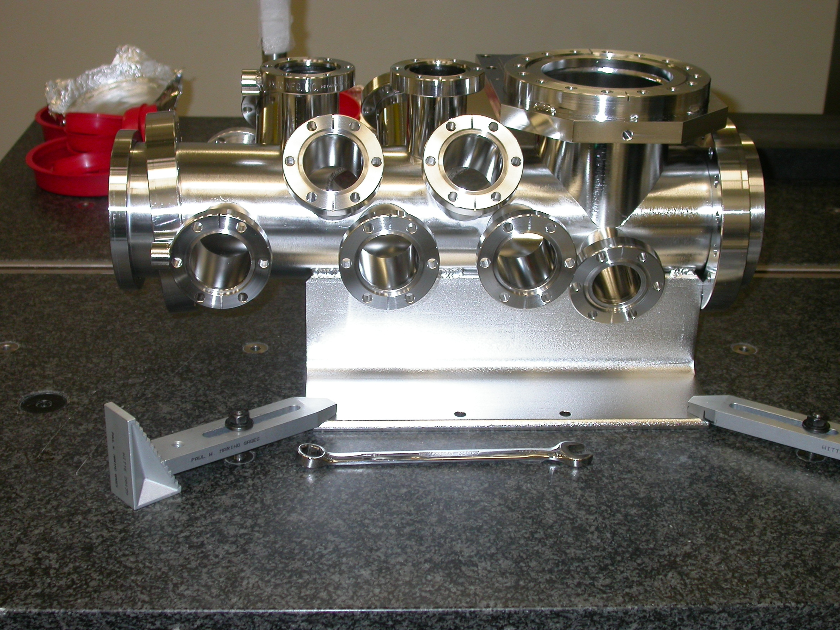
+Z
+Y

Tooling Ball Measurements/Locations

Using ½” Diameter Tooling Balls with 1” extension
TB’s are scribed on Part located near TB Holes and/or TB Adapters (welded)

Tooling Ball | Form | Diameter | X | Y | Z
TB 1 | 0.00053 | 0.50008 | 4.29470 | 3.32625 | 4.55414
TB 2 | 0.00148 | 0.49750 | 0.05429 | 3.32289 | 0.28612
TB 3 | 0.00175 | 0.48879 | -6.45838 | 3.32994 | 2.01373
TB 4 | 0.00179 | 0.49177 | -6.46689 | 3.32955 | 7.01322
TB 5 | 0.00150 | 0.48789 | -3.84150 | 0.00402 | 18.27746
TB 6 | 0.00036 | 0.48847 | 0.04657 | 3.83420 | 16.03227
TB 7 | 0.00279 | 0.48384 | 3.384548 | -0.09134 | 18.27977

Port Locations (Polar distance from centerline (XY) & Z Location



