
VAC CHMBR, PLS PICK / ATTEN
FIDUCIALIZATION REPORT

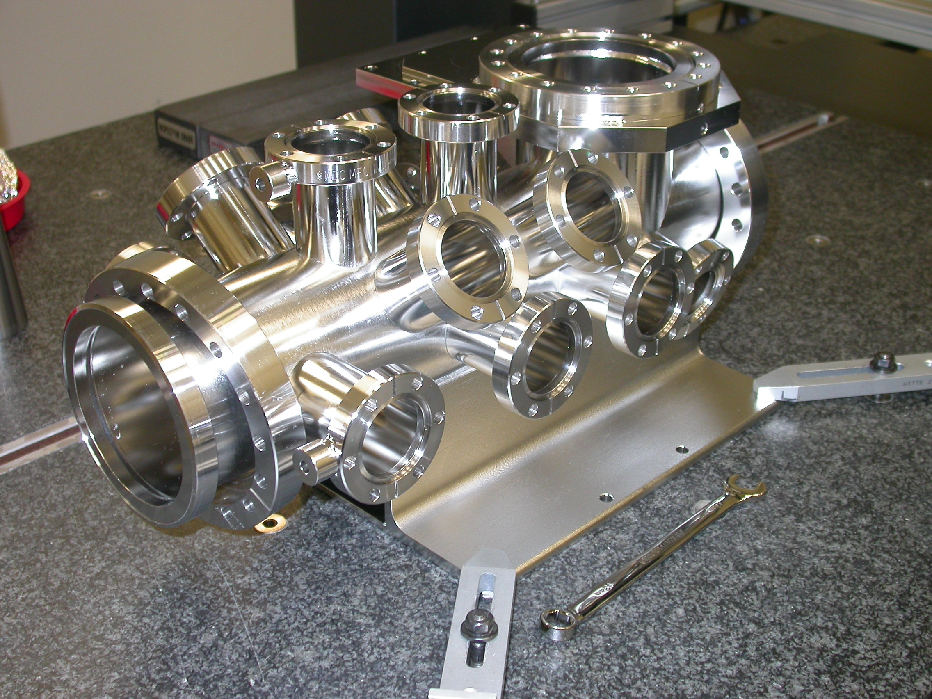

Inspector: | Keith Caban
Customer: | Marc Campell
Date: | Monday, April 12, 2010
Work Order/Charge No.: | 9120547
Serial Number: | 002
Drwg. #: | SA-391-900-10 Rev 1
URL of Fiducial Report: | \\Web002\www-group\met\Quality\FIDUCIAL REPORTS\SA-391-900-10\SA-391-900-10 SN 002.pdf

Part Set-up – Coordinate System Set-up

Used Datums A, B, & C for CSY.

Planar Alignment

- Axis of Port 1 flange to Port 17 flange is the Z axis in which positive Z is pointing towards Port 17.

Spatial Alignment

- Plane of Datum –A- (Port 3), which points in the positive Y direction.

“Z” Zero

- Plane of Datum –C- (Port 1) which sets zero in Z.

“X” & “Y” Zero

- X, Y zero is the axis created by Port 1 & 17 flanges (see planar alignment)

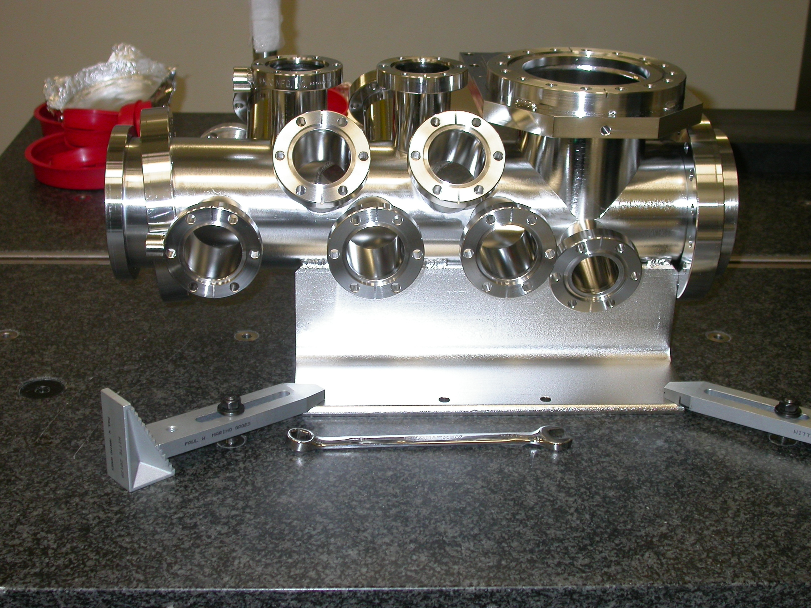
+Z
+Y

Tooling Ball Measurements/Locations

Using ½” Diameter Tooling Balls with 1” extension
TB’s are scribed on Part located near TB Holes and/or TB Adapters (welded)

Tooling Ball | Form | Diameter | X | Y | Z
TB 1 | 0.00307 | 0.49639 | 4.32056 | 3.31462 | 4.52571
TB 2 | 0.00636 | 0.48839 | 0.06169 | 3.31635 | 0.27543
TB 3 | 0.00196 | 0.49166 | -6.43382 | 3.32514 | 2.03216
TB 4 | 0.00061 | 0.49115 | -6.43504 | 3.32074 | 7.03284
TB 5 | 0.00456 | 0.47527 | -3.85495 | 0.01889 | 18.27474
TB 6 | 0.00336 | 0.48761 | 0.14035 | 3.83942 | 16.02468
TB 7 | 0.00292 | 0.48179 | 3.83061 | -0.00027 | 18.28117

Port Locations (Polar distance from centerline (XY) & Z Location



