LUSI CXI ROUGH TO UHV TUBE ASSY
FIDUCIALIZATION REPORT

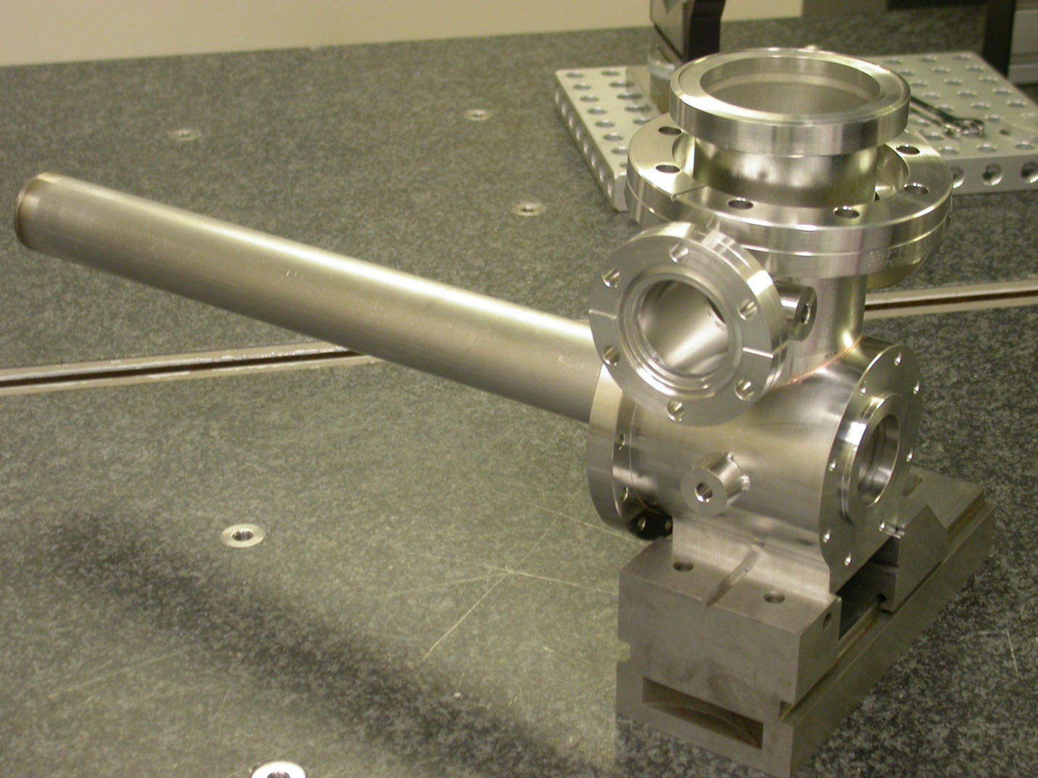

Inspector: | Keith Caban
Customer: | Don Schafer
ate: | Monday, July 11, 2011
Work Order/Charge No.: | 27272-1
Serial Number: | 001
Drwg. #: | SA-391-530-09 R0
URL of Fiducial Report: | \\Web002\www-group\met\Quality\FIDUCIAL REPORTS\SA-391-530-09\SN 001.pdf

Part Set-up – Coordinate System Set-up (Per Phone Conversation with D. Schafer 07/11/11)

- Based CSY off of the Drawing (SA-391-530-09).
- Datum ‘A’ is a plane measurement and is the spatial alignment, zero in Z.
- Datum ‘B’ is a cylinder measurement, sets zero in X & Y.
- Bottom Flat on Turbo Stage is the planar alignment (roll).

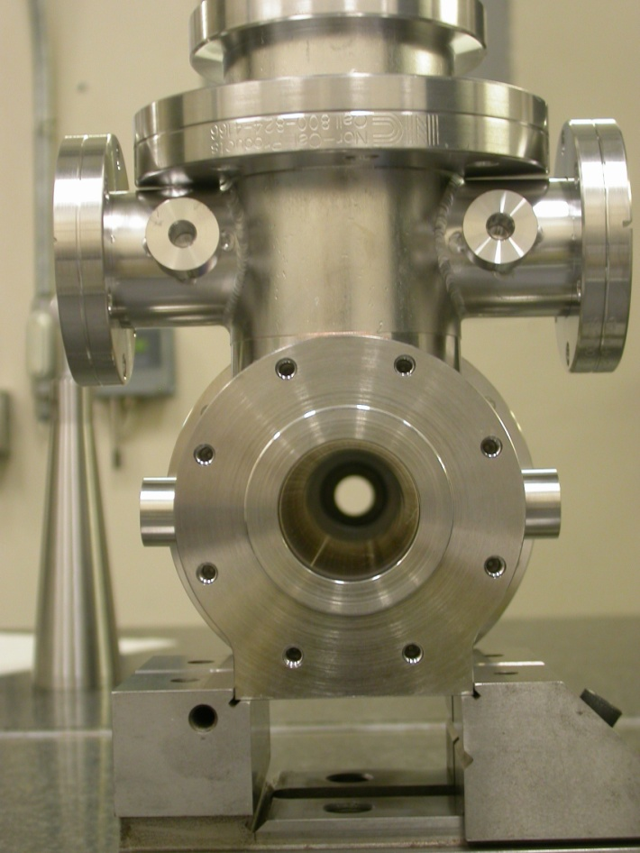
TB(1)
TB(4)
+X
TB(2)
+Y
TB(3)

Tooling Ball Measurements/Locations

Using ½” Diameter Tooling Balls with 1” extension
TB’s are scribed on Part located near TB Holes and/or TB Adapters (welded)

Tooling Ball | Form | Diameter | X | Y | Z
TB 1 | 0.00037 | 0.49981 | 3.19710 | 0.02839 | -1.95768
TB 2 | 0.00008 | 0.49996 | -3.19763 | -0.01576 | -1.92715
TB 3 | 0.00006 | 0.49994 | 1.56405 | 2.85671 | -4.04093
TB 4 | 0.00054 | 0.49966 | -1.55741 | 2.82253 | -4.04877

Location of .752 diameter on opposite end

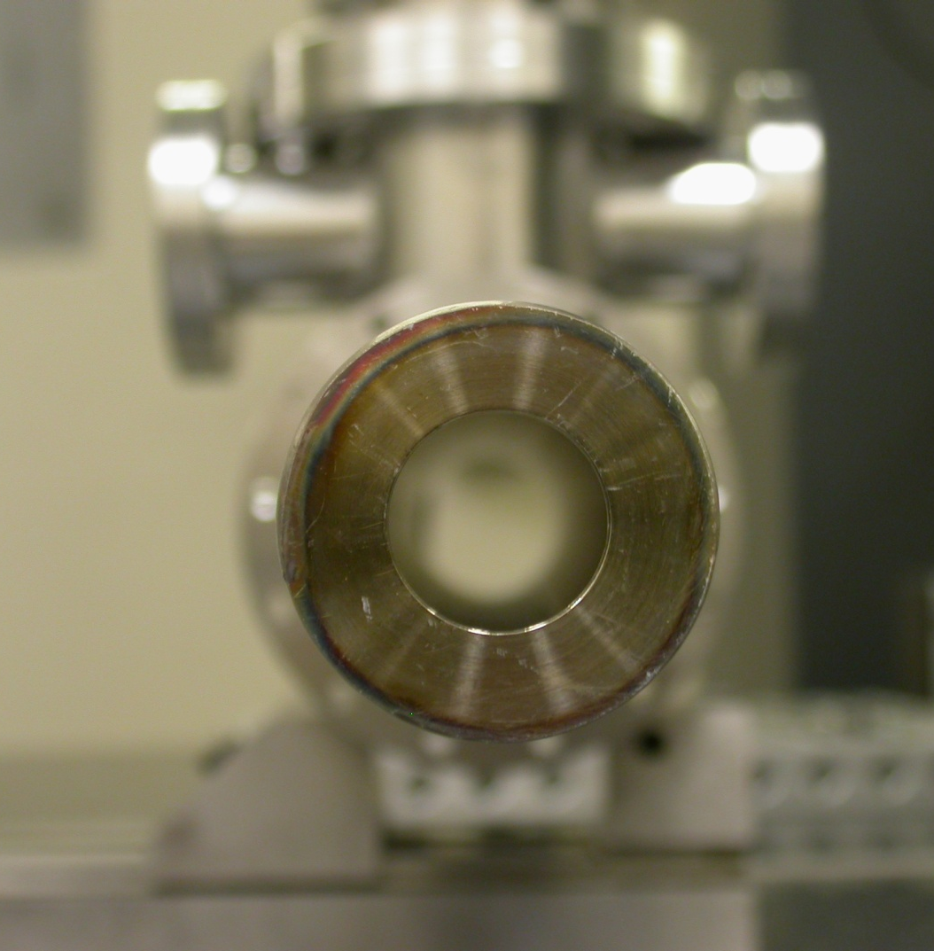
Actual center position =

X= -0.0246
Y= -0.0207
+X
+Y

