

QUADRUPOLE 4.31Q1.26
MAGNET CORE ASSY
(SA-235-978-11)
FIDUCIALIZATION REPORT

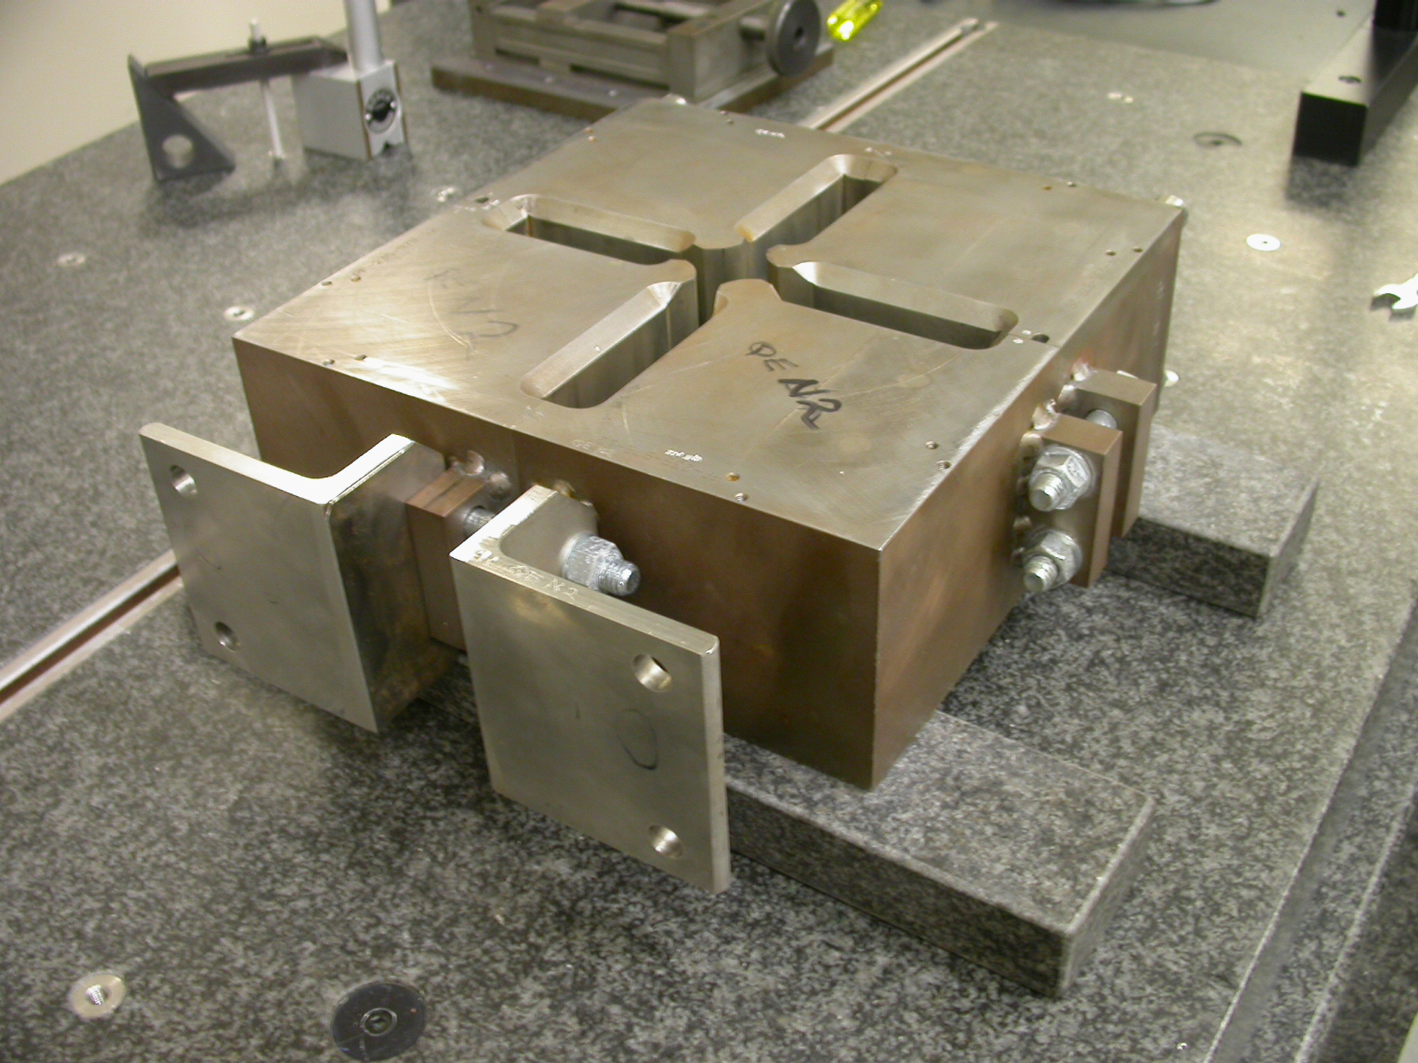

Inspector: Keith Caban
Engineer: Jim Spencer
Date: 3/9/05
Charge No: 18715-1
Mag. S/N: QE-N9

Fiducialization Coordinate System Set Up:

Magnet is set on 2 granite parallels, with the feet of the magnet pointing away from the probe rack, with dowel pins facing down on the parallels.

Z-
X+
Y+

FEET

Z zero is set by the mid-plane of the top surface and bottom surface or, the granite parallels.

X,Y zero is set by the cylindrical axis of the center 1.2550 diameter.

The magnet is aligned by the feet (denoted on picture above).

Z axis is the cylindrical axis of the center 1.2550 diameter.

MEASURMENTS

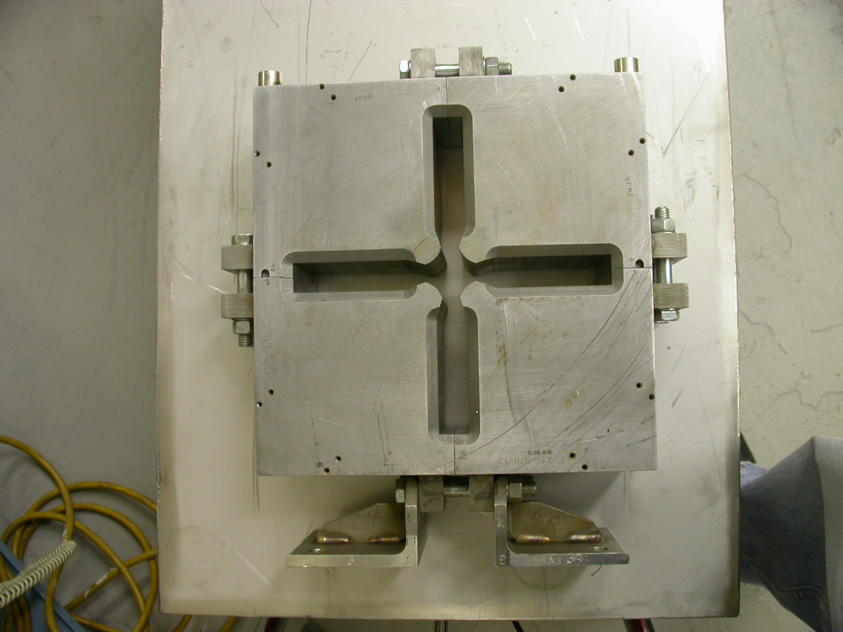
X+
Y+
A
B
C
D
E
F
G
H

Loc. | A | B | C | D | E | F | G | H
Dist. | 5.9064 | 5.9092 | 5.9029 | 5.9107 | 5.9040 | 5.9066 | 5.9004 | 5.9086

DISTANCE TO FEET (8.650) | 8.65024

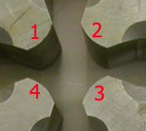
1.2550 ±0.0002 distance

LOCATION | Distance 1-3 | Distance 2-4
Z = -2 | 1.25439 | 1.25476
Z = 0 | 1.25460 | 1.25415
Z = +2 | 1.25428 | 1.25477

FIDUCIALIZE TOOLING BALLS

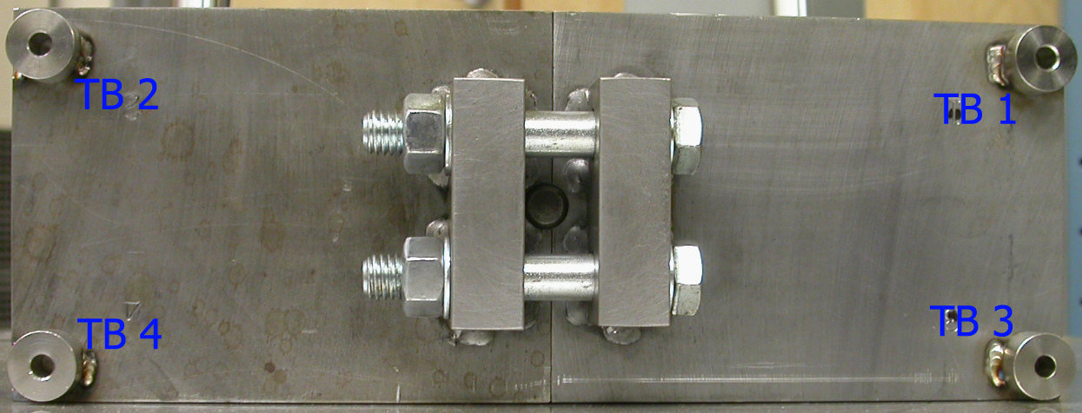
X+
Z+

Tooling Ball | Form | Diameter | X | Y | Z
1 | 0.00054 | 0.49808 | 5.40303 | 7.40291 | -1.65235
2 | 0.00005 | 0.49980 | -5.38411 | 7.41426 | -1.66877
3 | 0.00009 | 0.49964 | 5.40977 | 7.40381 | 1.59378
4 | 0.00032 | 0.49743 | -5.37430 | 7.41459 | 1.63755

