PIN HOLDER FIDUCIALIZATION
(SA-342-417-05 REV 01)

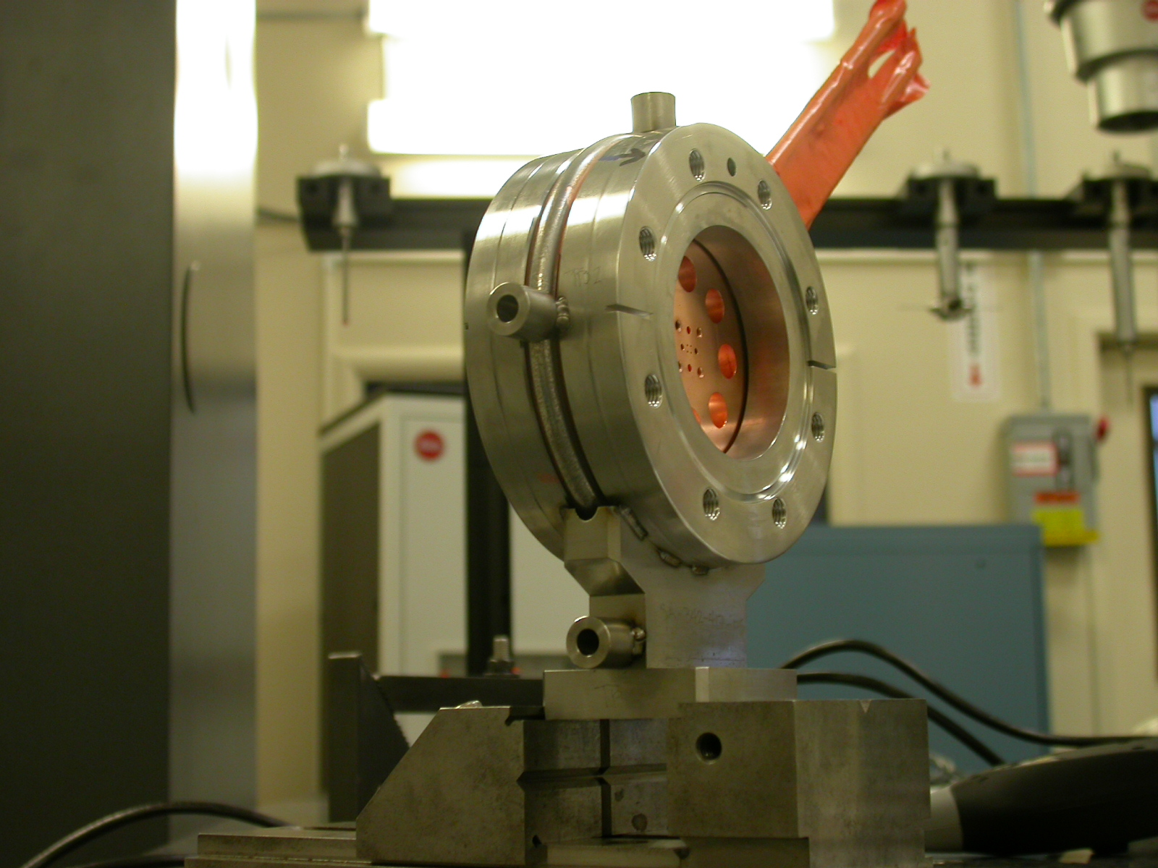

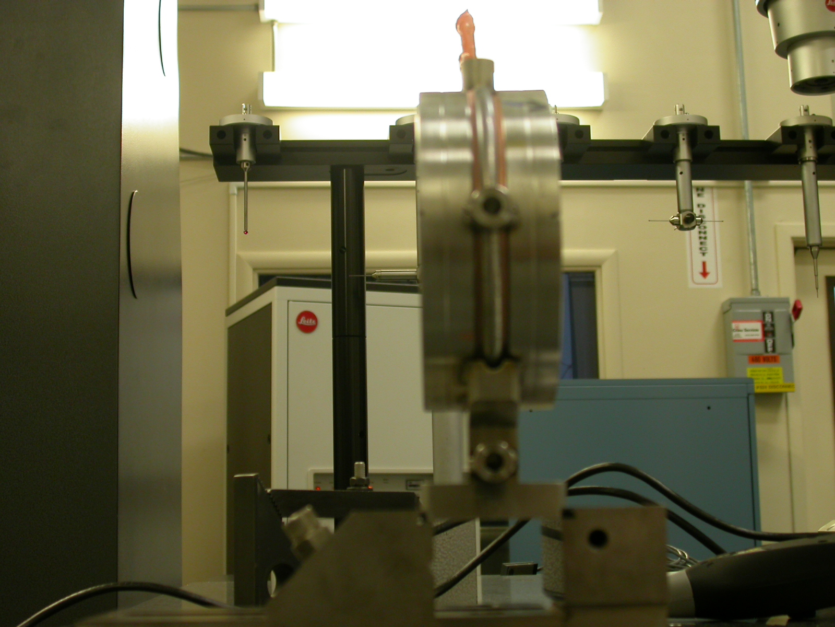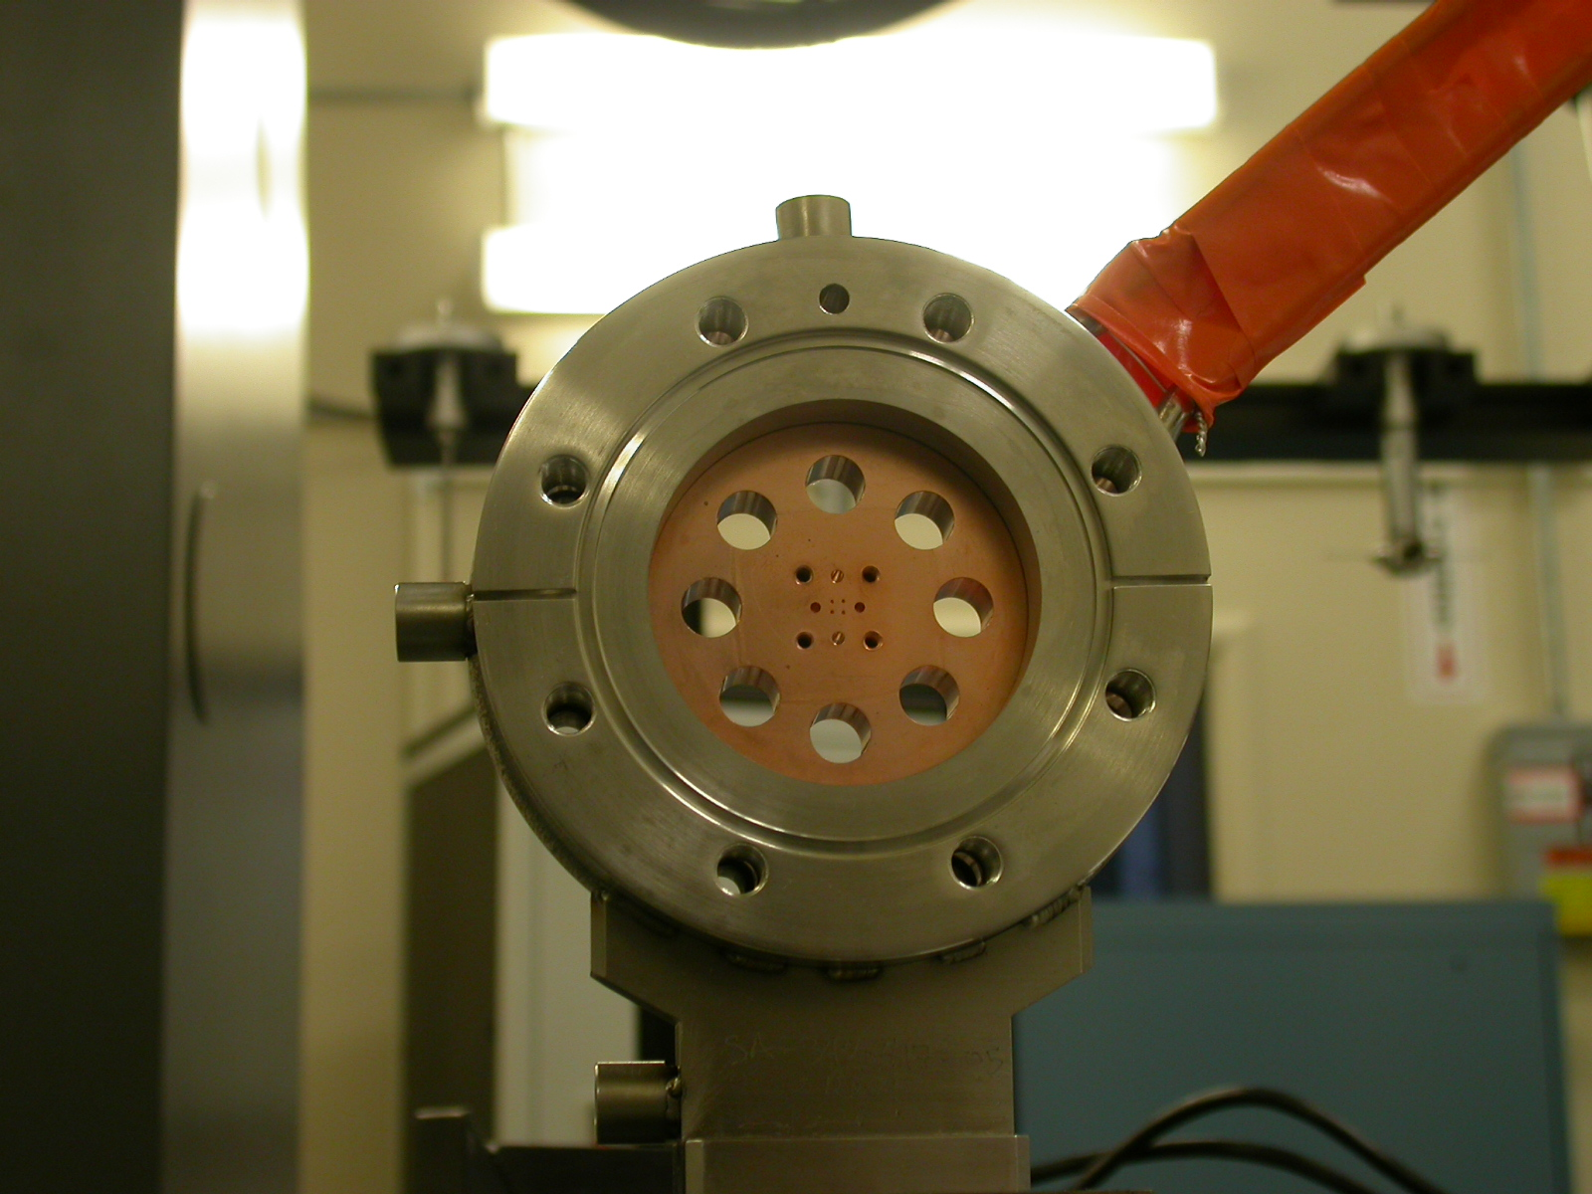

Keith Caban
QC METROLOGY
9/3/04

COORDINATE SYSTEM SET UP:

- The symmetry of Downstream Copper surface and Upstream Copper Surface sets zero in “Z” and sets spatial alignment.

- The lower .375 hole on Downstream Side sets zero in “X” and “Y”.
  - We will relate this with the offset given by Tom Nakashima on the Optical CMM of the .016 diameter holes in which he found the center and related that to the lower .375 hole.
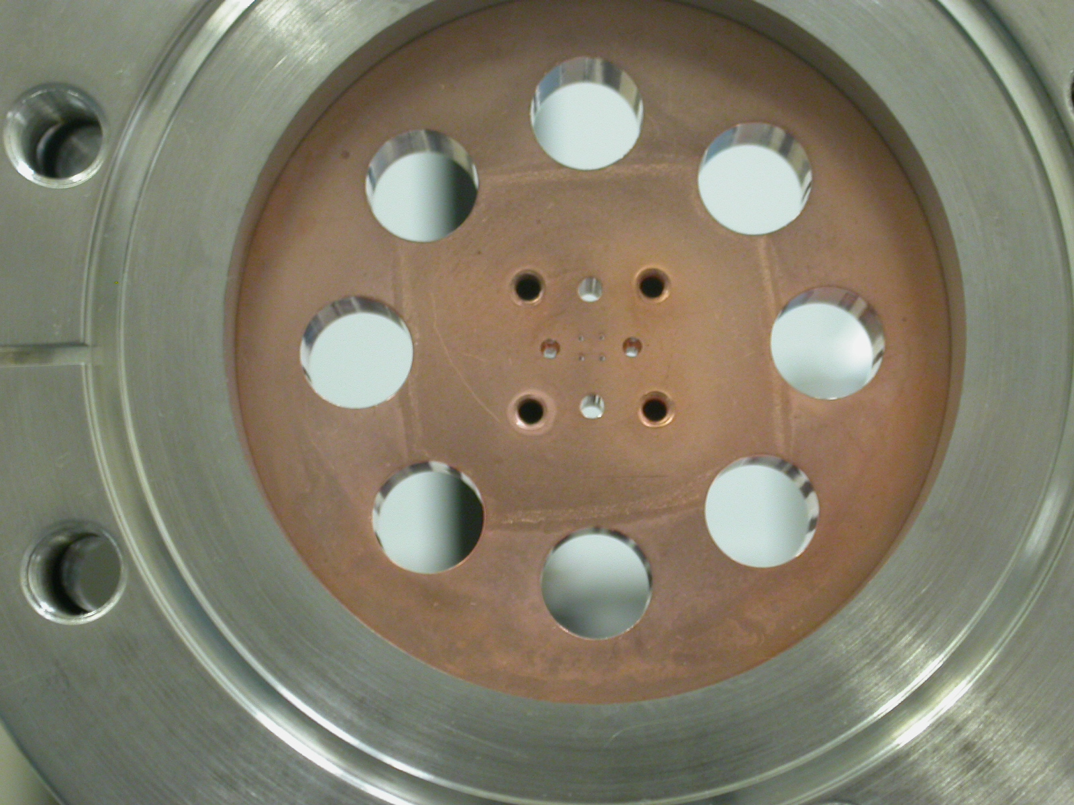

- A line created by 2 side .375 (circled in green) holes will be the planar alignment.

OFFSET DATA

From lower .375 Hole to the center of 4x 0.016 holes:

X = -0.00080
Y = -0.19816

CMM TB’S to Lower .375 Hole

TB | FORM | DIAMETER | X | Y | Z
TB1 | 0.00039 | 0.49845 | -0.12991 | 3.92710 | -0.00935
TB2 | 0.00046 | 0.49702 | -3.73300 | 0.16116 | -0.00413
TB3 | 0.00089 | 0.49449 | -2.51183 | -2.81140 | 0.00240

TB’S TO CENTER OF 0.016 HOLES (USING OFFSET DATA)

TB | FORM | DIAMETER | X | Y | Z
TB1 | 0.00039 | 0.49845 | -0.12911 | 3.72894 | -0.00935
TB2 | 0.00046 | 0.49702 | -3.73220 | -0.03700 | -0.00413
TB3 | 0.00089 | 0.49449 | -2.51103 | -3.00956 | 0.00240

