

SSRL SPEAR 3
WINDOW UPBEAM FLANGE
FIDUCIALIZATION REPORT
(PF-444-317-32)

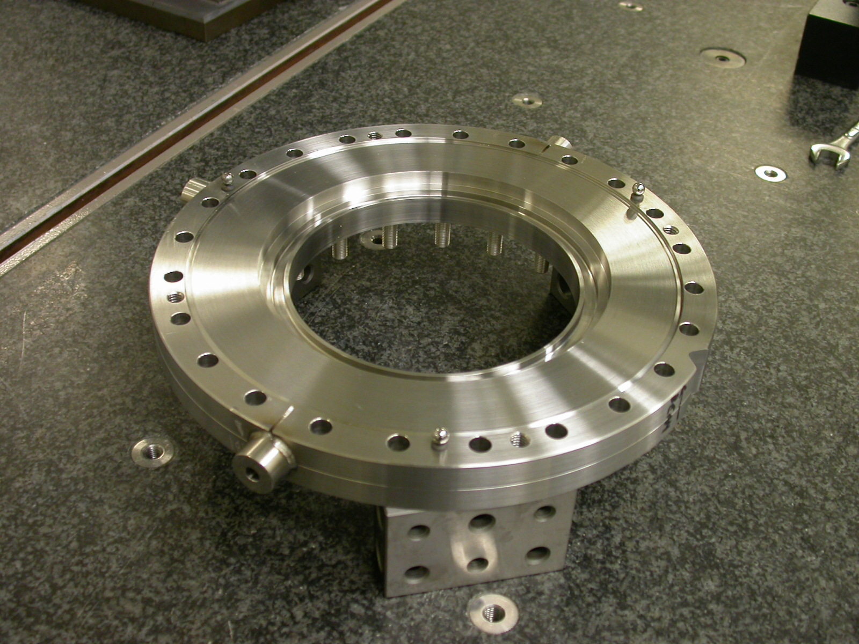

Inspector: Keith Caban
Engineer: Andy Ringwall
Date: 2/28/05
Charge No: 95-5102-0

Fiducialization Coordinate System Set Up:

Flange is set up with upbeam direction facing towards the ceiling on three 1-2-3 blocks, with one sphere pointing in the plus Y direction.

X+
Y+
Z+

Z zero is set by a plane Datum D on sheet 2 of PF-444-317-32.

X,Y zero is set by the diameter Datum B..

The flange is clocked by the sphere in the Y direction (circled in orange).

FIDUCIALIZE TOOLING BALLS

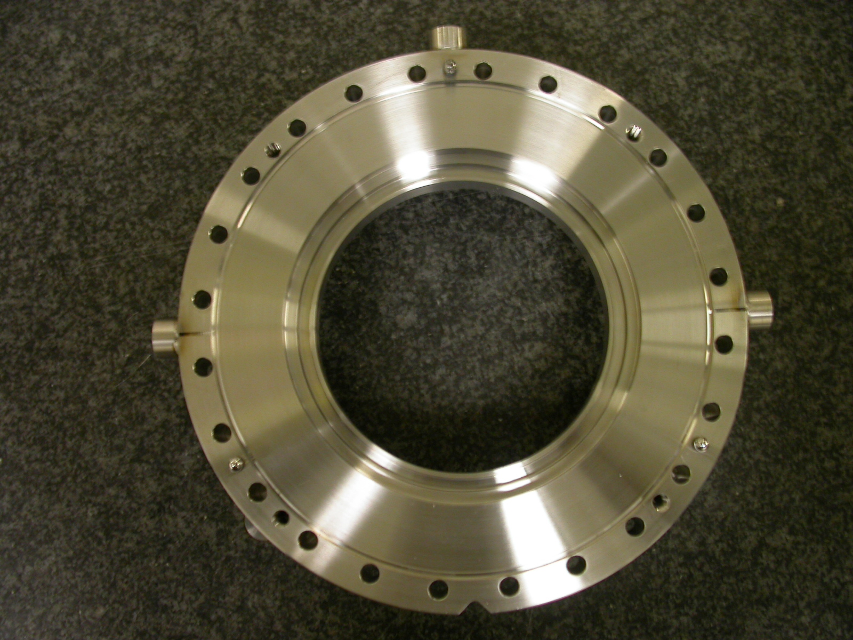
X+
Y+
TB 1
TB 2
TB 3

Tooling Ball | Form | Diameter | X | Y | Z
1 | 0.00008 | 0.49874 | -6.48339 | 0.01072 | -0.16509
2 | 0.00073 | 0.49666 | 0.00750 | 6.48584 | -0.13981
3 | 0.00046 | 0.49789 | 6.48378 | 0.04743 | -0.13466

