
LCLS WALL ONE COLLIMATOR ASSY
FIDUCIALIZATION REPORT

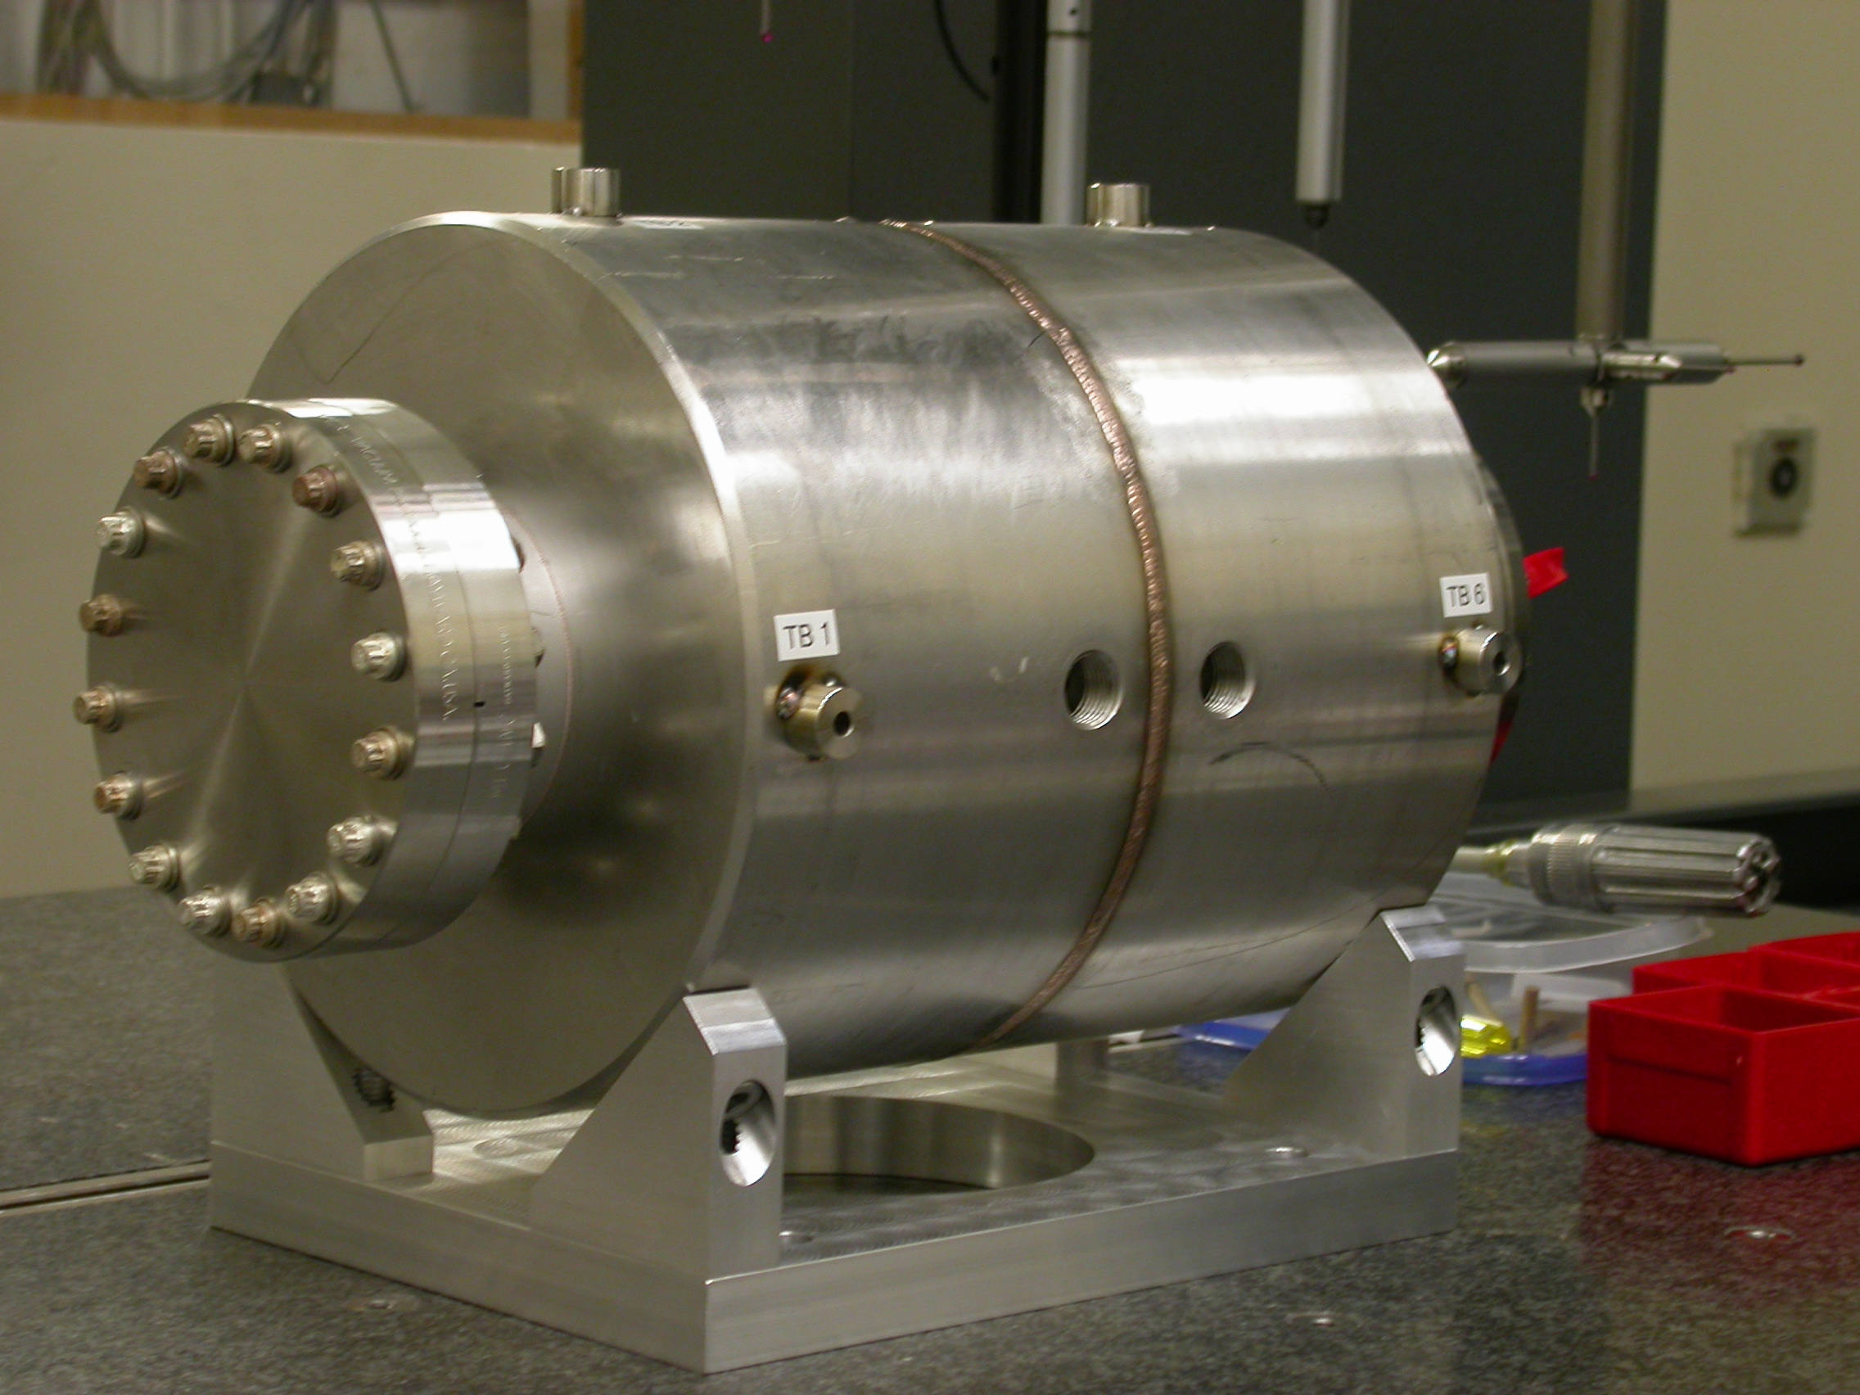

Inspector: | Keith Caban
Responsible Engineer: | Eric Bong
Date: | Tuesday, August 12, 2008
Work Order/Charge No.: | 23731-1/50
Serial Number: | 001
URL of Fiducial Report: | http://www-group.slac.stanford.edu/met/Quality/FIDUCIAL REPORTS/\LCLS WALL ONE COLLIMATOR\W1COL.pdf

Part Set-up – Coordinate System Set-up

Spatial Alignment

- Geometric axis created by 2 end inside profiles

Planar Alignment

- Plane on Granite Table that simulates support stand.

“Z” Zero

- Mid-plane of the body of the collimator

“X” & “Y” Zero

- Geometric axis of the 2 inside profiles.

+Y  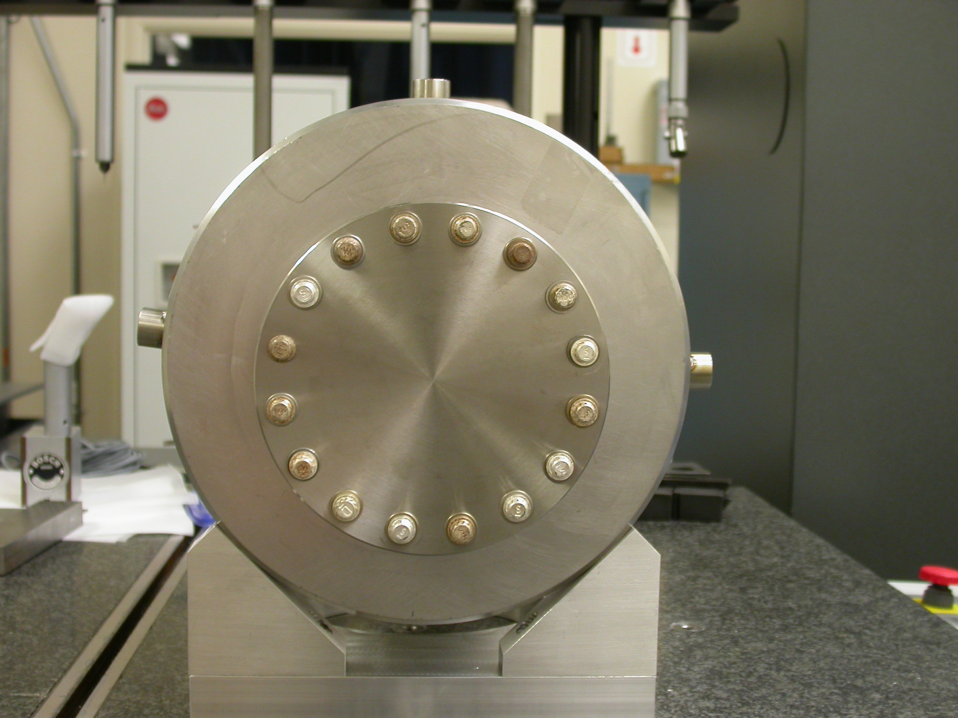  +X  Front View | 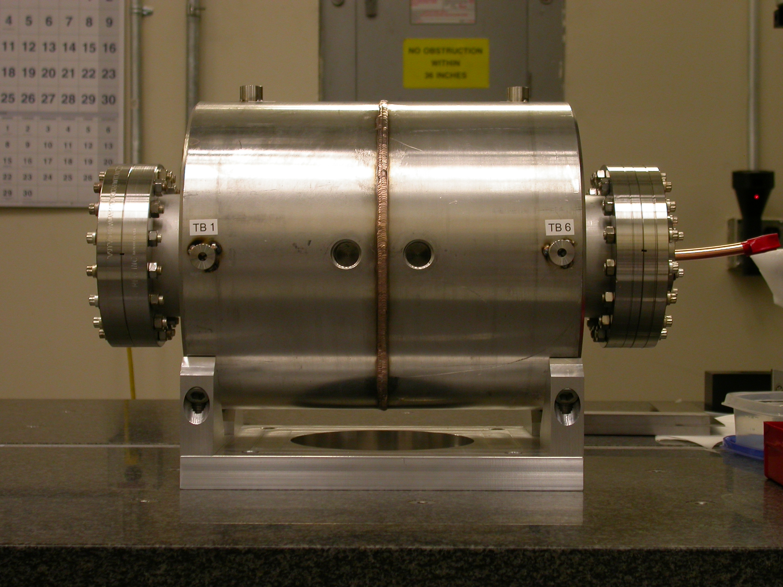  +Z  +Y  Side View

Tooling Ball Measurements/Locations

** Used 1” Tooling Ball Adapter (1/2” sphere)

Tooling Ball | FORM | Sph. Dia. | X | Y | Z
TB 1 | 0.00055 | 0.49710 | 6.49980 | -0.10727 | 5.21211
TB 2 | 0.00004 | 0.49877 | 0.01196 | 6.49321 | 4.29693
TB 3 | 0.00011 | 0.49899 | -6.45436 | 0.74418 | 5.39974
TB 4 | 0.00024 | 0.49660 | -6.46945 | 0.61970 | -5.12012
TB 5 | 0.00089 | 0.49585 | -0.30000 | 6.49655 | -4.38736
TB 6 | 0.00037 | 0.49633 | 6.50208 | 0.05363 | -5.21155

