
LCLS Undulator Quadrupole Magnet
FIDUCIALIZATION REPORT



Inspector: | Keith Caban
Responsible Engineer: | Scott Anderson
Date: | Friday, June 13, 2008
Work Order/Charge No.: | 88-1400-5
Serial Number: | SLAC – 000749 / STAMPED – 07
URL of Fiducial Report: | http://www-group.slac.stanford.edu/met/Quality/FIDUCIAL REPORTS/LCLS UNDULATOR QUADS/000749.pdf

Part Set-up – Coordinate System Set-up

Spatial Alignment

- Geometric axis of the poles of the magnet.

Planar Alignment

- Plane on where Aluminum Base Rests

“Z” Zero

- Mid-plane of the magnet (middle of upstream and downstream ends).

“X” & “Y” Zero

- Geometric axis of the poles of the magnet.

  +X  +Y  Front View |   +Z  +Y  Side View

Tooling Ball Measurements/Locations
Top View looking from +Y


TB 5
+Z
+X

Tooling Ball Adapter Cylinder Projected 1” Offset to the Tooling Ball Adapter Plane

Tooling Ball | FORM | Cyl. Dia. | X | Y | Z | b
TB 1 | 0.00011 | 0.25007 | 3.37219 | 6.81218 | 1.50212 | 0.00010
TB 2 | 0.00013 | 0.25004 | -3.37866 | 6.81411 | 1.49478 | 0.00042
TB 3 | 0.00013 | 0.25015 | -3.37324 | 6.81744 | -1.49972 | 0.00011
TB 4 | 0.00009 | 0.25009 | 3.37708 | 6.81298 | -1.49547 | 0.00009
TB 5 | 0.00009 | 0.25003 | 6.57935 | 0.13276 | 0.00155 | 0.00016



Z-distance of Quad = 3.58839

Pole Tip Additional Data
*Data looking from Downstream End


Side | Pole Dist A-C | Pole Dist B-D | Gap 1 | Gap 2 | Gap 3 | Gap 4
Downstream End (+Z) | 0.43473 | 0.43368 | 0.15972 | 0.16115 | 0.16130 | 0.15765
Upstream End  (-Z) | 0.43445 | 0.43211 | 0.15962 | 0.16038 | 0.16027 | 0.15908

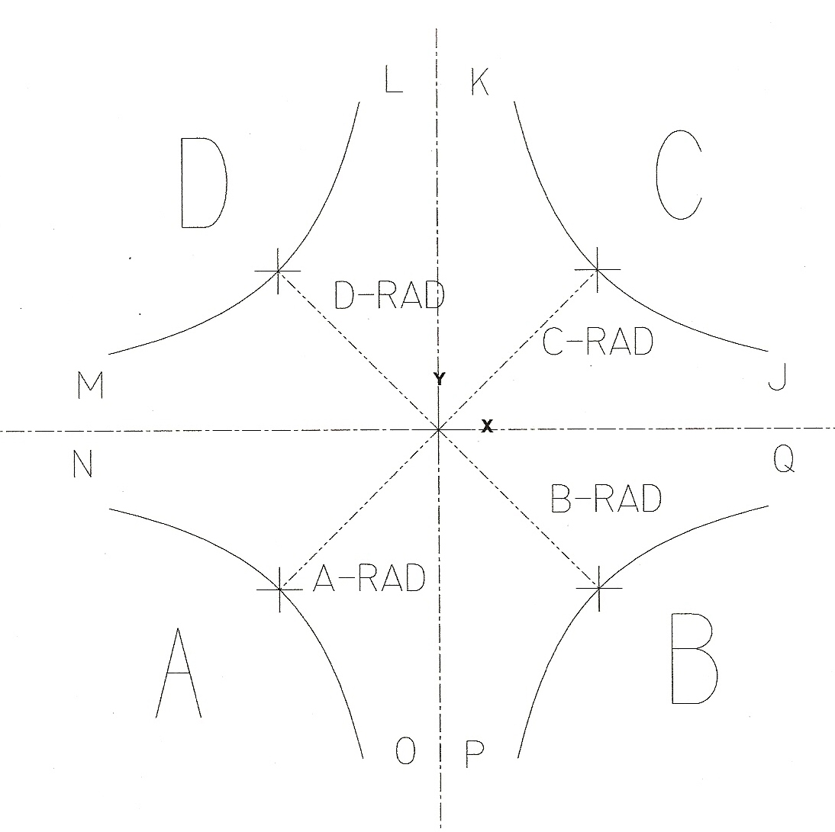

Side | A-Rad | B-Rad | C-Rad | D-Rad
+Z | 0.21685 | 0.21685 | 0.21789 | 0.21684
-Z | 0.21611 | 0.21608 | 0.21834 | 0.21604

Side | J | K | L | M | N | O | P | Q
+Z | 0.08062 | 0.07831 | 0.07934 | 0.08045 | 0.07927 | 0.08201 | 0.07914 | 0.08069
-Z | 0.08102 | 0.07906 | 0.08002 | 0.07966 | 0.07996 | 0.08099 | 0.07939 | 0.07925
Quadrupole Roll Angle
** Tolerance in milliradians is ± 5



Roll of the Base of Quad to Poles θ₁

θ₁ = 0.07858°

θ₁ = 1.37147 milliradians

