
LCLS Undulator Quadrupole Magnet
FIDUCIALIZATION REPORT



Inspector: | Keith Caban
Responsible Engineer: | Scott Anderson
Date: | Monday, June 16, 2008
Work Order/Charge No.: | 88-1400-5
Serial Number: | SLAC – 000744 / STAMPED – 14
URL of Fiducial Report: | http://www-group.slac.stanford.edu/met/Quality/FIDUCIAL REPORTS/LCLS UNDULATOR QUADS/000744.pdf

Part Set-up – Coordinate System Set-up

Spatial Alignment

- Geometric axis of the poles of the magnet.

Planar Alignment

- Plane on where Aluminum Base Rests

“Z” Zero

- Mid-plane of the magnet (middle of upstream and downstream ends).

“X” & “Y” Zero

- Geometric axis of the poles of the magnet.

  +X  +Y  Front View |   +Z  +Y  Side View

Tooling Ball Measurements/Locations
Top View looking from +Y


TB 5
+Z
+X

Tooling Ball Adapter Cylinder Projected 1” Offset to the Tooling Ball Adapter Plane

Tooling Ball | FORM | Cyl. Dia. | X | Y | Z | b
TB 1 | 0.00018 | 0.25007 | 3.37661 | 6.81346 | 1.49135 | 0.00010
TB 2 | 0.00014 | 0.25002 | -3.37456 | 6.81502 | 1.51409 | 0.00013
TB 3 | 0.00014 | 0.25003 | -3.38139 | 6.81463 | -1.48916 | 0.00007
TB 4 | 0.00019 | 0.25010 | 3.36810 | 6.81202 | -1.50859 | 0.00023
TB 5 | 0.00009 | 0.24999 | 6.57886 | 0.13666 | -0.00645 | 0.00021



Z-distance of Quad = 3.59438

Pole Tip Additional Data
*Data looking from Downstream End


Side | Pole Dist A-C | Pole Dist B-D | Gap 1 | Gap 2 | Gap 3 | Gap 4
Downstream End (+Z) | 0.43246 | 0.43274 | 0.15836 | 0.16066 | 0.15858 | 0.16070
Upstream End  (-Z) | 0.43278 | 0.43353 | 0.16085 | 0.15830 | 0.16042 | 0.15908

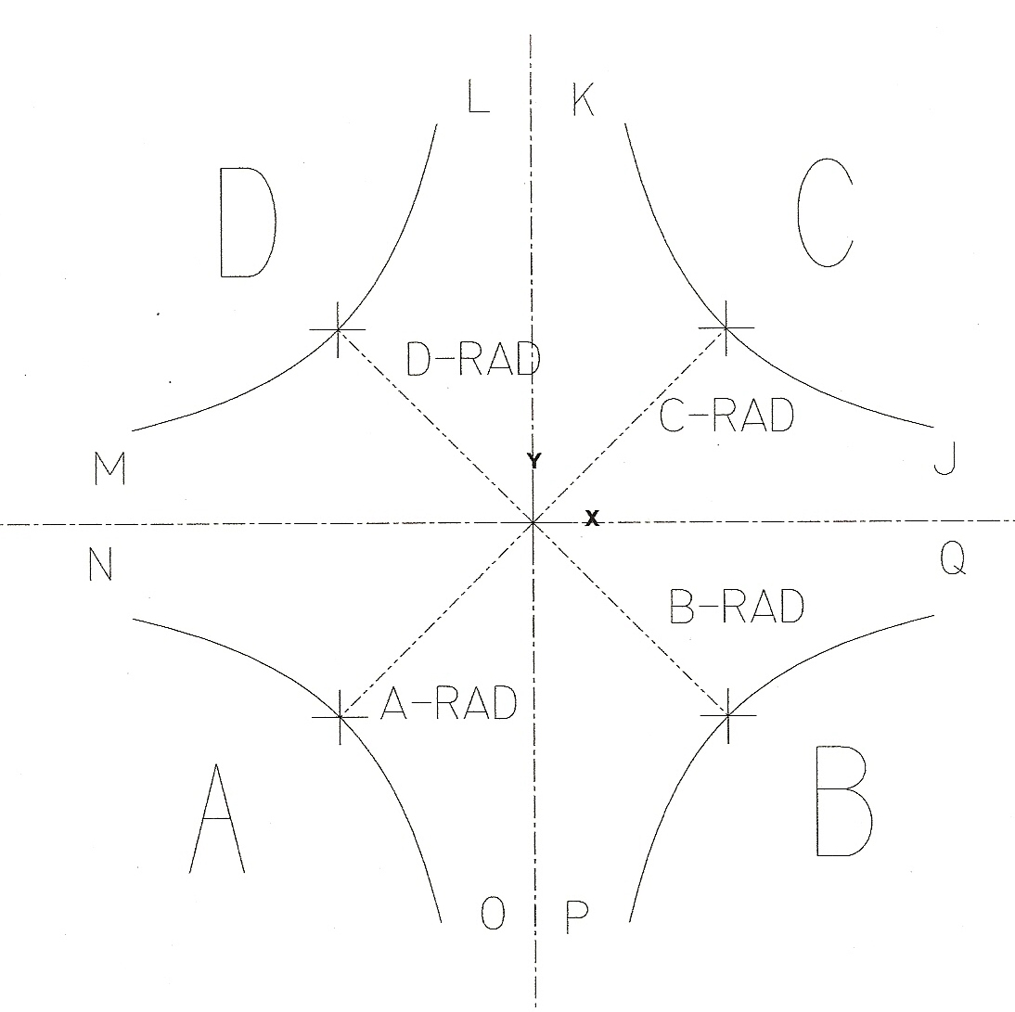

Side | A-Rad | B-Rad | C-Rad | D-Rad
+Z | 0.21620 | 0.21658 | 0.21627 | 0.21616
-Z | 0.21638 | 0.21722 | 0.21641 | 0.21632

Side | J | K | L | M | N | O | P | Q
+Z | 0.07925 | 0.07953 | 0.08117 | 0.07884 | 0.07952 | 0.08011 | 0.08055 | 0.07933
-Z | 0.07958 | 0.08044 | 0.08126 | 0.07977 | 0.08108 | 0.07952 | 0.07879 | 0.08084
Quadrupole Roll Angle
** Tolerance in milliradians is ± 5



Roll of the Base of Quad to Poles θ₁

θ₁ = −0.09030°

θ₁ = −1.57598 milliradians

