
LCLS Undulator Quadrupole Magnet
FIDUCIALIZATION REPORT



Inspector: | Keith Caban
Responsible Engineer: | Scott Anderson
Date: | Friday, June 13, 2008
Work Order/Charge No.: | 88-1400-5
Serial Number: | SLAC – 000748 / STAMPED – 11
URL of Fiducial Report: | http://www-group.slac.stanford.edu/met/Quality/FIDUCIAL REPORTS/LCLS UNDULATOR QUADS/000748.pdf

Part Set-up – Coordinate System Set-up

Spatial Alignment

- Geometric axis of the poles of the magnet.

Planar Alignment

- Plane on where Aluminum Base Rests

“Z” Zero

- Mid-plane of the magnet (middle of upstream and downstream ends).

“X” & “Y” Zero

- Geometric axis of the poles of the magnet.

  +X  +Y  Front View |   +Z  +Y  Side View

Tooling Ball Measurements/Locations
Top View looking from +Y


TB 5
+Z
+X

Tooling Ball Adapter Cylinder Projected 1” Offset to the Tooling Ball Adapter Plane

Tooling Ball | FORM | Cyl. Dia. | X | Y | Z | b
TB 1 | 0.00014 | 0.024994 | 3.36927 | 6.81186 | 1.49969 | 0.00015
TB 2 | 0.00011 | 0.25012 | -3.38235 | 6.81175 | 1.48489 | 0.00030
TB 3 | 0.00011 | 0.25014 | -3.37211 | 6.81254 | -1.51929 | 0.00008
TB 4 | 0.00022 | 0.25012 | 3.37697 | 6.81236 | -1.50367 | 0.00009
TB 5 | 0.00016 | 0.24997 | 6.57878 | 0.13251 | -0.00892 | 0.00014



Z-distance of Quad = 3.57452

Pole Tip Additional Data
*Data looking from Downstream End


Side | Pole Dist A-C | Pole Dist B-D | Gap 1 | Gap 2 | Gap 3 | Gap 4
Downstream End (+Z) | 0.43398 | 0.43079 | 0.15682 | 0.16048 | 0.15975 | 0.15999
Upstream End  (-Z) | 0.43096 | 0.43367 | 0.15850 | 0.15792 | 0.15914 | 0.16012

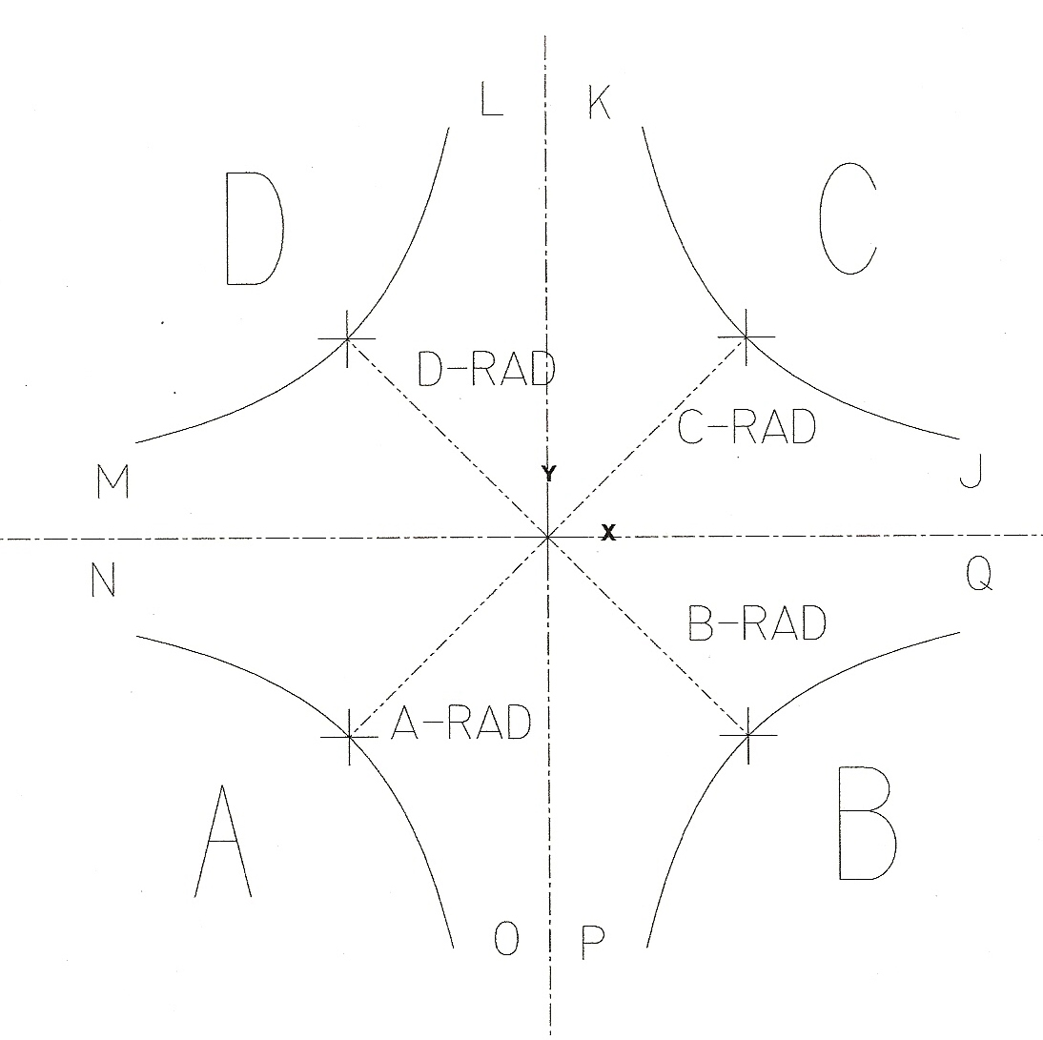

Side | A-Rad | B-Rad | C-Rad | D-Rad
+Z | 0.21815 | 0.21543 | 0.21583 | 0.21537
-Z | 0.21544 | 0.21808 | 0.21553 | 0.21560

Side | J | K | L | M | N | O | P | Q
+Z | 0.07953 | 0.08062 | 0.07937 | 0.07902 | 0.07781 | 0.08287 | 0.07761 | 0.08022
-Z | 0.07905 | 0.07842 | 0.08170 | 0.07794 | 0.08056 | 0.07727 | 0.08065 | 0.08009
Quadrupole Roll Angle
** Tolerance in milliradians is ± 5



Roll of the Base of Quad to Poles θ₁

θ₁ = −0.19106°

θ₁ = −3.33457 milliradians

