PEP II QDMP#3 Quadrupole Refurbishment
FIDUCIALIZATION REPORT

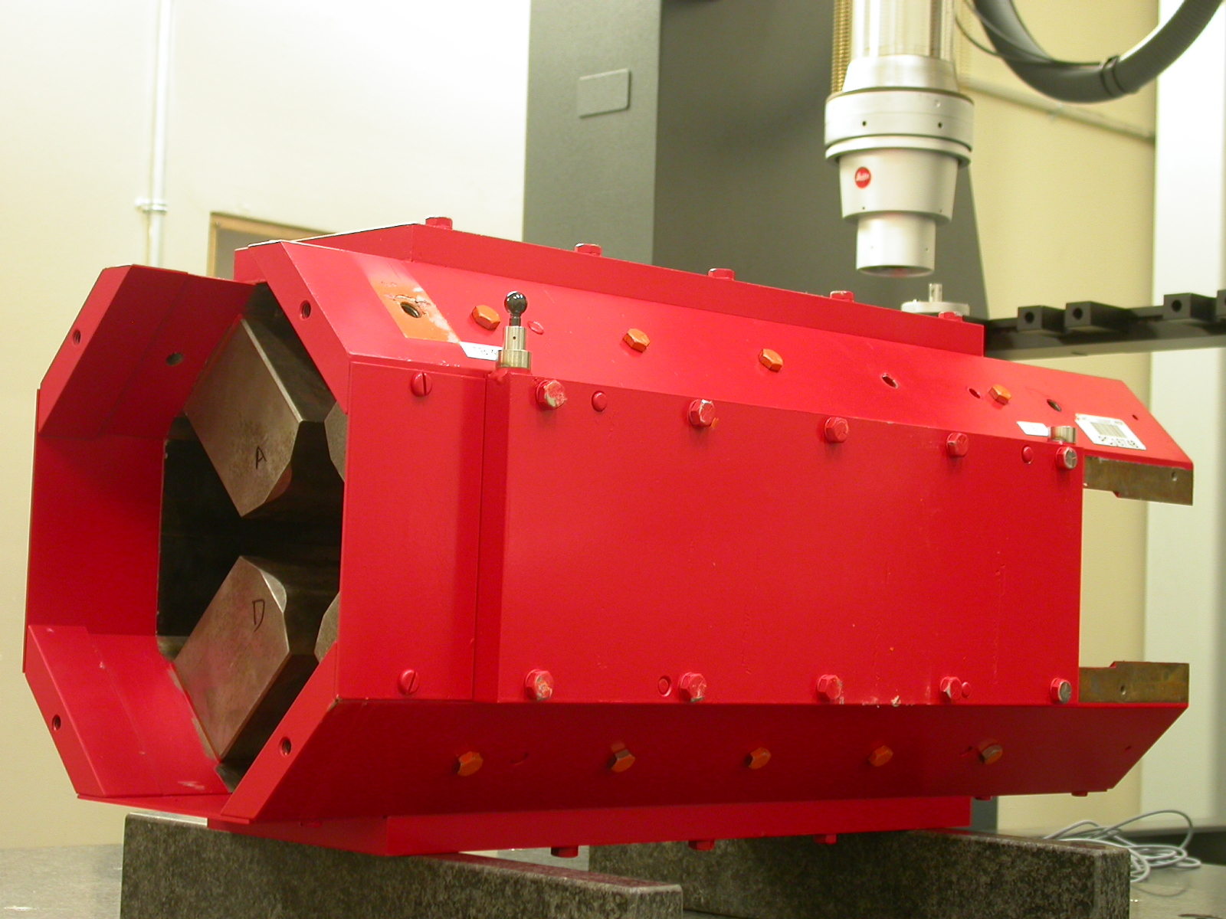

Inspector: | Keith Caban
Responsible Engineer: | Roger Carr
Date: | Thursday, August 03, 2006  Revised Tuesday, September 30, 2008
Work Order/Charge No.: | 92-4261-0
Serial Number | QDMP#3
LCLS BARCODE | 002415
URL | http://www-group\met\Quality\FIDUCIAL REPORTS\LCLS REFURBISH\QDMP3.pdf

Part Set-up – Coordinate System Set-up

Planar Alignment

- Mid-Plane of the Pole Faces.

Spatial Alignment

- A line on the top part of the magnet
  - +X goes opposite stamped SA-344-913-01

“Z” Zero

- Mid-Plane of the magnet

“X” & “Y” Zero

- On both ends
  - Tangent point of each radii (4 on each end, 8 total).
    - Create a line between diagonal tangent points creates 2 lines.
      - Intersect the lines.
        - Creates a point on each end.
- Create a line of these 2 end points
  - This is the “X” & “Y” Zero, and Beamline or” Z” Axis.

Y+
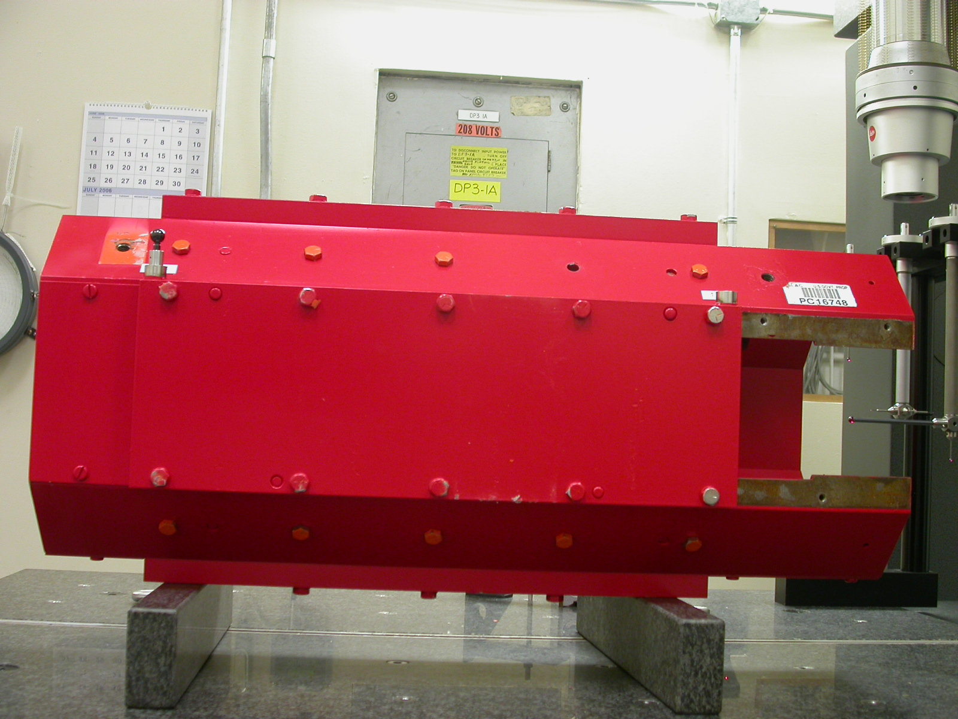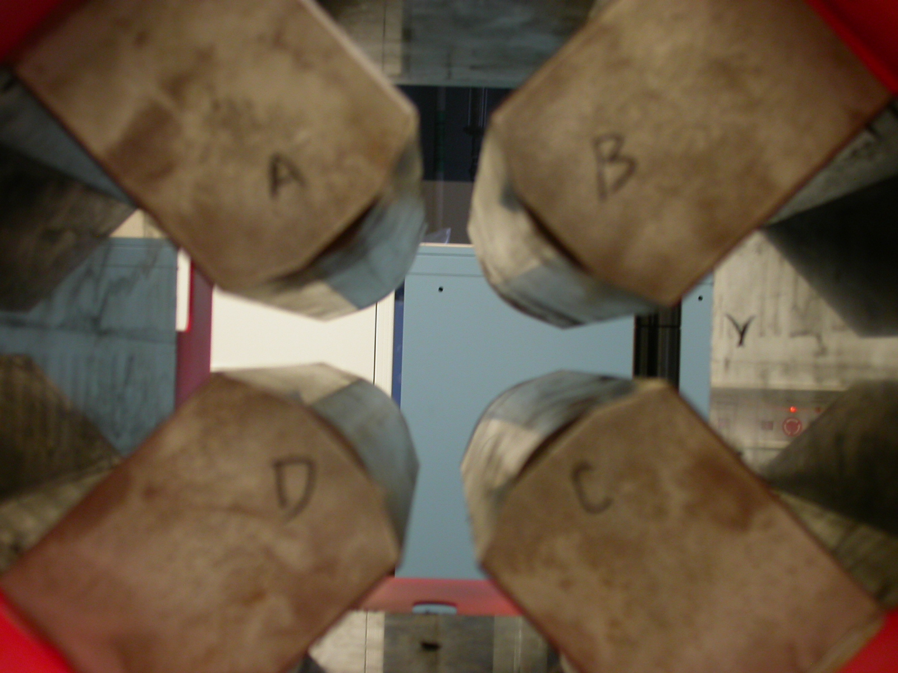
Z+
Y+
X+

Tooling Ball Measurements/Locations

Top of magnet; view from “+Y” (see photographs for more clarity above)

TB 2
TB 3

+Z
TB 6
TB 5

TB 4
TB 1

+X

Tooling Ball | Form | Diameter | X | Y | Z
TB 1 | 0.00082 | 0.49629 | 6.40353 | 4.87561 | -9.54392
TB 2 | 0.00072 | 0.49613 | -6.32486 | 4.88229 | -9.57312
TB 3 | 0.00055 | 0.49641 | -6.39686 | 4.89378 | 9.55756
TB 4 | 0.00080 | 0.49759 | 6.36654 | 4.87008 | 9.56918
TB 5 | 0.00061 | 0.49692 | 0.04368 | 8.31086 | 9.54508
TB 6 | 0.00047 | 0.49756 | 0.00749 | 8.31190 | -9.52832

62

View From +Z
Additional Requested Measurements

A
B
C
D

Pole Tip Dist A-C Z+= 3.25114

Pole Tip Dist A-C Z-= 3.25320

Pole Tip Dist B-D Z+= 3.25331

Pole Tip Dist B-D Z-= 3.25100

Z+ Side Δ = 0.0021

Z- Side Δ = 0.0023

Along A-C Δ = 0.0022 small to big from positive to negative “Z”
Along B-D Δ = 0.0022 small to big from negative to positive “Z”
(rises in opposite directions).

