
LCLS Injector Quadrupole Magnet
FIDUCIALIZATION REPORT

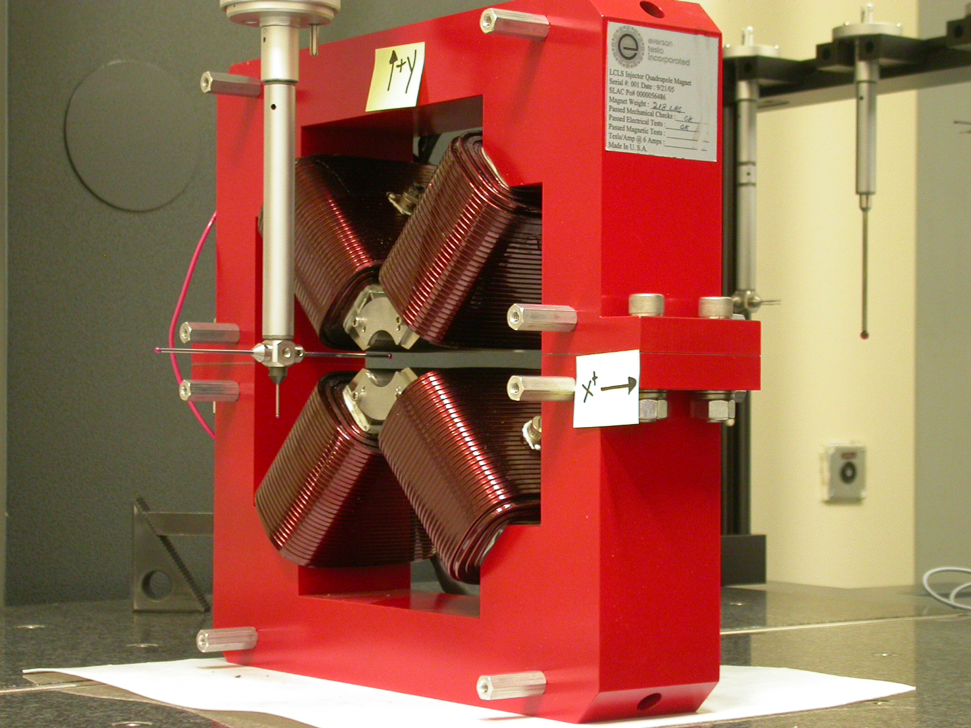

Inspector: | Keith Caban
Responsible Engineer: | T. Borden
Date: | Thursday, January 11, 2007
Work Order/Charge No.: | 92-4215-8
Serial Number: | 002404
URL of Fiducial Report: | \\Web002\www-group\met\Quality\FIDUCIAL REPORTS\LCLS QUADS\LCLS QUAD 002404.pdf

Part Set-up – Coordinate System Set-up

Planar Alignment

- Mid-Plane of the magnet

Spatial Alignment

- A line on the top part of the magnet
  - +X goes towards (Magnet Info Label)

“Z” Zero

- Mid-Plane of the magnet

“X” & “Y” Zero

- On both ends
  - Tangent point of each radii (4 on each end, 8 total).
    - Create a line between diagonal tangent points creates 2 lines.
      - Intersect the lines.
        - Creates a point on each end.
- Create a line of these 2 end points
  - This is the “X” & “Y” Zero, and Beamline or” Z” Axis.

Z+

Tooling Ball Measurements/Locations

Top of magnet; view from “+Y”

TB 1
TB 2
TB 3
TB 4

+X
+Z

Tooling Ball | FORM | DIAMETER | X | Y | Z
TB 1 | 0.00114 | 0.49618 | 6.49823 | 8.87835 | -1.24699
TB 2 | 0.00088 | 0.49584 | -6.50008 | 8.87831 | -1.24507
TB 3 | 0.00131 | 0.49669 | -6.50048 | 8.87835 | 1.25483
TB 4 | 0.00029 | 0.49942 | 6.49904 | 8.87701 | 1.25125

Additional Requested Measurements

A
B
C
D

Pole | Straightness | Parallelism
A | 0.00042 | 0.00040
B | 0.00021 | 0.00064
C | 0.00040 | 0.00033
D | 0.00024 | 0.00022

Pole Dist | Z+ Side | Z- Side
A-C | 1.25986 | 1.25919
B-D | 1.25919 | 1.25970

