
LCLS Injector Quadrupole Magnet
FIDUCIALIZATION REPORT

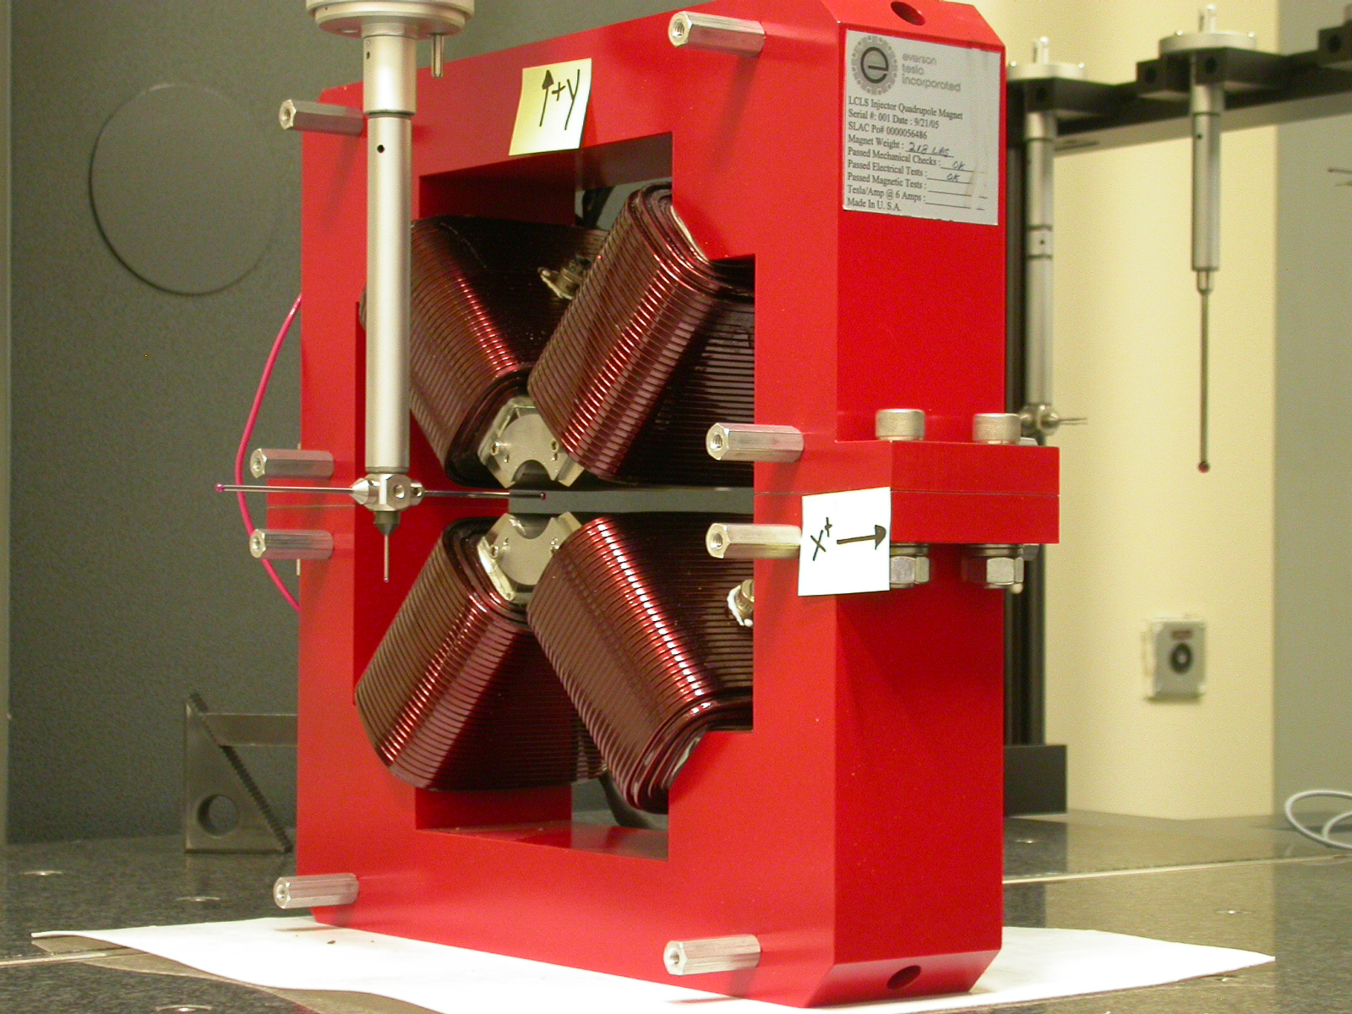

Inspector: | Keith Caban
Responsible Engineer: | Roger Carr
Date: | Tuesday, July 11, 2006
Work Order/Charge No.: | 92-4215-8
Serial Number | 000428

Part Set-up – Coordinate System Set-up

Planar Alignment

- Mid-Plane of the magnet

Spatial Alignment

- A line on the top part of the magnet
  - +X goes towards (Magnet Info Label)

“Z” Zero

- Mid-Plane of the magnet

“X” & “Y” Zero

- On both ends
  - Tangent point of each radii (4 on each end, 8 total).
    - Create a line between diagonal tangent points creates 2 lines.
      - Intersect the lines.
        - Creates a point on each end.
- Create a line of these 2 end points
  - This is the “X” & “Y” Zero, and Beamline or” Z” Axis.

Z+

Tooling Ball Measurements/Locations

Top of magnet; view from “+Y”

TB 1
TB 2
TB 3
TB 4

+X
+Z

Tooling Ball | FORM | DIAMETER | X | Y | Z
TB 1 | 0.00156 | 0.49182 | 6.50166 | 8.88043 | -1.24926
TB 2 | 0.00074 | 0.49528 | -6.49888 | 8.87853 | -1.24818
TB 3 | 0.00049 | 0.49705 | -6.49947 | 8.87789 | 1.25166
TB 4 | 0.00070 | 0.49624 | 6.49945 | 8.87898 | 1.25094

View From +Z
Additional Requested Measurements

A
B
C
D

Tangent Point Straightness
- 0.00023
- 0.00014
- 0.00042
- 0.00019

Parallelism to Beamline
- 0.00032
- 0.00024
- 0.00034
- 0.00026

Distance of opposite Tangent
Axis

A-C = 1.26017 (0.63011, 0.63006)
B-D = 1.25899 (0.62950, 0.62949)

