
LCLS Injector Quadrupole Magnet
FIDUCIALIZATION REPORT

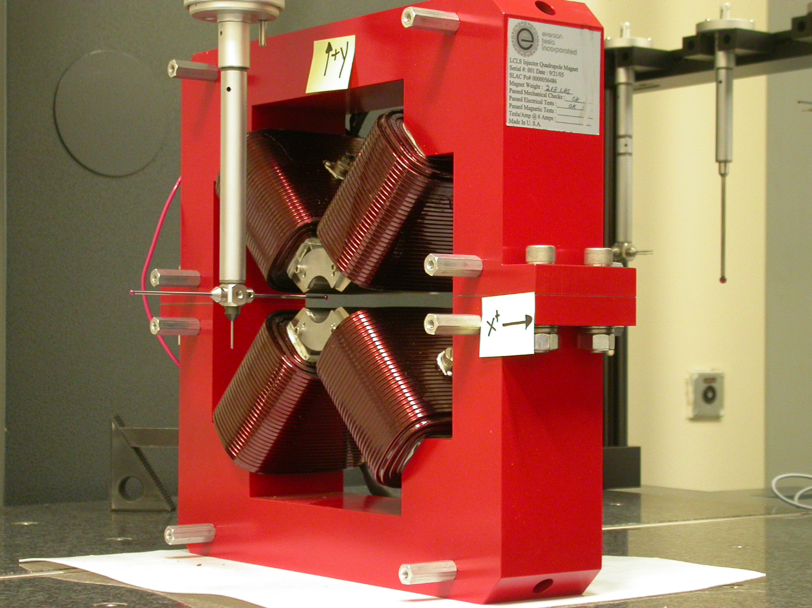

Inspector: | Keith Caban
Responsible Engineer: | Roger Carr
Date: | Friday, June 02, 2006
Work Order/Charge No.: | 92-4215-8
Serial Number | 000388

Part Set-up – Coordinate System Set-up

Planar Alignment

- Mid-Plane of the magnet

Spatial Alignment

- A line on the top part of the magnet
  - +X goes towards (Magnet Info Label)

“Z” Zero

- Mid-Plane of the magnet

“X” & “Y” Zero

- On both ends
  - Tangent point of each radii (4 on each end, 8 total).
    - Create a line between diagonal tangent points creates 2 lines.
      - Intersect the lines.
        - Creates a point on each end.
- Create a line of these 2 end points
  - This is the “X” & “Y” Zero, and Beamline or” Z” Axis.

Z+

Tooling Ball Measurements/Locations

Top of magnet; view from “+Y”

TB 1
TB 2
TB 3
TB 4

+X
+Z

Tooling Ball | FORM | DIAMETER | X | Y | Z
TB 1 | 0.00052 | 0.49772 | 6.50031 | 8.87874 | -1.25084
TB 2 | 0.00042 | 0.49832 | -6.49879 | 8.87880 | -1.25050
TB 3 | 0.00007 | 0.49995 | -6.49831 | 8.87873 | 1.25050
TB 4 | 0.00019 | 0.49857 | 6.49902 | 8.87904 | 1.24955

View From +Z
Additional Requested Measurements

A
B
C
D

Tangent Point Straightness
- 0.00025
- 0.00013
- 0.00024
- 0.00024

Parallelism to Beamline
- 0.00018
- 0.00041
- 0.00026
- 0.00022

Distance of opposite Tangent
Axis

A-C = 1.25844 (0.62921, 0.62923)
B-D = 1.25917 (0.62971, 0.62945)

