
LCLS Injector Quadrupole Magnet
FIDUCIALIZATION REPORT

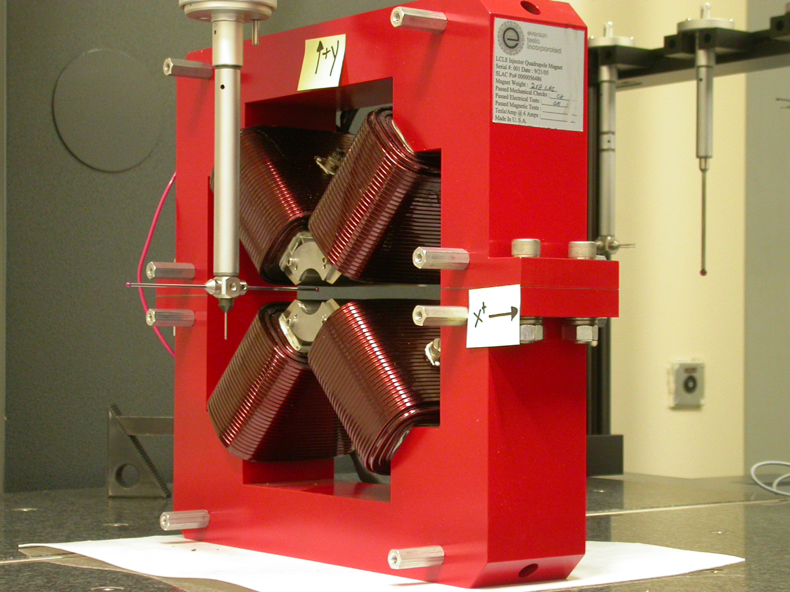

Inspector: | Keith Caban
Responsible Engineer: | Roger Carr
Date: | Monday, May 10, 2006
Work Order/Charge No.: | 92-4215-8
Serial Number | 000384

Part Set-up – Coordinate System Set-up

Planar Alignment

- Mid-Plane of the magnet

Spatial Alignment

- A line on the top part of the magnet
  - +X goes towards (Magnet Info Label)

“Z” Zero

- Mid-Plane of the magnet

“X” & “Y” Zero

- On both ends
  - Tangent point of each radii (4 on each end, 8 total).
    - Create a line between diagonal tangent points creates 2 lines.
      - Intersect the lines.
        - Creates a point on each end.
- Create a line of these 2 end points
  - This is the “X” & “Y” Zero, and Beamline or” Z” Axis.

Z+

Tooling Ball Measurements/Locations

Top of magnet; view from “+Y”

TB 1
TB 2
TB 3
TB 4

+X
+Z

Tooling Ball | FORM | DIAMETER | X | Y | Z
TB 1 | 0.00014 | 0.49937 | 6.49932 | 8.87570 | -1.24998
TB 2 | 0.00011 | 0.49963 | -6.49953 | 8.87525 | -1.25097
TB 3 | 0.00015 | 0.49872 | -6.49993 | 8.87595 | 1.24961
TB 4 | 0.00036 | 0.49933 | 6.50055 | 8.87670 | 1.24848

View From +Z
Additional Requested Measurements

A
B
C
D

Tangent Point Straightness
- 0.00039
- 0.00023
- 0.00043
- 0.00028

Parallelism to Beamline
- 0.00023
- 0.00028
- 0.00036
- 0.00028

Distance of opposite Tangent
Axis

A-C = 1.25963 (0.62977, 0.62986)
B-D = 1.25927 (0.62961, 0.62966)

