
LCLS Injector Quadrupole Magnet
FIDUCIALIZATION REPORT

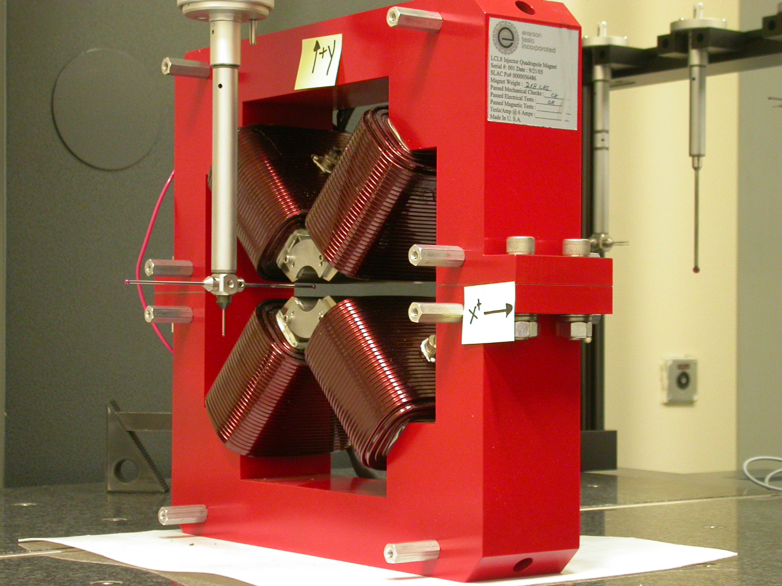

Inspector: | Keith Caban
Responsible Engineer: | Roger Carr
Date: | Thursday, August 17, 2006
Work Order/Charge No.: | 92-4215-8
Serial Number | 000383

Part Set-up – Coordinate System Set-up

Planar Alignment

- Mid-Plane of the magnet

Spatial Alignment

- A line on the top part of the magnet
  - +X goes towards (Magnet Info Label)

“Z” Zero

- Mid-Plane of the magnet

“X” & “Y” Zero

- On both ends
  - Tangent point of each radii (4 on each end, 8 total).
    - Create a line between diagonal tangent points creates 2 lines.
      - Intersect the lines.
        - Creates a point on each end.
- Create a line of these 2 end points
  - This is the “X” & “Y” Zero, and Beamline or” Z” Axis.

Z+

Tooling Ball Measurements/Locations

Top of magnet; view from “+Y”

TB 1
TB 2
TB 3
TB 4

+X
+Z

Tooling Ball | FORM | DIAMETER | X | Y | Z
TB 1 | 0.00096 | 0.49535 | 6.50065 | 8.87767 | -1.25051
TB 2 | 0.00049 | 0.49793 | -6.49896 | 8.87678 | -1.24943
TB 3 | 0.00032 | 0.49870 | -6.49858 | 8.88167 | 1.25141
TB 4 | 0.00062 | 0.49804 | 6.50165 | 8.87745 | 1.24871

View From +Z
Additional Requested Measurements

A
B
C
D

Tangent Point Straightness
- 0.00038
- 0.00027
- 0.00053
- 0.00037

Parallelism to Beamline
- 0.00045
- 0.00066
- 0.00057
- 0.00046

Distance of opposite Tangent
Axis

A-C = 1.26003 (0.62994, 0.63009)
B-D = 1.25919 (0.62954, 0.62964)

