
LCLS Injector Quadrupole Magnet
FIDUCIALIZATION REPORT

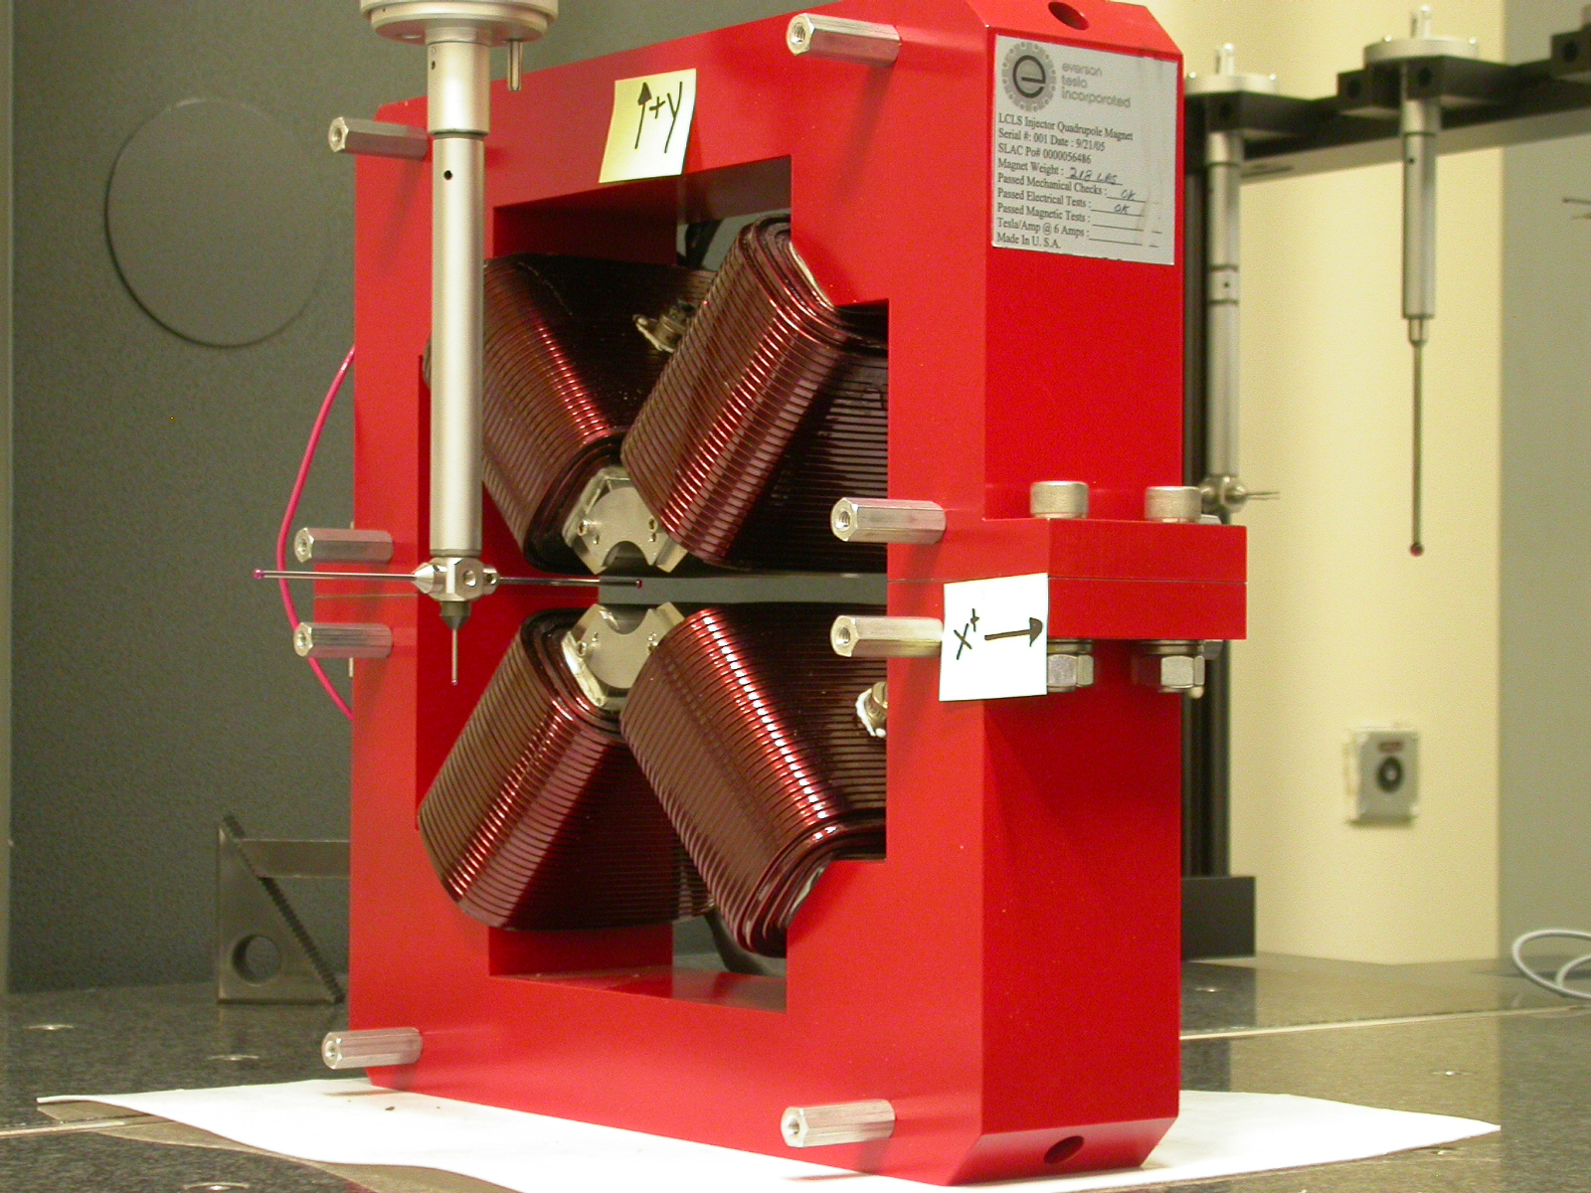

Inspector: | Keith Caban
Responsible Engineer: | Roger Carr
Date: | Friday, April 28, 2006
Work Order/Charge No.: | N/A
Serial Number | 000381

Part Set-up – Coordinate System Set-up

Planar Alignment

- Mid-Plane of the magnet

Spatial Alignment

- A line on the top part of the magnet
  - +X goes towards (Magnet Info Label)

“Z” Zero

- Mid-Plane of the magnet

“X” & “Y” Zero

- On both ends
  - Tangent point of each radii (4 on each end, 8 total).
    - Create a line between diagonal tangent points creates 2 lines.
      - Intersect the lines.
        - Creates a point on each end.
- Create a line of these 2 end points
  - This is the “X” & “Y” Zero, and Beamline or” Z” Axis.

Z+

Tooling Ball Measurements/Locations

Top of magnet; view from “+Y”

TB 1
TB 2
TB 3
TB 4

+X
+Z

Tooling Ball | FORM | DIAMETER | X | Y | Z
TB 1 | 0.00087 | 0.49507 | 6.49838 | 9.37867 | -1.25062
TB 2 | 0.00052 | 0.49718 | -6.49606 | 9.37673 | -1.25002
TB 3 | 0.00063 | 0.49606 | -6.49845 | 9.37954 | 1.24732
TB 4 | 0.00065 | 0.49661 | 6.5000 | 9.37660 | 1.24801

View From +Z
Additional Requested Measurements

A
B
C
D

Tangent Point Straightness
- 0.00021
- 0.00026
- 0.00020
- 0.00024

Parallelism to Beamline
- 0.00030
- 0.00017
- 0.00022
- 0.00046

Distance of opposite Tangent
Axis

A-C = 1.25874 (0.62936, 0.62995)
B-D = 1.25986 (0.62991, 0.62938)

