
LCLS Injector Quadrupole Magnet
FIDUCIALIZATION REPORT

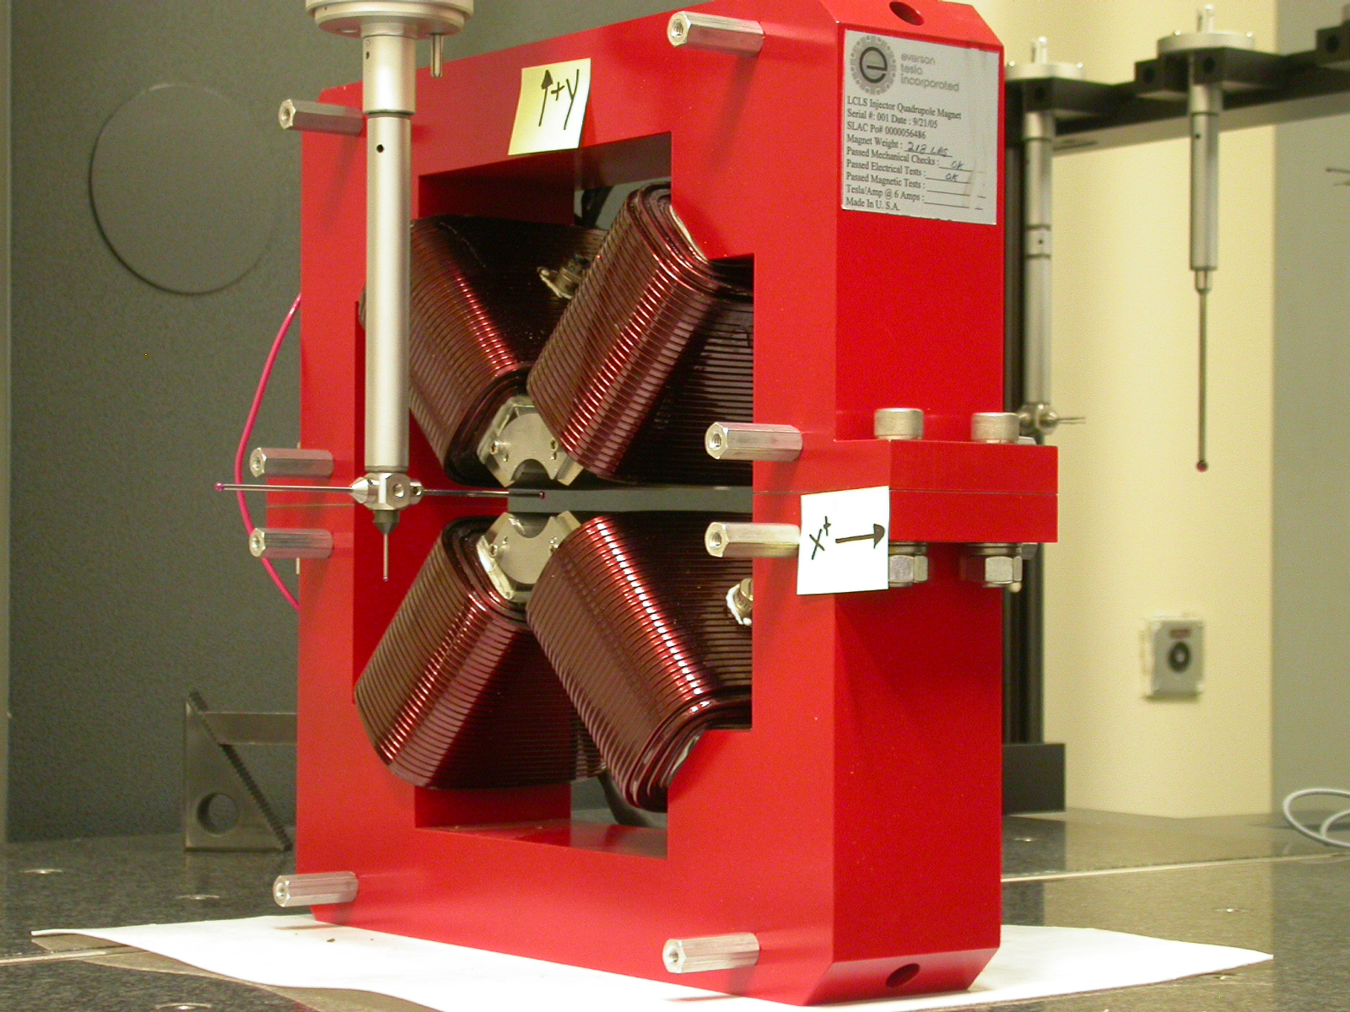

Inspector: | Keith Caban
Responsible Engineer: | Roger Carr
Date: | Wednesday, May 31, 2006
Work Order/Charge No.: | 92-4215-8
Serial Number | 000380

Part Set-up – Coordinate System Set-up

Planar Alignment

- Mid-Plane of the magnet

Spatial Alignment

- A line on the top part of the magnet
  - +X goes towards (Magnet Info Label)

“Z” Zero

- Mid-Plane of the magnet

“X” & “Y” Zero

- On both ends
  - Tangent point of each radii (4 on each end, 8 total).
    - Create a line between diagonal tangent points creates 2 lines.
      - Intersect the lines.
        - Creates a point on each end.
- Create a line of these 2 end points
  - This is the “X” & “Y” Zero, and Beamline or” Z” Axis.

Z+

Tooling Ball Measurements/Locations

Top of magnet; view from “+Y”

TB 1
TB 2
TB 3
TB 4

+X
+Z

Tooling Ball | FORM | DIAMETER | X | Y | Z
TB 1 | 0.00005 | 0.49965 | 6.50195 | 8.87652 | -1.25002
TB 2 | 0.00031 | 0.49855 | -6.49892 | 8.87650 | -1.24980
TB 3 | 0.00021 | 0.49874 | -6.49823 | 8.87659 | 1.24932
TB 4 | 0.00020 | 0.49842 | 6.50062 | 8.87735 | 1.25021

View From +Z
Additional Requested Measurements

A
B
C
D

Tangent Point Straightness
- 0.00024
- 0.00023
- 0.00032
- 0.00027

Parallelism to Beamline
- 0.00020
- 0.00048
- 0.00066
- 0.00058

Distance of opposite Tangent
Axis

A-C = 1.26014 (0.63004, 0.63010)
B-D = 1.25932 (0.62969, 0.62963)

