
LCLS Gun Spectrometer Quad Dipole Corrector Magnet
FIDUCIALIZATION REPORT

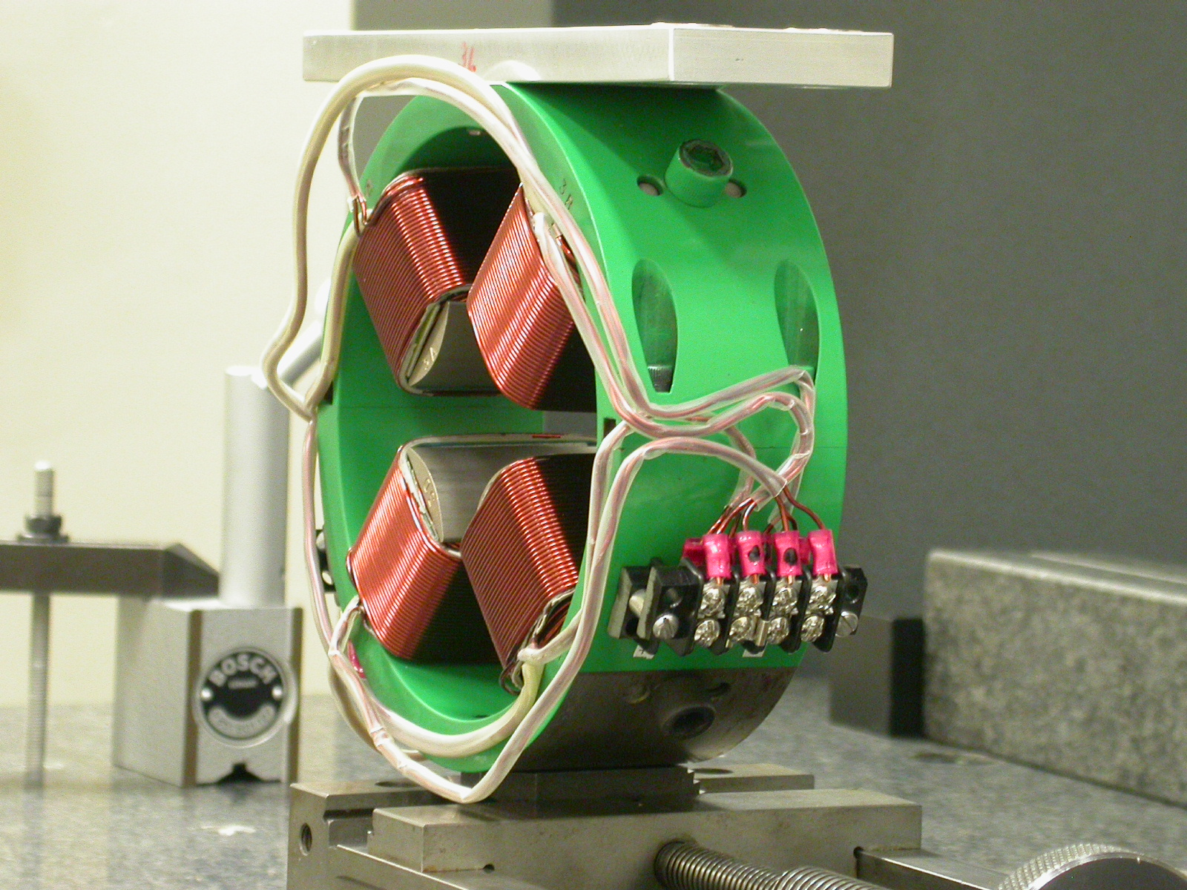

Inspector: | Keith Caban
Responsible Engineer: | Roger Carr
Date: | Monday, May 15, 2006
Work Order/Charge No.: | 20966-1 Task – 30
Serial Number | 1

Part Set-up – Coordinate System Set-up

Planar Alignment

- Mid-Plane of the magnet

Spatial Alignment

- A line on the top part of the magnet
  - +X is from TB 1 & 2 side to TB 3 & 4 Side

“Z” Zero

- Mid-Plane of the magnet

“X” & “Y” Zero

- On both ends
  - Tangent point of each radii (4 on each end, 8 total).
    - Create a line between diagonal tangent points creates 2 lines.
      - Intersect the lines.
        - Creates a point on each end.
- Create a line of these 2 end points
  - This is the “X” & “Y” Zero, and Beamline or” Z” Axis.
Z+

+Y  -Z  ISO | 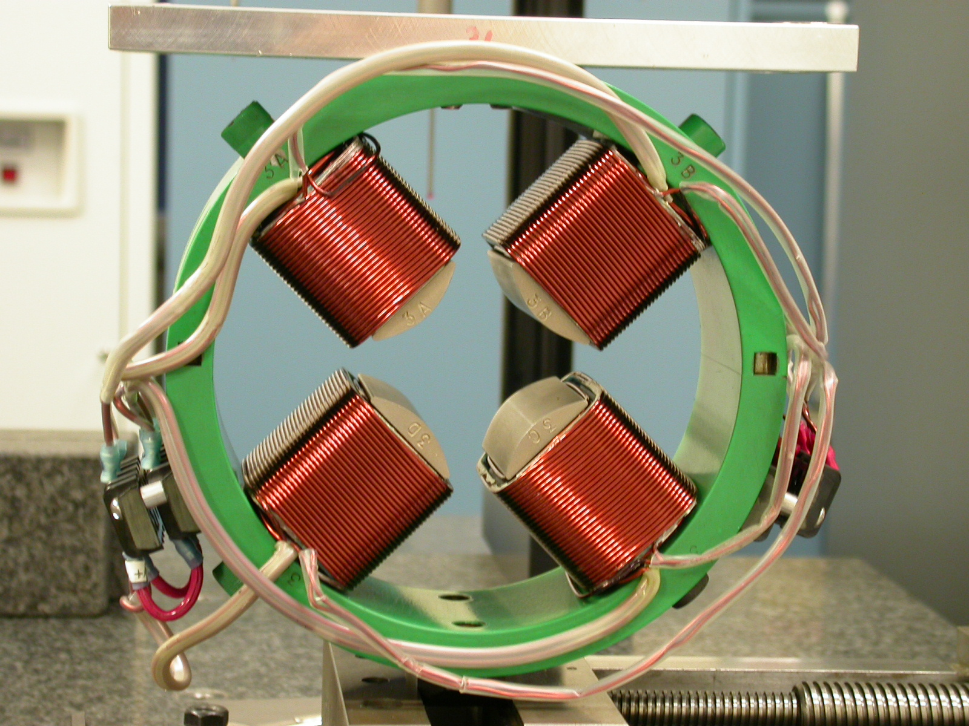  +Y  +X  BACK VIEW

Tooling Ball Measurements/Locations

Top of magnet; view from “+Y”

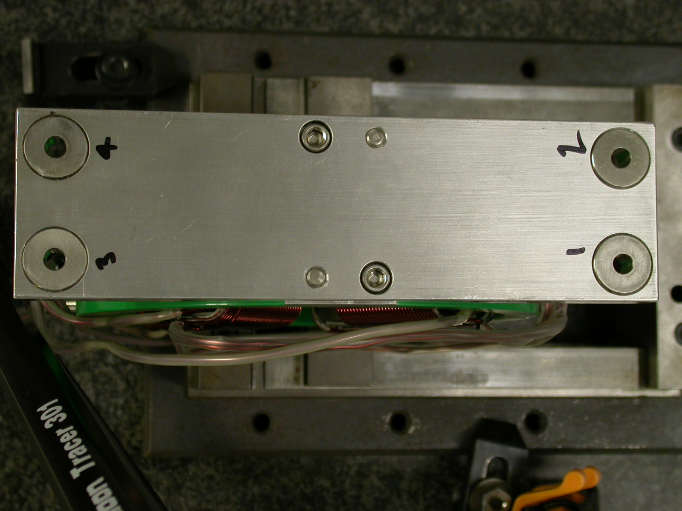
+X
+Z

+X
+Z

Tooling Ball | FORM | DIAMETER | X | Y | Z
TB 1 | 0.00065 | 0.49657 | -3.51001 | 4.82224 | -0.68423
TB 2 | 0.00090 | 0.49673 | -3.51151 | 4.82349 | 0.66619
TB 3 | 0.00073 | 0.49698 | 3.54427 | 4.82099 | -0.68228
TB 4 | 0.00097 | 0.49708 | 3.54301 | 4.82216 | 0.66856

View From +Z
Additional Requested Measurements


Distance from Tangent point of 4X poletips
A
B
C
D

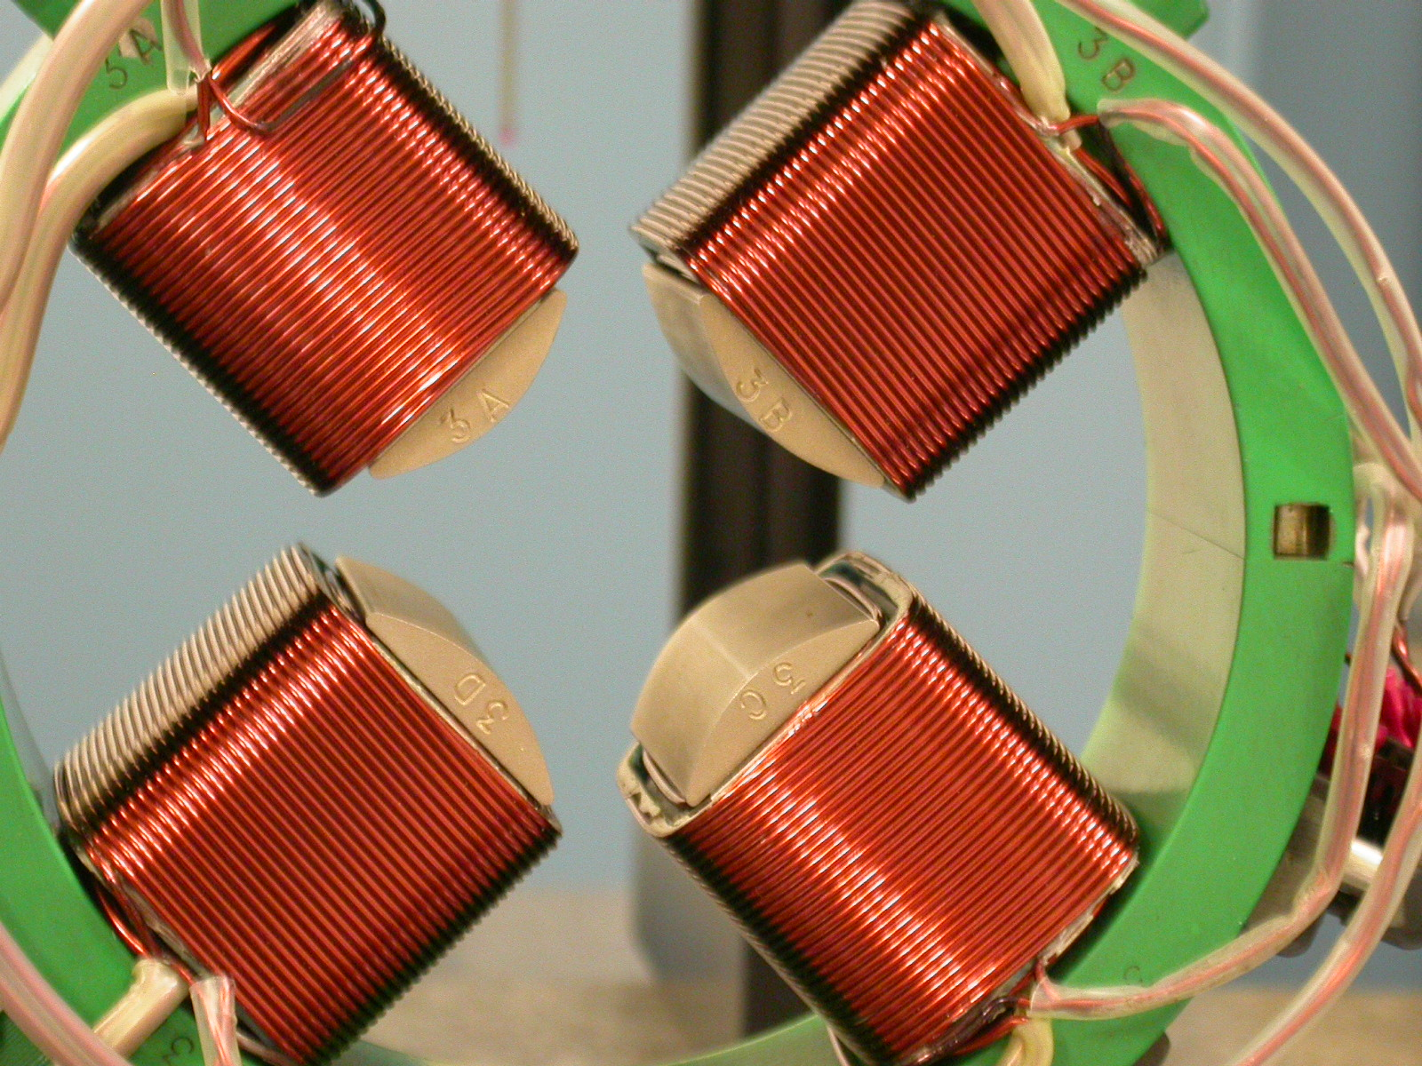

A-C = 1.66521
B-D = 1.66543

Parallelism of 4X pole tips to the beamline

- 0.00037
- 0.00033
- 0.00044
- 0.00052

