
LCLS ‘QE’ QUADRUPOLE MAGNET
FIDUCIALIZATION REPORT

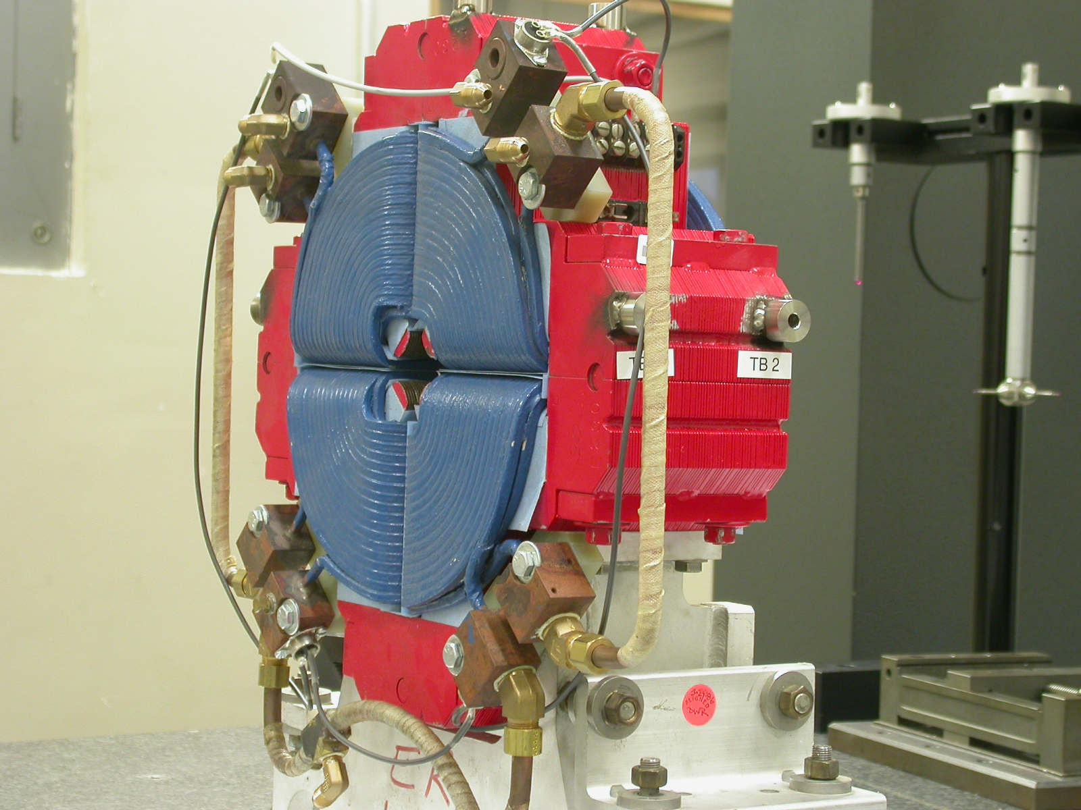

Inspector: | Keith Caban
Responsible Engineer: | Carl Rago
Date: | Friday, October 26, 2007
Work Order/Charge No.: | 23188-49
Serial Number: | 002798
URL of Fiducial Report: | \\Web002\www-group\met\Quality\FIDUCIAL REPORTS\LCLS QE QUAD'S\002798.pdf

Part Set-up – Coordinate System Set-up

Spatial Alignment

- Geometric axis of the poles of the magnet.

Planar Alignment

- A 4 point plane on the top of where 2 arrows indicate in the picture below.
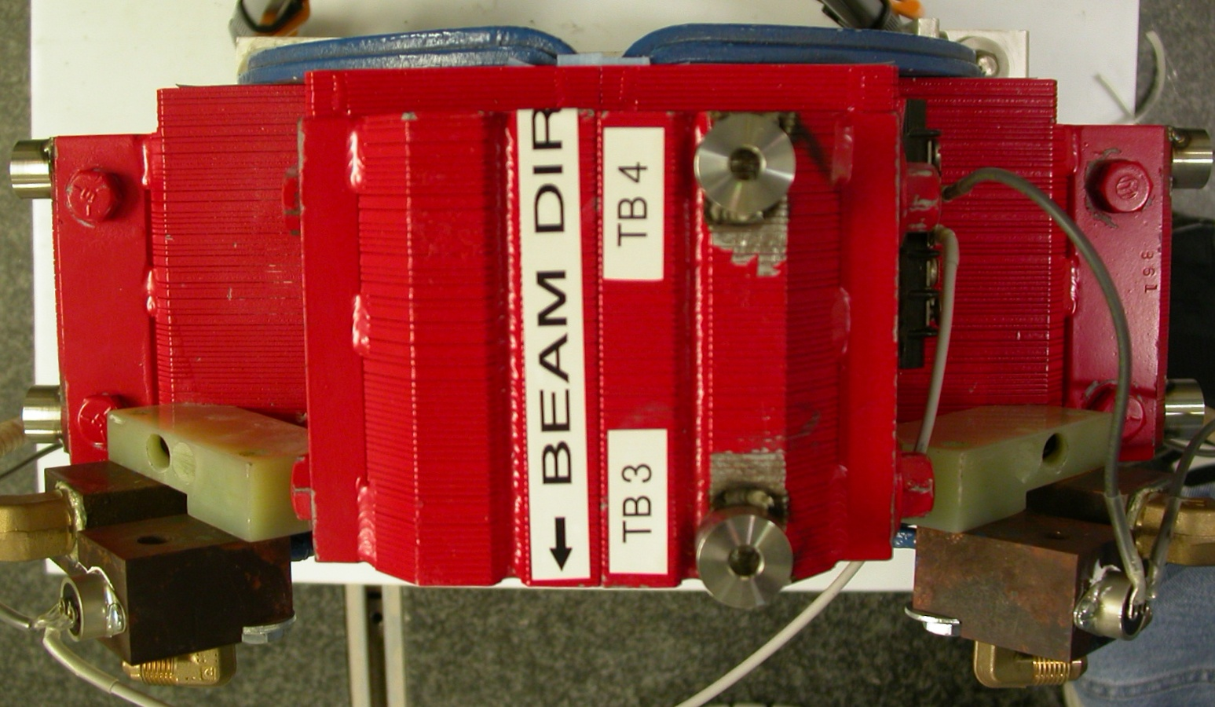

“Z” Zero

- Mid-Plane of the magnet

“X” & “Y” Zero

- Geometric Axis of the Poles of the magnet.
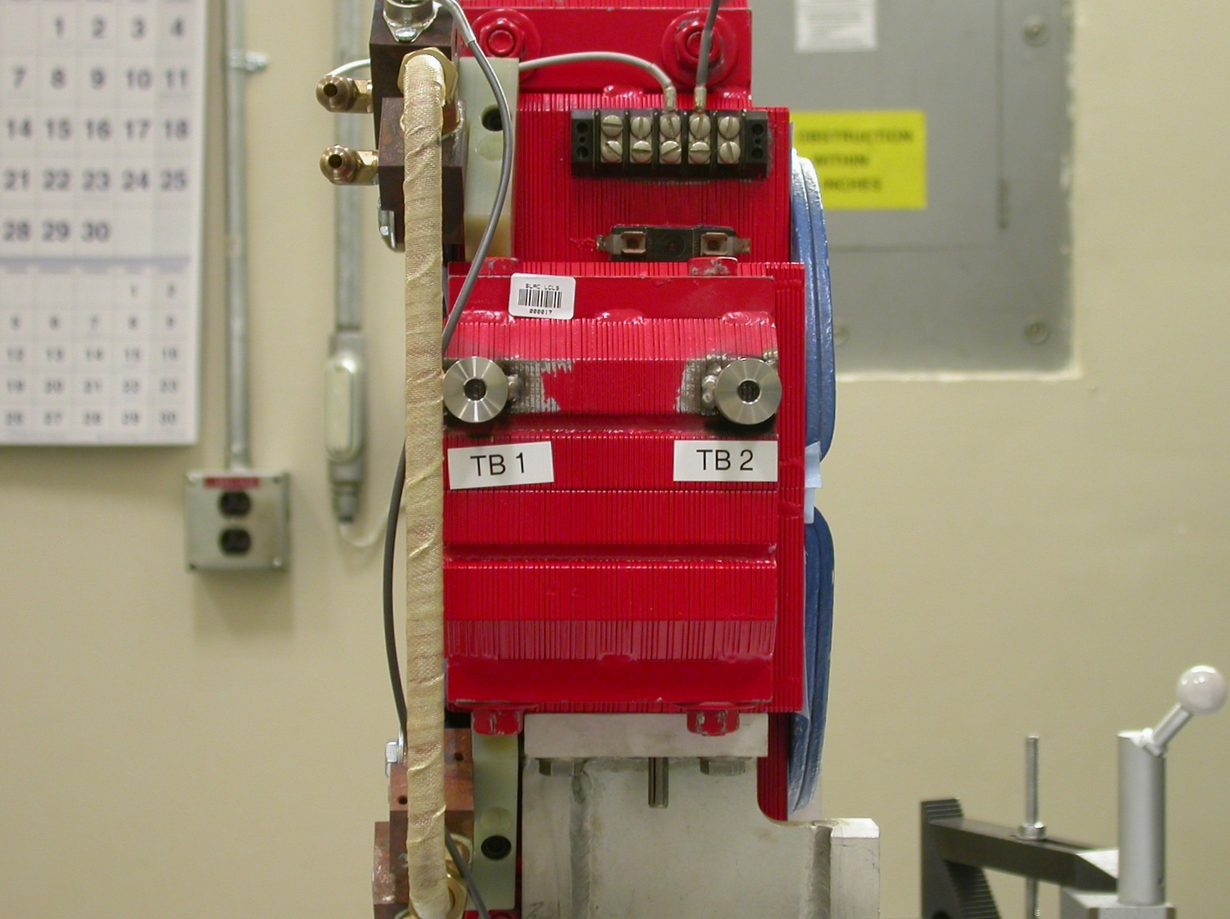  +Y  +Z  Side View | 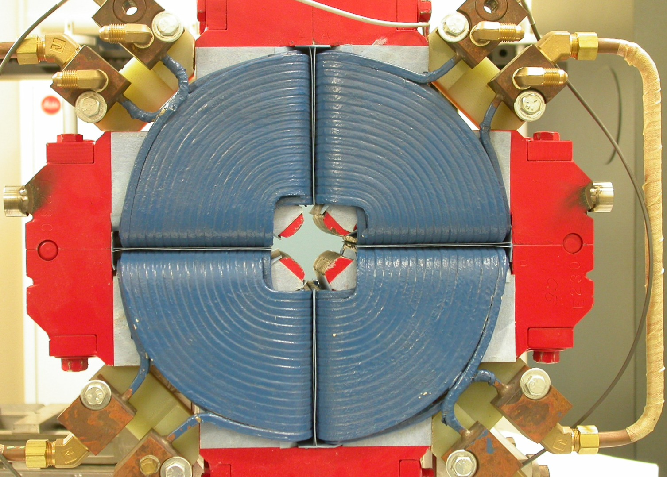  +Y  +X  Front View

Tooling Ball Measurements/Locations

Top of magnet; view from “+Y”

+Z
+X
TB 1
TB 2
TB 5
TB 6

Tooling Ball | FORM | DIAMETER | X | Y | Z
TB 1 | 0.00002 | 0.50004 | 8.24443 | 1.21314 | 1.75578
TB 2 | 0.00010 | 0.49915 | 8.25298 | 1.19965 | -1.22083
TB 3 | 0.00009 | 0.49922 | 1.16572 | 8.27989 | 1.70096
TB 4 | 0.00017 | 0.49907 | 1.19201 | 8.26105 | -1.27926
TB 5 | 0.00012 | 0.49935 | -8.26094 | 1.20963 | 1.70687
TB 6 | 0.00003 | 0.49948 | -8.25074 | 1.20051 | -1.26231

Pole Distances
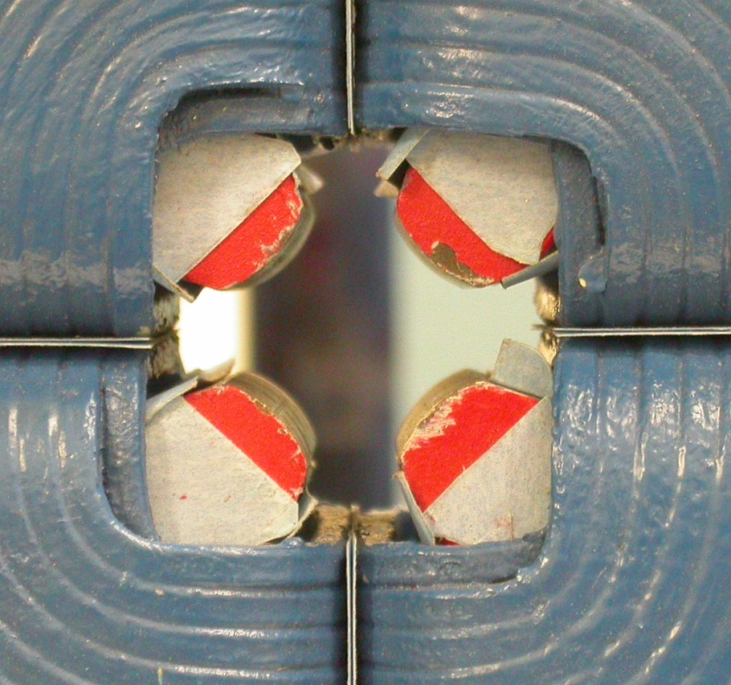
Pole | +Z side | -Z side | Δ  C  D
A-C | 1.08574 | 1.08668 | 0.00094
B-D | 1.08502 | 1.08729 | 0.00227
*** Points collected approx. 0.125 from each end
*** Picture to the left is looking down from +Z
A
B
``

