
LCLS ‘0.91Q17.72’ LTU Quadrupole Magnet
FIDUCIALIZATION REPORT

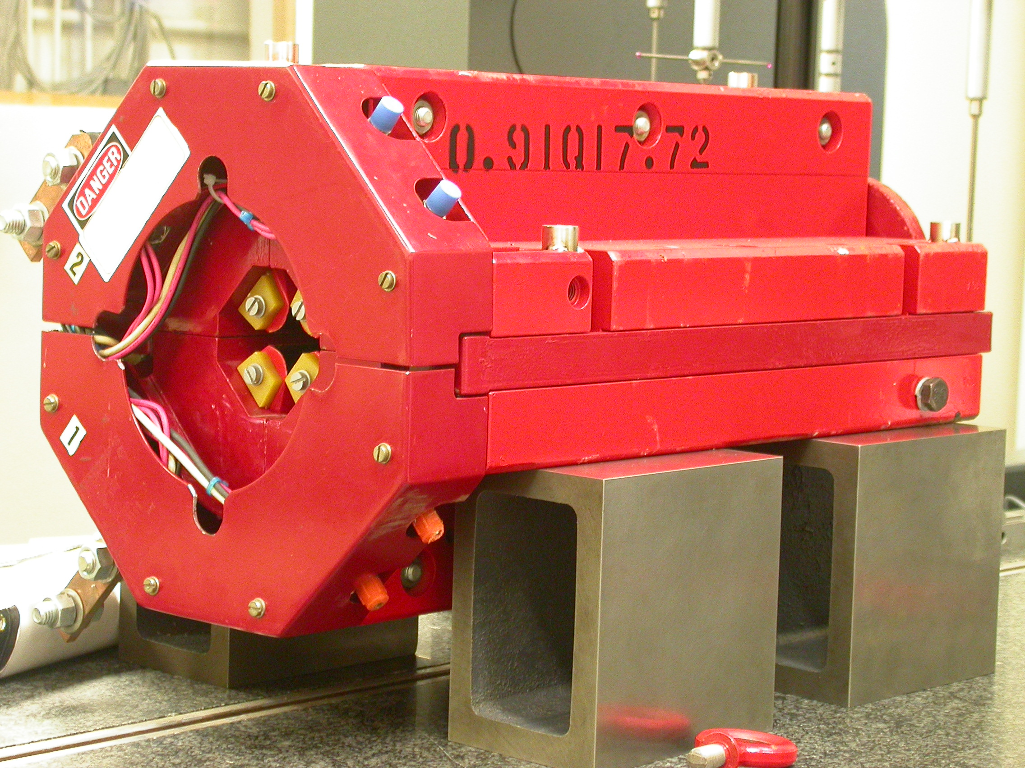

Inspector: | Keith Caban
Responsible Engineer: | Carl Rago
Date: | Wednesday, February 28, 2007
Work Order/Charge No.: | 21699-1
Serial Number: | 000462
URL of Fiducial Report: | \\Web002\www-group\met\Quality\FIDUCIAL REPORTS\LCLS LTU QUAD\000462.pdf

Part Set-up – Coordinate System Set-up

Spatial Alignment

- Geometric axis of the poles of the magnet.

Planar Alignment

- Clocking plane where TB A,C, D, & E reside.

“Z” Zero

- Mid-plane of the magnet (pole planes on each end).

“X” & “Y” Zero

- Geometric axis of the poles of the magnet.

  +X  +Y  Front View | 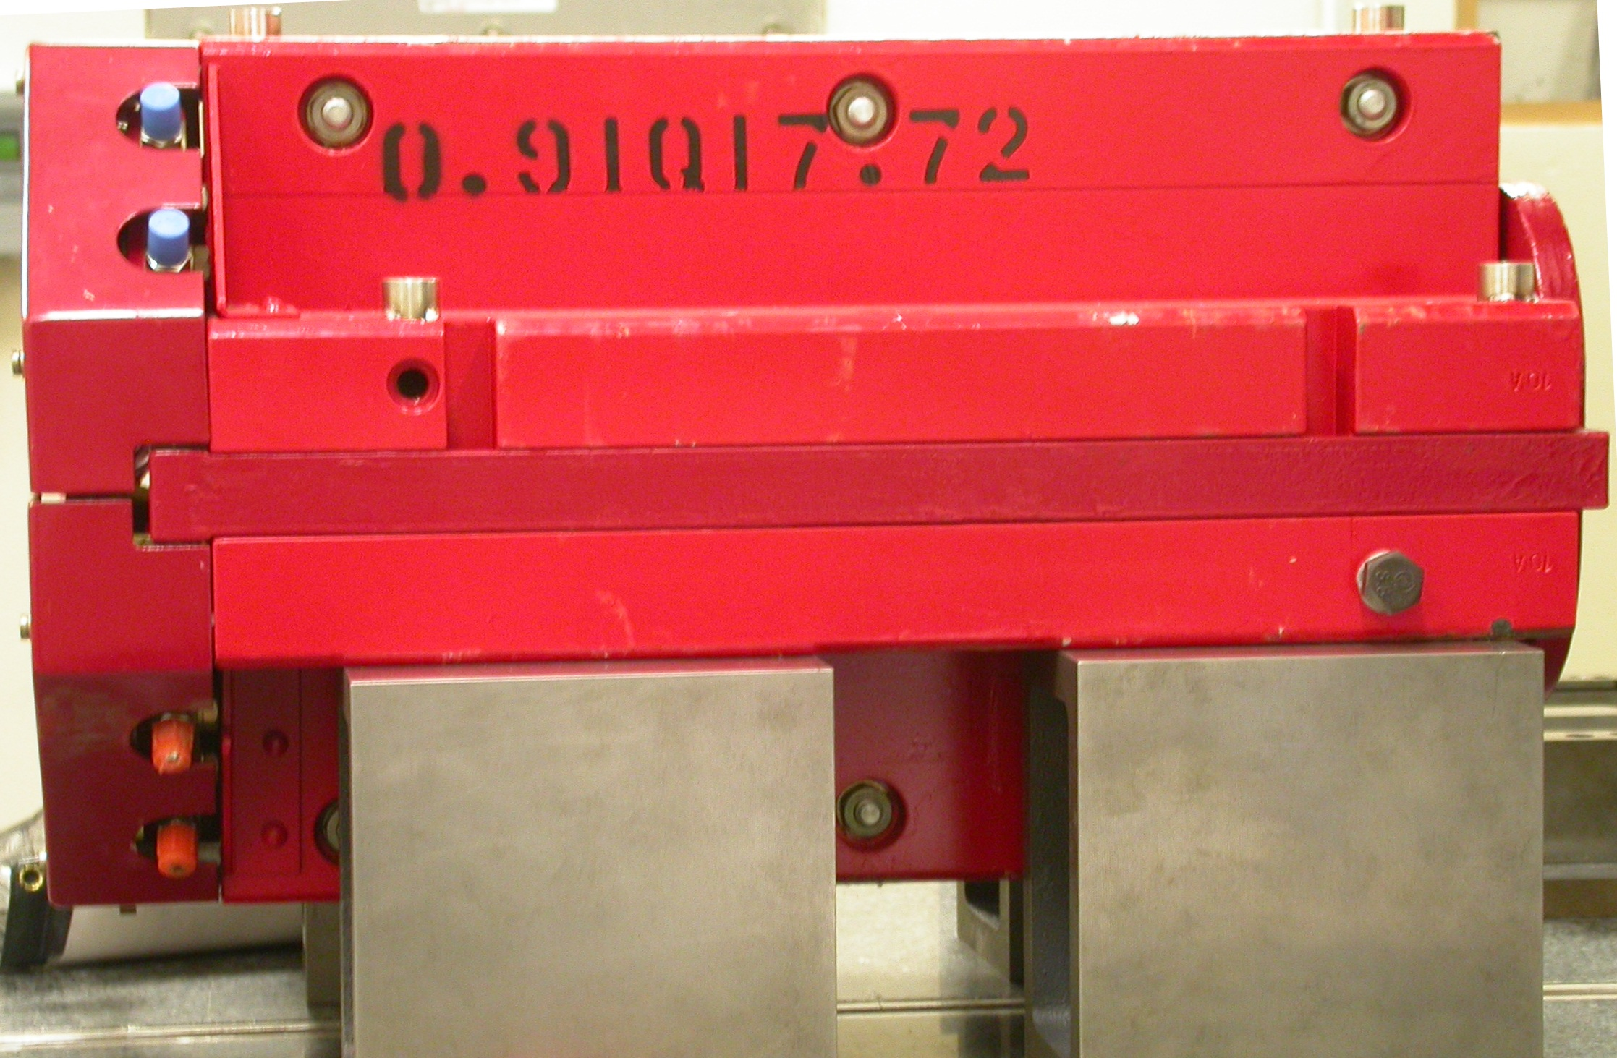  +Z  +Y  Side View

Tooling Ball Measurements/Locations

Top of magnet; view from “+Y”
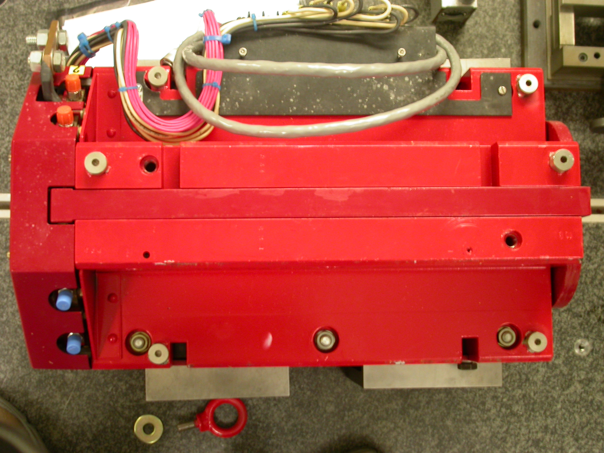

+Z

+X

Tooling Ball | FORM | DIAMETER | X | Y | Z
TB A | 0.00016 | 0.49800 | 5.00833 | 3.72194 | -8.05438
TB B | 0.00018 | 0.49916 | -1.37340 | 7.30538 | -8.00001
TB C | 0.00023 | 0.49730 | -5.01854 | 3.67519 | -8.08101
TB D | 0.00064 | 0.49636 | -5.32069 | 3.67425 | 6.32448
TB E | 0.00001 | 0.49995 | -1.39906 | 7.30575 | 8.01331
TB F | 0.00026 | 0.49823 | 5.24275 | 3.72333 | 6.30076
.

Pole Distances
C
D
Pole | -Z side | +Z side | Δ
A-C | 0.90582 | 0.90712 | 0.00130
B-D | 0.90640 | 0.90598 | 0.00042
A
B

