
LCLS ‘0.91Q17.72’ LTU Quadrupole Magnet
FIDUCIALIZATION REPORT

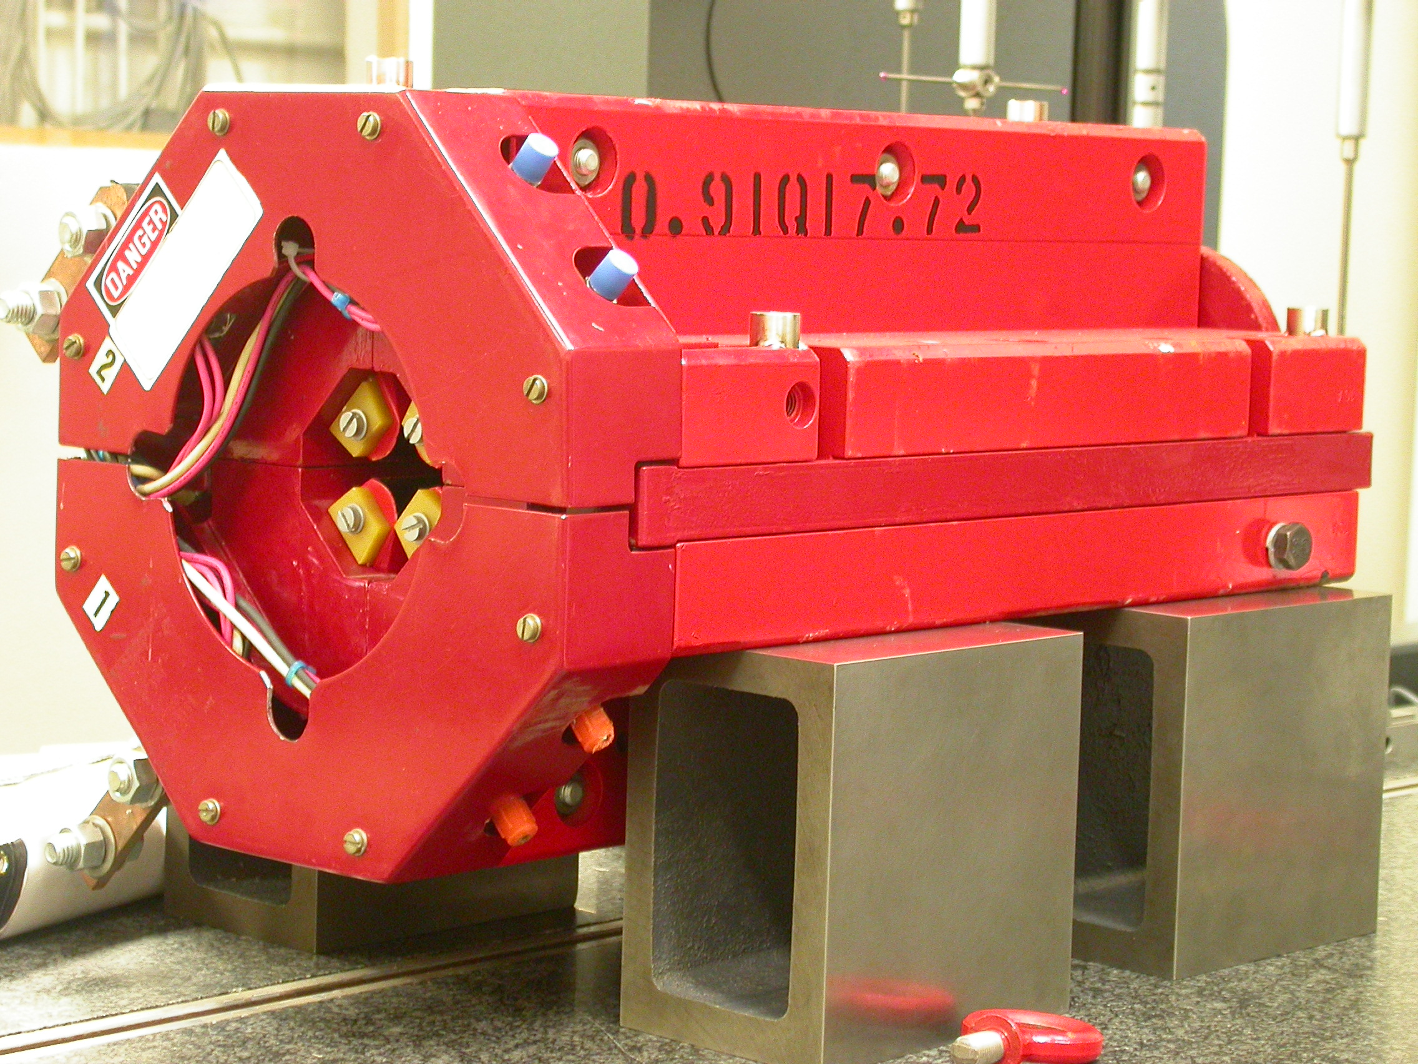

Inspector: | Keith Caban
Responsible Engineer: | Carl Rago
Date: | Wednesday, February 21, 2007
Work Order/Charge No.: | 21699-1
Serial Number: | 000317
URL of Fiducial Report: | \\Web002\www-group\met\Quality\FIDUCIAL REPORTS\LCLS LTU QUAD\000317.pdf

Part Set-up – Coordinate System Set-up

Spatial Alignment

- Geometric axis of the poles of the magnet.

Planar Alignment

- Clocking plane where TB A,C, D, & E reside.

“Z” Zero

- Mid-plane of the magnet (pole planes on each end).

“X” & “Y” Zero

- Geometric axis of the poles of the magnet.

  +X  +Y  Front View | 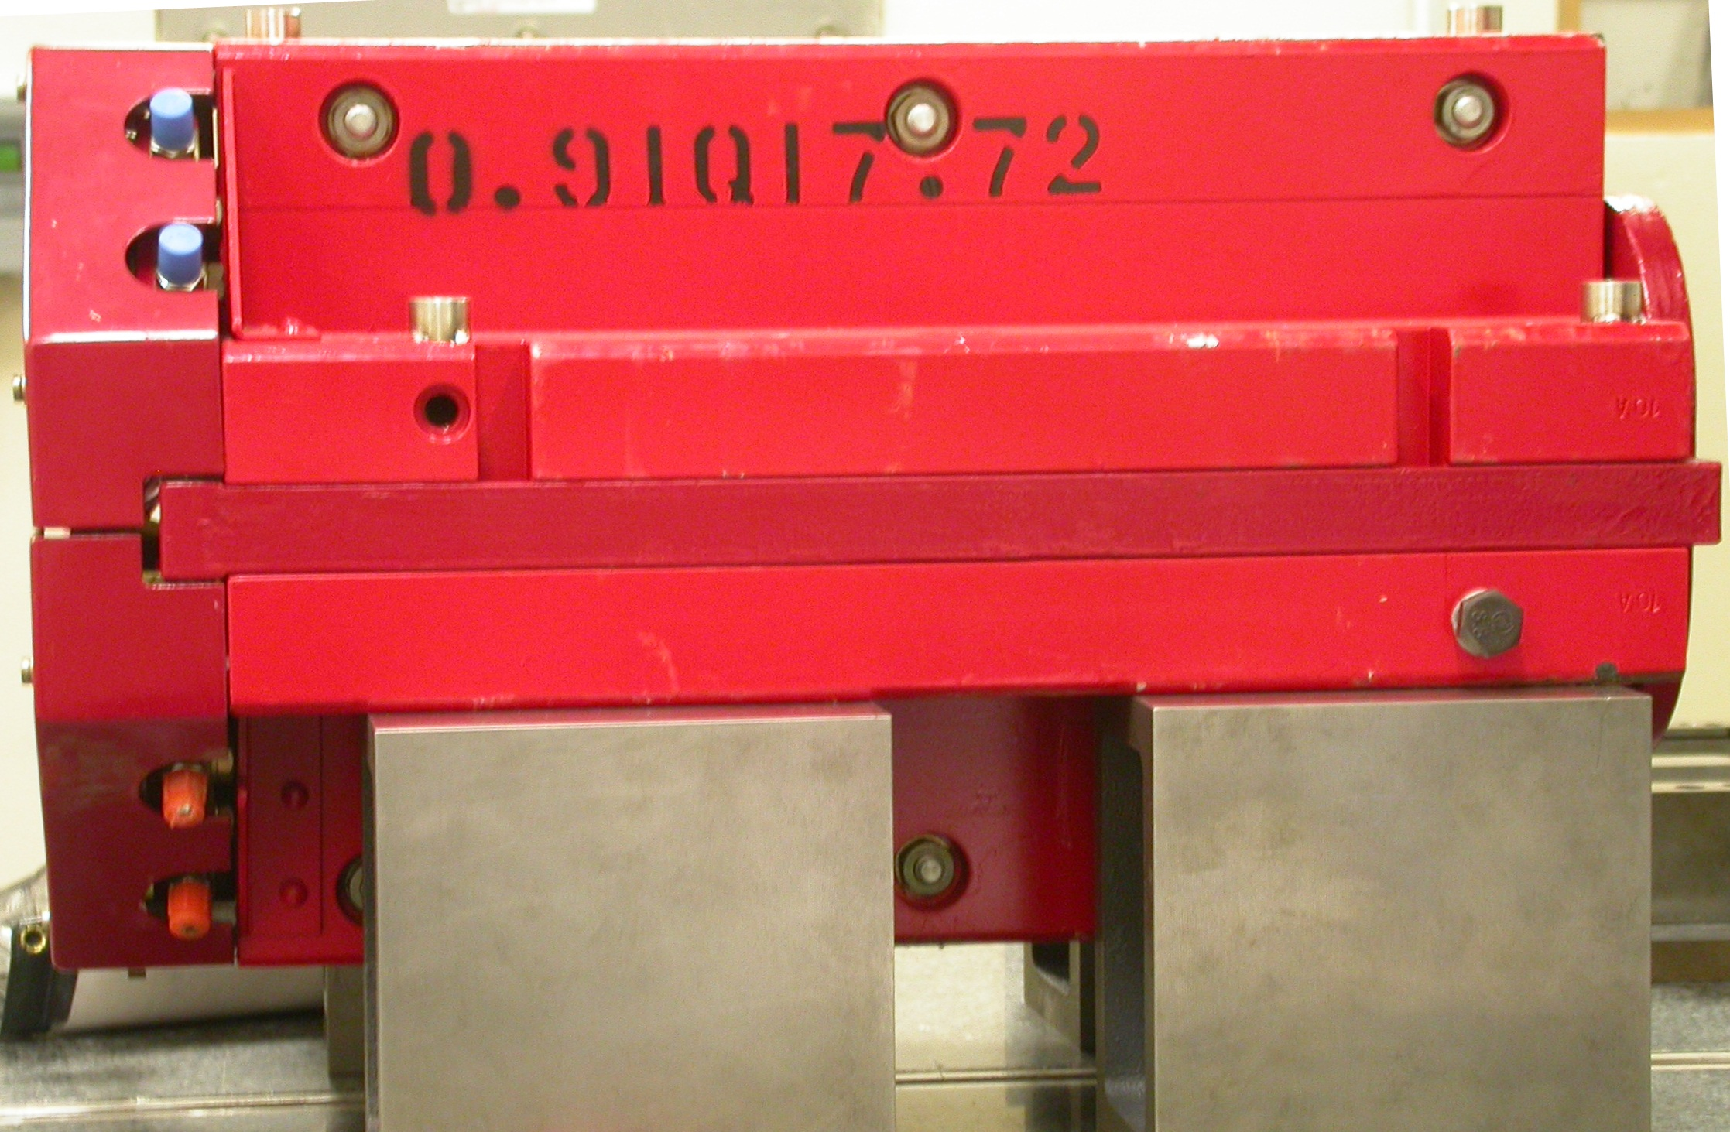  +Z  +Y  Side View

Tooling Ball Measurements/Locations

Top of magnet; view from “+Y”
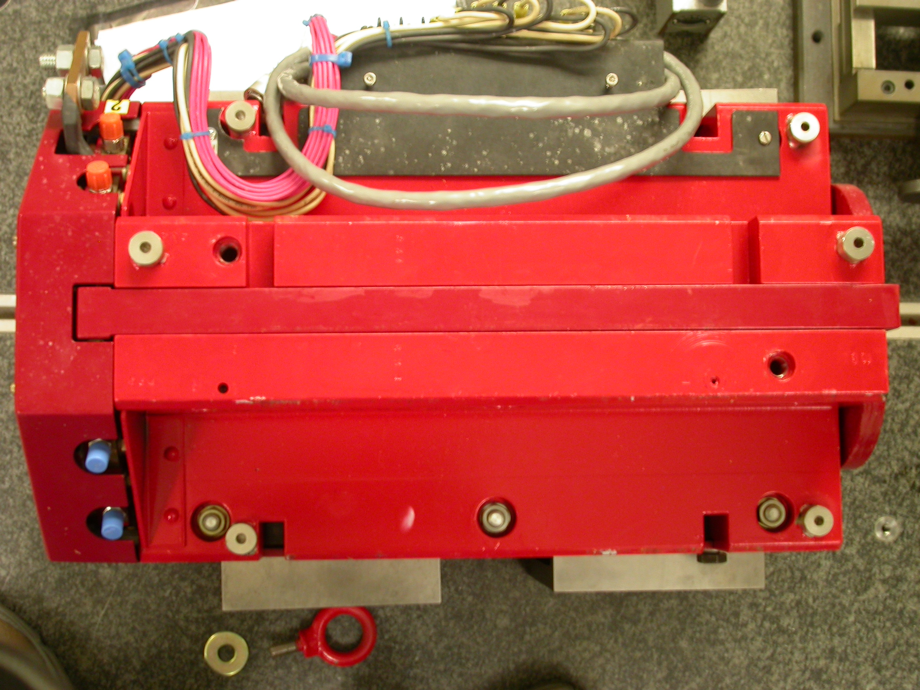

+Z

+X

Tooling Ball | FORM | DIAMETER | X | Y | Z
TB A | 0.00014 | 0.49725 | 5.02802 | 3.69313 | -8.05779
TB B | 0.00020 | 0.49683 | -1.37014 | 7.30119 | -8.05007
TB C | 0.00039 | 0.49676 | -4.97993 | 3.69161 | -8.05734
TB D | 0.00011 | 0.49725 | -5.20112 | 3.69175 | 6.30079
TB E | 0.00011 | 0.49613 | -1.38315 | 7.29894 | 8.07283
TB F | 0.00029 | 0.49678 | 5.26562 | 3.69430 | 6.29219
.

Pole Distances
C
D
Pole | -Z side | +Z side | Δ
A-C | 0.90599 | 0.90636 | 0.00037
B-D | 0.90597 | 0.90561 | 0.00036
A
B

