
LCLS ‘0.91Q17.72’ LTU Quadrupole Magnet
FIDUCIALIZATION REPORT

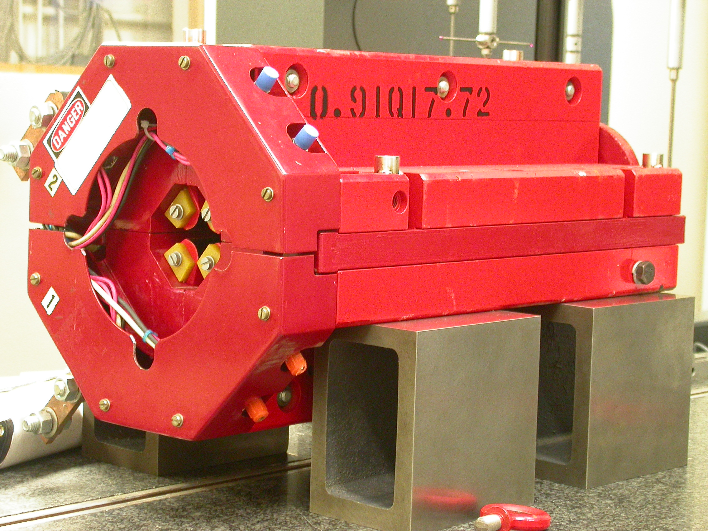

Inspector: | Keith Caban
Responsible Engineer: | Carl Rago
Date: | Thursday, March 01, 2007
Work Order/Charge No.: | 21699-1
Serial Number: | 000316
URL of Fiducial Report: | \\Web002\www-group\met\Quality\FIDUCIAL REPORTS\LCLS LTU QUAD\000316.pdf

Part Set-up – Coordinate System Set-up

Spatial Alignment

- Geometric axis of the poles of the magnet.

Planar Alignment

- Clocking plane where TB A,C, D, & E reside.

“Z” Zero

- Mid-plane of the magnet (pole planes on each end).

“X” & “Y” Zero

- Geometric axis of the poles of the magnet.

  +X  +Y  Front View | 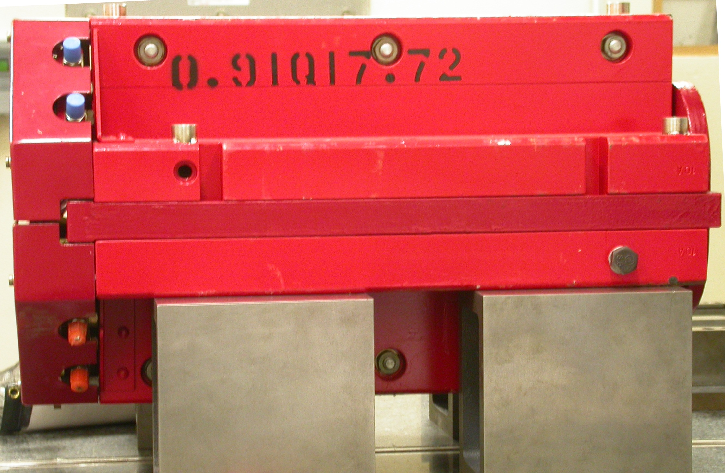  +Z  +Y  Side View

Tooling Ball Measurements/Locations

Top of magnet; view from “+Y”
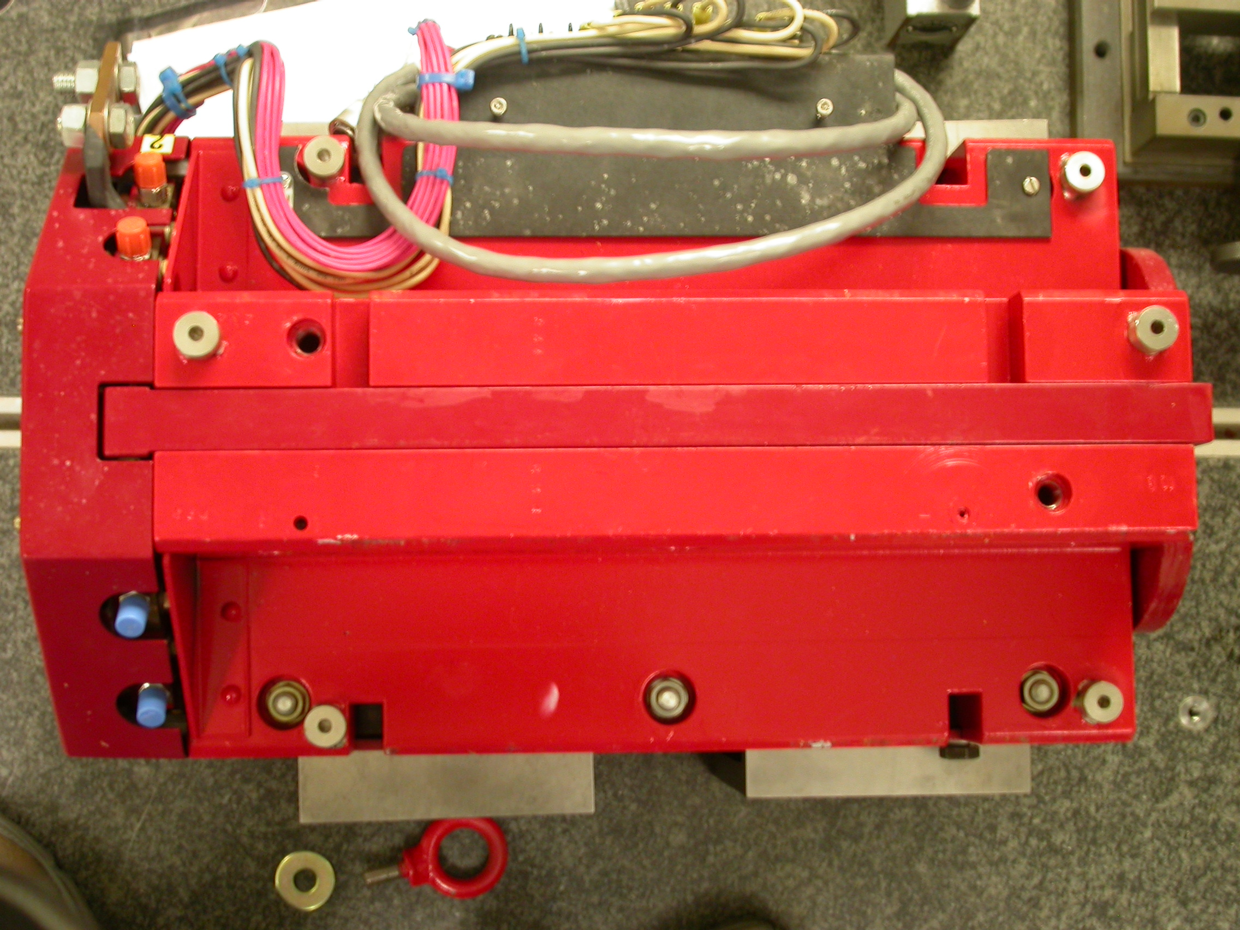

+Z

+X

Tooling Ball | FORM | DIAMETER | X | Y | Z
TB A | 0.00050 | 0.49690 | 5.00770 | 3.70930 | -8.07092
TB B | 0.00013 | 0.49760 | -1.36319 | 7.32516 | -7.96878
TB C | 0.00034 | 0.49723 | -4.97299 | 3.70126 | -8.06870
TB D | 0.00009 | 0.49723 | -4.97299 | 3.70126 | 6.27280
TB E | 0.00020 | 0.49807 | -1.33486 | 7.32735 | 8.01484
TB F | 0.00012 | 0.49955 | 5.24907 | 3.70696 | 6.29137
.

Pole Distances
C
D
Pole | -Z side | +Z side | Δ
A-C | 0.90680 | 0.90691 | 0.00011
B-D | 0.90707 | 0.90734 | 0.00027
A
B

