
LCLS ‘0.91Q17.72’ LTU Quadrupole Magnet
FIDUCIALIZATION REPORT

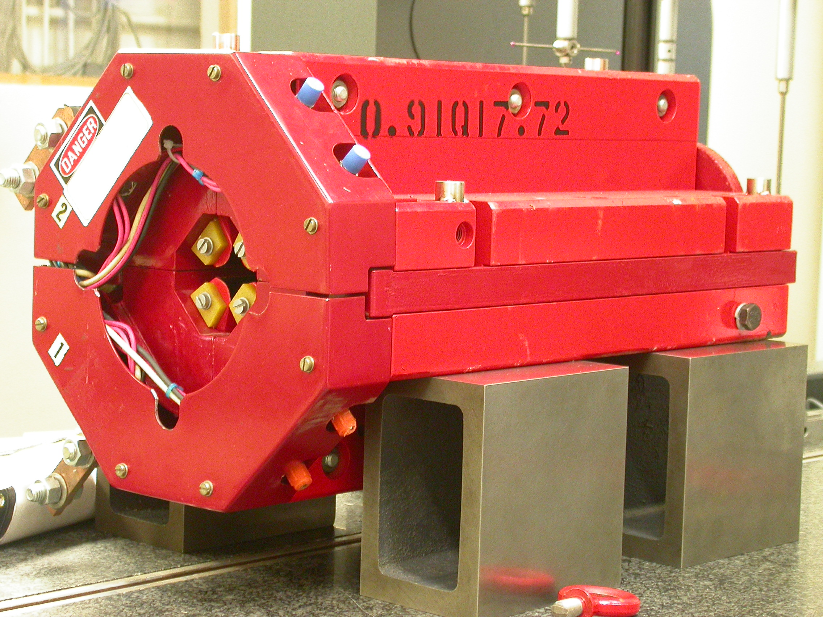

Inspector: | Keith Caban
Responsible Engineer: | Carl Rago
Date: | Wednesday, February 28, 2007
Work Order/Charge No.: | 21699-1
Serial Number: | 000314
URL of Fiducial Report: | \\Web002\www-group\met\Quality\FIDUCIAL REPORTS\LCLS LTU QUAD\000314.pdf

Part Set-up – Coordinate System Set-up

Spatial Alignment

- Geometric axis of the poles of the magnet.

Planar Alignment

- Clocking plane where TB A,C, D, & E reside.

“Z” Zero

- Mid-plane of the magnet (pole planes on each end).

“X” & “Y” Zero

- Geometric axis of the poles of the magnet.

  +X  +Y  Front View | 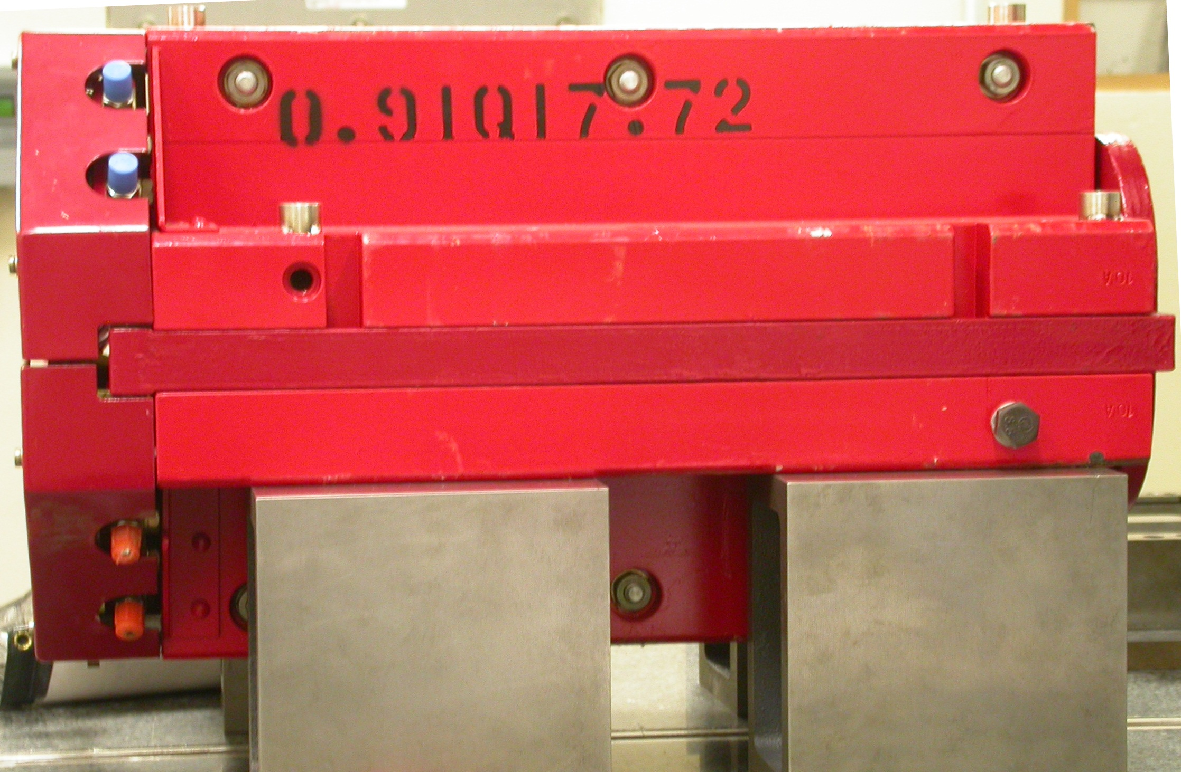  +Z  +Y  Side View

Tooling Ball Measurements/Locations

Top of magnet; view from “+Y”
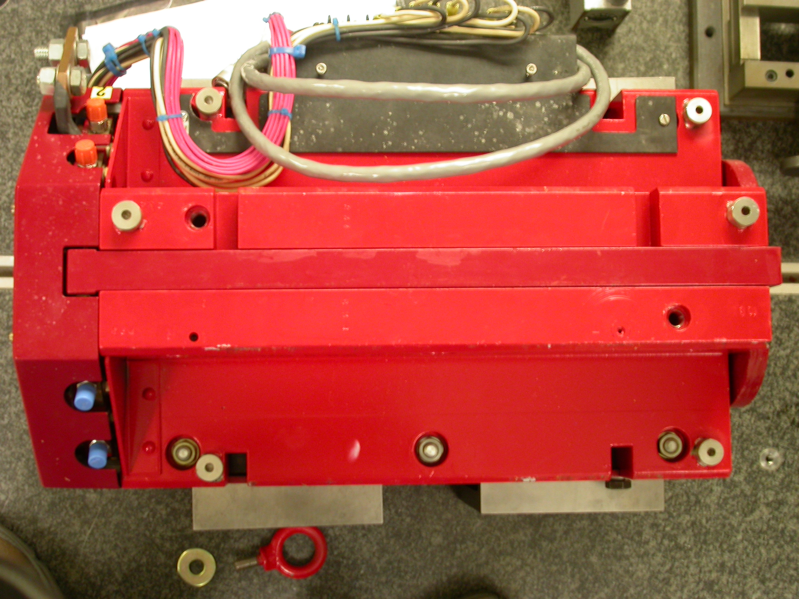

+Z

+X

Tooling Ball | FORM | DIAMETER | X | Y | Z
TB A | 0.00019 | 0.49742 | 5.05497 | 3.71420 | -8.09705
TB B | 0.00035 | 0.49833 | -1.45509 | 7.31688 | -8.05082
TB C | 0.00009 | 0.49973 | -5.04517 | 3.69186 | -8.05783
TB D | 0.00052 | 0.49808 | -5.30611 | 3.69181 | 6.27965
TB E | 0.00003 | 0.49996 | -1.43912 | 7.31738 | 8.06021
TB F | 0.00004 | 0.49837 | 5.30018 | 3.71439 | 6.30034
.

Pole Distances
C
D
Pole | -Z side | +Z side | Δ
A-C | 0.90711 | 0.90685 | 0.00026
B-D | 0.90693 | 0.90614 | 0.00079
A
B

