
LCLS ‘0.91Q17.72’ LTU Quadrupole Magnet
FIDUCIALIZATION REPORT

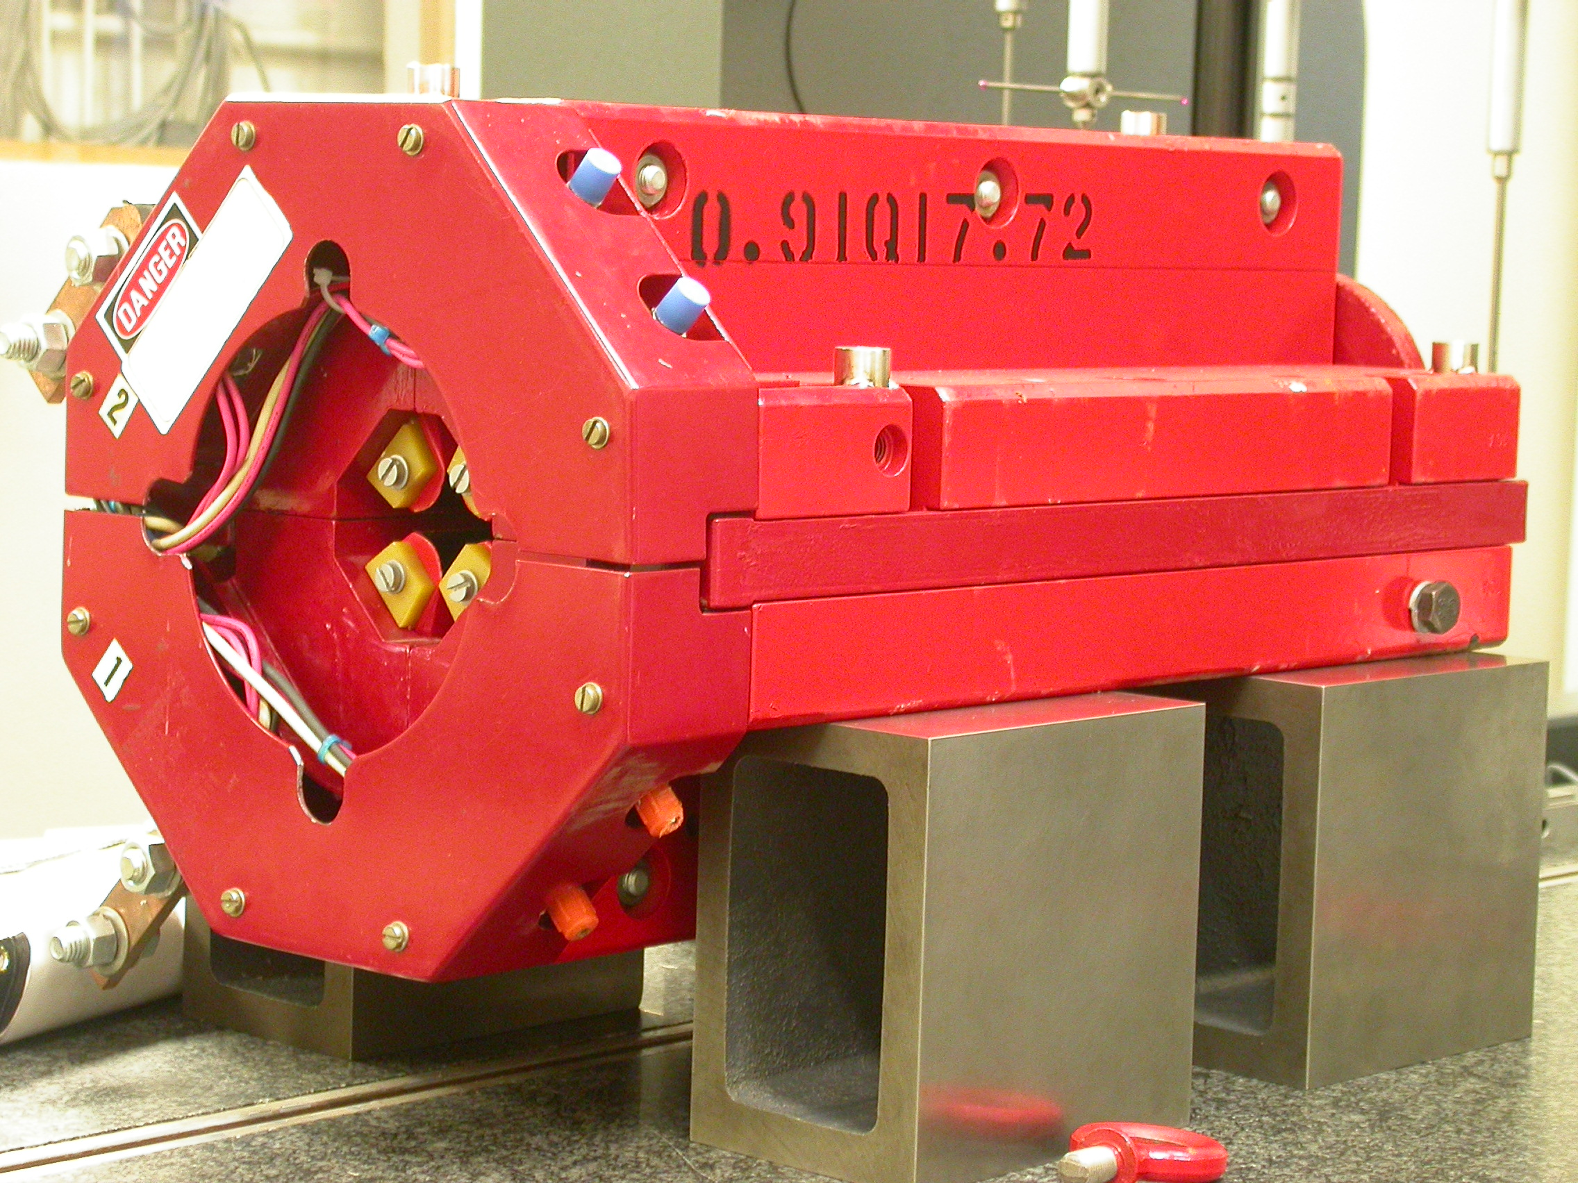

Inspector: | Keith Caban
Responsible Engineer: | Carl Rago
Date: | Wednesday, February 21, 2007
Work Order/Charge No.: | 21699-1
Serial Number: | 000304
URL of Fiducial Report: | \\Web002\www-group\met\Quality\FIDUCIAL REPORTS\LCLS LTU QUAD\000304.pdf

Part Set-up – Coordinate System Set-up

Spatial Alignment

- Geometric axis of the poles of the magnet.

Planar Alignment

- Clocking plane where TB A,C, D, & E reside.

“Z” Zero

- Mid-plane of the magnet (pole planes on each end).

“X” & “Y” Zero

- Geometric axis of the poles of the magnet.

  +X  +Y  Front View | 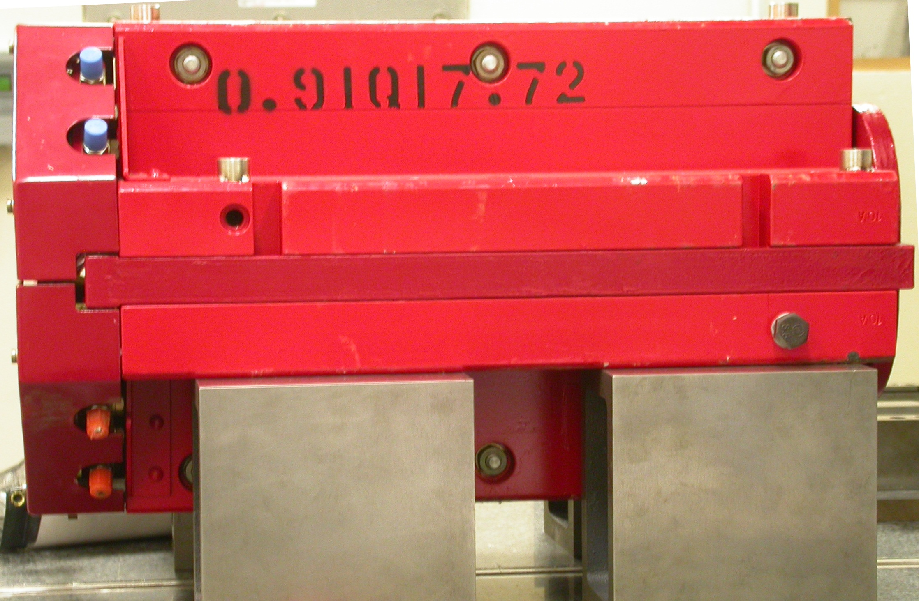  +Z  +Y  Side View

Tooling Ball Measurements/Locations

Top of magnet; view from “+Y”
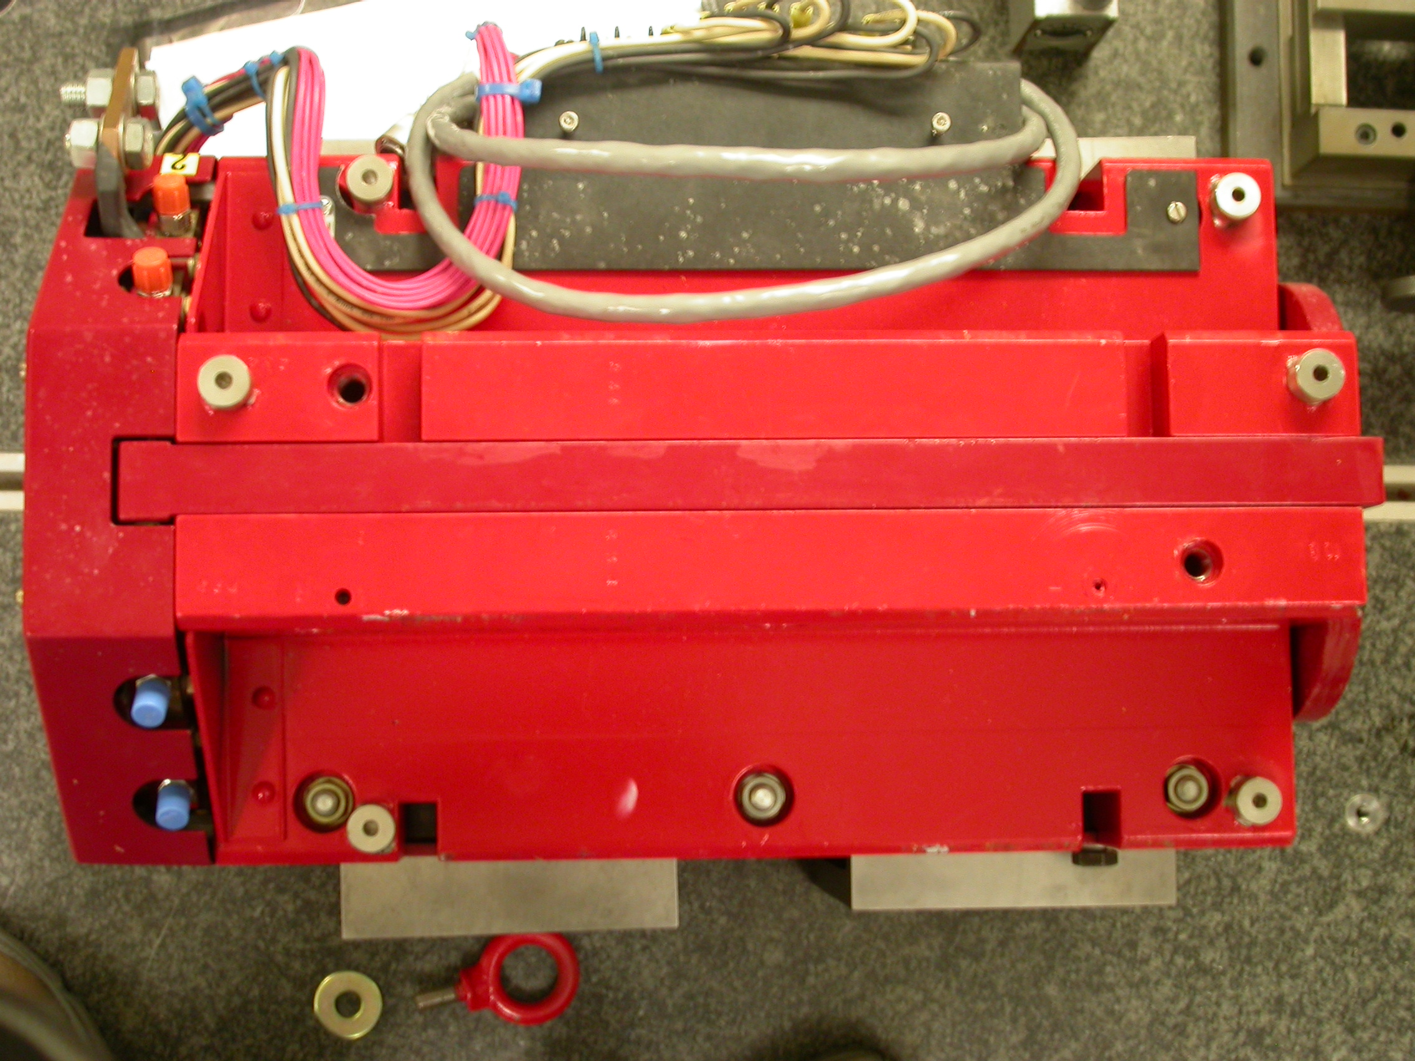

+Z

+X

Tooling Ball | FORM | DIAMETER | X | Y | Z
TB A | 0.00006 | 0.49913 | 5.00712 | 3.70673 | -8.03280
TB B | 0.00003 | 0.49967 | -1.40711 | 7.32741 | -8.02921
TB C | 0.00012 | 0.49840 | -4.95756 | 3.67656 | -8.02702
TB D | 0.00024 | 0.49740 | -5.29555 | 3.67526 | 6.28779
TB E | 0.00023 | 0.49766 | -1.41054 | 7.32776 | 8.02866
TB F | 0.00002 | 0.49982 | 5.21845 | 3.70606 | 6.27925
.

Pole Distances
C
D
Pole | -Z side | +Z side | Δ
A-C | 0.90691 | 0.90712 | 0.00021
B-D | 0.90654 | 0.90662 | 0.00008
A
B

